Miniature Loop Alarm
By Tomaz Lazar - Ljubljana, Slovenia
A few months ago, I decided to build a compact, yet effective alarm. My demands were:- simple construction, reliable operation, very small power consumption, and, most of all, small size. I started with CMOS logic gates, but was soon forced to abandon the concept after a few unsuccessful (and far too complicated) attempts. Then I suddenly realized that a simple transistor switch might do the job and I was right.

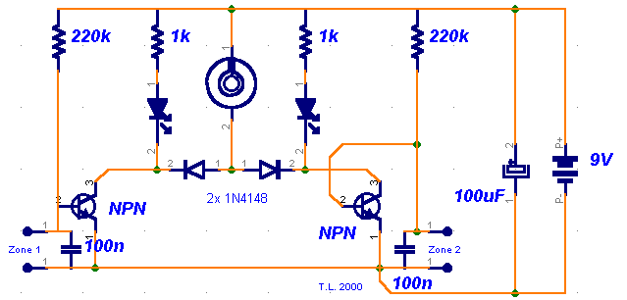
As you can clearly see from the schematics, the circuit is utterly primitive and consists of two identical transistor switches. Each has its own alarm LED and they're coupled to a neat 82dB buzzer. The two 1N4148 diodes are used to prevent a signal from one sensor from triggering both LEDs. The sensors used are either wire loops or normally closed reed switches or even a combination of both. You could, for example, tie a wire loop to your suitcase and place a reed switch to the door of your hotel room.

Since this little alarm is intended to be kept in arms reach at all times, there aren't any provisions for automatic shutdown after a certain period of time. The buzzer will sound until you turn the whole circuit off or connect the wire loop back to the jumpers. The same goes for the two LEDs, each indicating its own zone.

Construction is not critical and there aren't any traps for the novice. The two 100n capacitors aren't really necessary, I just included them to make sure that there is no noise interference coming from the long wire loops. For transistors, you can use any NPN general-purpose audio amplifiers/switches (BC 107/108/109, BC 237/238, 2N2222, 2N3904...). Assemble the circuit on perf board. Together with the buzzer and a 9V battery, it should easily fit in a pocket-sized plastic box smaller than a pack of cigarettes. A fresh battery should suffice for weeks of continuous operation.

