4.0 Emergency Communications Organizations and Systems
Learning Unit 4
Emergency Communication Organizations & Systems
Objective:
Emergency communication organizations are what make an emcomm response possible. This unit introduces several of the largest and best-known organizations, and a number of related emcomm and public warning systems.
Information:
Why is organization so important to emcomm?
Imagine a random group of volunteers trying to tackle a full-scale disaster communication emergency, working together for the first time. They do not know each other well, have very different approaches to solving the same problem, and half of them want to be in charge. Get the picture?
It is not too far fetched. Just ask anyone who has been around emcomm for a while -- they have seen it! This course is intended to help solve that problem, but without emcomm organizations, this course would be worthless.
Emcomm organizations provide training, and a forum to share ideas and develop workable solutions to problems in advance of a real disaster. This way, when the time comes to assist the served agency, you will be as prepared as you can be. The response will occur more smoothly, challenges will be dealt with productively, and the served agency's needs met.
Some of the organizations discussed here do not directly involve Amateur Radio operators, but knowing about them and how they might assist in an emergency may be helpful. Your served agency may utilize or interact with one or more of these systems or organizations.
Amateur Radio Emergency Service (ARES)
Among the largest and oldest emcomm groups is ARES, a program sponsored by the American Radio Relay League (ARRL) since 1935. ARES is part of the League's field organization, which is composed of "Sections". Most Sections are entire states, but some larger states have two or more Sections.
The elected Section Manager (SM) appoints the ARES leadership. The top ARES leader in each Section is the Section Emergency Coordinator (SEC).
Some larger Sections, like Wisconsin, Michigan, and Florida, are further divided into two or more Districts. In this case, each District is guided by a District Emergency Coordinator (DEC) and Assistant DEC, working directly under the SEC and/or Assistant SEC. (See diagram below.)
The next subdivision within ARES is the "county" or similar region assigned to an Emergency Coordinator (EC). Most ECs will have one or more Assistant Emergency Coordinators (AEC), who may have responsibility for specific tasks or cities. A large city with complex needs may have its own EC, but most towns and smaller cities will have an AEC.

ARES has Memoranda of Understanding (MOUs) with a variety of agencies at the national level, including the Federal Emergency Management Agency (FEMA), American Red Cross, Salvation Army, and the National Weather Service. These documents set out the general relationship between ARES and the agency at the national level, and provide guidance for local units of both organizations to draft more specific local MOUs.
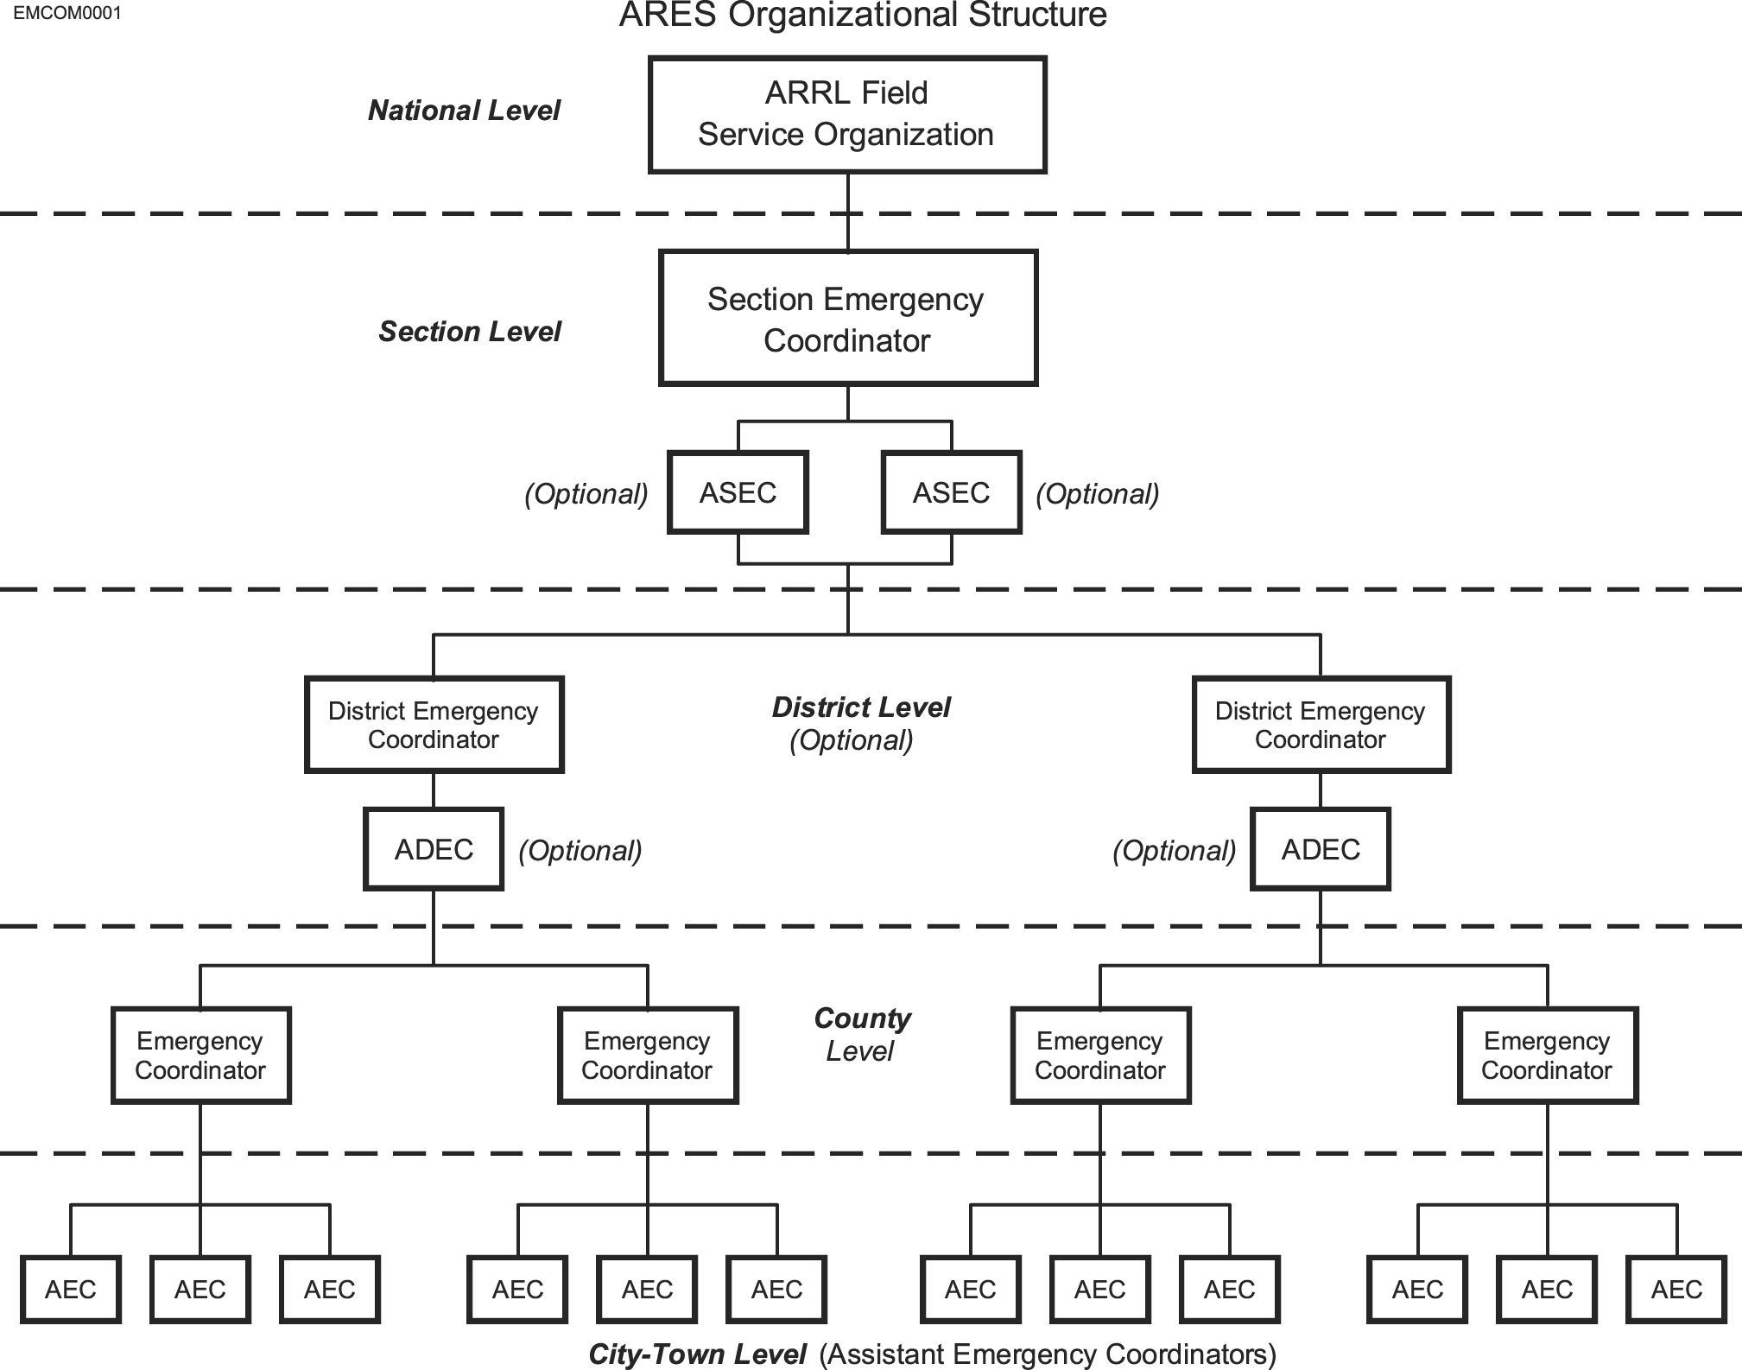
Section Manager SJV
AE6SX Dan Pruitt
Section Emergency Coord.
SJV
N6ZFN Marie Thompson
In addition to local chapters of national groups, ARES groups often have MOUs or other written or verbal agreements with state and city emergency management departments, hospitals, schools, police and fire departments, public works agencies, and others.
County Emergency Coordinator
KC5LUB Hal Clover
Assistant Emergency Coordinators
KJ6OH Al Drake, W6RAY Ray Quinn, WA7HRG Jim Purvis
Radio Amateur Civil Emergency Service (RACES)
The federal government created RACES after World War II. The RACES rules addressed the need for Amateur Radio operators to function as an integral part of a state, county, or local Civil Defense (CD) agency in time of national emergency or war. The RACES authorization provides the means to continue to serve the public even if the President or the FCC suspends regular Amateur operations. In this situation, the RACES rules provide for use of regular Amateur frequencies, but place strict limits on the types of communications made, and with whom.
At one time, Civil Defense agencies could obtain a "RACES station license" that would allow non-ham agency personnel to use Amateur frequencies under limited conditions. These licenses are no longer issued, and cannot be renewed. Operators of any RACES stations must be licensed Amateurs, and must follow the RACES rules at all times.
Over the years, both "Civil Defense” (known as “Emergency Management" in most states) and the way it utilizes Amateur radio operators have changed dramatically. There are fewer RACES only operators today. Increasingly, RACES-registered operators also belong to ARES, and can "switch hats" when the need arises. Emergency management officials like this arrangement since it provides more flexibility, and gives them more direct control over their ham radio volunteers.
Salvation Army Team Emergency Radio Network (SATERN)
SATERN members are also Salvation Army volunteers. Their HF networks are used for both logistical communication between various Salvation Army offices and for health and welfare messages. At the local level, ARES, REACT and other groups often help support the Salvation Army's operations.
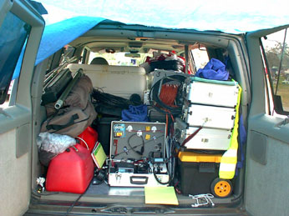
One RRT's geared up and headed for hurricane Katrina support.
The "Rapid Response Team" (RRT)
In the first minutes of an emergency, it is sometimes important to get the basic essentials of a network on the air quickly. The solution is the "RRT" concept, although its name may vary. In Hawaii, it is known as a "Quick Response Team" (QRT), and in New Hampshire, a "Rapid Emergency Deployment Team" (RED Team). Rather than a stand-alone organization, a RRT is small team within a larger emcomm group. Their job is to put a few strategically placed stations on the air within the first half-hour to an hour. These stations will usually include the emergency operations center (EOC), a resource NCS, and often a few field teams where needed most. This is commonly known as a "Level 1 RRT response".
A Level 2 RRT response follows within a few hours, bringing additional resources and operators. Level 1 teams have pre-assigned jobs, and short-term (12-24 hour) "jump kits", ready to go whenever the call comes. Level 2 teams have longer term (72 hour) jump kits, and a variety of other equipment, possibly including tents, portable repeaters, extended food and water supplies, sleeping gear, spare radios, and generators, depending on local needs.
ARES Mutual Assistance Team (ARESMAT)
When a communication emergency lasts longer than a day or two, or when the scale of the emergency is beyond the ability of a local ARES group to handle, help can be requested from neighboring areas. The ARESMAT concept was created to meet that need. These teams consist of hams who are willing and able to travel to another area for a period to assist ARES groups based in the disaster area. They may also bring additional resources in the form of radios, antennas, and other critical equipment. If you travel to another area as part of an ARESMAT, remember that the local group is still in charge -- you are there to do what they need done. In a sense, the host ARES group becomes a "served agency".
Military Affiliate Radio Service (MARS)
MARS is a Department of Defense sponsored auxiliary communication program, established as three separately managed and operated programs by the United States Army, Navy/Marine Corp, and Air Force.
The program enlists the services of licensed hams who operate disciplined and structured nets on assigned military radio frequencies adjacent to the Amateur bands. MARS has a strict set of rules regarding the type, content and format of messages. Special call signs are issued for MARS use.
In day-to-day service, MARS stations handle quasi-official and morale messages for the three services. During times of emergency, MARS provides backup communication networks to military, federal, state, and local agencies. MARS' most visible mission, providing phone patches to family members for US military personnel overseas, has diminished with the advent of new satellites that provide email and phone service almost anywhere. However, this has never been MARS largest or most important function.
One advantage of the MARS system is that it is specifically authorized to communicate with other government radio services in time of emergency, including the federal SHARES HF networks.
National Traffic System (NTS)
Long before e-mail and the Internet, there was ARRL's NTS. The concept on which NTS is based is as old as ARRL itself. The NTS consists of local, regional and national nets operating on a regular basis to pass messages (traffic) from place to place. In day-to-day usage, the NTS handles non-critical organizational messages for its own members and ARRL field organizations, radiograms for the public, and various personal messages.
Since e-mail has become popular, the NTS has seen a significant decrease in the number of messages passed through the system, and a corresponding decrease in membership and overall effectiveness. However, NTS still has an important role in emergency communication, and discussions about modernizing the NTS are underway. A more in depth discussion of NTS will follow later in this course.
Local Radio Clubs
Not every area has a working ARES or other nationally affiliated emcomm group. In many cases, the void is filled by local radio clubs who either work informally with served agencies, or with a formal MOU.
National Communications System (NCS)
A Federal agency, the NCS consists of 23 government organizations tasked with ensuring that the Federal Government has the necessary communication capabilities under all conditions from day-to-day use to national emergencies and international crises. These include the Forest Service, Federal Emergency Management Agency, Coast Guard, FBI, ATF, and others who have a variety of communication assets. The Manager of the NCS is also the Director of the Defense Information Systems Agency (DISA), usually an Air Force general.
SHARES
Even those who have been involved with emcomm for years may not know of the US Government's "Shared Resources System", known as "SHARES". This system is part of the NCS. It pairs certain MARS operators with various federal agencies and state emergency operations centers to provide a high frequency (HF) communication backbone if normal communication systems should fail. In addition to government agencies, key communications companies such as AT&T, and agencies such as the Red Cross have SHARES radios. The SHARES system utilizes a number of nationwide and regional networks.
Federal Emergency Management Agency - FEMA National Radio System (FNARS)
This is a FEMA high frequency (HF) radio network designed to provide a minimum essential emergency communication capability among federal agencies, state, local commonwealth, and territorial governments in times of national, natural and civil emergencies. FEMA monitors the FNARS HF frequencies on a daily basis. At the state level, FNARS radios are typically located at the states emergency operations center (EOC).
Radio Emergency Associated Communications Teams (REACT)
REACT is another national emcomm group, whose members include Citizen's Band (CB) radio operators, hams, and others. In addition to CB and Amateur Radio, they may use General Mobile Radio Service (GMRS), Family Radio, and the Multiple Use Radio Service (MURS).
REACT has an organizational structure similar to ARRL/ARES, with local teams who directly serve many of the same agencies served by ARES and other ham radio emcomm groups. REACT has MOUs with many of these agencies, as well as with ARRL.
REACT's mission is somewhat broader than that of ARES. They offer crowd and traffic control, logistics, public education, and other services that usually (but not always) include a need for radio communication.
Emergency Warning Systems
Emergency Alert System -- EAS - (Broadcast Radio & TV):
The current EAS system has evolved from the earlier Emergency Broadcast System (EBS) and the original "CONELRAD System" developed during World War II. The EAS relies on radio and TV broadcast stations to relay emergency alert messages from federal, state, and local authorities. Messages may pertain to any immediate threat to public safety, including enemy attack, storm warnings, earthquake alerts, and wildfires. Messages are relayed from station to station using automatic switching systems and digital signaling. You may have heard the required weekly EAS tests performed by radio and TV stations and their distinctive digital "squawk" sound.
NOAA Weather Alert and National Weather Radio (NWR):
The National Weather Service (NWS) division of the National Oceanic and Atmospheric Administration (NOAA) operates NWR.
NWR uses seven frequencies in the 162MHz band to carry audio broadcasts to the public. Forecast and warning information originates from the regional network of forecasting offices, and yields timely and quality alerts dealing with weather and other natural events.
Newer "weather alert" radios are available from a variety of manufacturers with the digital Specific Area Message Encoding (SAME) alert mechanism. SAME equipped radios will remain silent until an alert is received for a specific geographic area. The user programs one or more five-digit FIPS codes for the areas they wish to monitor. When the NWS broadcasts the alert with the SAME code matching that programmed into the receiver, the receiver will activate and allow you to hear the audio message concerning the alert. Some receivers also provide a textual display of the alert information. The NWS tests the SAME network at least once weekly, and the radio will indicate that it has heard the test alert within the past week.
NAWAS (National Warning System):
The federal government maintains a "hardened" and secure national wireline phone network connecting the warning points in each state (usually the state police HQ or state EOC). The center of NAWAS operations is the National Warning Center at NORAD's Cheyenne Mountain command and control complex in Colorado. Its primary purpose is to provide notification in case of enemy attack, and to inform and coordinate alert and warning information among states in a given region. During peacetime, it carries alerts on a variety of wide-ranging emergencies. Roll call check-ins are taken periodically during the day to ensure that the phone circuits are functioning properly.
Statewide Warning Systems:
These systems are similar to NAWAS, but at a state level. For most states that have such a system, county warning points are part of a statewide alert and warning network. It is known by different names in each state. For example, in Hawaii, it is HAWAS (Hawaii Warning System). In California, it is CALWAS.
In Hawaii, HAWAS connects the warning points in each island county, the Pacific Tsunami Warning Center, the local National Weather Service Forecast Office and the Hawaii Air National Guard's 199th Fighter (interceptor) Squadron, 154th Wing, stationed at Hickam Air Force Base. It keeps these key entities informed on a real-time basis of bulletins crucial to these agencies. The warning systems in other states are similar.
Tsunami Warning System:
A national and international network of warning points are connected together to provide timely exchange of tsunami warning information. In the United States, it is known as the Tsunami Warning System (TWS).
Information is relayed to a wide range of government, civil defense, military, and international tsunami research/warning points within each country or area.
National Earthquake Information Center (NEIC):
The U.S. Geological Survey operates the National Earthquake Information Center, located in Golden, Colorado. The NEIC issues rapid reports for those earthquakes that register at least 4.5 on the Richter Scale in the United States, or 6.5 on the Richter Scale (or are known to have caused damage) anywhere else in the world. Public warning reports are disseminated in the affected areas via the NWR and EAS systems.
Reference links:
National Communication System: www.ncs.gov
REACT International: www.reactintl.org
FEMA National Radio System: www.fema.gov
Amateur Radio Emergency Service: www.arrl.org/Fand ES/field/pscm/sec1-ch1.html
NOAA Weather Radio: http://www.weather.gov/nwr/
Emergency Alert System (EAS): www.fcc.gov/eb/eas/
Hawaii EAS: http://www.scd.state.hi.us/documents/EAS_Plan.pdf
National Earthquake Information Center: http://earthquake.usgs.gov/regional/neic
Army MARS: http://www.netcom.army.mil/mars/
Navy MARS: http://www.navymars.org/
Air Force MARS: http://public.afca.af.mil/library/factsheets/factsheet.asp?id=7037
SATERN: http://www.satern.org/
Review:
Organization is critical to any emergency response. Without an organization that plans and prepares in advance, an Amateur Radio emcomm response is likely to be disorganized and ineffective.
A variety of government and private emergency communication groups assist in time of disaster. While Amateur Radio operators may not interact with many of these systems, it may help to know that they exist, since your served agency may utilize or interact with one or more.

