20.0 Hazardous Materials Awareness

Learning Unit 20
Hazardous Materials Awareness
Objective:
This learning unit introduces the reporting of hazardous materials (HazMat) incidents and stresses personal safety awareness for emcomm volunteers.
Information:
Amateur radio operators may encounter HazMat incidents during their travels, or they may be asked to assist with emergency communications in such incidents. Proper training is required for your own safety. Moreover, a wrong move by you during a HazMat operation can endanger not only your own safety, but also the safety of other responders as well as the entire local community.
The term "hazardous materials" (HazMat) refers to any substances or materials, which if released in an uncontrolled manner (e.g., spilled), can be harmful to people, animals, crops, water systems, or other elements of the environment. The list is long and includes explosives, gases, flammable and combustible liquids, flammable solids or substances, poisonous and infectious substances, radioactive materials, and corrosives. One of the major problems faced by emergency responders is determining which chemicals are involved and determining the potential hazards.
Hazardous Chemicals On The Move
As the primary regulatory agency concerned with the safe transportation of such materials in interstate commerce, the US Department of Transportation (DOT) has established several systems to manage HazMat materials. These include definitions of various classes of hazardous materials, placards and other marking requirements for vehicles, containers and packages to aid in rapid identification of cargoes, and an international cargo commodity numbering system.
The DOT requires that all freight containers, trucks, and rail cars transporting these materials display placards identifying the hazard class or classes of the materials they are carrying. The placards are diamond-shaped, 10 inches on a side, color-coded and show an icon or graphic symbol depicting the hazard class (flammable, caustic, acid, radioactive, etc). They are displayed on the ends and sides of transport vehicles. A four-digit identification number may also be displayed on some placards or on an adjacent rectangular orange panel. If you have spent any time on the roads, you have undoubtedly seen these placards or panels displayed on trucks and railroad tank cars. You may recognize some of the more common ones, such as 1993, which covers a multitude of chemicals including road tar, cosmetics, diesel fuel, and home heating oil. You may have also seen placards with the number "1203" (gasoline) on tankers filling the underground tanks at the local gas station.
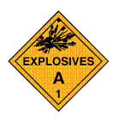 | 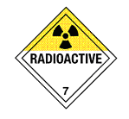 | 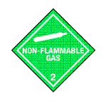 | 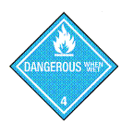
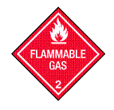 | 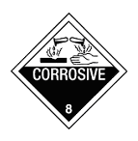 | 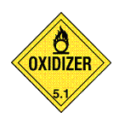 | 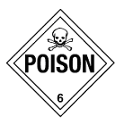
In addition to truck and rail car placards, warning labels must be displayed on most packages containing hazardous materials. The labels are smaller versions (4 inches on a side) of the same placards used on vehicles. In some cases, more than one label must be displayed, in which case the labels must be placed next to each other. In addition to labels for each DOT hazard class, other labels with specific warning messages may be required. Individual containers also have to be accompanied by shipping papers that contain the proper product name, the four-digit ID number and other important information about the hazards of the material.
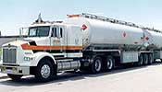
Tanker displying placards.
Hazardous Chemicals in Buildings
The National Fire Protection Association (NFPA) has devised a marking system to alert firefighters to the characteristics of hazardous materials stored in stationary tanks and facilities. This system, known as NFPA 704M, can also assist citizens visiting a site in identifying the hazard presented by the stored substance. Use of the system is voluntary, unless specified by local codes.
The NFPA 704M label is diamond-shaped, and is divided into four parts, or quadrants. The left quadrant, colored blue, contains a numerical rating of the substance's health hazard. Ratings are made on a scale of 0 to 4, with a rating of 4 indicating a danger level so severe that a very short exposure could cause serious injury or death. A zero, or no code at all in this quarter, means that no unusual hazard would result from the exposure. The top quadrant of the NFPA symbol contains the substance's fire hazard rating. As you might expect, this quadrant is red. Again, number codes in this quadrant range from 0 to 4, with 4 representing the most serious hazard. The NFPA label's right quadrant, colored yellow, indicates the substance's likelihood to explode or react. As with the health and fire hazard quadrants, ratings from 0 to 4 are used to indicate the degree of danger. If a 4 appears in this section, the chemical is extremely unstable, and even under normal conditions may explode or react violently. A zero in this quadrant indicates the material is considered to be stable even in the event of a fire. The bottom quadrant is white, and contains information about any special hazards that may apply. There are three possible codes for the bottom quarter of the NFPA symbol:
OXY means this material is an oxidizer. It can easily release oxygen to create or worsen a fire or explosion hazard.
The symbol W indicates a material that reacts with water to release a gas that is either flammable or hazardous to health.
If the material is radioactive, the usual tri-blade "propeller" symbol for radioactivity will appear.
Guidelines for Handling HazMat Incidents
- Once you are in a safe position up-hill and up-wind, try to identify the material. However, it cannot be over-emphasized that you MUST stay well away from the site. Do NOT be tempted to get just a little closer so that you can read placards or other items. If you cannot read these items using a spotting scope or binoculars, simply report what you can see from a safe position. If you are able to see from a safe position, look for:
  - The four-digit number on a placard or orange panel.
  - The four-digit number preceded by the initials "UN/NA" on a shipping paper, package or drum.
  - The name of the material on the shipping papers, placard, or package.
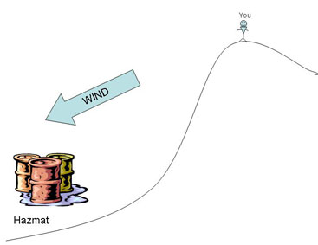
Safe positioning from hazardous materials
- Call for help immediately and let the experts handle the situation. Remember, even ordinary firefighters and police are prohibited by federal law from taking certain actions at some HazMat incidents. Do not attempt to personally take any action beyond your report and preventing others from approaching. This is an instance when it is vitally important to know your limitations, not just for your own safety, but also for the safety of others.
- When reporting a HazMat incident, include the following information:
  - Identify yourself.
  - Give your current location and the location of the incident, i.e. street address or cross streets, road and mile marker, distance from nearest town, etc.
  - Briefly describe what you see (from a distance), i.e. liquid spill, gaseous cloud, etc, and any placard numbers or other information you can safely see.
  - If a gaseous cloud or liquid spill exists, give the direction the contaminant is flowing or moving. Give any pertinent weather or other information you can observe from a safe distance that might help the experts in responding to the incident. Be concise.
Reference links:
- Details of the placards and emergency response procedures can be found in the comprehensive DOT Emergency Response Guidebook, copies of which may be available for your review at your local Emergency Management, police, sheriff or fire department. A copy is also available online at: http://hazmat.dot.gov/pubs/erg/gydebook.htm. You may also consult your Local Emergency Planning Committee (LEPC) or State Emergency Response Commission (SERC) concerning what role Amateur Radio might have in your local plan. For more information about hazardous materials in general, contact FEMA, Technological Hazards Division, Federal Center Plaza, 500 C St., SW, Washington, DC, 20472 (202) 646-2861.
- Additional related links:
http://safety.science.tamu.edu/nfpa.html
www.people.memphis.edu/nfpa.htm
http://www.ehs.neu.edu/laboratory_safety/general_information/nfpa_hazard_rating/
http://safety.science.tamu.edu/dot.html

Review:
If you happen upon a hazardous materials incident, first take precautions to protect yourself and others with you by remaining at a safe distance, upwind and uphill. Next, report any basic information you can safely gather, including placard legends and numbers, wind conditions, scene conditions, and other information to the appropriate public safety agency. Take no direct action except to report, and to protect yourself and others.

