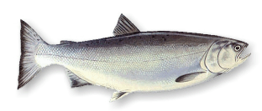
Skamokawa, Washington Wahkiakum County

K7PAR/7
Puget Amateur Radio Society
2000 Washington Salmon Run

Op _______________________________ confirming 2-way QSO with:
Station | Day-Mo-Yr | UTC | Band | RS(T) | Mode
PARS  PSE QSL  TNX QSL
PO Box 32

Kirkland WA 98083-0032 www.qsl.net/k7par

