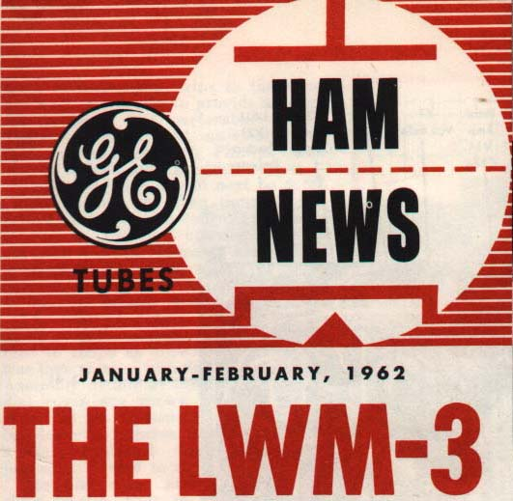

AN AMATEUR RADIO 23 TUBE, 5 BAND, CW/SSB TRANSCEIVER.

The bands are covered in 11 individual 200 KHz segments of the assigned amateur radio bands.

A DESIGN BY;

W.C. Loudon, W8WFH and A.F. Prescott, W8DLD

Featured in a two-part GE Ham News article;

Volume 16, No 6 Nov-Dec 1961, Part 1 Design and Electrical Details
Volume 17, No. 1 Jan-Feb 1962, Part 2 Mechanical Details.

Plus

GE Ham News Bulletin, 1962. ‘Changes and Additions’
14 Pages of Changes and Additions to the original Articles listed above.

A preview by famed Lighthouse Larry of the GE Ham Team. It contains one home brewing expression that I had forgotten – ‘A Chinese Copy’.

Of the some 600 units built by radio amateurs many were Chinese copies and the others were in the time-honoured tradition of ‘variations’ on the original design. I expect quite a few projects fell by the wayside’.

The pages carried many questions and answers, which arose out of building such a complicated and detailed project. There were some circuit changes and correction to component values etc.

Building the LWM 3

An amateur radio home brew 23 tube, 5 Band, CW/SSB Transceiver

J.B. Smith, VK9NS
Norfolk Island

April 2003

It seems an age since the days of ‘home brewing’ amateur radio equipment was an art, a skill to be proud of in addition to saving a few pennies here and there. The heydays of post WWII with the mountain of surplus material available on the open market was quite a period to live through. Of course in our own case the surplus item we amateurs were interested in was the huge quantity of communications equipment with its own mountain of radio tubes, components etc.

The fertile mind of the radio amateur would over two or three decades produce endless articles in amateur radio publications worldwide. These are a lasting record of the modifications and improvements made to many items of surplus material. Of course some equipments were more suitable for modification than others but there were many items, which could be used almost immediately. For example this was true of several of the ex wartime receivers. Many became icons in our world, the HRO, the AR88 and the BC34X series would serve as examples.

Home Brewing

Then there was another approach; that of using discrete components or subassemblies salvaged from a particular unit. The quality of many of these components was remarkable and ended up being used over and over again as a radio amateur home brewed from one article to another.

So it was in my own case, home brewing was the way to go. I never regretted having to (for purely economic reasons) take this path to enable me to become active in amateur radio. The process sharpened my technical knowledge and skills over many years. Most of my early equipment was self made or at least a surplus unit modified to serve some purpose or another. There is a great feeling of achievement and personal reward once that latest home brew project is up and running. Then the other plus was that home brew equipment was fair game for further modifications; a better receiver mixer, a better detector or whatever. We thought in the world of change and possible improvement to our rigs. No self-respecting amateur would be party to a ‘leave well enough alone’ outlook!

By the early 60’s I had certainly done my share of home brewing and in particular that of CW/SSB gear. As VS1BQ in Singapore made a start to SSB back in 1949. In Singapore there was a treasure trove of war surplus equipment of US, Japanese and British origin.

The 60’s and GE Ham News

In late 1961, as G3HSR I received a courtesy copy of the latest issue of GE Ham News. This Nov-Dec 1961 issue featured a home brew 23 Tube, 5 band CW/SSB Transceiver named the LWM 3. This first part carried the Design and Electrical Details and the article certainly caught my attention. By the time I had finished reading the article I was completely hooked. It was to be the receipt of the next issue of GE Ham News with the second and final part of the LWM 3 article that set my mind on a ‘Must Do’ course.

In re-reading the circuit diagram, looking at the parts lists, I almost knew in my mind what I had in suitable parts and, maybe more importantly what I did not have. However, I certainly had sufficient bits and pieces to make a start and there was much to do in chassis work alone. During that period of several weeks’ of metal work more could be done to get other needed parts together.

The LWM 3

The LWM 3 was developed jointly by W.C. Louden, W8WFH and A.F. Prescott, W8DLD and was designed around the basic circuitry of the Collins KWM 2 (A) series of transceivers. The bands were split up into 11 - 200 KHz segments and Bill and Al had decided to make it a mobile rig and as such the transmitter section had a modest output of just a few watts. If more power was required then a linear amplifier could be used and could be mounted in another part of the vehicle.

Initially I decided to build the LWM 3 with one major change (what self respecting home brewer would think otherwise) and this was to add a PA unit. A pair of 6146 tubes as a final Amplifier would make the rig more similar to the KWM 2 (A). This would then make the LWM 3 a substantial stand-alone rig.

It took around one year to build with many problems and periods of frustration but I got there eventually. I used it extensively as G3HSR in Weston Super Mare and I came to regard it as one of the most significant rigs I had ever built. It rewarded my labour of love and a great deal of hard work many times over.

The Present

To move closer to the point of this article we have to jump forward in time a mere 40 years to late 2001. My amateur radio outlook had hit rock bottom. For various reasons I had taken a couple of issues very personally and felt that after all said and done I had been there, done that so calling it quits might be a good idea. Would I miss amateur radio? Well of course but at the ripe old age of over 70 maybe some of my other interests would get more attention.

The next few weeks had me in a ‘Clean Up’ mode and a great deal of material sorted, filed away, etc. In addition that pile of rubbish was increasing and the place was certainly tidier. It was on opening a long forgotten small cardboard box, to find a permeability tuning mechanism from a car radio inside, that was to change my outlook yet again. This mechanism took me back, in the blink of an eye, to those days of that LWM 3 in the early 60’s. The designers had used a similar unit to tune the RX/TX - R/F amplifier by mechanically moving the slugs within the coils. This was the classic Collins Radio approach to variable band tuning. In those far off days I did not have access to such a thing as there were not many junk car radios around! I had therefore used a 2-gang variable capacitor in lieu to tune the amplifier.

Build the LWM 3 again? You must be Joking!

Within the next few minutes it was realised exactly what I wanted to do. It would break this anti amateur radio mood of mine; it would give me a real challenge and little did I know just how ‘real’! I decided there and then to build this 23 tube LWM 3 transceiver once again. ‘Practice makes Perfect’ or ‘A Glutton for Punishment’. Take your pick!

The reality of this ‘great idea of mine’ took several days to sink it. It was soon realised that it would be an almost impossible task, I no longer had any information on the rig. Of course I could have built something similar more or less from memory. After all circuits are circuits and are easily recalled. But, it would have been nice to have those old articles. Where to start?? This lost period of some 40 years was becoming a brick wall.

The LWM 3 Articles

I approached an old time friend Chuck; N6FX who I recalled had built the LWM 3 at around the same time as myself. In those days of the late 50’s early 60’s he was K1SHN in the East Coast of the USA and we had numerous contacts. My question was “Do you by any chance have any of your material on the LWM 3.” He responded quickly that he would think about it but, as he never ever threw anything out, there was a good chance that his original folder was still around. It took a few weeks but Chuck came through with the goods; a large envelope with photocopies of the two original articles. In addition there was a copy of a multi page document called ‘Changes and Additions’ to the original LWM articles.’ I had never seen this particular material before and it was very interesting. Basically this document answered many of the endless questions (including some which I had experienced) being asked by the hams building the LWM 3. There was another plus, a complete set of the LWM 3 circuitry, which had been enlarged during photocopying. These certainly made things easier in the weeks ahead as those GE Ham News diagrams had been hard to read.

To put it mildly I was delighted and truly in business. It was a very generous gift from Chuck. In sitting down once again and reading through the articles I began to feel at ease, my mind was refocused. Even at 70 plus I knew it could build it one more time. This time around though there would be no dual 6146s PA on board. It would be built in its original form as a low power rig.

A working LWM 3 circa 2002/3

As I write this now, a few days ago I used my homebrew LWM 3 running about 6-8 watts to make a 20m two way SSB QSO with Larry, AH8LG in American Samoa. Norfolk Island to American Samoa is not the exactly the ends of the earth but far enough to give me that feeling of achievement, pleasure and satisfaction. Those ‘down feelings’ of mine had gone.

The elapsed time between making a start and that QSO has been about 14 months. It forced me to realise again and again that 40 years is a long time. Components available then are just not so easy to come by and of course more so being on Norfolk Island. It has been hard to get many bits and pieces but perseverance and often a ‘little help from my friends’ has got me there with a now completed LWM 3 rig. Thank goodness for e-mail!

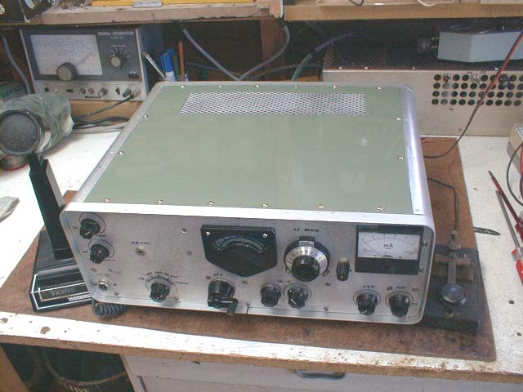

Completed LWM3 (more or less) in April 2003.

Thinking about it. (making a start that is!)

Those articles with the diagrams and part lists from Chuck were food for thought. On checking, I had all of the required 23 tube sockets and most of them were recycled (see picture) from a local source and thoroughly cleaned. All B7G sockets were PTFE!!

Of those 23 tubes required in the LWM 3 I had them all in my junk box except for 5 types. Getting those missing tubes, which were the 2 X 6BA7, one each of 12AT7, 6AR8, 6GH6 and 6U8A proved to be reasonably easy. I obtained the 6BA7s and the 6U8A from an Australian source, which was kind enough to point me to a source in the USA for others, which they did not normally stock. I purchased the more uncommon 6AR8 and 6GH6 tubes from Antique Electronics Supply in the US.

In my junk box I could also see ‘the makings’ of the required 6 pole, 11-way band change switch. Unfortunately those switch wafers were not ceramic, but under the circumstances they would certainly do.

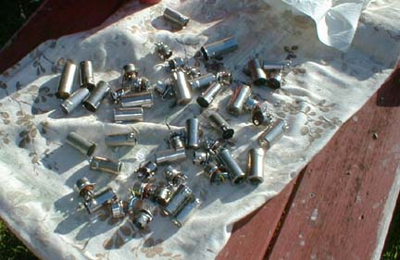

Those recycled 7-pin and 9-pin tube sockets drying in the sun!
(I had very few 9-pin sockets)

Hard to get Parts

Norfolk Island is very isolated but we do have excellent communications. To be successful in starting there were several Key Parts required. These were the heart of the rig.

VFO; For example the original design for the VFO of the LWM 3 of a variable capacitor of WWII Vintage from the ARC 5 series of equipments. It was used endlessly by radio amateurs in building a VFO as it was a quality item and very stable.

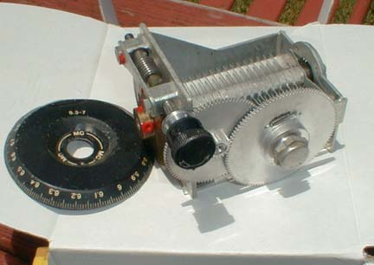

ARC 5 Variable Capacitor, just received in the mail from VK land.

This capacitor has a superb worm drive and a sprung split gear to rotate the plates completely free of backlash. Attached to the mechanism (but removable) it also has an arrangement of a circular dial read out which makes for an easy to read scale. It has an almost 360 degree scale for that 180 degree of the capacitor rotation from minimum to maximum capacity.

The picture shows that original dial before it was modified for use in the rig.

I consider myself fortunate to get this needed item from a VK source at a very reasonable price. The capacitor arrived beautifully packed and was in ‘as new’ condition despite the lapse of some 45 years or so.

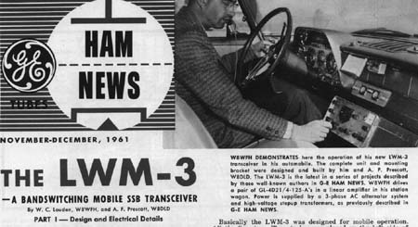

Header of the Part 1 of GE Ham News.

Dual IF Circuits; The original LWM 3 was of a dual IF design. It made use of a 200 KHz band pass 1st IF centred on 3 MHz with the usual 2nd IF of 455 KHz. A Symmetrical 455 KHz, Collins Mechanical Filter provided ultimate IF selectivity of 2.1 KHz and the same filter was also used on transmit for Sideband generation. Sideband switching from LSB to USB utilises two carrier crystal frequencies

The first IF; Required a 200 KHz pass band centred on 3.055 MHz. (2.955 – 3.155 MHz) The LWM 3 bands were therefore split up into 200 KHz segments. (Like the Collins KWM 2 series) The circuit called for the use of tube type TV 4.5 MHz IF Transformers that were modified by additional padding. I tried very hard but never had any luck in locating these. (See later note)

So I built the IF transformers using material which I had and they worked well enough to move on to the next circuit area to be tackled. The 1st TX mixer used the then new 6AR8 GE frame grid tube, which helped overcome the usual mixer problem of inadequate balance etc.

The Second IF; In my ex UK junk box I had a pair of Collins 500 KHz USB and LSB mechanical filters (more of this later) plus the required 500 KHz carrier crystal. I went along this road for obvious reasons and my 2nd IF became 500 KHz, I had the filters and so sideband switching would be very easy.

It proved difficult to find suitable valve type IF transformers and the three transformers for this IF were modified from material I had so that at least the basic circuits could be put together.

NB Just a couple of months ago I saw an advert in the UK RadCom Magazine offering a mixture of old IF cans for sale. After an e-mail enquiry I received a photo of the components and I bought them all for literally nothing plus Air Mail charges. In due course they arrived here and one of the packages inside contained 6 ‘new’ Tube Type TV IF Ratio Detector transformers with bifilar wound centre tapped primary etc. With slight modification they are exactly what was required for that 3 MHz IF circuit.

A start is made

I had sufficient re-cycled aluminum sheet to start the chassis and I opted for a flat chassis approach with no bending required. I then made a start by raising the chassis and used re-cycled aluminium angle material to go round all edges of the chassis. By attaching a couple of temporary side plates I gave the underside a depth of about 3 inches clearance and more progress could then be made.

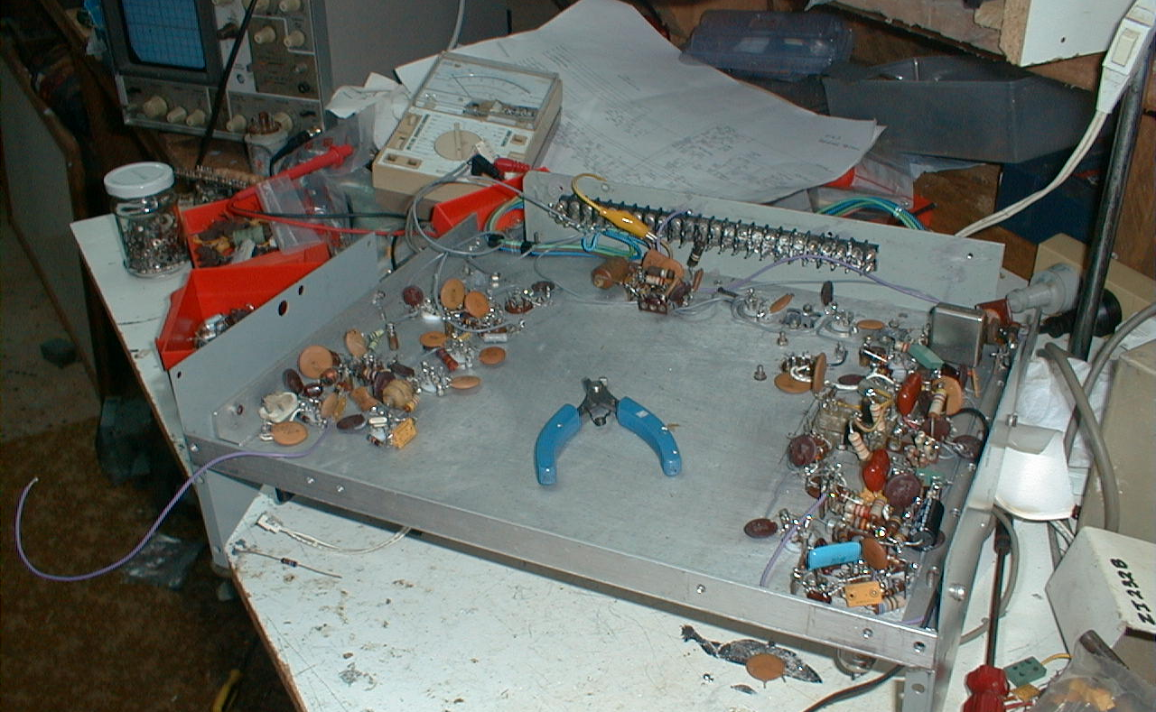

Underside of the chassis. The aluminium angle is prominent along that front edge.

In one initial marathon session I punched all the required base socket holes and actually mounted most of the bases. The layout was based on the original design with the odd change here and there to cater for current components. I was then able to wire up all those heaters and make a start to the endless wiring of each of the tubes.

Remember those days items? Cathode bias resistors, grid resistors, screen resistors and the endless decoupling capacitors. Gradually the odd stage here and there was completed; the mike amplifier, an IF amplifier and so on. It all depended on what components I had and there was an endless search for this or that value of resistance, capacitor etc. For example 100K and 47K resistors were in great demand but those values are rarely used in today’s transistor world.

However the circuit was slowly coming to life.

Transceiver Control

I took time off to set up the TX/RX relay control circuitry, which basically switches the HT (275VDC) supply from the RX to TX circuits and antenna change over. It also uses a minus 65 VDC supply to cut off tubes not used on receive or transmit and of course vice versa. I mounted the required relays and wired up the VOX control relay tube, the triode section of that 6GH8. It was then very easy to arrange to manually switch the tube on and off and go from receive to transmit. The TX/RX relays can be seen on the far left, centre of the chassis in the picture below.

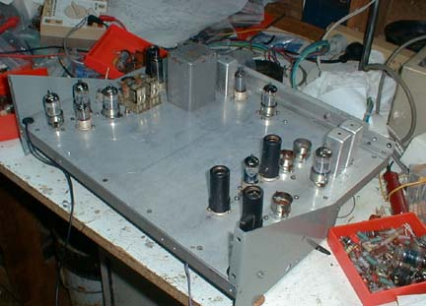

Top View of Chassis

The back right hand corner has the 2 original home brew 3 MHz Band Pass IF Cans

The Transceiver VFO

When I received that ARC 5 Variable capacitor I was able to construct the actual VFO of the LWM 3 as a sub assembly.

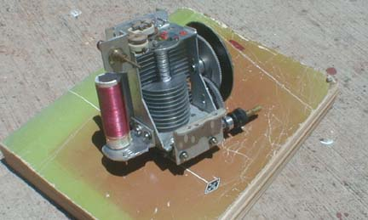

Complete VFO unit showing coil mounted on the VFO frame for stability.

Chassis Work

Shortly after, I attached the front and back panels which then gave the chassis a permanent depth. Various controls were mounted on the front panel and a cut out was made to make the VFO dial visible and the actual VFO was soon being controlled via the front panel control.

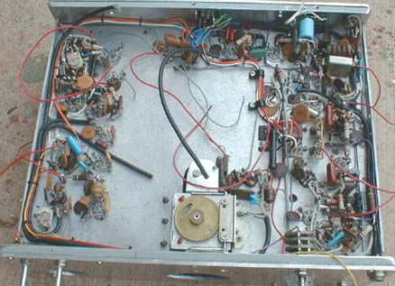

The ARC 5 Capacitor is mounted vertically with coil. The other VFO components
are attached to the frame and results in good mechanical stability.

The flat chassis had enabled me to position the VFO unit accurately and to mark out the cut out required. This cut out was then completed and the VFO mounted as shown.

Before going further I suffered a mechanical style set back in that it was realised that the recycled angle aluminium I had used was NOT exactly right angled. I had to take them off the chassis one by one and square them up. So the front and back panels then became truly vertical and ditto for the side panels.

The complete VFO covers the 200 KHz range of 2.455 – 2.655 MHz. The overall design results in a very stable oscillator and has given no trouble. I made a further change (sorry about that) in the circuit in that I supply the oscillator HT from a VR 105 tube regulated source. A modification
had been recommended using a HV Zener Diode to achieve the same thing but that VR 105 was in my junk box.

Calibration of the VFO Dial is straightforward and this time around I used a frequency counter to do the calibration and mark the dial.

Band Switch Area.

The band switch area was tackled as a completely separate task. There was much to do in this area and a number of sub assemblies were made. In due course this area underwent a major change to fit the new Slug Rack mentioned elsewhere.

Four sub assemblies were required with the switch wafers mounted on the dividing partitions.
Of course the work required to do this was considerable but it gave flexibility to actually remove a section if there was a problem later.

The four required sub assemblies were the 1st Crystal Oscillator, input circuit of the RX/TX R/F amplifier, the output circuit of the same amplifier and input to the TX R/F Amplifier and the output Pi Network circuits, with tuning capacitor and O/P matching capacitors.

This arrangement worked well and gradually the band switching circuitry took shape. Incidentally the use of permeability tuning has one great advantage and this is the use of only one coil for all the bands. (The idea of the addition of those WARC bands becomes very simple) The inductance is varied of course but each band has a separate fixed capacitor plus a trimmer to set up each band. This is much easier than the more normal separate inductor per band. The actual bands are as follows,

1. 3.5 - 3.7 7 21.0 - 21.2
2 7.0 - 7.2 8 21.2 - 21.4
3 10.0 - 10.2 (Crystal to be ordered) 9 24.9 - 25.1 (Crystal to be ordered)
4 14.0 - 14.2 10 28.0 - 28.2
5 14.2 - 14.4 11 28.4 - 28.6
6 18.0 - 18.2 (Crystal to be ordered)

NB I had decided at the beginning of the project to have WARC bands available in due course. Those bands were of course not available in the 60’s.

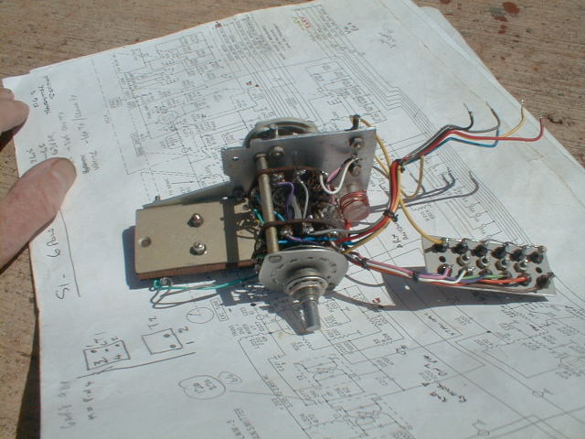

1St Oscillator sub assembly, switch wafers and crystal sockets.

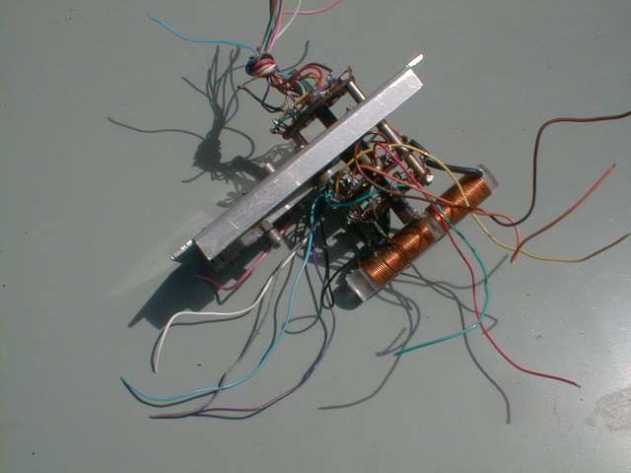

Coil Assembly of the TX Output Amplifier, flying leads go to output loading capacitors.

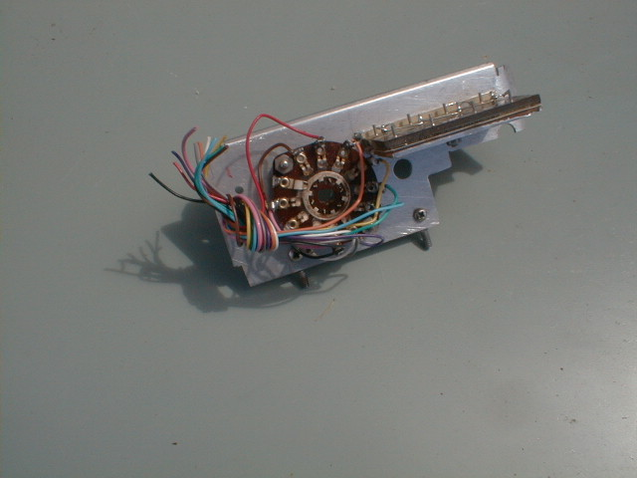

RX/TX amplifier O/P section – switch wafer and trimmer capacitor board.

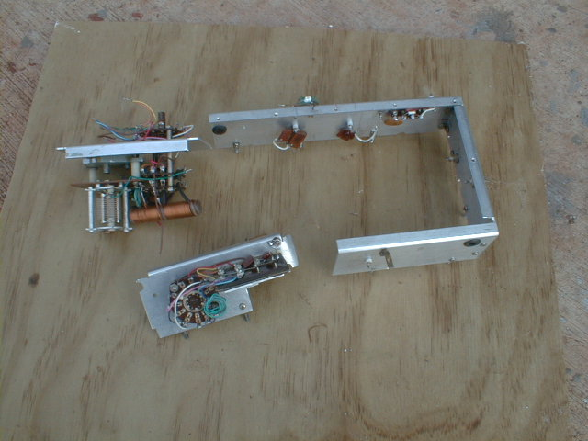

Completed PA tuning assembly, outer screen of switch area and TX output circuits.

Slug Tuning Rack

The car radio mechanism, which I had so carefully saved, was just not suitable as it had insufficient slug movement and this was a major set back. It had however allowed me to get the R/F amplifier circuit going and tested but there were a number of problems to overcome in this, the most important area of the permeability tuning of the R/F stage. So basically I ended up by making my own slug mechanism. This is a whole story in itself and it was to literally ‘eat up time’ until it was all solved. I eventually had a slug rack with a movement of about 1¼ inch, which works fine. I can tune the circuits from 80m through to 10m very easily.

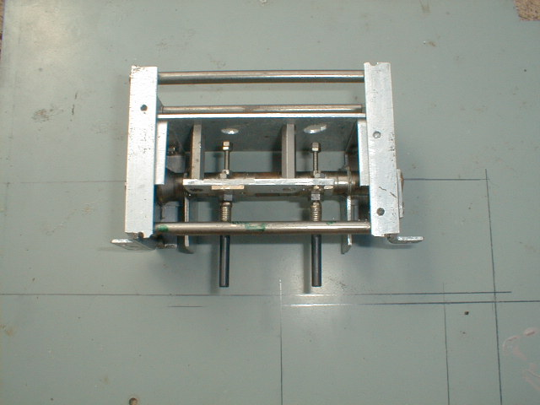

This proto-type of the tuning rack was rebuilt to make the final unit now in use.

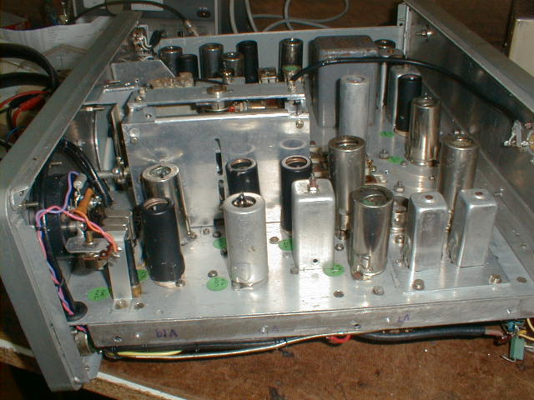

Finalised Slug Tuning rack in place – slightly large but okay.
1st Crystal Oscillator.

Occasionally band crystals for the KWM 2 (A) are available here and there but by choosing that 500 KHz IF they were unsuitable for my use. I had various junk box crystals, which would have got me on some portion of this band or that band. However I had made a decision to make things easier by actually purchasing the required individual band crystals for that 1st Mixer oscillator. In particular the VFO calibration would work for all bands and the band edges would be at the same point on the dial etc.

It was certainly a good move as it made subsequent band alignment and the checking of those VFO dial calibration points straightforward. I ordered the required crystals from QuartzLab Marketing in the UK and they provided an excellent service.

3 MHz Band pass Filter

In the case of the 3 MHz, 200 KHz Band pass IF it was quite a challenge to build. Using material, which I had on hand, I built the two items required and it worked well enough to get the rig going. However I had to rebuild those two circuits a couple of times to get them right. This was another of those time consuming areas.

Recently I was very lucky recently to have Larry, WA9VRH give me the two components used in the ‘real KWM 2A’ and these are T2 and L4 in the Collins KWM 2A manual.

I made up a small sub assembly to take those two Collins transformer cans and this was fitted to replace my home brew items. Being of original Collins design they work extremely well and of course I am indebted to Larry for his very generous assistance.

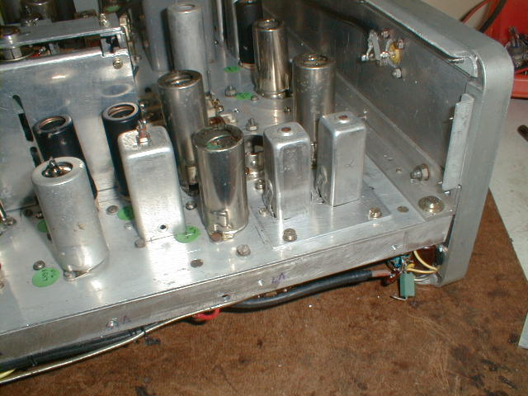

View of the chassis and the Collins T4 and L2 cans in place

The two Collins IF cans are on the extreme right and if you look closely you can see the small plate used to fit them to the chassis after my home brew transformers were removed.

The tube just to the left of the cans is the original 12AT7 2nd TX mixer. This was used until just a few weeks ago when I decided to change this circuit to a pair of 6AU6 tubes in a double balanced mixer configuration. It has excellent inherent rejection of the input signals resulting in a very clean output.

500 KHz – TX and RX

Turning now to the 500 KHz section, the two Collins mechanical filters are used on both Receive and Transmit and provide selectable sideband. As we know, in any transceiver several circuits are used on both RX and TX and I decided to make this circuit as a separate Filter sub assembly. It can be removed it very easily.

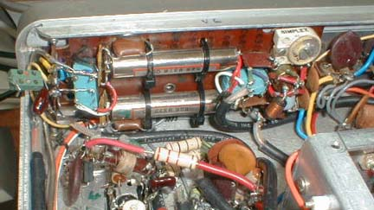

Small sub assembly board that carries the USB/LSB filters etc.

On receive it uses the upper and lower sideband filters selectable by relay switching. On transmit it utilises the additional onboard circuitry of the balanced modulator. In other words the generation of the actual SSB signal uses a balanced modulator of four matched diodes, which takes the 500 KHz carrier signal plus the audio to generate a double side band signal. The switching of the mechanical filter(s) then allows the upper or lower sideband to be selected. A carrier balance control takes care of circuit unbalance and by adjustment of this, plus a trimmer capacitor, the 500 KHz carrier is to all intents and purposes removed.

Mechanical Filter Hiccup

It was shortly after this that I had my first really major hiccup. I had gradually worked towards getting the receiver to function on 20m. I had made a 20m vertical and mounted it adjacent to the workshop and with coax connected to the rig I then had a transmitting and receiving antenna for further tests. Shortly after, I was copying SSB signals on 20m but the problem was that they were on the wrong sideband. I could not resolve them at all. Switching sidebands from the front panel did nothing and I assumed several things – faulty wiring, incorrect 1st Oscillator frequency, faulty relays and so on. However when all these things were checked and re-checked I still had lower sideband only on 20m.

It took one of these ‘brilliant flashes of inspiration’ to make me realise that I had two lower sideband filters in place! Quite impossible! But never the less once I removed that filter sub assembly board and really checked, I realised that the two different numbers which I had assumed were the filter part numbers, so giving me a USB and LSB filter, was incorrect. There was another number string on each filter staring me in the face and each was exactly the same. In fact these were the Collins Part numbers and so they were both USB filters.

For the record the required filters were.

Collins Part Number 526-9377-000 F500Z – 4 Upper Sideband. (I had two!)

Collins Part Number 526-9376-000 F500Z -5 Lower Sideband (I needed one)

NB To avoid confusion here please remember that sideband inversion takes place in the first mixer of the rig. Those 2 Upper Sideband filters were functioning correctly but sideband inversion made them appear to be LSB filters.

Confused? Well So Be It. To clarify things completely, what I actually needed was a Collins LSB Filter. It would then appear to be an Upper Sideband filter. QED.

That needed Collins Filter

With the assistance of another old friend of mine Henry, G3GIQ, who was wise in the ways of Collins collectors and the ‘web’, he posted a notice on the Collins Collector web site for this needed filter. There were only two replies but one of those was a winner and in due course I had this needed 30-year-old Collins filter here on Norfolk Island.

Incidentally it was completely unused, in its original box but it had a tiny visual terminal defect.
It looked as though a seal had been broken (incidentally I was told of the defect) but on quickly checking the filter it appeared to be okay. It was then installed and it did not take long to rebuild the filter sub assembly board. I was certainly glad that I had chosen to do it this way as it made these changes very easy.

The receiver now worked properly with ‘selectable sideband’ and finally I was copying signals on 20m SSB correctly. The purchase of the filter was the most expensive item of the whole rig must say that I feel very lucky to have obtained one.

NB The advantage of this method is ease of switching sidebands. The adjustment required to the VFO frequency when using a single Filter and two carrier frequencies is not needed.
Incidentally, typically, that filter board had to come out again a week or so later as one of the two sealed relays started to play up but it was aged a mere 30 years. Both relays were replaced with more modern devices and since then they have worked well.

NB My own two original filters were also of about 30-year plus vintage. I purchased them (used ex equipment) in Singapore in 1970 at a place called Thieves Alley (I wonder why) at a very reasonable price.

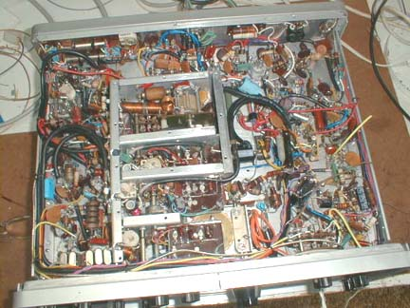

The LWM 3 had come a long way when this picture was taken just a few weeks ago.

The Power Supply

In terms of the needed power supply this was initially a formidable problem and it was required almost immediately. Transformers with filament and HT windings are hard to come by these days. The filament current requirements were considerable at 6.3 VAC. The LWM 3 had used pairs of tube filaments in series to make the current demand lower by using 12 VAC.

However, once again my own junk box came to the rescue and I had an ideal used transformer of US manufacture to hand. It was unusual in having dual 115 AC I/P windings so could be run on 115 or 230 VAC and that it had two 6.3 VAC filament windings with very large current capacity – plenty for all those tubes. It also had two HT windings, which were not centre tapped. These days HV bridge silicon rectifiers are readily available and I soon had the required 275DC HT. I had to add a minus 65 VDC supply which I have mentioned elsewhere and is used for the control of the RX/TX switching. I also required a 12 VDC supply for those mechanical filter-switching relays. This 12 VDC is now also be used to run a cooling fan which I have fitted to the back panel of the LWM 3 the other day. (see picture)

This power supply has been up and running for some time now.
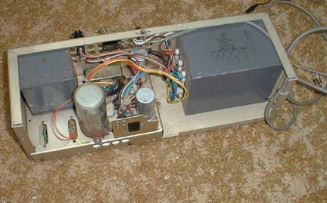

An early picture of the power supply and currently it is completely enclosed.

Today April 2003

As you can see from the picture below things are progressing. In ‘getting there’ or maybe that should be ‘where the project is today’ there have been numerous hiccups. Strangely enough they have all be fixable. That tuning rack saga was a blow, ditto for the mechanical filter mix up and a couple of other things, which come to mind.

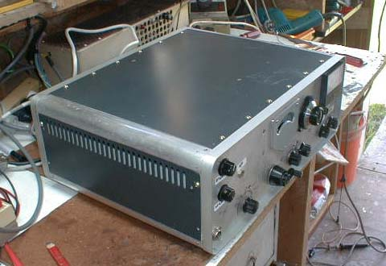

Home brew LWM 3 enclosure taking shape, the rig will look nice once it is painted.
To get the rounded corner look to the enclosure I took two pieces of aluminium tubing and sawed them down the middle. A step-by-step movement of a claw hammer and a vice has opened the four pieces slightly to match the existing corner curves of the front and back panels. The four pieces were then attached to the back and front panels at each of the four corners.

The enclosure was completed using 4 flat pieces of re-cycled aluminium sheet. I think it looks okay and in any case who is going to really complain? Right now I am making some finishing touches to the cabinet and the new coat of paint has brightened up that recycled aluminium. I have also made a suitable ventilation cut out in back area of the top cover. The bottom cover has also now been fitted with two ventilation areas. A fan has been fitted on the back panel as an aid to cooling the rig.

Another view of the LWM 3 now re-sprayed to new colour.

The Future

In coming days there is further tidying up work to do and I do promise to try and leave well enough alone! I will complete the marking up of the front panel and replace of the VFO Dial read out plate with one having a white surface for clearer reading of the frequency calibration points.

I may actually get around to putting that power supply in a slightly better enclosure but make no promises. If not, at the very least the present enclosure will get a coat of green paint from that spray can.

I plan to get the LWM 3 rig over into the shack and connected to the beam. I will then try to make more QSOs with this rig running low power of course.

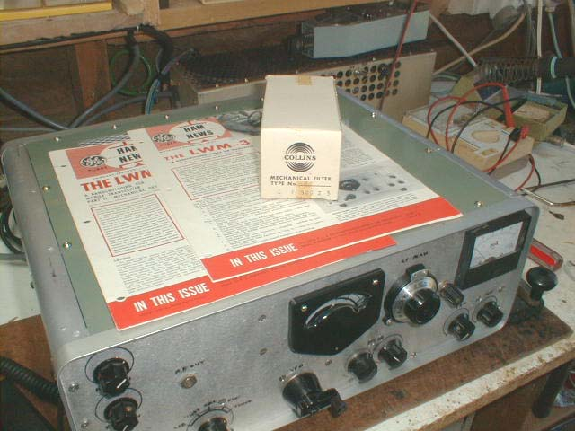

The two GE Ham News articles and the elusive Collins Filter (original box)
on top of the completed LWM 3. (April 2003)

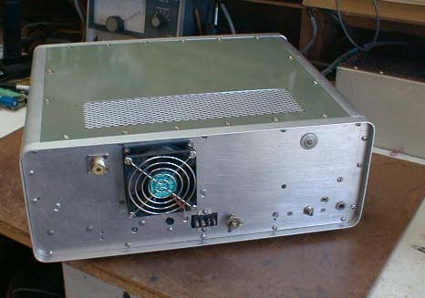

Rear View of the LWM 3 and the cooling fan (ex Computer) now fitted in place.

Bill Loudon, W8WFH

I have been in touch with Bill for just over a year now. As one half of the design team for the LWM 3 back in the 60’s I thought he would like to know of my decision to build the rig again. (Unfortunately Al, W8DLD the other half of the KWM 3 team is a silent key.)

From Bill (and that GE Update Release) it is understood that some 600 hams tackled the rig when the articles came out. Bill and Al received many letters of support. I mentioned to Bill my own letter written in late 1963 saying how much I had enjoyed the project. Time flies.

Bill these days is a bright and alert 88 years of age and I feel he has appreciated my telephoning him and saying hello a few times over the last year or so. I have also written him a couple of times and he already has several pictures of the LWM 3 rig as it progressed..

Although not in the best of health these days his mind is very sharp and he was delighted when I told him of that SSB QSO with Larry, AH8LG of a few days ago. I also promised him yesterday (on the phone) that there would be one more photograph of the completed rig. He will also get a copy of this article just for old times sake. That wheel will then have turned the full circle

73

Jim, VK9NS

Norfolk Island

April 2003

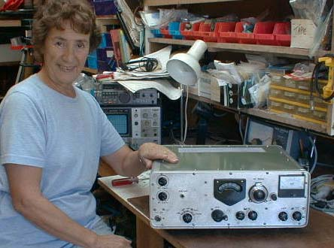

Kirsti, VK9NL who gave me the first QSO on CW, 20m using the LWM 3.

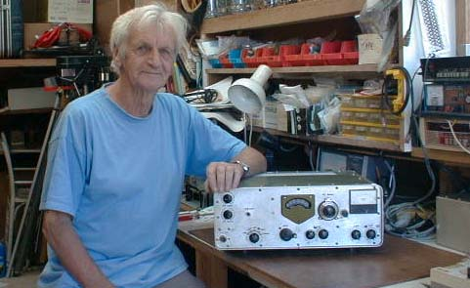

Jim, VK9NS and the ‘monster’ the LWM 3, April 2003

We were both very reluctant to claim the CW contact as a world record for a distance of some 400m. However for the record Kirsti was using 100 watts and an 11 element Log Periodic and I used about 6 watts to a home brew Vertical. To make things harder we used the long path!!

Acknowledgements

I am indebted to many people and I hope they do not mind my word of thanks here. Without this assistance the LWM 3 MK II would never have happened and I might have remained unhappy with amateur radio. If anyone has been left out it is not intentional and I offer apologies for any oversight.

To GE Ham News, which presented great articles for and by radio amateurs over many years. There was also a continual stream of information to the radio amateur in relation to a wide range of GE tubes that were noted for reliability. It supported the famous Edison Award, which gave credit to many of those in our hobby who furthered the hobby in some special way.

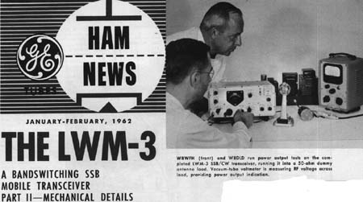

The header of the 2nd part of the GE Ham News showing Bill and Al with the LWM 3.

To Bill Louden, W8WFH the surviving half of the design team which gave us the LWM 3. This GE Ham News article (in two parts) was a leap ahead of many home brew projects. It was a major undertaking to build and I can testify to this, having built it twice. That Bill, W8WFH is around, and knows my interest in this fascinating amateur radio project, has been of great importance to me personally. He has my thanks and respect.

To that small cardboard box that started it all. I should have thrown it out years ago! It had been part of my UK junk box brought here to Norfolk Island in 1980 along with all of my worldly possessions. However here on Norfolk Island very little is thrown away – just in case.

To Chuck Banta, N6FX who refused to throw anything away despite a move from the East to the West Coast, USA many years ago. He had the key to my desire to try and home brew something worthwhile once again. (Chuck should move to Norfolk Island. He would be at home here!) I received his Air Mail package around mid November 2001.

To Brian Clarke, VK2GCE who, as an avid enthusiast and collector of the WWII ARC series of military radio equipment, (typically air borne in the DC 3) just happened to have a ‘cannibalised’ ARC 5 chassis with the capacitor I required. It was packed with loving care and arrived here on Norfolk Island in pristine condition. It was the most important part required to make a basic start to the LWM 3.

To Jack MacLean, K2IUK for sending me those two original issues of GE Ham News in November 2001. He had heard me talking on 10m SSB one day and my mention of the articles – ‘rang a bell’. They are as new and I am happy that they are here. Just looking at them makes it easy to recall those ‘years ago’ feelings on reading the beginnings of the article for the first time.

To Allan, K0AL (Cedar Rapids) who promptly answered that web request by Henry, G3GIQ for that needed Collins Radio Z5 – 500KHz Filter. In purchasing this filter it overcame a rather awkward moment in the building of the LWM 3! The filter was ‘as new’ and arrived safely on Norfolk Island and was quickly tested and fitted. SSB signals always sound better when received on the correct sideband.

To Tom Ivas, Vintage Radio in Western Australia who sold me two of those needed tubes types and in addition pointed me the way to obtaining the others. I also purchased a couple of used tube type IF transformers from him and I was able to modify them in due course.

To Antique Electronics Supply in the AZ, U.S.A. who caters for these older equipment style projects and for example have a wonderful range of tubes available. They have a great catalogue for the enthusiast and I was able to purchase a couple of the rarer tubes used in the LWM 3.

To Ocean Electronics in RI, USA who also run a comprehensive catalogue and I purchased a few needed bits and pieces from them. They were not at all fazed by receiving an order from Norfolk Island and in this case my order went by FAX.

To an old friend Henry, G3GIQ who in one session, whilst I was visiting him during a visit to the UK, went through his junk box to find me several of the silver mica capacitors I needed. Henry is a noted Collins enthusiast and it is always interesting to look his collection of equipment. On this visit of course a real KWM 2A was looked over with a slightly different eye! It is a great rig of truly thoroughbred qualities.

To Jay, AF2C (NJ) who offered to go through his junk box for possible tubes. He provided me with four tubes giving me a spare for that 6AR8, 12AT7, 6BA7 and the 6BZ6. He would accept no payment, no ifs and no buts. By the way his ‘new’ 6BA7 gave me another S point when installed as one of my 6BA7’s was a used item of uncertain age.

To another old friend Larry, AH8LG who in our almost daily skeds on 14222 often had to listen to me ‘going on’ about progress to the rig. Often my frustration was showing over some difficulty or another. I think we were both thankful that it was all over with that SSB QSO of a week or so ago. I received a very fast QSL from him for this special QSO. . It had all been worth it

To John Munro, G3GBB an old timer who is also keen on Collins equipment. He advertised and I purchased from him a KWM 2A read out dial assembly and have plans to try and use in the LWM 3. He is currently refurbishing a Collins KWS 1.

I have also just received from John the complete alignment instructions, tube voltages, etc. for the KWM 2A. I plan to use this to build up a similar set of figures for the LWM 3. The Collins alignment procedure for that 3 MHz Band pass IF is very interesting and I will use the technique to re-check my alignment.

To Larry Saletzki, WA9VRH who generously supplied me with those two used Collins Band pass IF components namely T2 and L4. They were installed in the LWM 3 and work perfectly.

To Norfolk Island

To a couple of local sources who gave me some old equipment from which I could salvage material, e.g. aluminium sheet and ‘that’ angle aluminium. Endless nuts, bolts and washers etc. One unit even had the 11 HC6/U xtal sockets required, plus one spare!! It was quite a leap forward on that day and they can be seen in the sub assembly pictures.

To another old friend Peter Ely, Norfolk Island who helped me in so many ways with the metal work. He is an expert with the laser-cutting tool and has access to a bending machine and guillotine. My various chassis dividers and front panel attachments all needed metal bending work. Plates for the cabinet (for example) were cut for me by Peter using my recycled material.

Peter has followed the building of the LWM 3 on a more or less weekly basis with great interest.

Finally

In general terms by late November/ mid December 2001 I was more or less on my way with the LWM 3. In the ensuing weeks and months I often felt like heaving the whole thing over Headstone, which is out local tipping area.

Often, I missed one thing which I had in 1963 and this was having a couple of local hams to whom I could occasionally ask those questions which had stopped me dead from time to time. However ‘the monster’ was finally completed (a few bits still to do here and there of course) and I am content. Thanks to you all. It has been fun.

73, Jim, VK9NS

