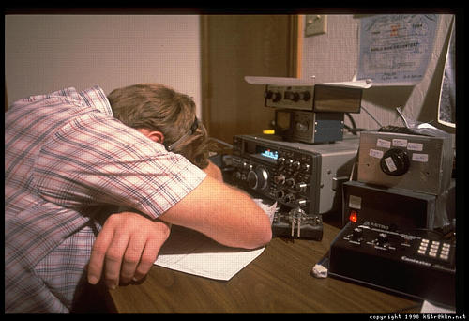
160 Contesting – Or, Trying to be a Big Dog.

Thanks for coming tonight. I’m not here to tell you how you’ll win at 160 Contesting, nor will I give you complete masterful insight into working DX. What I’m here to do is try to tell you that even with smaller antennas and lower power, you can successfully play on the Top Band. You can even do pretty well there, with a little persistence and luck. The true focus of this one is the ARRL 160 Contest, coming up in a couple weeks. As RDXA Members, we can participate in club competition.

My station is a pretty good example of a “Little Pistol”. A Kenwood TS-930S, Amp Supply LA-1000 sweep tube PA and an inverted-L are all that I’ve been using on the band for the past few years. In the RDXA newsletter a year or so back, I wrote up the diagram of my antenna – so there’s something for reference. (I’ll put the file at the back of this package for you to look at!)

Let’s talk Technique:
Speed Kills: As in other contests, you’ll hear folks winging along at 30+wpm. No big deal, but sometimes you’ll find them sitting in a pileup for a while. Why? QSB Cycling on 160 can be deep and long. Therefore, a single slower call often bridges the fading, where a single fast call can be missed completely. I’ve often found a well-placed 20wpm call can beat bigger stations.
When the DX starts popping (here, between 0100 – 0500 Z is prime Eu), you’ll want to think about modifying your speeds. Early on, you’ll be working stuff out to 1500 miles - lots of it, but fairly short loud signals. Crank it up then! Once DX is there, that’s where the speed reduction really works. Last year, I found a clear spot, called CQ at 23wpm, and ended up running 50+ EU stations. I was snuggled in-between 2 large stations. Ironically, many of these stations had been calling one of them, but gave up since he wasn’t listening long enough. I just happened to be there, and easy to work. When the VK/ZLs popped – 20wpm was just enough to get their attention. No faster stations I heard work them.
Center is Bad: Like most, you’d think that hovering around 1.830 or so is the place to be. Unless you are K1ZM or WB9Z, that MAY not be the case. Often, you’ll be on a spot for HOURS, only to find someone try to “take over your spot”. Well, they’re saying the same thing about YOU. When propagation changes – you will notice a W5/6/7 sitting calling CQ where you have been. That’s the way it is – whoever is being hurt more by the other moves along! It is often better to stay to the fringes of the activity and CQ. You’ll be more assured of a cleaner spot, and since you AREN’T K1ZM, will be heard by more people. Don’t get me wrong – there are TIMES where being in the middle of the band is needed. Just CQing, though – isn’t one of them.

I’ve often found that, just like a VHF Contest on 6 meters – going around the crowd to something like 1.845 or 1.801 is a good place to be. These spots are great for running. Frankly, I worked more multiplier QSOs by staying away from the grunge than within the fray. If you are loud enough, go in the middle.

Run, THEN pounce: The first few hours of the ARRL 160 Contest are where you make 1/3rd of your QSOs. The past 2 years, I’ve averaged over 300 QSOs in the first 3 hours (1st hour over 130/hr) with a minimal station. It will be really difficult to make up many of these contacts. . . so if you can don’t miss it! Try finding a spot, plop down and start CQing. You’d be surprised that even with 100w and a dipole you’ll be able to run stations.

Don’t Stop at Sunrise!: Depending on conditions – you’ll probably hear/work the juiciest DX of the contest during this time. I worked 2 VK6s and 1 ZL along with a couple KH6s about 30 minutes past sunrise. Remember the Grayline propagation – that’s what makes 160 so much fun. I’ll generally keep blasting until about 10:30AM or so, just to make certain I’ve wiped out all potential callers.

Install another Transmitting/ Receiving Antenna: Having a horizontal dipole might just be a good thing! If you have a choice – be able to switch between them at a moments notice! If you’re limited in space, and can’t install beverages – a low horizontal dipole is often a quieter receiving antenna than an inverted-L or vertical. It ain’t optimum, but you’ll hear better that way. Last year, I used my horse pasture fencing as a large unterminated loop. It worked pretty well, reducing the S-9 noise to S-1, while the signals actually became MUCH MORE AUDIBLE. You’d be really surprised how well Vertical antennas hear crap. EWEs, Pennants and the like are super-easy to install and use. Do it if you can.
(See next page for a photo of the Pasture fence. Top-center of the photo is NE – right towards Europe).
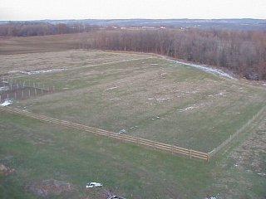
My receiving Loop – Front fence is ~300’, to the woods is 450’.
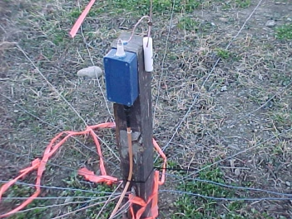
The Feedpoint for the Inverted-L. The blue box houses the 500pf, 30KV series capacitor, a connector and a ceramic feedthru. The wire goes up the side of the tower, about 2’ spacing from the legs. The other end is tied to a 40’ tree, so the horizontal portion slopes downward.
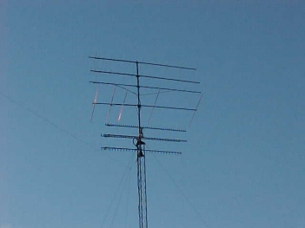
You can kinda’ see the antenna hanging from the tower if you look REALLY close.
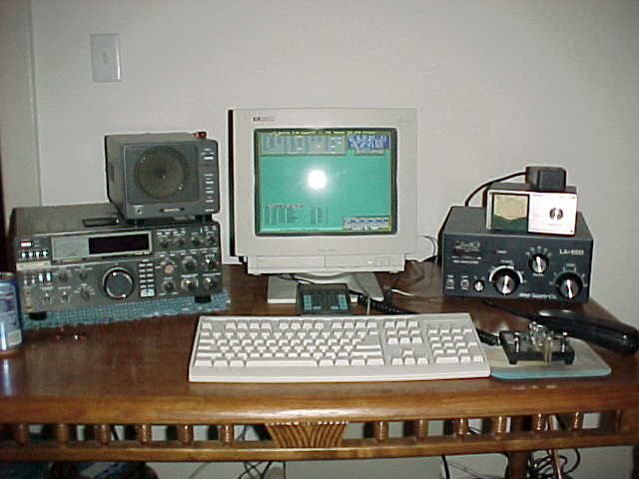
The K2AXX 1999 ARRL Contest Location. See – it really isn’t very much of a station. CT keys the radio, have a paddle just in case I need to fill info not in the keyboard buffer.
This station worked 952 QSOs and 80-some multipliers, including 50+ European stations and 2 VK6s and 1 ZL. All states minus KL7, too. Not bad for a puny 600w station and puny wires!

Building a simple transmitting antenna for 160 meters – that really works!
Mark Hoffman, K2AXX (ex-KA2RDO)
This fall, I put up a 64’ tower for my VHF and above stuff. HOWEVER – being the contradiction that I am - decided to decorate it with a wire antenna for my other love, 160. I wanted something resonant, with reasonable bandwidth (2:1 SWR B/W of about 50KHz) and above all, simple. Talking with K2UA, he pointed me towards the venerable Inverted L (he has one that barks, too!). In analyzing the design, there’s NOT much to it. Here’s how it looks:
This setup gives 2:1 SWR B/W of about 60KHz (1.800 – 1.860). At 1.823, it is 1.12:1.
K2AXX
Inverted L:

60’ Vertical
110’ Horizontal

#12 THHN Stranded
500pf, 30kv doorknob series capacitor

30, 66’ ground-laying radials

4’ ground rod.
2 ceramic insulators (end and tower)
Coax input
SO-239

- Buy THHN wire from Home Depot or Lowes. You can get #12 stranded, 500’ roll, for about $20. This wire is decent, jacketed, and seems to hold up pretty well. So cheap, in fact, that if it breaks – replace it. Don’t repair it. The broken ANTENNA makes great RADIALS!
- Start off with more wire. I began at about 180’, and trimmed to about 170’ for resonance at 1.823. Don’t short yourself! You might find that the lower to the ground you get – the more wire you’ll need to achieve the resonance in the band. F’rinstance – if you have only 30’ vertical, you MAY NEED up to 190’ of wire to start. Make certain you borrow an antenna analyzer – makes tweaking so much easier!
- Use Ground buss bars to connect radials. These things are cheap in any electrical shop, and make a really good common ground point. No more copper pipe and flame. Radials can be just about any wire you can find – doesn’t matter. If you can elevate the radials – do that too. Just need 4 133’ radials for that. . . and 4 tall end supports.
- You don’t need a 30kv cap – you can get by with an air-variable if you’re adventurous. Just make certain it is in series with the antenna wire. If you want to design your own remote-tuning network – there are a number of articles on doing just this. Put it in a cheap Radio Shack plastic project box, use a ceramic feedthrough to connect the wire. Seal it from the wx, but DO drill some weep holes. Nothing like a water-cooled series cap. . .

