**The HIARC Bulletin**

July 2023 Edition

**Newsletter of the Harris-Intersil Amateur Radio Club**

**Club Meetings:** Second Thursday of each month at Meemaw’s Barbecue on Babcock Street between Palm Bay Road and Port Malabar Road. Supper is at 5:30 PM, business is at 6:30 PM. Prizes at 7:45 PM. Our programs start around 7:00 PM. Meeting ends by 8:00 PM. As some members have allergies, we kindly ask that you refrain from wearing fragrances. Thanks.

**Repeaters:** K4HRS,145.47 Mc, tone 107.2 cycles. Down at the moment.

**Nets:**

Open to everyone:

* South Brevard Emergency Net: Thursdays at 7:00 PM. 146.61 Mc. In event of repeater failure 146.85 Mc and or 146.58 Mc simplex.
* Skywarn Net: Thursdays, after the SBEN net / 7:30 PM or so, 146.61 Mc
* Palm Bay Informal Net: 8 PM Thursdays on 147.255 Mc.
* Medical Complaint Nets: evenings 3.6 to 4.0 Mc.

**HIARC Web Site:** www.qsl.net/hiarc. Website administrator; Jim Tonti, KC7SSW

**Officers:** President: Francis Parsche (“Butch”), WA4AQV

Treasurer: Pat Reilly KA4ZEC

Secretary: Open

Repeater Chairman: Clyde KD8AN

Program Chairman: Open

Field Day Chairman: Open

Sunshine Chairman: Open

Club Jester: Ken N8KH

**Annual Membership:**

Annual dues are $12.00. You can join at the meeting or send a check to:

HIARC Treasurer

Pat Reilly, KA4ZEC

1985 Howell Lane

Malabar, FL 32950

We are on a calendar year dues system with annual dues due in June. Dues are prorated by a dollar a month. If you join in April dues are $2.00 to get to June.

Send me your email address to receive the newsletter: francis.parsche@l3harris.com

**Select Hamfests**

* Melbourne Hamfest. October 13 and 14, 2023. [Melbourne Hamfest 2023 – PCARS – W4MLB](https://pcars.org/wp/melbourne-hamfest-2023/)

**Ham Radio Lunches:**

* Every Friday, 11:00 AM till 1:00 PM or so, Golden Corral on Palm Bay Road in Palm Bay. Talk in on 146.61 Mc repeater.
* Every Friday, 11:00 AM till 1:00 PM or so. Deli on W. New Haven (US192) across from the Melbourne Mall. Talk in on 146.61 Mc repeater.
* Once a month, the Saturday after the PCARS meeting, Sarno Restaurant and Pizzaria, 11:00 AM. Talk in 146.61 repeater. This restaurant is at the corner of Sarno Road and Croton Road.

**July 2023 HIARC Meeting And Program**

When: The next HIARC meeting is Thursday July 13, 2023.

Where: Meemaws Barbecue on Babcock Street.

Time and agenda:

5:30 PM dinner

6:30 PM business

6:45 PM prizes

7:00 PM program

Office elections will be at the July meeting.

Door prizes for the meeting will include several Icom F3 handheld radios kindly donated by of Hank KZ4HE. These are commercial grade radios programmable for the 2 meter band.

**HIARC Mailing List**

The HIARC newsletter is emailed monthly a bit before the club monthly meeting date. Getting the newsletter out helps keep this fun amateur radio club going, it is now more then 50 years old. We stopped doing paper US mail newsletters in 1999 to my recollection.

Blind carbon copy mode (BCC) is used to email the HIARC newsletter. This avoids public sharing of the emailing addresses. You are receiving this newsletter because you are a Radio Amateur at L3Harris or perhaps you expressed interest. If you do not wish to receive this newsletter let me know and I’ll remove you from the email: francis.parsche @l3harris.com.

Thanks

Butch WA4AQV

Francis Parsche

**Interest Group Mailing List**

From time to time HIARC members have formed amateur radio special interest groups for emergency communications, fox hunting, Field Day, interference mitigation, amateur television etc. Usually everybody has a good time. email is used to coordinate.

But so you know if you provide your email there you may experience:

* Your email address being be shared or forwarded
* Communications you do not want, such as communications off the core topic
* Irritating communications. People seem to be willing to say many things in emails.
* Your email list may be “hijacked” where your participants go off in a different direction
* Your email list being reused for other purposes
* It seems inevitable that long email strings will develop where people comment everyone else’s comments.

If these concerns are unacceptable do not provide your email address to a special interest group. If you run an interest group consider using blind carbon copy (BCC) mode to send coordinating emails. In some circumstances the delete button is a good to use.

**QSL Via Burro?**

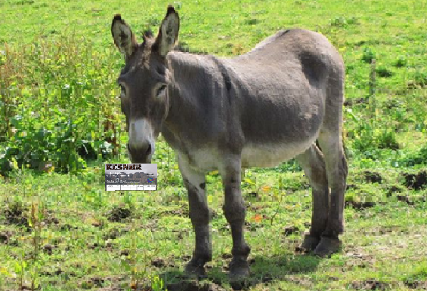

QSL Via Burro?

Sometimes it can seem that burros are doing the work. QSL Bureaus need to save your QSL cards up and send them to you in bundles so it takes a while. All the work is done by volunteers we should be thankful too. Yes paper QSL cards still happen. So here is a reminder to keep self addressed stamped envelopes on file at the W4 ARRL QSL bureau. Exact details: <https://www.qsl.net/sterling/QSLBuro4/QSLBuro4.html>

**Bill Johnson Introduces Amateur Radio Emergency Preparedness Act**

|  |
| --- |
| **WASHINGTON –** *Congressman Bill Johnson released the following statement after introducing H.R. 4006, the Amateur Radio Emergency Preparedness Act, to govern private land use restrictions on amateur radio. Johnson was joined in introducing the legislation by Rep. Joe Courtney of Connecticut:*  Antennas are essential for all wireless communication, whether TV broadcasts, wireless internet, Wi-Fi, or amateur radio. Existing federal law provides for the installation of TV broadcast and wireless internet antennas and satellite dishes at private homes, but amateur radio antennas are not included in the statute as currently written. This bill would correct that.  “I reintroduced the Amateur Radio Emergency Preparedness Act to remove barriers to disaster and emergency communications and training, and to promote education in STEM subjects related to critically needed wireless technology,” **Bill Johnson said.** “Passage of this bill will promote developing and sustaining our nation’s wireless future and facilitate and encourage amateur radio operations as a public benefit.”  “As their actions during recent natural disasters such as Hurricane Sandy proved, amateur radio operators in Connecticut can be a critical component of disaster response and emergency management. It is in our communities’ best interest that we give them the capabilities to operate at the highest level, and with the re-introduction of this bill, we’ve taken a strong step in that direction,” **said Rep. Courtney (CT-02).**  **Rick Roderick, K5UR**, President of The American Radio Relay League, the National Association For Amateur Radio, extended on behalf of the ARRL, its Members, and America’s Amateur Radio community their thanks and appreciation for the leadership of Congressman Johnson in his tireless efforts to support and protect the rights of all Amateur Radio Operators and to further STEM education and the advancement of American expertise in wireless technology.  [The full legislation can be viewed here.](https://billjohnson.house.gov/UploadedFiles/Amateur_Radio_Emergency_Preparedness_Act_signed_bill_text.pdf) |

**Space Weather News for July 3, 2023**  
[https://spaceweather.com](https://Spaceweather.us11.list-manage.com/track/click?u=0c5fce34d5ca05f64a13d085d&id=03a9057ae9&e=318bb49a70)  
[https://www.spaceweatheralerts.com](https://Spaceweather.us11.list-manage.com/track/click?u=0c5fce34d5ca05f64a13d085d&id=2d0b0c14b6&e=318bb49a70)  
  
**SUNSPOT COUNTS HIT A 21-YEAR HIGH:** It's official: The average sunspot number in June 2023 hit a 21-year high. Solar Cycle 25 has shot past its predecessor, Solar Cycle 24, and may be on pace to rival some of the stronger cycles of the 20th century. Full story @ [Spaceweather.com](https://Spaceweather.us11.list-manage.com/track/click?u=0c5fce34d5ca05f64a13d085d&id=f7e5f0584d&e=318bb49a70).  
  
**Solar Flare alerts:** Sign up for [Space Weather Alerts](https://Spaceweather.us11.list-manage.com/track/click?u=0c5fce34d5ca05f64a13d085d&id=0a5786eec0&e=318bb49a70) to receive instant text messages when strong flares are underway.

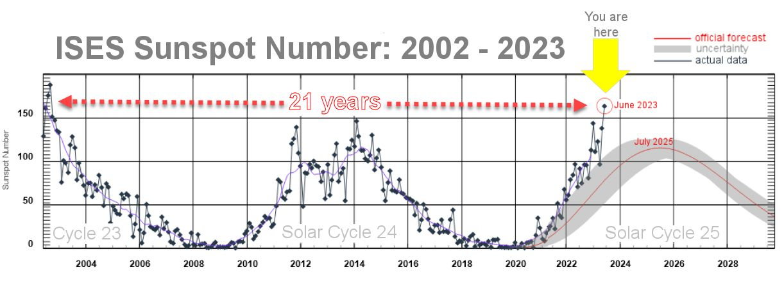

**For Sale**

HP 8660C  RF SIGNAL GENERATOR – FULLY FUNCTIONAL WITH A COMPLETE SET OF SPARES.  NEVER HAS BEEN OUT OF A CONTROLLED ENVIRONMENT

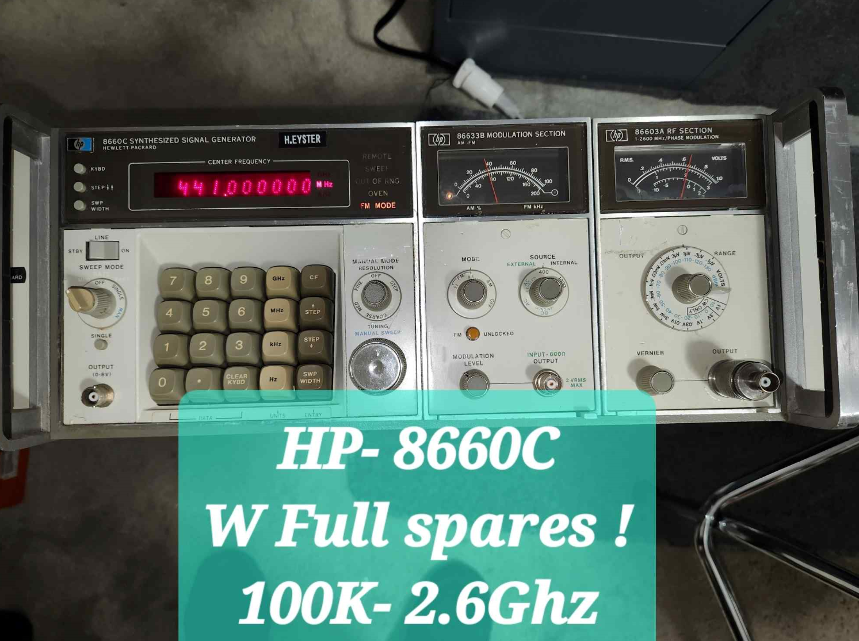

SPECS –

100Khz to 2600 MHZ

-130 to +20 Dbm RF output

AM, FM and Phase modulation.

Full set of spares ( everything except the metal chassis)

Full set of all original service manuals

Works great and has been a “ standard” RF signal generator for decades.   Just bulky

I will be glad to demonstrate and will accept a “ reasonable offer “

Hank , KZ4HE

321-215-7868  Melbourne, Fl

**Kenwood R200 Receiver For sale**

$150 Let me know if you are interested

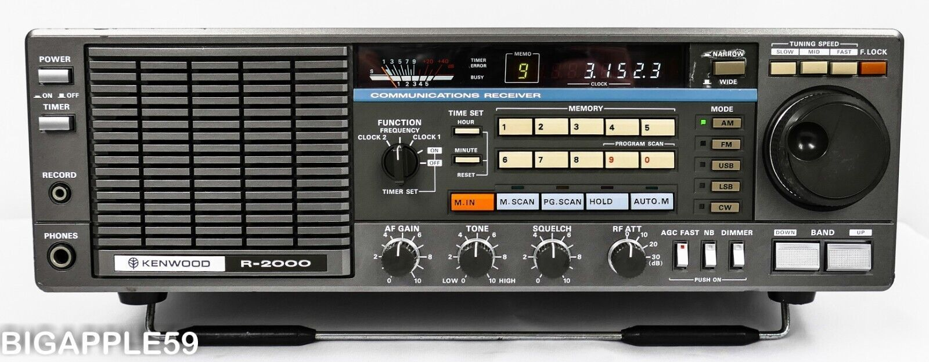

Joseph A. Friske

585-654-1955

E-mail: [joe.friske@l3harris.com](mailto:joe.friske@l3harris.com)