The HIARC Bulletin

January 2023 Edition

Newsletter of the Harris-Intersil Amateur Radio Club

Club Meetings: Second Thursday of each month at Meemaw’s Barbecue on Babcock Street between Palm Bay Road and Port Malabar Road. Supper is at 5:30 PM, business is at 6:30 PM. Prizes at 7:45 PM. Our programs start around 7:00 PM. Meeting ends by 8:00 PM. As some members have allergies, we kindly ask that you refrain from wearing fragrances. Thanks.

Repeaters: K4HRS, 145.47 Mc, tone 107.2 cycles. Down for the moment, being moved to the Turkey Creek Tower.

Nets:

Open to everyone:

- South Brevard Emergency Net: Thursdays at 7:00 PM. 146.61 Mc. In event of repeater failure 146.85 Mc and or 146.58 Mc simplex.

- Skywarn Net: Thursdays, after the SBEN net / 7:30 PM or so, 146.61 Mc

- Palm Bay Informal Net: 8 PM Thursdays on 147.255 Mc.

- Medical Complaint Nets: evenings 3.6 to 4.0 Mc.

HIARC Web Site: www.qsl.net/hiarc. Website administrator; Jim Tonti, KC7SSW

Officers: President: Francis Parsche (“Butch”), WA4AQV
Treasurer: Pat Reilly KA4ZEC
Secretary: Open
Repeater Chairman: Clyde KD8AN
Program Chairman: Open
Field Day Chairman: Open
Sunshine Chairman: Open
Club Jester: Ken N8KH

Annual Membership:

Annual dues are $12.00. You can join at the meeting or send a check to:

HIARC Treasurer
Pat Reilly, KA4ZEC
1985 Howell Lane
Malabar, FL 32950

We are on a calendar year dues system with annual dues due in June. Dues are prorated by a dollar a month. If you join in April they are $2.00 to get to June, or you can pay ahead.

Send me your email address to receive the newsletter: francis.parsche@l3harris.com

Select Hamfests

- 1-14-23, Orlando, K4KDI Winter Tailgate, http://k4kdi.square.site
- 2-10-23. Orlando Hamcation, 2nd biggest hamfest in the USA, www.hamcation.com
- 3-18-23, Stewart, www.stuarthamfest.com

Ham Radio Lunches:
- Every Friday, 11:00 AM till 1:00 PM or so, Golden Corral on Palm Bay Road in Palm Bay. Talk in on 146.61 Mc repeater.
- Every Friday, 11:00 AM till 1:00 PM or so, Crystal Buffet on 192. Talk in on 146.61 Mc repeater.
- Once a month, the Saturday after the PCARS meeting, Sarno Restaurant and Pizzaria, 11:00 AM. Talk in 146.61 repeater. This restaurant is at the corner of Sarno Road and Croton Road.
January 2023 HIARC Meeting And Program

When: The next HIARC meeting is Thursday January 12

Where: Meemaws Barbecue on Babcock Street.

Agenda:

5:30 PM dinner
6:30 PM business
6:45 PM prizes
7:00 PM program

Program: “Vacuum Tube Receivers with an Example Collins R648”

Bob N4UVC Silent Key

If you have not heard Bob n4uvc passed away Thursday evening. We are all
very saddened and shocked.
The viewing will be at 10:30 am at the Holy name of Jesus Catholic
church. The funeral will begin shortly after at 11:00 am on Thursday Jan
12th. The address is 3050 North highway A1A Indiatlantic beach FL.

Bon was active on 146.55 MHz FM and other frequencies and a friend to many. He was also an accomplished musician.

What’s Up With End Fed Dipoles?

It has been common to feed dipole antennas at a gap in the middle. The simple center fed wire dipole provides about 72 ohms at half wave resonance, a VSWR under 1.5 to 2 to 50 ohm coaxial cables and radios. This antenna may also be used / reused with modest VSWR at odd harmonic frequencies, such as a 40 meter half wave being used again on 15 meters.

Ok, here is the what’s up with the end fed dipole: unlike the center fed dipole the end fed dipole has about the same impedance at even AND odd harmonic resonance frequencies. The end fed dipole can cover more frequency bands with simpler matching. It can do 40, 20, 15 ande 10 meters for example. The impedance on those multiple bands may be about 2500 ohms resistive with little to no reactance on the harmonically related bands. Many of our HF bands are harmonically related so the end fed can work multiple bands using a 50:1 resistance transforming device at antenna end. This 50 to 1 resistance transforming device may be a multiple winding (bucking type) balun, a conventional transformer, or otherwise.

Electrical circuit theory says two terminals are needed for a circuit load yet the end fed half wave has only one terminal. It may be confusing when first encountered.

The end fed half wave may benefit from common mode choking to keep cable currents off the coax cable exterior. Yet users get by without one. I own and end fed dipole without a balun and am happy with it. This antenna is a Ringo Ranger antenna:

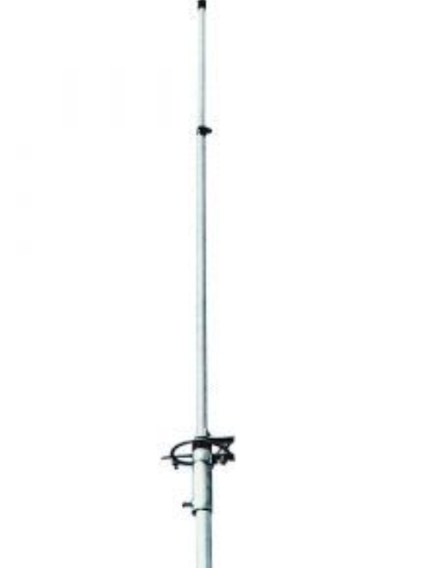

Ringo Ranger AR-2 Antenna, an end fed half wave

It has some radiation pattern ripple and lost gain as the matching circuit drives both the mast, the cpax cable exterior and the antenna proper. This is not much. The DC ground the matching coil provides is nice.
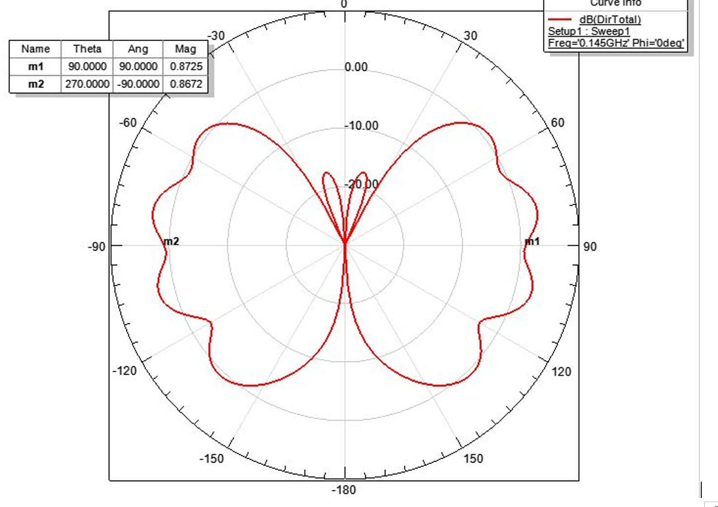

Radiation Pattern Of An End Fed Half Wave Dipole Without A Balun: The Ringo Ranger AR-2

This antenna is usefully close to the gain of a half wave center fed dipole for the local repeaters and FM simplex.

Emergency Communications In Brevard County 2023

There were communications systems failures in the storms of 2004 and later. Brevard County did not however experience the total communications outages that accompany complete devastation. The value of amateur radio is less apparent when some of the phones and public safety radios are still working.

BEARS has gone under. Bears was consortium of sorts of the county amateur radio clubs to provide emergency communications. I was difficult to get all the clubs to agree at times. Funding for the BEARS vehicle was a problem. A lot of people worked hard on the BEARS project.

Brevard County started requiring a background check for amateur radio emergency communications volunteers, I don’t recall exactly when maybe 2005 to 2012 time period. This reduced the pool of volunteers as the terms of the background check form were unpalatable to many. When the background check was announced at meetings there were a lot of objections. It appeared there were more objectors than there were people known to volunteer. The hams did not have a lot of say on the form.

Brevard County Southern Florida ARRL Section | ARRL Southern Florida Section (sflarrl.org) advises the south Brevard Emergency Coordinator is Don Bush KD0CXT. It is good to have an EC for the area.

Wireless Charging

As if - - the onset of VHF long range LAN and the takeover of the 3GHz and 10GHz bands wasn’t enough (also remember 11 meters and 220MHz?), Wireless Charging is still marching forward. No one was really worried about short range inductive chargers running at low kHz resonant frequencies. However, at the CES, another wireless power company pushed their solution. What I am worried about: 1) Single frequency carrier beamed-power technologies targeting an “underused” Band like 30, 20, 15, or 10 Meters, or a VHF frequency. UHF attenuates too quickly with distance unless the power allocation is raised significantly above 4W. 2) potentially worse: the use of spread spectrum technology to reduce the impact of a single carrier, which will “ONLY” raise the white noise level across all of HF or VHF. I have attached an old 2017 Recommendation from the ITU stating the “early” frequencies that are being used, where 6.765 – 6.795 (30 kHz bandwidth) would be used for single carrier wireless charging. Add 455kHz for cheaper or leaky receivers and see what results: 7.220 MHz – 7.250 MHz! The longwave frequencies are also listed which approach some of the new longwave bands, if your I.F. image is in the right place, or if your front-end is overloaded. I don’t know if the ITU has updated their 2017 Recommendations (the attachment) or not. EV Chargers could be a problem, but the only one of these I ever saw up close used a magnetic core to closely couple into a secondary core in the car, and then functioned like a high efficiency transformer with minimal radiation. However, I wouldn’t want to operate any HF mobile equipment in the car while I was charging.

I have also attached 2 links below pointing to 2 companies (one, WiTricity, has an Amateur Extra as the chief technical officer). The Ubiquity company makes the Powercast device which was just introduced at this year’s Consumer Electronics Show. It can output 4W EIRP, which implies it is a “beamed” device per the ITU. To get universal charging coverage within a house, several of these devices would logically be spread through the house beaming in multiple different directions. The Powercast folks use an “Undisclosed” frequency per the link that allows charging up to 120 feet away. The undisclosed frequency is true, since I haven’t found any direct reference to a frequency, leading me to believe that multiple frequencies may be involved. I haven’t searched any the FCC site to see if a notice of rulemaking has been opened on this device. Since Ubiquity is “Licensing” their proprietary design, most appliance and consumer equipment makers would tend to ignore any potential FCC impact and just put this device into a critical mass of products as fast as they can. Then the FCC can be accused of heavy-handed interference with commerce $$$$, and the Amateurs must just accept the new technology, no matter what happens. It also seems like passive intermodulation has been totally ignored in the development of any of these devices. This can really cause big problems if there is a rusty wire fence or a gutter between you and your neighbors. Think “local AM station beats with 5 powercast devices from the house next door” and see if it causes any problems with your next DX search.

https://witricity.com/newsroom/blog/does-wireless-ev-charging-impact-am-radio-reception/

https://techspective.net/2022/10/21/powercasts-effort-to-create-wireless-power/

Please read and put into the next newsletter if you think any of this is important.

Craig WB5NCB

