The HIARC Bulletin

February 2023 Edition

Newsletter of the Harris-Intersil Amateur Radio Club

Club Meetings: Second Thursday of each month at Meemaw’s Barbecue on Babcock Street between Palm Bay Road and Port Malabar Road. Supper is at 5:30 PM, business is at 6:30 PM. Prizes at 7:45 PM. Our programs start around 7:00 PM. Meeting ends by 8:00 PM. As some members have allergies, we kindly ask that you refrain from wearing fragrances. Thanks.

Repeaters: K4HRS, 145.47 Mc, tone 107.2 cycles. Down for the moment, being moved to the Turkey Creek Tower.

Nets:

Open to everyone:

- South Brevard Emergency Net: Thursdays at 7:00 PM. 146.61 Mc. In event of repeater failure 146.85 Mc and or 146.58 Mc simplex.

- Skywarn Net: Thursdays, after the SBEN net / 7:30 PM or so, 146.61 Mc

- Palm Bay Informal Net: 8 PM Thursdays on 147.255 Mc.

- Medical Complaint Nets: evenings 3.6 to 4.0 Mc.

HIARC Web Site: www.qsl.net/hiarc. Website administrator; Jim Tonti, KC7SSW

Officers: President: Francis Parsche (“Butch”), WA4AQV
Treasurer: Pat Reilly KA4ZEC
Secretary: Open
Repeater Chairman: Clyde KD8AN
Program Chairman: Open
Field Day Chairman: Open
Sunshine Chairman: Open
Club Jester: Ken N8KH

Annual Membership:

Annual dues are $12.00. You can join at the meeting or send a check to:

HIARC Treasurer
Pat Reilly, KA4ZEC
1985 Howell Lane
Malabar, FL 32950

We are on a calendar year dues system with annual dues due in June. Dues are prorated by a dollar a month. If you join in April they are $2.00 to get to June, or you can pay ahead.

Send me your email address to receive the newsletter: francis.parsche@l3harris.com

Select Hamfests

- 1-14-23, Orlando, K4KDI Winter Tailgate, http://k4kdi.square.site
- 2-10-23. Orlando Hamcation, 2nd biggest hamfest in the USA, www.hamcation.com
- 3-18-23, Stewart, www.stuarthamfest.com

Ham Radio Lunches:
- Every Friday, 11:00 AM till 1:00 PM or so, Golden Corral on Palm Bay Road in Palm Bay. Talk in on 146.61 Mc repeater.
- Every Friday, 11:00 AM till 1:00 PM or so, Crystal Buffet on 192. Talk in on 146.61 Mc repeater.
- Once a month, the Saturday after the PCARS meeting, Sarno Restaurant and Pizzaria, 11:00 AM. Talk in 146.61 repeater. This restaurant is at the corner of Sarno Road and Croton Road.
February 2023 HIARC Meeting And Program

When: The next HIARC meeting is Thursday February 9.

Where: Meemaws Barbecue on Babcock Street.

Agenda:

5:30 PM dinner
6:30 PM business
6:45 PM prizes
7:00 PM program

Program 1: “How To Renew Your Amateur Radio License” by Butch WA4AQV
Program 2: “Trip To SBX and The USS Missouri” by Fred KB4DMQ. Fred does nice programs.

Local Amateur Emergency Communications

I was advised at the January meeting that the ARRL Emergency Coordinator pertaining to South
Brevard County is now K4ILG. Being February it may have changed again.

Happy Days Are Here Again

On Wednesday 1-18-23 the solar flux was 222, sunspot number at 164. Here is a midday US ionosphere measurement showing near vertical incidence returns coming back all the way to 13 Mc! Low take off angle propagation was available at 41 Mhz, perhaps with F2 propagation reaching 6 meters available for better stations.

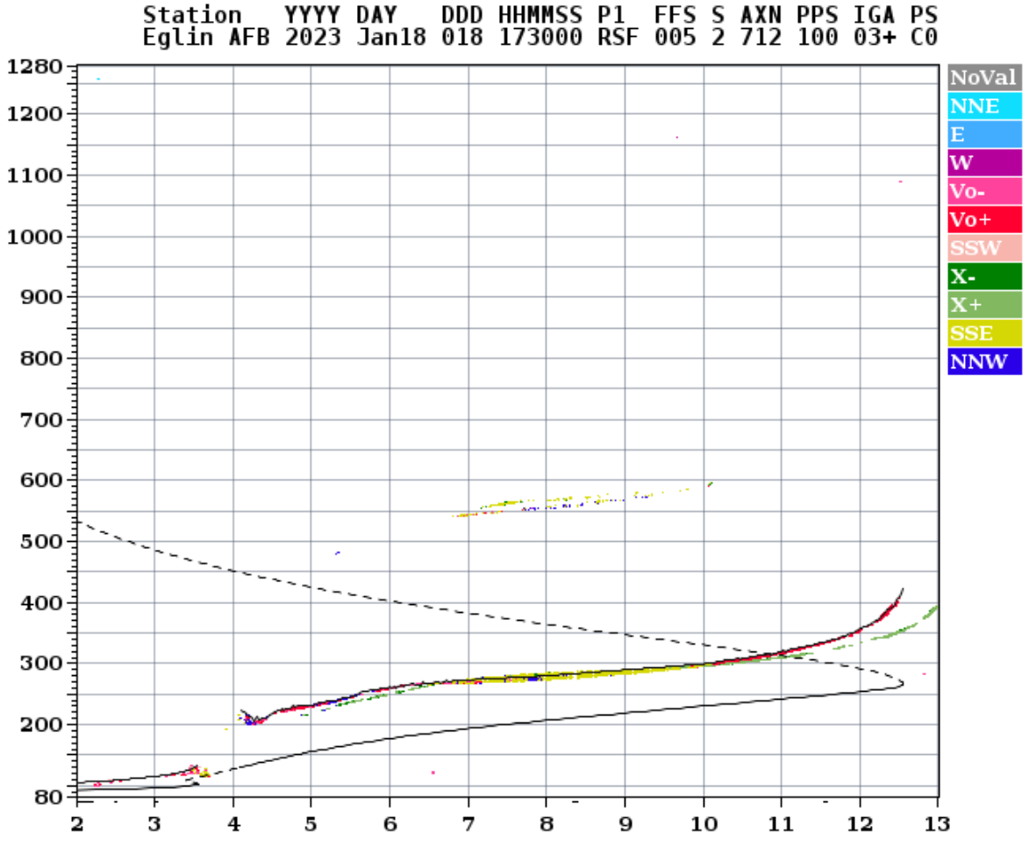

146.61 Mc Repeater Is Going Tone

The PCARS 146.61 Mc. Repeater is going to add a tone requirement on the input at some point about now. When that happens the tone frequency required will be 107.2 Hz. The PL tone is to reduce interference.

Bouvet Island

The 2023 Bouvet Island DX’pedition has landed on the island and operations have begun. Slowly at first, more station will be added. Bouvet is number 2 on the most wanted DX lists! The island is located in the far southeast Atlantic Ocean in a region of near perpetual storms. Temperatures hover just above freezing year round.

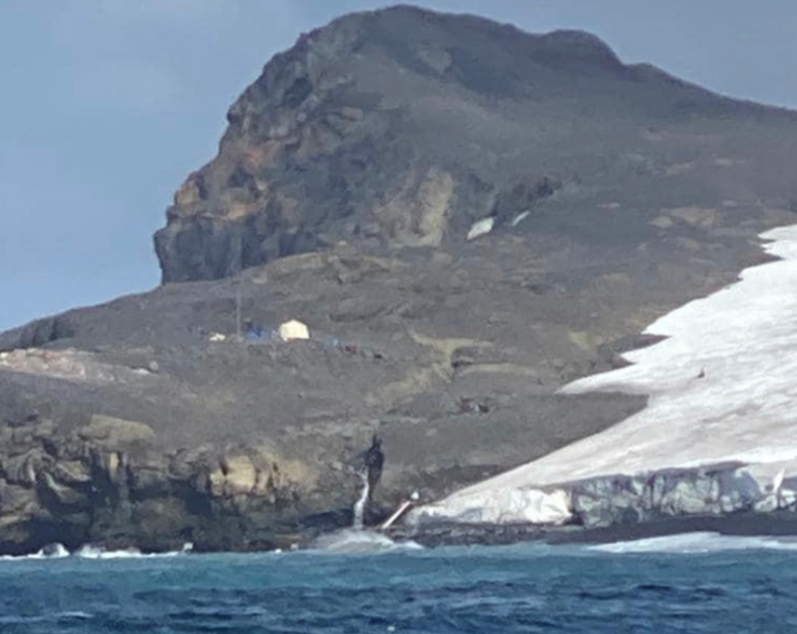

Here is a propagation analysis. Best conditions to Florida are after sunset here on 40 through 20 meters. The Bouvet operating site is on the southeast side of the island making their radiation patterns least favorable towards north America. That may knock signal down a bit to us. Bouvet is at 6900 miles range and 142 degrees azimuth.
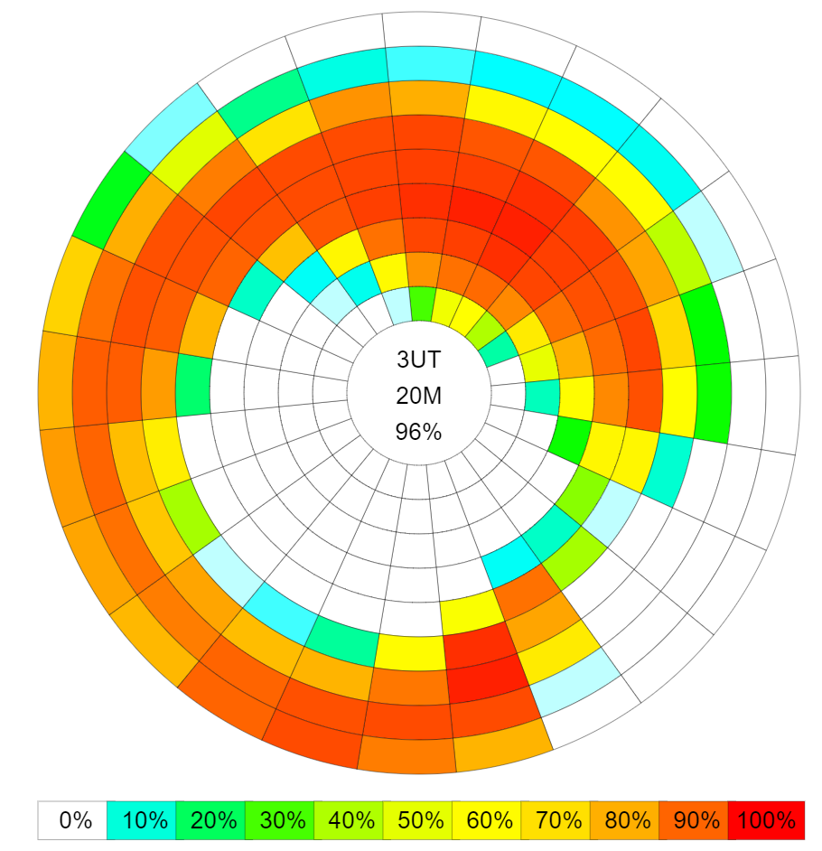

NEW CANADIAN 24 GHz RECORD

VA3TO, VA3ELE, and K2UA made a new Canadian 24 GHz record on snow-scatter from EN93qj to FN12fs. WX in EN93 was -17C with 18km/h winds, 71% RH giving a dewpoint of -21C. Peter VA3ELE described the WX as “Cold AF”. The path was 259 km.

Rus K2UA says the WX in Rochester, NY was -22C when he left the house at 8:15 am and -17C when he got home at 9:45. So conditions were similar. Bright sunshine for the first hour after sunrise. High clouds when they finished. Dew point was -21C at 9 am.

Kevin VE3KH tail-ended Rus for another QSO on 24 GHz.

Contact could not be made on 47 GHz.

Video from the Canadian end at EN93qj is here: https://YouTu.be/cprLVqp1sQk

There was some obvious frequency distortion from the snow-scatter, but not as bad as with rain-scatter, and nowhere near as bad as with aurora. Congratulations guys!!

Ken N8KH

Shortwave, VOA, WRMI and Ukraine

WRMI plays a one-hour long program “VOA Flashpoint Ukraine” at 2 PM eastern time on shortwave frequencies 7730 and 15570 kc. These signals are beamed at 44 degrees azimuth / towards Ukraine to help inform there. As you may recall WRMI is the commercial model shortwave broadcaster near Okeechobee FL.

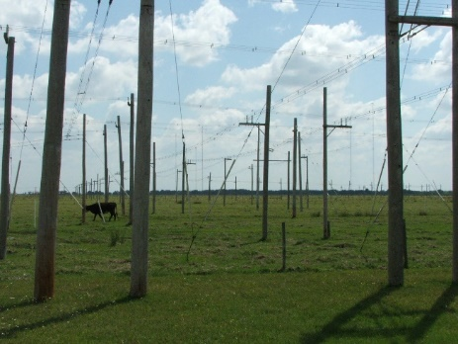

WRMI Antennas Include Big Rhombics

The WRMI transmissions on 15570 kc received here were in Palm Bay were much stronger using a horizontally polarized receive antenna. This is for two reasons: 1) WRMI transmits only horizontal polarization and 2) tropospheric scatter propagation is available even at HF. The 15570 kc signals were very stable in strength suggesting tropospheric scatter over ionospheric modes. EIRP / effective isotropic radiated power for the 15570 kc transmission exceeds 1 megawatt including the antenna gain. That helps.

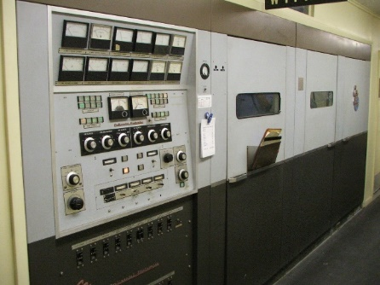

A WRMI Transmitter

The role of international shortwave broadcasting has diminished as a means of informing people in war areas, making the WRMI transmission is a rare example. Last I heard WRMI was donating the broadcast time. The only other transmission I am aware of has been BBC transmissions for Ukraine which I heard here in Melbourne FL in the time slot 10 to 11 AM eastern on the 19 meter shortwave band. In developed countries people with shortwave broadcast reception capability are mostly radio amateurs. In undeveloped areas and in Asia shortwave broadcasting is more listened too by the general public. Governmental shortwave broadcasting dropped greatly in 2007. When the BBC greatly cut back shortwave broadcasting other governments cut back as well, sort of a domino effect.

WRMI is a commercial business model shortwave broadcaster. You can buy WRMI airtime by the hour. WRMI succeeds where others have failed in shortwave broadcasting. Their website is www.wrmi.net

Anyway, that’s the story on shortwave broadcasting.

Butch WA4AQV

Missing Radios

Please keep an eye out for Motorola Motorola XPR 6550 HTs having “NASCAR” on the case with sequential numbers starting at 17177 thru 17198. Batteries will have RE Emblem on them. If you see any of these please contact Robert Arnold W4RAA at <w4raael99lf@gmail.com>.

