The HIARC Bulletin

August 2023 Edition

Newsletter of the Harris-Intersil Amateur Radio Club

Club Meetings: Second Thursday of each month at Meemaw’s Barbecue on Babcock Street between Palm Bay Road and Port Malabar Road. Supper is at 5:30 PM, business is at 6:30 PM. Prizes at 7:45 PM. Our programs start around 7:00 PM. Meeting ends by 8:00 PM. As some members have allergies, we kindly ask that you refrain from wearing fragrances. Thanks.

Repeaters: K4HRS, 145.47 Mc, tone 107.2 cycles. Down at the moment.

Nets:

Open to everyone:

- South Brevard Emergency Net: Thursdays at 7:00 PM. 146.61 Mc. In event of repeater failure 146.85 Mc and or 146.58 Mc simplex.

- Skywarn Net: Thursdays, after the SBEN net / 7:30 PM or so, 146.61 Mc

- Palm Bay Informal Net: 8 PM Thursdays on 147.255 Mc.

- Medical Complaint Nets: evenings 3.6 to 4.0 Mc.

HIARC Web Site: www.qsl.net/hiarc. Website administrator; Jim Tonti, KC7SSW

Officers: President: Francis Parsche (“Butch”), WA4AQV
Treasurer: Pat Reilly KA4ZEC
Secretary: Open
Repeater Chairman: Clyde KD8AN
Program Chairman: Open
Field Day Chairman: Open
Sunshine Chairman: Open
Club Jester: Ken N8KH

Annual Membership:

Annual dues are $12.00. You can join at the meeting or send a check to:

HIARC Treasurer
Pat Reilly, KA4ZEC
1985 Howell Lane
Malabar, FL 32950

We are on a calendar year dues system with annual dues due in June. Dues are prorated by a dollar a month. If you join in April dues are $2.00 to get to June.

Send me your email address to receive the newsletter: francis.parsche@l3harris.com

Select Hamfests

- Melbourne Hamfest. October 13 and 14, 2023. Melbourne Hamfest 2023 – PCARS – W4MLB

Ham Radio Lunches:
- Every Friday, 11:00 AM till 1:00 PM or so, Golden Corral on Palm Bay Road in Palm Bay. Talk in on 146.61 Mc repeater.
- Every Friday, 11:00 AM till 1:00 PM or so. Crystal Buffet on W. New Haven (US192) across from the Melbourne Mall. Talk in on 146.61 Mc repeater.
- Once a month, the Saturday after the PCARS meeting, Sarno Restaurant and Pizzaria, 11:00 AM. Talk in 146.61 repeater. This restaurant is at the NW corner of Sarno Road and Croton Road.
August 2023 HIARC Meeting And Program

When: The next HIARC meeting is Thursday August 10, 2023.

Where: Meemaws Barbecue on Babcock Street.

Time and agenda:

5:30 PM dinner
6:30 PM business
6:45 PM prizes
7:00 PM program

Program: “Two Loop Antennas” by Ed Messer K4EEM

Officer Elections:

Office elections were held at the July meeting. Results are:

Butch WA4AQV, nonserious president
Ken N8KH, serious jester
Pat KA4ZEC, treasurer
Jim KC7SSW, secretary (he was not there to avoid it)
Clyde KD8AN expert repeater person

New Radio Amateur

Welcome to our new radio amateur and club member Clay Gool KQ4KAB

24 GHz DX Contact

Video of QSO between Peter VE3ELE and Ron WB2WGH across lake Ontario on 24 GHz:
https://YouTu.be/SdX8eE9ga98
This was from the western end of Lake Ontario to the eastern end.
The video was made on the western end of the path.
It was way past line of sight (245 km). Strong QSB.
Both stations were only 5-10 feet above the water level.

73,
Ken N8KH

What Size Antenna Wire?

Invisible HF antennas are becoming more and more important with all the neighborhood rules.

When small in diameter wire higher strength wire may be needed yet more electrical conductivity is needed two. Yes there is copper coated steel wire but it seems almost unavailable below #22 gauge with thick copper plating. Brass however is almost as strong as steel and has an electrical conductivity much better than steel. So brass may be a good choice for invisible antenna wire. Here is graph of wire diameter and gain for brass wire dipoles:

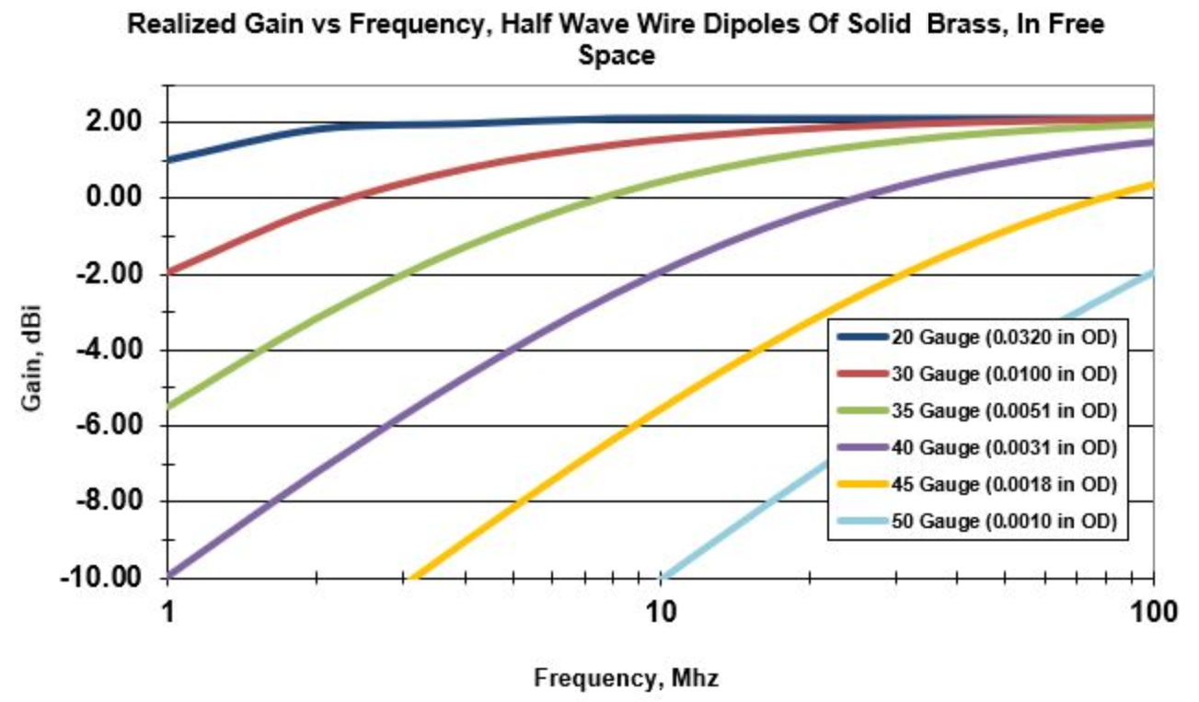
Graph of antenna gain for brass wire half wave dipoles

So number 30 gauge brass has resistive losses of 1 dB or less for frequencies above 3.5 MHz. Now where to get the fine brass wire. It is sold online for hobbies, holding flower arrangements and as EDM wire. EDM wire is electrodischarge machining wire and is brass wire used in metal manufacturing machine shops to cut sheet metal.

New TV Remote Control

Perhaps this could be adapted for amateur radio?

