The HIARC Bulletin

April 2023 Edition

Newsletter of the Harris-Intersil Amateur Radio Club

Club Meetings: Second Thursday of each month at Meemaw’s Barbecue on Babcock Street between Palm Bay Road and Port Malabar Road. Supper is at 5:30 PM, business is at 6:30 PM. Prizes at 7:45 PM. Our programs start around 7:00 PM. Meeting ends by 8:00 PM. As some members have allergies, we kindly ask that you refrain from wearing fragrances. Thanks.

Repeaters: K4HRS, 145.47 Mc, tone 107.2 cycles. Down at the monent.

Nets:

Open to everyone:

- South Brevard Emergency Net: Thursdays at 7:00 PM. 146.61 Mc. In event of repeater failure 146.85 Mc and or 146.58 Mc simplex.

- Skywarn Net: Thursdays, after the SBEN net / 7:30 PM or so, 146.61 Mc

- Palm Bay Informal Net: 8 PM Thursdays on 147.255 Mc.

- Medical Complaint Nets: evenings 3.6 to 4.0 Mc.

HIARC Web Site: www.qsl.net/hiarc. Website administrator; Jim Tonti, KC7SSW

Officers: President: Francis Parsche (“Butch”), WA4AQV
Treasurer: Pat Reilly KA4ZEC
Secretary: Open
Repeater Chairman: Clyde KD8AN
Program Chairman: Open
Field Day Chairman: Open
Sunshine Chairman: Open
Club Jester: Ken N8KH

Annual Membership:

Annual dues are $12.00. You can join at the meeting or send a check to:

HIARC Treasurer
Pat Reilly, KA4ZEC
1985 Howell Lane
Malabar, FL 32950

We are on a calendar year dues system with annual dues due in June. Dues are prorated by a dollar a month. If you join in April dues are $2.00 to get to June.

Send me your email address to receive the newsletter: francis.parsche@l3harris.com

Select Hamfests

- 4-15-23, Melbourne, PCARS swapmeet, Melbourne fire Training Center, 1850 Hugher Road Melbourne FL 32935. Starts about 9 AM, some may come earlier. Talk in 146.61 repeater, tone 107.2.

Ham Radio Lunches:
- Every Friday, 11:00 AM till 1:00 PM or so, Golden Corral on Palm Bay Road in Palm Bay. Talk in on 146.61 Mc repeater.
- Every Friday, 11:00 AM till 1:00 PM or so, Crystal Buffet on 192. Talk in on 146.61 Mc repeater.
- Once a month, the Saturday after the PCARS meeting, Sarno Restaurant and Pizzaria, 11:00 AM. Talk in 146.61 repeater. This restaurant is at the corner of Sarno Road and Croton Road.
February 2023 HIARC Meeting And Program

When: The next HIARC meeting is Thursday April 13.

Where: Meemaws Barbecue on Babcock Street.

Agenda:

5:30 PM dinner
6:30 PM business
6:45 PM prizes
7:00 PM program

Business. The 145.47 repeater has been down for 11 months as we lost the Rialto repeater site. Hopefully someone will one comes forward at the meeting to do the resiting work. Otherwise a motion will have to be discusssed to relenquish the frequency allocation back to the coordinating body.

Program: “Pico Balloons” by Rob KC9TLS with slides.

QEX Magazine

QEX is the more technical magazine that ARRL offers. For the technically oriented it offers more advanced theory with useful practice. QST is getting thinner, less technical, and now reruns back articles as filler. QEX is thinner too.

As a journal, the problem is that back articles are not downloadable at the ARRL.

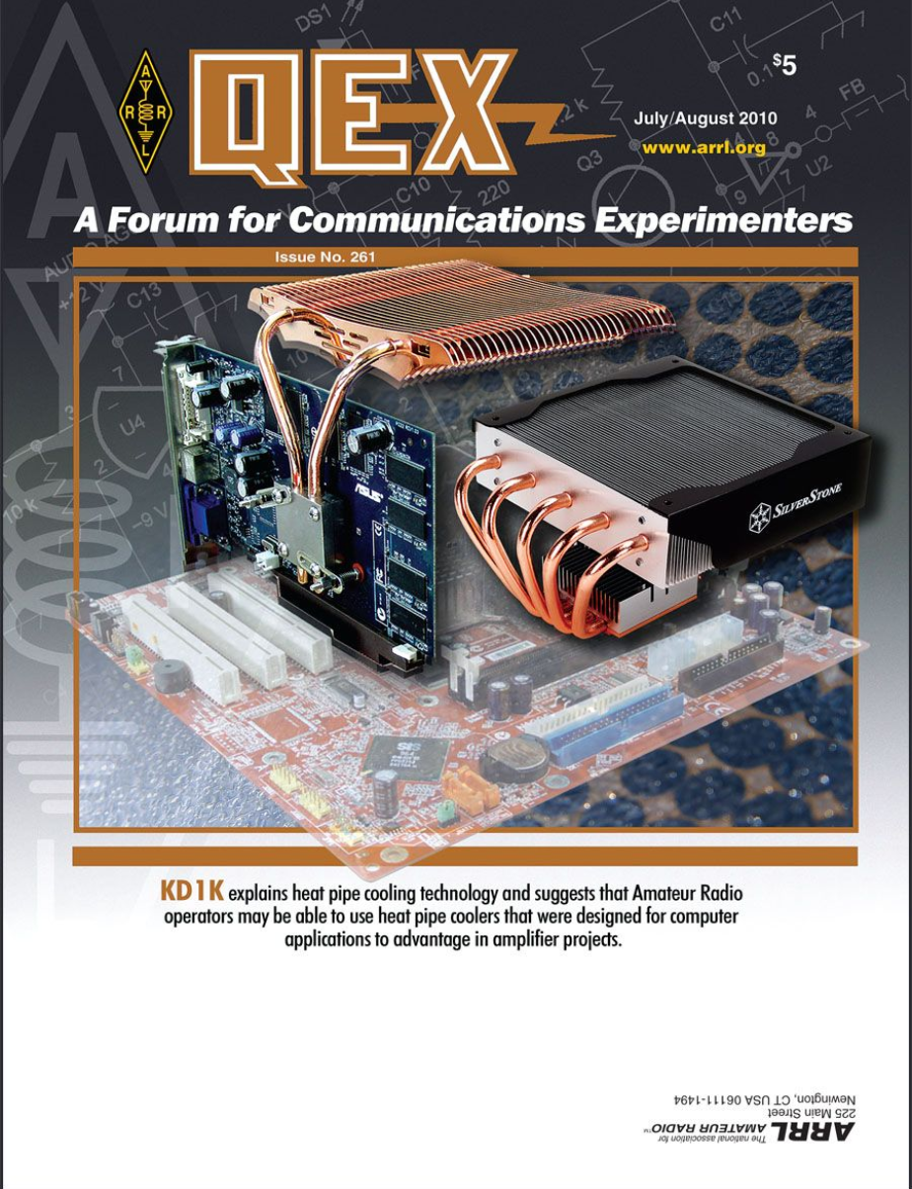

A QEX Magazine

Some back issues are available here: https://archive.org/details/QEX19812016/QEX%201981/QEX%201981-12/

If you know of a more complete way to access QEX articles please let me know: wa4aqv@att.net

The TBY-8 manpack transceiver of World War Two and the Codetalkers

The May HIARC program was on the TBY8 manpack radio and the Codetalkers of Weorld Wr Two.
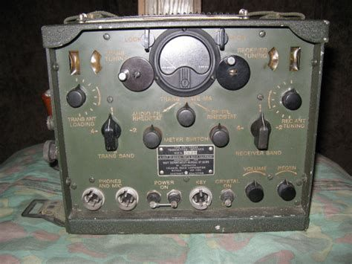

TBY-8 Manpack Radio

The TBY8 radio was a prewar design from 1938. It was perhaps the best manpack radio of all at the start of the war. There were few VHF infantry radios when World War Two started. Some viewed VHF as providing only optical line of sight propagation. It was later learned that manpacks could almost always reach 5 miles and someimes 10 miles. Signals propagated through foilage, rolled over hills, and diffracted around buildings.

The TBY8 was a seperate transmitter and receiver in the same box. The receiver was superregenerative and the transmitter a modulated oscillator. Specifications of ther TBY8 manpack radio:

- Frequency Range 26 to 80 MHz
- 0.5 Watts AM + FM voice (modulated oscillator)
- 0.75 watts AM +FM tone modulated AM code
- Superegenerative receiver
- 5 uV intelligible speech sensitivity
- 60 kc receiver bandwidth estimated
- 13 pound battery , 15 to 25 hour battery life 50 50 xmit rcv, 3 to 6 months storage life

The military needed a communications security solution. The solution was to use indians especially the Navajhos to do the coommunicating in their native language.

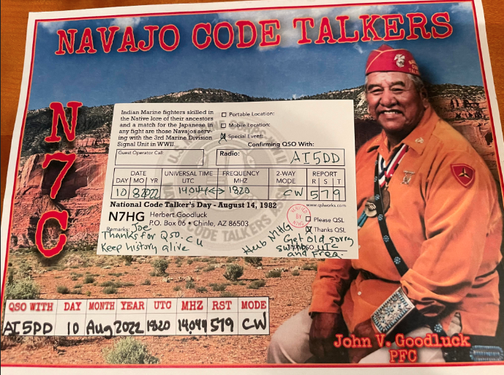

Original TBY-8 radio sets mayy sell for $300 to $2000 today. They are a military collectable. If you would like to experience the interesting behavior of a somewhat similar vacuum tube superegenerative transceiver you can try the Heathkit HW-29A, which usually sells for less than $100.00.

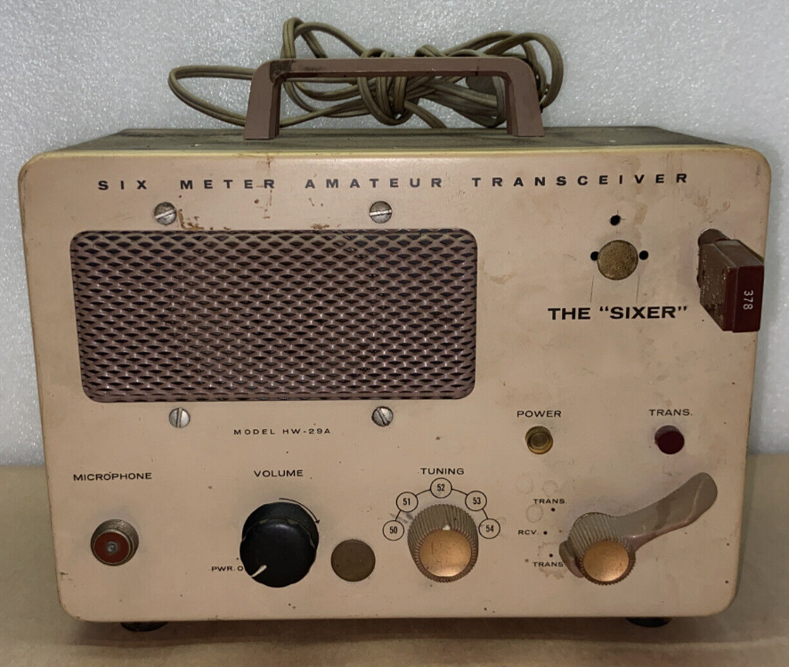

Heathkit HW-29A Transceiver

How To Identify Solar Power System Interference

HF and VHF interference is on the rise from solar power systems, you know all those panels on residential roofs. While the panels themselves may not generate interference such systems use switch mode power converters to change voltages and or create 60 Hz AC. The switch mode power converters create chopped waveforms at frequencies typically from 30 to 100 kHz. The converter waveforms are rich in harmonic content into HF and even VHF, and the converters all too often lack filtering provisions to avoid radio interference. The interference can be radiated by the wiring connected to the power converter.

So here is what the RF interference looks like as radiated from a residental solar power system as experienced by a radio amateur.

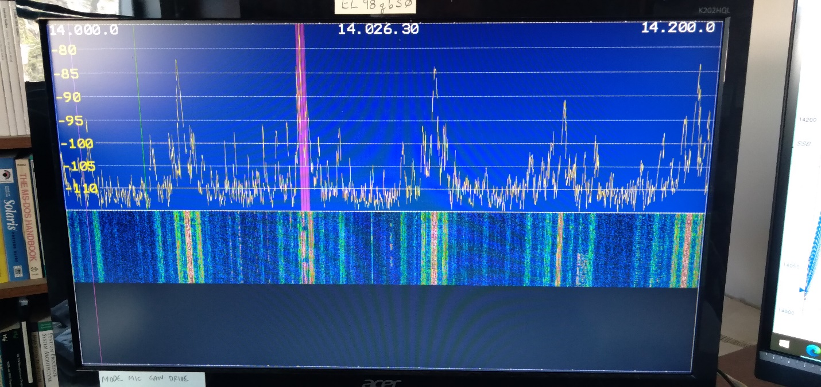

Amateur Station Receiver Showing Solar Power System Interference Spikes

As can be seen high amplitude interference spikes occur every 58 kc or so. Different bands may have different interference levels. One local amateur had it on 10 meters. Another 20 meters. One of the give away characteristics of solar power interference is that this noise disappears at night and becomes less in the day when clouds pass over.

What to to? Inteference filters installed on the solar system have solve the problem when they get installed. Some of the manufacturers already have the required filters available. Typically the solar system owner has to request the manufacturer to install the interference filters. It may be tricky to get the interference mitigated if the solar system is owned by a neighbor.

