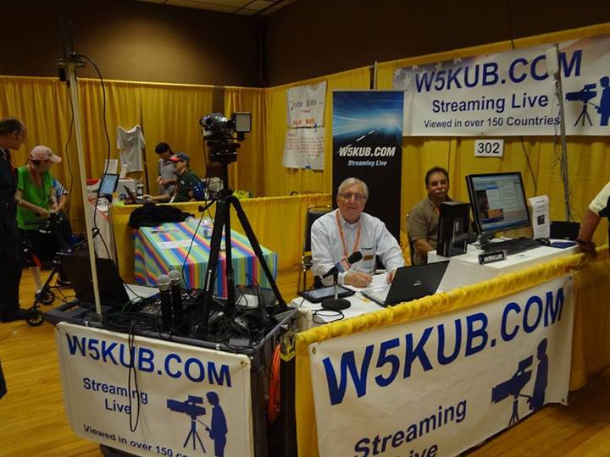
W5KUB STREAMING VIDEO

TOM MEDLIN, W5KUB, AT DAYTON 2013

Have you ever wanted to go to a Ham radio event such as Hamvention but were not able to go for a number of reasons? Now, with just a computer and internet connection you can virtually attend these events. W5KUB.com has been webcasting hamfests for over 11 years. The webcast has viewers in over 150 countries, and pulls an audience of approximately 50,000 viewers during the Dayton Hamvention.

Every year that W5KUB.COM has been webcasting they have been making improvements to the equipment and the technology. Today you can watch near HD quality video of these events in full screen on your computer.

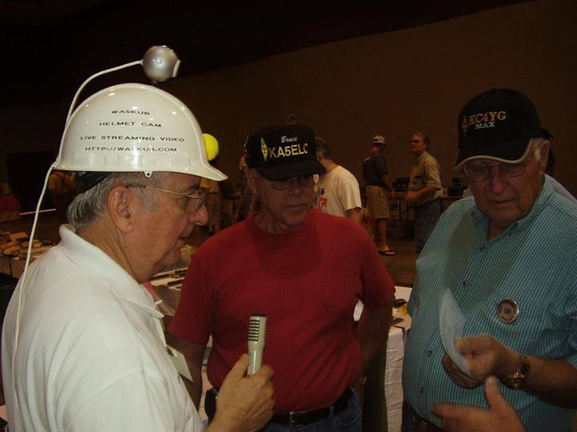
THE W5KUB HELMET CAM USED IN THE EARLY YEARS

There are several different aspects which make the webcast enjoyable.

First the webcast page has a chat room where hams around the world can log in and chat directly with the W5KUB.COM group at the event. In addition to being able to ask real time questions and receive answers from vendors such as MFJ, ICOM, Yaesu and more, online viewers are able to chat with other hams, some located on the opposite side of the world.

Secondly, and this is the fun part, W5KUB.COM gives out prizes to online viewers. There is no cost to anyone! Viewers just have to be logged in to the chat room and winners are randomly picked from the list of logged in viewers. The winner must claim the prize within the allotted timeframe (usually 2-3 minutes) to win it. Prizes vary from magazine subscriptions to high end equipment such as D-STAR radios, watt meters, HTs, dual band radios, antenna tuners, microphones, and more. In the last two years, over $26,000 in prizes have been awarded to viewers. Many hamfest don’t award this much!

And thirdly, viewers get to virtually make the trip and ride along during the drive to and from the hamfest. The webcast usually starts one or two days before the ham event. Viewers are 'virtually' in the passenger seat and experience the entire drive, even getting pulled over by the police for speeding! Viewers also get to see the scenery while APRS on the W5KUB.COM page identifies their exact location and driving speed on the map.

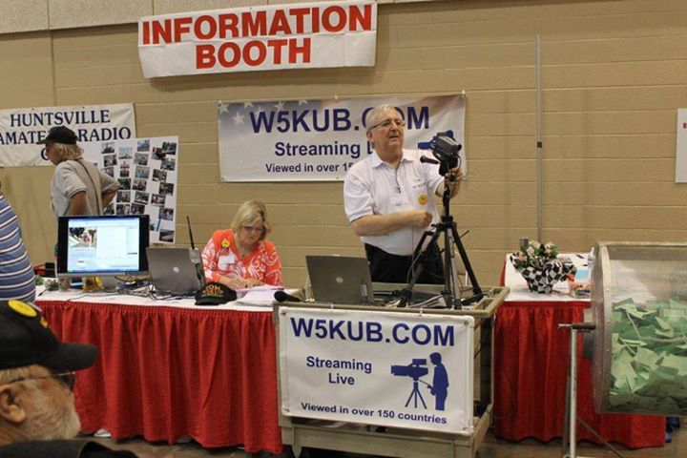
TOM W5KUB AT THE HUNTSVILLE HAMFEST 2013

W5KUB.COM plans to expand the next Hamvention show with new and special guests, in addition to regular interviews with manufacturers. To assure the best quality video, a dedicated Ka band satellite uplink will be installed for our internet connection.

The 2014 Dayton Hamvention schedule:

Wed. May 14th 1300 UTC - go live beginning with the drive from Memphis, Tennessee to Dayton, Ohio -550 Miles and 10 hours of driving

Thurs May 15th 1400 UTC - Webcast booth setup at Hamvention

Friday May 16th 1300 UTC -Hamvention webcast begins

Saturday May 17th 1300 UTC - Second day of Hamvention webcast

Sunday May 18th 1300 UTC - Third day of Hamvention webcast

Sunday May 18th approximately 1800 UTC - begin the webcast of the drive from Dayton, Ohio back to Memphis, Tennessee

W5KUB.COM has a Facebook group for viewers to follow the webcast and to provide suggestions throughout the year and discuss all aspects of ham radio. Our Facebook group is https://www.facebook.com/groups/w5kub/.
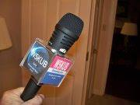
Tom Medlin, W5KUB, Licensed for 50 years
Degree in Electronic Engineering
Recently retired after 34 years managing a global company’s International Telecommunications
Senior Member of the Institute of Electrical and Electronic Engineers (IEEE)
Holder of the FCC Radio Telephone license (formally First Class) with radar enforcement
Holder of Extra Class Amateur Radio License

2014 Dayton Hamvention Webcast

Please join W5KUB.com the week of May 12 for a live webcast of the Dayton Hamvention in Dayton, Ohio. We will be webcasting from inside Hara Arena at Booth SA302. To join the webcast go to http://W5KUB.com where the fun begins!

W5KUB will interview Hamvention vendors regarding their latest products. Our 2013 Dayton Hamvention webcast included many special guests; such as, Bob Heil (K9EID) of Heil Sound; Martin F. Jue (K5FLU) founder of MFJ Enterprises; John Amodeo (NN6JA) producer of ABC TV’s hit show, “Last Man Standing”; and more.

During the live webcast, viewers will also have the opportunity to meet and chat with other ham radio operators from all over the world. During the 2013 Dayton Hamvention we had 47,400 viewers that followed our webcast for the 5 day event.

Viewers can win one of many prizes to be awarded during the webcast! Past prizes have included dual band transceivers, HTs, D-STAR ID-51A, Comet Antenna Analyzer, Heil microphone and headset, antennas, weather station, computer to radio interface, spool LMR-400, auto antenna tuners, and more. Prizes are possible because of our relationship with partners; such as, GigaParts, Icom, Ten-Tec, NCG Company, Kantronics, MP Antenna, Heil Sound, ARRL, MFJ, and more. Over $10,000 in prizes were awarded to online viewers last year! Of course, no purchase is necessary to win a prize. W5KUB does not sell any products or services.

2014 Dayton Hamvention webcast schedule (all times are subject to change):

- Wed. May 14th 1300 UTC - go live beginning with the drive from Memphis, Tennessee to Dayton, Ohio -550 Miles and 10 hours of driving

- Thurs May 15th 1400 UTC - view the webcast booth setup at Hamvention

- Friday May 16th 1300 UTC -Hamvention webcast begins

- Saturday May 17th 1300 UTC - Second day of Hamvention webcast

- Sunday May 18th 1300 UTC - Third day of Hamvention webcast

- Sunday May 18th approximately 1800 UTC - begin the webcast of the drive from Dayton, Ohio back to Memphis, Tennessee

W5KUB.COM has a Facebook group for viewers to follow the webcast and to provide suggestions throughout the year and discuss all aspects of ham radio. Our Facebook group is https://www.facebook.com/groups/w5kub/.

