◆ INTRODUCTION 3
◆ RECORD OF CHANGES 5
◆ WINDOWS 95 / 98 6
1. Windows 98 Driver Installation Guide 6
2. How to check your Win98 installation 8
3. How to Configure COM port 9
4. Windows 98 uninstall guide 11
5. How to connect your peripheral to SUNIX LPT device 12
6. How to connect your peripheral to SUNIX COM device 15
◆ WINDOWS NT 18
1. Windows NT 4.0 Driver Installation Guide 18
2. Check Your Windows NT 4.0 Installation 19
3. How to configure your PCI Multi I/O Card 20
4. Windows NT 4.0 Uninstall Guide 22
◆ DOS 23
1. Installation Guide for PCI Serial / Parallel Ports 23
◆ WINDOWS 3.1 26
1. Installation Guide for PCI Serial Ports 26
2. Installation Guide for PCI Parallel Ports 30
◆ LINUX 32
1. Installation Guide for PCI Serial Ports 32
2. Installation Guide for PCI Parallel Ports 37
◆ Windows 2000 41
1. Windows 2000 Driver Installation Guide 41
2. Windows 2000 uninstall guide 43
3. How to check your Win2000 installation 45
4. How to Configure COM port 48

- INTRODUCTION
The PCI 32 Bit Multi I/O series cards are equipped with High-Speed Standard Serial-Interface and/or IEEE 1284 Parallel Interface.

- Commercial Cards
- Serial ports cannot remap to address 3F8h, 2F8h, 3E8h, 2E8h.
- Parallel ports can remap via user interface to 378h, 278h if any one of those addresses is available.

Model | Function | Connector
4006A | 1P(SPP/BPP) | 1 DB25F
4008A | 1P(ECP/EPP) | 1 DB25F
4014A | 2P(SPP/BPP) | 1 DB25F  1 3x2Header
4018A | 2P(ECP/EPP) | 1 DB25F  1 3x2Header
4014C | 2P(SPP/BPP) | 1 DB62F
4018C | 2P(ECP/EPP) | 1 DB62F
4025A | 1S(16FIFO) | 1 DB9M
4027A | 1S(32FIFO) | 1 DB9M
4036A | 2S(16FIFO) | 2 DB9M
4037A | 2S(32FIFO) | 2 DB9M
4055A | 4S(16FIFO) | 1 DB37F
4056A | 4S(32FIFO) | 1 DB37F
4056R | 4S(32FIFO) | 4 RJ45
4065A | 8S(16FIFO) | 1 DB37F  1 20x2Header
4066A | 8S(32FIFO) | 1 DB37F  1 20x2Header
4066R | 8S(32FIFO) | 1 DB62F
4078A | 2S(16 FIFO) + 1P (SPP/BPP) | 2 DB9M  1 13x2Header
4078U | 2S(32 FIFO) + 1P (SPP/BPP) | 2 DB9M  1 13x2Header
4079H | 2S(16FIFO) + 1P (ECP/EPP) | 2 DB9M  1 13x2Header
4079A | 2S(32FIFO) + 1P (ECP/EPP) | 2 DB9M  1 13x2Header
4079R | 2S(16FIFO) + 1P (ECP/EPP) | 1 DB62F
4079S | 2S(32FIFO) + 1P (ECP/EPP) | 1 DB62F
4085H | 2S(16FIFO) + 2P (SPP/BPP) | 1 DB9M  1 DB25F  1 5x2Header  1 13x2Header
4085U | 2S(32FIFO) + 2P (SPP/BPP) | 1 DB9M  1 DB25F  1 5x2Header  1 13x2Header
4088A | 2S(16FIFO) + 2P (ECP/EPP) | 1 DB9M  1 DB25F  1 5x2Header  1 13x2Header
4089A | 2S(32FIFO) + 2P (ECP/EPP) | 1 DB9M  1 DB25F  1 5x2Header  1 13x2Header
4095A | 4S(16FIFO) + 2P (ECP/EPP) | 1 DB62F  2 13x2Header
4096A | 4S(32FIFO) + 2P (ECP/EPP) | 1 DB62F  2 13x2Header

- Commercial Cards
- Serial ports can automatically remap to address 3F8h, 2F8h, 3E8h, 2E8h if any one of those addresses is available.
- Parallel ports can remap via user interface to 378h, 278h if any one of those addresses is available.

Model | Function | Connector
4025D | 1S(16FIFO) | 1 DB9M  (or 1 5x2Header)
4027D | 1S(32FIFO) | 1 DB9M  (or 1 5x2Header)
4028D | 1S(64FIFO) | 1 DB9M  (or 1 5x2Header)
4036D | 2S(16FIFO) | 2 DB9M  (or 2 5x2Header)
4037D | 2S(32FIFO) | 2 DB9M  (or 2 5x2Header)
4038D | 2S(64 FIFO) | 2 DB9M  (or 2 5x2Header)
4079D | 2S(16FIFO) + 1P (ECP/EPP) | 2 DB9M  1 13x2Header
4079E | 2S(32FIFO) + 1P (ECP/EPP) | 2 DB9M  1 13x2Header
4079F | 2S(64FIFO) + 1P (ECP/EPP) | 2 DB9M  1 13x2Header

- Industrial RS422/485 Cards
- Serial ports cannot remap to address 3F8h, 2F8h, 3E8h, 2E8h.

Model | Function | Connector
8137 | 2S(32FIFO) | 2 mini block
8137S | 2S(32FIFO),surge | 2 mini block
8138 | 2S(32FIFO) | 2 DB9M
8138S | 2S(32FIFO),surge | 2 DB9M
8156 | 4S(32FIFO) | 4 mini block
8156S | 4S(32FIFO),surge | 4 mini block
8157 | 4S(32FIFO) | 4 RJ45
8157S | 4S(32FIFO),surge | 4 RJ45
8166 | 8S(32FIFO) | 1 DB62F
8166S | 8S(32FIFO),surge | 1 DB62F

- Industrial Current Loop Cards
- Serial ports cannot remap to address 3F8h, 2F8h, 3E8h, 2E8h.

Model | Function | Connector
8237 | 2S(32FIFO) | 2 mini block
8237S | 2S(32FIFO),surge | 2 mini block
8238 | 2S(32FIFO) | 2 DB9M
8238S | 2S(32FIFO),surge | 2 DB9M
8256 | 4S(32FIFO) | 4 mini block
8256S | 4S(32FIFO),surge | 4 mini block
8257 | 4S(32FIFO) | 4 RJ45
8257S | 4S(32FIFO),surge | 4 RJ45

➢ The driver put in CD-ROM sub-dir. /IO/PCI IO/

- RECORD OF CHANGES

- Add new models
- Serial ports can remap to 3F8h, 2F8h, 3E8h, 2E8h
- Industrial RS422/485 cards
- Industrial Current Loop cards
- New bracket for saving usage of PCI slots

- Add new DOS and Win3.1 driver
- Serial port that can remap to 3F8h, 2F8h, 3E8h, 2E8h will remap automatically if any one of those ports is available.
- Parallel ports will remap automatically if 378h or 278h is available.
- Inquire and display the card information (port index, I/O and IRQ)

- Solve WinNT LPT port index problem
- In V3.1 driver: To solve the connection with the scanner, the port driver will start with higher priority than scanner, thus the on board parallel port will become the last port.
- In V3.2 driver: The on board parallel port is the LPT1 if the remap function is not enabled. When the parallel port is remap to 378h or 278h to support the scanner or ZIP disk, the on board is the last port.

- WINDOWS 95 / 98

Windows 98 Driver Installation Guide

➢ Turn off the power of your computer.
➢ Plug-in the SUNIX Multi I/O card to PCI bus of your computer
➢ Add-on the peripheral（Modem, Printer, Scanner… etc.）that you need to this card
➢ Turn on the power of your computer
➢ You can press “Pause” key on the keyboard to see the message when PCI device listing display (for example…)

Bus No | Device No | Func No | Vendor ID | Device ID | Device Class | IRQ
0 | 9 | 0 | 1409 | 7168 | Simple Comm. Controller | 10
or

Bus No | Device No | Func No | Vendor ID | Device ID | Device Class | IRQ
0 | 13 | 0 | 1409 | 7268 | Simple Comm. Controller | 10

➢ After running the Windows 98, Windows 98 will find a “PCI Serial Controller” or “PCI Parallel Controller ” installed in your computer and need new drivers to support this hardware.

➢ Click 【Next】
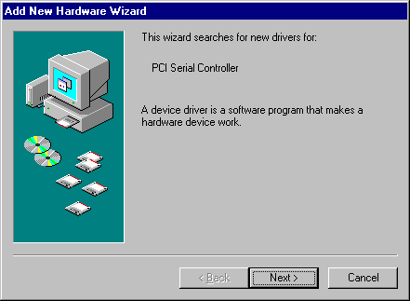

➢ Click 【Next】.
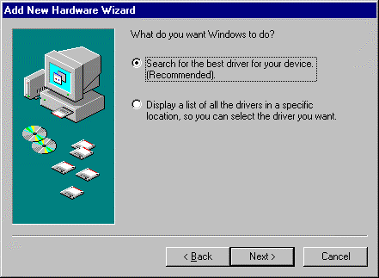
➢ Please insert the driver disk provided with PCI multi I/O card by SUNIX to floppy disk Driver A: or B:
Click 【Next】.
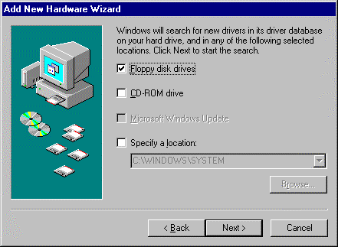
➢ Click 【Next】.
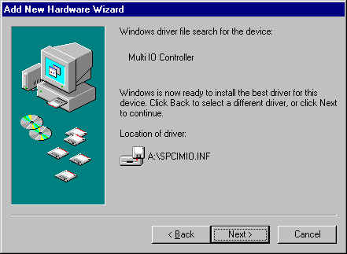
Windows 98 will install PCI multi I/O card driver to your computer.
➢Click 【Finish】.
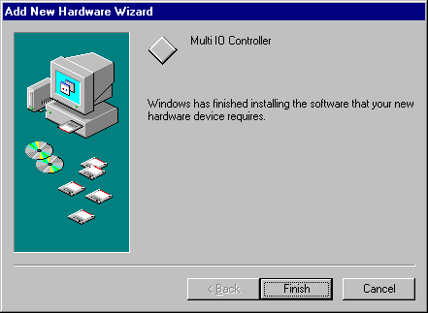

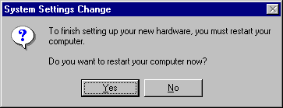
- Note: If you install PCI parallel ports to your system, you will be requested to restart your computer when you finish setting up each parallel port. Click 【Yes】 if all parallel ports have been installed, others click 【No】. For example, if you install two parallel ports in your system, click 【No】 for the first System Setting Change and click 【Yes】 for the last System Setting Change.

How to check your Win98 installation
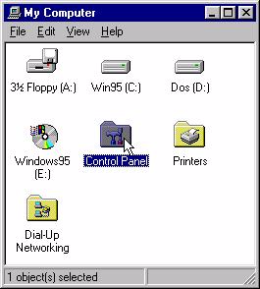
Step 1:

Double click my computer icon
Double click Control Panel icon

Step 2:

Double click System icon


Step 3:
After install PCI multi I/O card (for example 4079A), you will find three ports added (COM3, COM4, LPT2).
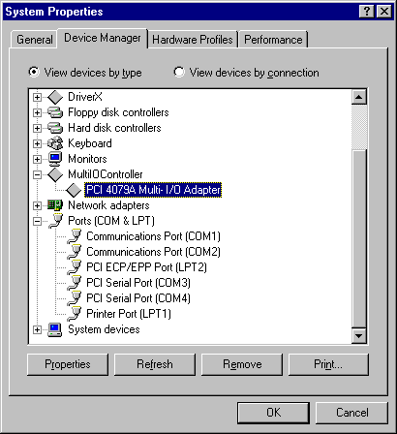

How to Configure COM port
Step 1:
Select the PCI Serial Port you want to configure for example COM3.
Press the 【Properties】.

Step 2:
Click the 【Sunix Port Settings】.

Configure the Bits per second, Data bits, Parity, Stop bits and Flow control if you want to change.
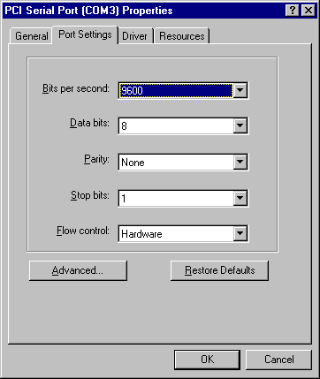
There are three kinds of flow control: Xon/Xoff, Hardware and None. The Xon/Xoff is using software protocol. The Hardware means the flow control is using RTS/CTS, but the RTS/CTS is controlled by software. The None means there is no flow control.
Click the 【Advanced】 if you want to set more advanced features.

Step 3:
Configure the Enable Auto CTS/RTS Flow Control, 16/32/64 bytes FIFO length, and Receive/Transmit Buffer trigger level if you want to change.
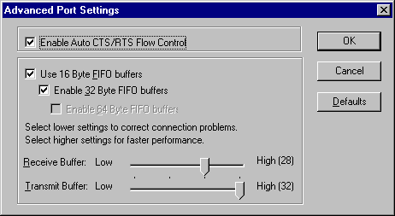

Enable Auto CTS/RTS Flow Control means the CTS/RTS flow control is controlled by hardware automatically. System will be more stable if the function is enabled.

If your card can support 32 bytes FIFO, you can use 16 or 32 bytes FIFO. The default value is Use 16 Byte FIFO buffers. If your card cannot support 32 bytes FIFO, the Enable 32 Byte FIFO buffers will be shadowed.

Set the Receive/Transmit Buffer to higher value will get faster performance because the interrupts will be reduced, but the time for interrupt service routine will become shorter. The receive buffer overflow will be easily happened if the CPU speed is not enough to handle. If the system is not stable, select the lower value to correct problems.

Windows 98 uninstall guide
- Double click Add/Remove Programs in Control Panel.

- Choose PCI Multi-I/O Card.
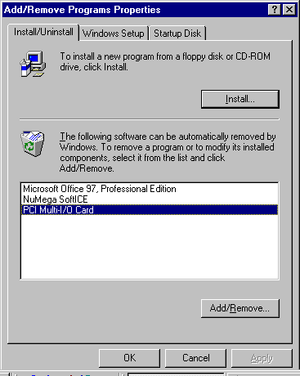
Click 【Add/Remove】.

- Click 【Yes】 to remove Multi-I/O Card driver
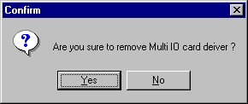
- Click 【Yes】 to restart the computer.


How to connect your peripheral to SUNIX LPT device
Step 1:

Be sure your printer or other parallel peripheral had connected to SUNIX PCI Multi I/O card.

Step 2:
Double click my computer icon, Double click Printers icon
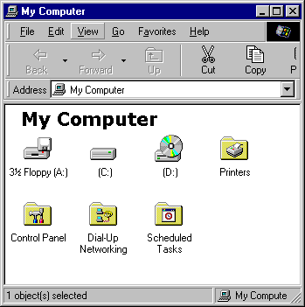
Step 3:
Double click Add Printer icon.

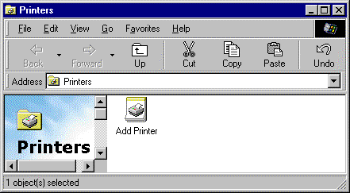
Step 4:
Click 【Next】.
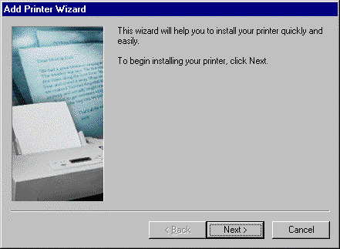
Step 5:

Install Printer (for example HP DeskJet 1120C) driver from disk.
Click 【OK】.

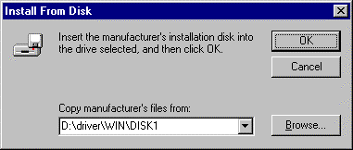
Step 6:

Select HP DeskJet 1120C Printer.
Click 【Next】.

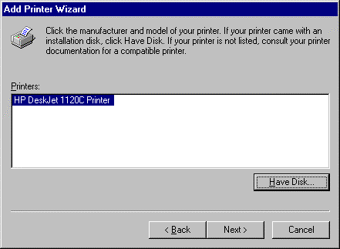

Step 7:
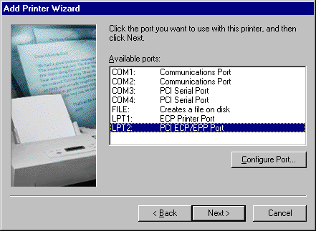
If you want to connect the printer to your PCI Multi I/O Card, select PCI ECP/EPP Port to your device.
Click 【Next】.
Step 8:
Type the printer name then click 【Finish】.
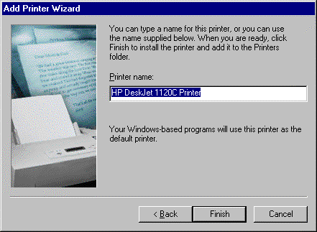
Note: If you want to connect the scanner or the zip disk to PCI multi I/O Card, you need to remap the Parallel Port I/O address to 0x378 or 0x278.

- Double click MultiIOController in Device Manager of System Properties.
Select PCI 4079A Multi-I/O Adapter.
Click 【Properties】.

- If you want to remap I/O address, select Remap to legacy 0x378 and/or 0x278 I/O ports. Click 【OK】, then it will be set after reboot computer
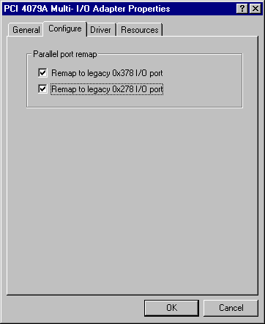
- After reboot comoputer, you can check Parallel Port I/O address from System Properties.

- If you don’t want to remap Parallel Port I/O address to 0x378 or 0x278, unselect Remap to legacy 0x378 and/or 0x278 I/O port.
Click 【OK】, then it will be set after reboot computer

How to connect your peripheral to SUNIX COM device

Step 1:
Be sure your modem or other serial peripheral had connected to SUNIX PCI Multi I/O card.
Step 2:
Double click my computer icon, Double click Control Panel icon.

Step 3:
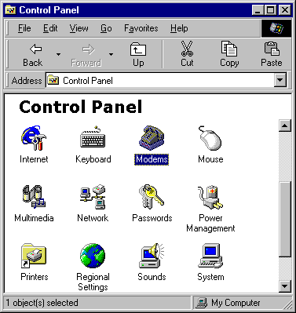
Here will take modem for example.
Click Modem icon
Step 4:
Then Windows 98 will start modem install wizard , click 【Next】.
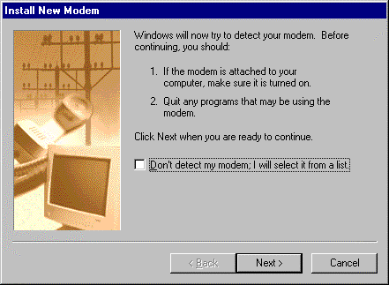

Step 5:
Please wait a moment, Windows 98 will search you modem.
If display standard modem or other modem type, then click 【Next】.
Otherwise, please check your modem. (Power on? Connect right? Telephone line?)
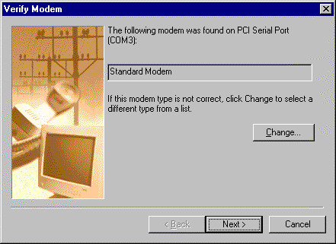
Step 6:
Click 【Finish】
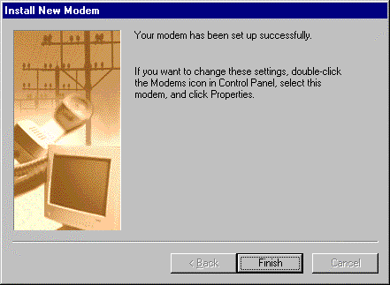
Step 7:
You can find Standard Modem in Modems Properties.
The installation finishes.

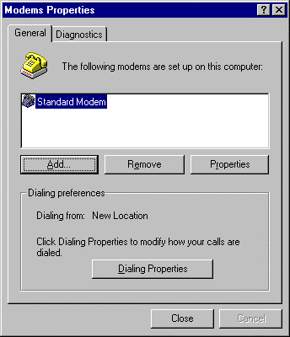
- WINDOWS NT

Windows NT 4.0 Driver Installation Guide
Step 1:
Run the setup.exe program in PCI Multi I/O card (for example 4079A) Installation Disk.
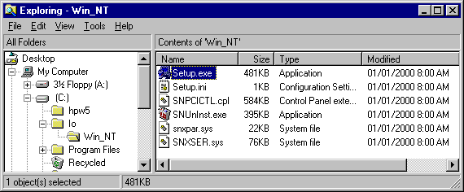
Step 2:
Press 【Continue】 to install the driver.
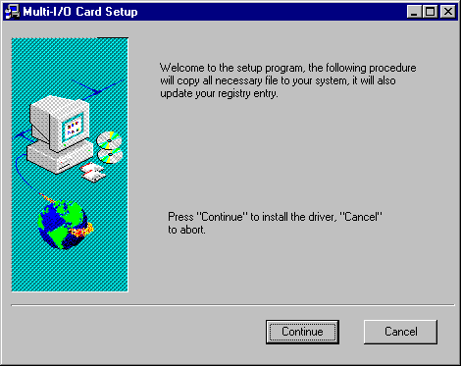
Step 3:
Click 【OK】to reboot computer to load the new installed driver to NT.
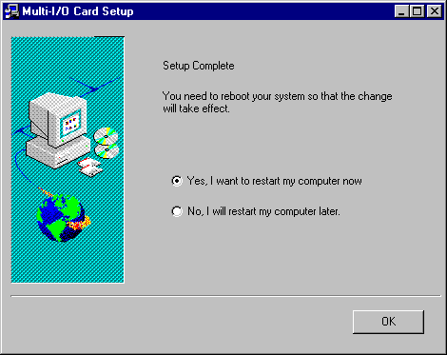

Check Your Windows NT 4.0 Installation
- Click 【Start】 →【Programs】 →【Administrative Tools [Common] 】→【Windows NT Diagnostics】
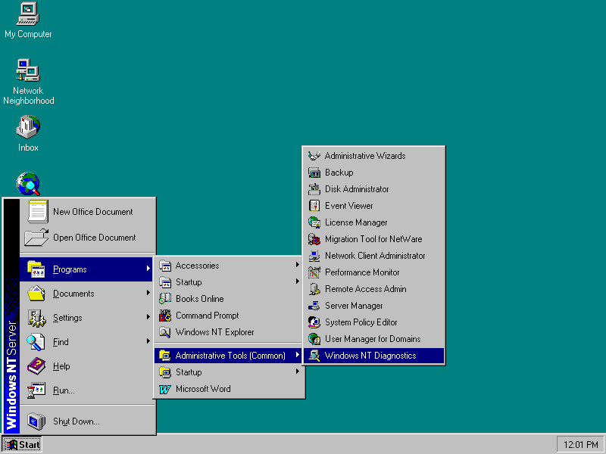
- Press Resources then press I/O port.
You can find the I/O address of one parallel port (SNXPAR) and two serial ports (SNXSER).
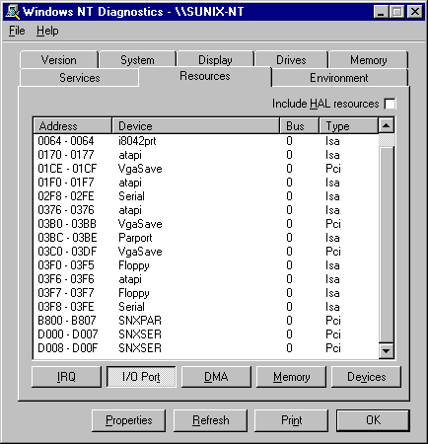
You can find the IRQ information by press 【IRQ】.

How to configure your PCI Multi I/O Card
- Double click Multi-I/O Card Configuration icon.
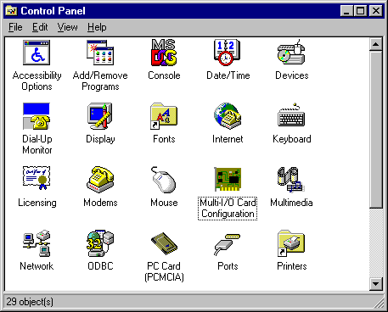

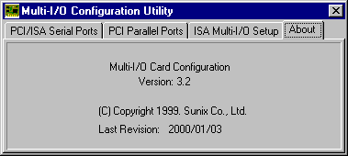

- Press 【PCI/ISA Serial Ports】 and select the serial port you want to configure, press 【Setup】 to configure the serial port .
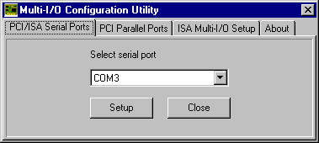

- Set the 32 byte FIFO or Auto Flow Control or Receive Trigger Level, click 【Ok]】.
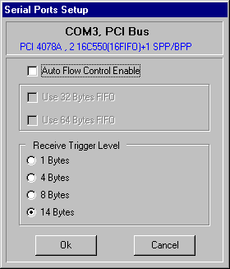

If your card can support 32 (64) bytes FIFO, you can use 16 or 32 (or 64) bytes FIFO. The default value is Use 16 Byte FIFO buffers. If your card cannot support 32 (64) bytes FIFO, the Use 32 (32 and 64) Bytes FIFO will be shadowed.

Auto Flow Control Enable means the CTS/RTS flow control is controlled by hardware automatically. System will be more stable if the function is enabled.

Set the Receive Trigger Level to higher value will get faster performance because the interrupts will be reduced, but the time for interrupt service routine will become shorter. The receive buffer overflow will be easily happened if the CPU speed is not enough to handle. If the system is not stable, select the lower value to correct problems.

Note:
If you stall the modem that is using auto detect by windows NT, the Auto Flow Control Enable shall be disabled.

- Click PCI Parallel Ports to configure the I/O address of parallel port.
Select Remap to legacy 0x378 and/or 0x278 I/O Ports, if you want to remap I/O address to 0x378 and/or 0x278.
Click 【Ok】.
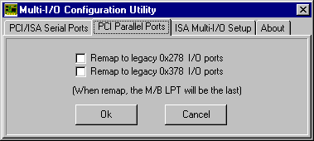
- It will be set after reboot computer.

Note:
- The on board parallel port is always LPT1 if the remap function is disabled. When the parallel port is remap to 0x378 or 0x278, the on board parallel port will become the last LPT port.

- When you connect the scanner to the remap parallel port, you must turn on the scanner before the computer.

Windows NT 4.0 Uninstall Guide
- Double click Add/Remove Programs in Control Panel.
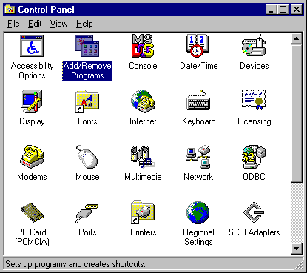
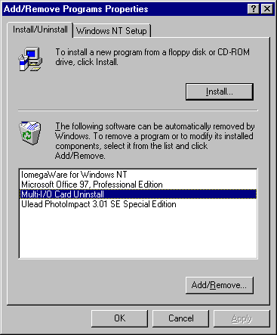
- Select Multi-I/O Card Uninstall, press 【Add/Remove】.
- Press 【OK】 to remove Multi-I/O Card driver.
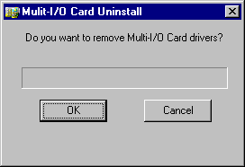

- Click 【OK】 to reboot the computer.
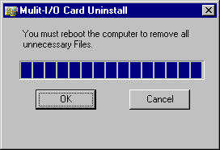

- DOS

Installation Guide for PCI Serial / Parallel Ports

This installation guide describes the procedures to install Sunix PCI serial / parallel ports in MS-DOS environment.

Normally serial and parallel I/O ports can be supported by BIOS call services in DOS environment. However there are only support 4 serial ports (3F8h,2F8h,3E8h,2E8h) and 3 parallel ports (3BCh/378h/278h) are supported by BIOS/DOS.

In case the Sunix PCI serial and parallel ports are different from the above configurations (e.g. I/O address or more than 4 serial ports / 3 parallel ports), they are not supported by BIOS/DOS directly. However some applications (e.g. "PComm Plus" could support 8 serial ports and each I/O address is settable) have their own driver, thus Sunix PCI cards could work correctly.

[DOS platform]

- Microsoft DOS : V5.0/V6.0/ V6.22

[Installation Steps]

- Run Install.exe (from DOS driver disk)
Please enter the directory path for installation
C:\PCI_DOS (return for default)

- Enter the destination subdirectory

You could enter your preferred destination subdirectory for installation, RETURN for default path. Once the dos driver has been installed successfully, the response looks like below.
succeed ...Press Any Key

Note:
1. The installation program will add the dos driver (one command line) "C:\Sunix\SunixPCI.exe AUTO" to autoexec.bat file. The original batch file will be saved to autoexec.SNX.
2. For uninstallation, just restore autoexec.snx into autoexec.bat.

- Start the dos driver automatically

Once the installation is completed, Install.exe will start the dos driver (SunixPCI.exe) automatically. This means that it is not necessary to restart the system once again.
On-Board/ISA Serial COM1 3f8H
On-Board/ISA Serial COM2 2f8H
PCI Serial COM3 Remap 3e8H,IRQ 11
PCI Serial COM4 Remap 2e8H,IRQ 11

On-Board/ISA Parallel LPT1 3bcH
PCI Parallel LPT2 Remap 378H,IRQ 11
PCI Parallel LPT3 Remap 278H,IRQ 10

Note : This display is dependent on which PCI card you have.

- Check / inquire the Sunix PCI card information

You could run SunixPCI.exe any time to inquire the Sunix PCI serial and parallel port's I/O address & IRQ information.

ISA PCI Setup Card About
On-Board/ISA Serial COM1 3f8H
On-Board/ISA Serial COM2 2f8H
PCI Serial COM3 Remap 3e8H,IRQ 11
PCI Serial COM4 Remap 2e8H,IRQ 11

On-Board/ISA Parallel LPT1 3bcH
PCI Parallel LPT2 Remap 378H,IRQ 11
PCI Parallel LPT3 Remap 278H,IRQ 10
ESC: Exit

ISA : Detect on-board/ISA legacy serial /parallel ports.
PCI : Find PCI serial /parallels ports.
Setup : Remap PCI serial port to legacy port / display port resources.
Card : Display Sunix PCI card model.
About : Version Information.
NOTE :
- All Sunix PCI parallel ports are possible to be remapped to legacy I/O address (378h,278h), thus the DOS driver will start remapping function automatically if any one of legacy ports is free.

- Since some Sunix PCI serial ports can support the remapping function (e.g. 4025D/4027D/4028D/4036D/4037D/4038D/
4079D/E/F). thus please check it by "SETUP" in SunixPCI.exe utility.
Clock= 1.8432 Mhz for remapable port in DOS
Item | Actual Baudrate | BIOS/DOS setting | Remark
1 | 921600 |  | Do not support
2 | 460800 |  | Do not support
3 | 230400 |  | Do not support
4 | 115200 | 115200
5 | 57600 | 57600
6 | 38400 | 38400
7 | 19200 | 19200
8 | 9600 | 9600
9 | 4800 | 4800
10 | 2400 | 2400
11 | 1200 | 1200
12 | 300 | 300

- Since Sunix PCI serial card are drived by a higher CLK (14.7456 Mhz), thus the actual baud rate is 8 times higher than the BIOS/DOS baud rate setting. The below table shows the relation.
Clock=14.7456 Mhz for all non-remapable port
Item | Actual Baud rate | BIOS/DOS setting | Remark
1 | 921600 | 115200
2 | 460800 | 57600
3 | 230400 | 28800 | Non BIOS standard
4 | 115200 | 14400 | Non BIOS standard
5 | 57600 | 7200 | Non BIOS standard
6 | 38400 | 4800
7 | 19200 | 2400
8 | 9600 | 1200
9 | 4800 | 600 | Non BIOS standard
10 | 2400 | 300
11 | 1200 | 150
12 | 300 | 37.5 | Non BIOS standard
- WINDOWS 3.1

Installation Guide for PCI Serial Ports

This installation guide describes the procedures to install Sunix PCI serial / parallel ports in MS WINDOWS 3.1 environment.

Normally serial and parallel I/O ports can be supported by WINDOWS 3.1 default device driver. However there are only 4 serial ports (3F8h,2F8h,
3E8h,2E8h) and 3 parallel ports (3BCh/378h/278h) are supported by default.

Most likely the Sunix PCI serial ports are different from the above configuration (eg. I/O address or IRQ), these ports setting need to changed / modified in WINDOWS 3.1 manually. However it is necessary to inquire these PCI serial and parallel ports's resources in advance.

[OS Platform]

- Microsoft WINDOWS : V3.1/V3.11

[Installation Steps]

- Inquire the PCI serial port resources (I/O address & IRQ) in DOS

Run "C:\PCI_DOS\SunixPCI.exe AUTO".

On-Board/ISA Serial COM1 3f8H
On-Board/ISA Serial COM2 2f8H
PCI Serial COM3 b800H,IRQ 10
PCI Serial COM4 b808H,IRQ 10

On-Board/ISA Parallel LPT1 3bcH
PCI Parallel LPT2 Remap 378H,IRQ 10

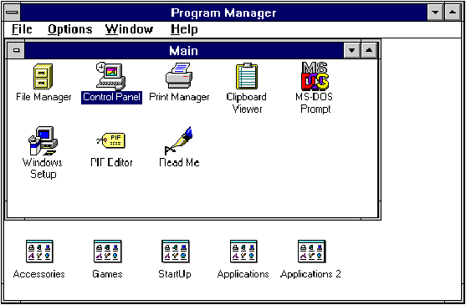
- Start the WINDOWS 3.1
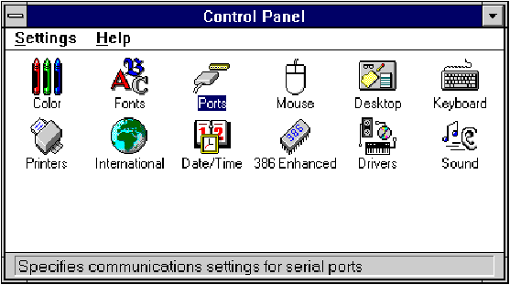
- Change the port setting in Control Panel
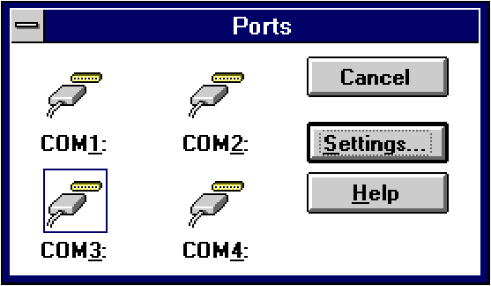
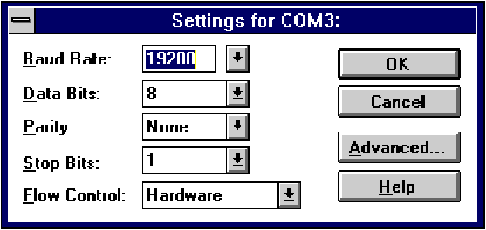
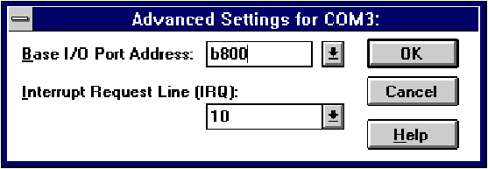

- Restart the system
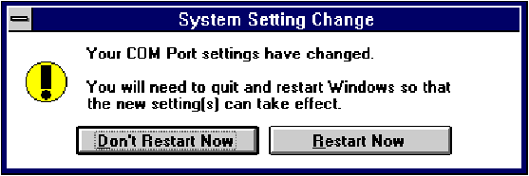
- Check the new setting

After system restart, the I/O port setting maybe become DEFAULT.
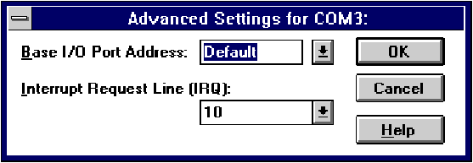
At this time, it is possible to check the PCI serial port setting in \windows\system.ini file.

…..
…..
[386Enh]
…..
…..
COM3Base=B800
COM4Base=B808
COM3Irq=10
COM4Irq=10
…

NOTE :
1. Since some Sunix PCI serial ports can support the remapping function (4025D/4027D/4028D/4036D/4037D/4038D/4079D/E/F), thus please check the Sunix PCI card by SunixPCI.exe utility.
Clock= 1.8432 Mhz for remapable port
Item | Actual Baudrate | BIOS/DOS setting | Remark
1 | 921600 |  | Do not support
2 | 460800 |  | Do not support
3 | 230400 |  | Do not support
4 | 115200 | 115200
5 | 57600 | 57600
6 | 38400 | 38400
7 | 19200 | 19200
8 | 9600 | 9600
9 | 4800 | 4800
10 | 2400 | 2400
11 | 1200 | 1200
12 | 300 | 300

2. Since Sunix PCI serial card are drived by a higher CLK (14.7456 Mhz), thus the actual baud rate is 8 times higher than the BIOS/DOS baud rate setting. The below table shows the relation.
Clock= 14.7456 Mhz for all non-remapable port
Item | Actual Baud rate | BIOS/DOS setting | Remark
1 | 921600 | 115200
2 | 460800 | 57600
3 | 230400 | 28800 | Non BIOS standard
4 | 115200 | 14400 | Non BIOS standard
5 | 57600 | 7200 | Non BIOS standard
6 | 38400 | 4800
7 | 19200 | 2400
8 | 9600 | 1200
9 | 4800 | 600 | Non BIOS standard
10 | 2400 | 300
11 | 1200 | 150
12 | 300 | 37.5 | Non BIOS standard

Installation Guide for PCI Parallel Ports

Since WINDOWS 3.1 only support 3 parallel port (3BCh, 378h,278h) by default device driver. Thus the Sunix PCI parallel ports can be recognized in WINDOWS 3.1 if the DOS driver is activated in advance.

[Installation Steps]

- Check the PCI parallel port resources in DOS

Run "C:\PCI_DOS\SunixPCI.exe AUTO".
On-Board/ISA Serial COM1 3f8H
On-Board/ISA Serial COM2 2f8H
PCI Serial COM3 b800H,IRQ 10
PCI Serial COM4 b808H,IRQ 10

On-Board/ISA Parallel LPT1 3bcH
PCI Parallel LPT2 Remap 378H,IRQ 10
PCI Parallel LPT3 Remap 278H,IRQ 11

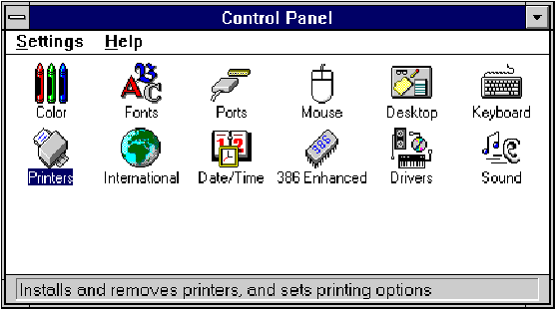
- Install the Printer in Control Panel
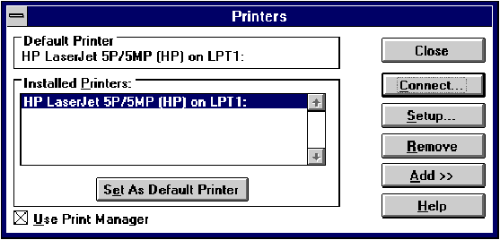

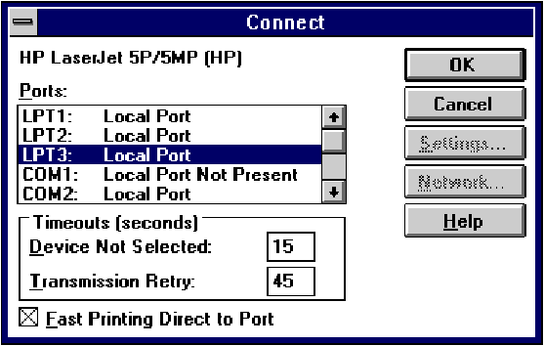
- Select Parallel Port for Printer Connection

NOTE :
- All Sunix PCI parallel ports are possible to be remapped to legacy I/O address (378h,278h), thus the DOS driver will start remapping function automatically if any one of the legacy ports is free.
- For the better compatibility, it is recommended that on-board LPT1 is set to 3BCh.
- LINUX

Installation Guide for PCI Serial Ports

This installation guide describes the procedures to install SUNIX PCI serial ports in Linux platform.

[Linux Platform]

- Operating System : RedHat V6.1/V6.0 (Kernel 2.2.x / 2.0.x)
- Terminal Emulation AP : minicom / xminicom
- Internet Dialer : Kppp

[Installation Steps]

(1) Find the available serial ports

Since Linux only support 4 serial ports (ttyS0, ttyS1, ttyS2, ttyS3) under the default condition. Most likely, ttyS0 & ttyS1 are supported by mother board's built-in 16550 controllers and ttyS2 & ttyS3 are free for additional I/O card. (Note that ttyS2: S is upper case)

It could be checked by the following commands.

#setserial /dev/ttyS0 -a (COM1)
#setserial /dev/ttyS1 -a (COM2)
#setserial /dev/ttyS2 -a (COM3)
#setserial /dev/ttyS3 -a (COM4)

If COM1 is used by mouse, the response is similar to

/dev/ttyS0 : Device or resource busy

If the COM1 does not attach any device, the response is similar to

/dev/ttyS0, Line 0, UART: 16550A, Port: 0x3f8, irq: 4
Baud_base: 115200, clos_delay: 50, divisor: 0
closing_wait: 3000, closing_wait2: infinite
Flags: spd_normal skip_test

In case ttyS2 (COM3) is free, the response for command
# setserial /dev/ttyS2 -a is shown below.

/dev/ttyS2, Line 2, UART: unknown, Port: 0x3e8, irq: 4
Baud_base: 115200, clos_delay: 50, divisor: 0
closing_wait: 3000, closing_wait2: infinite
Flags: spd_normal skip_test
(note that UART: unknown)

In case ttyS3 (COM4) is free, the response for command # setserial /dev/ttyS3 -a is shown below.

/dev/ttyS3, Line 3, UART: unknown, Port: 0x2e8, irq: 3
Baud_base: 115200, clos_delay: 50, divisor: 0
closing_wait: 3000, closing_wait2: infinite
Flags: spd_normal skip_test
(note that UART: unknown)

Finally, the /dev/ttyS2 & /dev/ttyS3 are free for PCI serial ports.

(2) Find the PCI card resource ( IO port address & IRQ) for the serial ports

Please enter the command "#more /proc/pci".
The response is similar to the following

…………………………………………………………………..
…………………………………………………………………..
Bus 0, Device 11, function 0:
^^
Serial controller : Unknown vendor Unknown device (rev 1).
Vendor id=1409, Device id=7168
Medium devsel. Fast back-to-back capable. IRQ 10
^^
I/O at 0xef80 [0xef81]
^^^^ ^^^^
…………………………………………………………………..
(note : ^^ means it could be different from the above.
They are varied with the different PC.)

From the /proc/pci file, it is possible to find the PCI card's IO port address and IRQ. Especially, the SUNIX card always shows

"Vendor id=1409, Device id=7168".

- Configure the parameters for ttyS2 & ttyS3

for SUNIX 4025A card (PCI 1S), please enter (if ttyS2 is free)
# setserial /dev/ttyS2 port 0xef80 UART 16550A
irq 10 Baud_base 921600

for SUNIX 4036A card (PCI 2S), please enter (if ttyS2 & ttyS3 are free)

# setserial /dev/ttyS2 port 0xef80 UART 16550A
irq 10 Baud_base 921600
# setserial /dev/ttyS3 port 0xef88 UART 16550A
irq 10 Baud_base 921600

- Check the setting for ttyS2 & ttyS3

Please enter # setserial /dev/ttyS2 -a
The response look likes below

/dev/ttyS2, Line 2, UART: 16550A, Port: 0xef80, irq: 10
Baud_base: 921600, clos_delay: 50, divisor: 0
closing_wait: 3000, closing_wait2: infinite
Flags: spd_normal skip_test

(5) Then the ttyS2 & ttyS3 are ready for application
(eg. minicom -s or xminicom -s or Kppp ...)

(6) In case more than 4 serial ports are needed
If there are more than 4 serial ports to be supported by Linux system, (e.g. Sunix 4055A/4056A/4065A/4066A/4095A/4096A cards) the first step is to add more tty device nodes into system.

Inquire the system tty device nodes,
#ls -al /dev/ttyS*
crw------- 1 root tty 4, 64 Jan 8 11:40 /dev/ttyS0
crw------- 1 root tty 4, 65 Jan 8 11:40 /dev/ttyS1
crw------- 1 root tty 4, 66 Jan 8 11:40 /dev/ttyS2
crw------- 1 root tty 4, 67 Jan 8 11:40 /dev/ttyS3

Add tty device node one by one
#mknod /dev/ttyS4 c 4 68 (for ttyS4)
#mknod /dev/ttyS5 c 4 69 (for ttyS5)
#mknod /dev/ttyS6 c 4 70 (for ttyS6)
#mknod /dev/ttyS7 c 4 71 (for ttyS7)
………………………….
Please add all tty device nodes accordingly

Configure the parameters for all new ttyS*
Please repeat step (2) (3) (4) to inquire and change the I/O address for each tty device. Because all the new added tty device nodes are still invalid by default.

For PCI 4S card (4055A/4056A), it allocate 2 I/O resources. You could inquire it according to step(2). E.g.
# more /proc/pci
……………………………….
Vendor id=1409, Device id=7168
Medium devsel. Fast back-to-back capable. IRQ 10

I/O at 0xd000 [0xd001] ➔ 1st port=0xd000, 2nd port=0xd008
I/O at 0xb800 [0xb801] ➔ 3rd port=0xb800, 4th port=0xb808

For PCI 8S card (4065A/4066A), it allocate 6 I/O resources. You also need to inquire its allocated address
# more /proc/pci
……………………………….
Vendor id=1409, Device id=7168
Medium devsel. Fast back-to-back capable. IRQ 10
^^
I/O at 0xd000 [0xd001] ➔ 1st port=0xd000, 2nd port=0xd008
I/O at 0xb800 [0xb801] ➔ 3rd port=0xb800, 4th port=0xb808
I/O at 0xb400 [0xb401] ➔ 5th port=0xb400
I/O at 0xb000 [0xb001] ➔ 6th port=0xb000
I/O at 0xa800 [0xa801] ➔ 7th port=0xa800
I/O at 0xa400 [0xa401] ➔ 8th port=0xa400

Re-Inquire the system tty device nodes,
#ls -al /dev/ttyS*
crw------- 1 root tty 4, 64 Jan 8 11:40 /dev/ttyS0
crw------- 1 root tty 4, 65 Jan 8 11:40 /dev/ttyS1
crw------- 1 root tty 4, 66 Jan 8 11:40 /dev/ttyS2
crw------- 1 root tty 4, 67 Jan 8 11:40 /dev/ttyS3
crw-r--r-- 1 root root 4, 68 Jan 18 11:40 /dev/ttyS4
crw-r--r-- 1 root root 4, 69 Jan 18 11:40 /dev/ttyS5
crw-r--r-- 1 root root 4, 70 Jan 18 11:40 /dev/ttyS6
crw-r--r-- 1 root root 4, 71 Jan 18 11:40 /dev/ttyS7
………………………….

Important Notes :
- Since all serial ports on Sunix PCI card are using only one interrupt pin, you must set them the same IRQ number with setserial command.

- Un-installation,
e.g.#rm /dev/ttyS4 (remove ttyS4 device)

Installation Guide for PCI Parallel Ports

This installation guide describes the procedure to install SUNIX PCI parallel ports in Linux platform.

[Linux Platform]

- Operation System: RedHat V6.1/V6.0 (Kernel 2.2.x / 2.0.x)
- "AnotherLevel menu -> administration -> printtool" in X windows.

[Installation steps]

Linux kernel provide a 'parport' code to support parallel port (/dev/lp0, /dev/lp1, /dev/lp2). This code provides the ability to share one port between multiple devices. And it is loadable when kernel is running.

The 'parport' code is split into two parts : generic (which deals with port sharing) and architecture-dependent eg. X86, SPARC. (which deals with actually using the port). Thus, please take the following steps to install 'parport' module!

- Check the on-board parallel port's hardware resources

Most likely each motherboard has one built-in parallel port. And its hardware resources are settable with BIOS utility.

(for example, on-board parallel is in 0x378 port, IRQ=7 )

- Find the PCI resource ( IO port address & IRQ) for the parallel ports

please enter the command "# more /proc/pci"
The response will look like the following

…………………………………………………………………..
…………………………………………………………………..
Bus 0, Device 11, function 0:
^^
Parallel controller : Unknown vendor Unknown device (rev 1).
Vendor id=1409, Device id=7268 (or 7168)
Medium devsel. Fast back-to-back capable. IRQ 10
^^
I/O at 0xe000 [0xe001]
I/O at 0xd800 [0xd801]
I/O at 0xd400 [0xd401]
I/O at 0xd000 [0xd001]
^^^^ ^^^^
…………………………………………………………………..
…………………………………………………………………..

(Note : ^^ means it could be different from the above.
They are varied with the different PC.)

From the /proc/pci file, it is possible to find the PCI card's I/O port address and IRQ. Especially, the SUNIX card always shows

"Vendor id=1409, Device id=7268"
or
"Vendor id=1409, Device id=7168"

- Install 'parport' module

<step I> to load the generic 'parport' code

# insmod parport.o

<step II> to load the architecture-dependent code to tell 'parport' code

# insmod parport_pc.o io=0x378,0xe000,0xd400
irq=7,none,none

that you have three PC-style ports, one at 0x378 with IRQ 7, one at
0xe000 with no IRQ, one at 0xd400 with no IRQ.

Note :
1. Please enter "#find /lib -name parport.o" to find out the correct file path. (it is varied with the different kernel version)
2. For the detailed description, please refer to /Documentation /parport.txt in Linux kernel

- Check the attached printer device [optional]

once the architecture-dependent part of the paraport code is loaded
into the kernel. You could enter the following command

# insmod parport_proble.o

to check any attached devices and log a message similar to

parport0: Printer, BJC-210 (Canon)

- Then /dev/lp0, /dev/lp1 and /dev/lp2 are ready for service

Now parallel port is available, please connect a correct type of printer for your printing applications.
(eg. AnotherLevel menu -> administration -> printttool in X windows)

Note :
- Type "# cat /dev/printcap" to inquire the printer connection.
- It's possible to print a text file to the printer for verification
(#lpr -Pprinter_name textfile_name)

- In case more than 3 parallel ports ( eg. /dev/lp3, /dev/lp4 …) are needed for service

Please get the root privilege and enter the following command

#mknod /dev/lp3 6 3
#chmod 660 /dev/lp3
#chgrp daemon /dev/lp3
➔to add /dev/lp3 into kernel

#mknod /dev/lp4 6 4
#chmod 660 /dev/lp4
#chgrp daemon /dev/lp4
➔to add /dev/lp4 into kernel

………
………

then please enter the following command to check /dev/lp devices

#ls -al /dev/lp*
crwxrwxrwx 1 root daemon 6, 0 may 5 1998 /dev/lp0
crwxrwxrwx 1 root daemon 6, 1 may 5 1998 /dev/lp1
crwxrwxrwx 1 root daemon 6, 2 may 5 1998 /dev/lp2
crwxrwxrwx 1 root daemon 6, 3 dec 9 1999 /dev/lp3
crwxrwxrwx 1 root daemon 6, 4 dec 9 1999 /dev/lp4

and then repeat step (3) to load parport module for /dev/lp*.

Note : #rm /dev/lp3 to remove it

- Windows 2000

Windows 2000 Driver Installation Guide
➢ After running the Windows 2000, Windows 2000 will find a “PCI Serial Port” or “PCI Parallel Port ” installed in your computer and need new drivers to support this hardware.

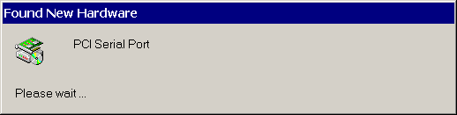

- Click [Next].
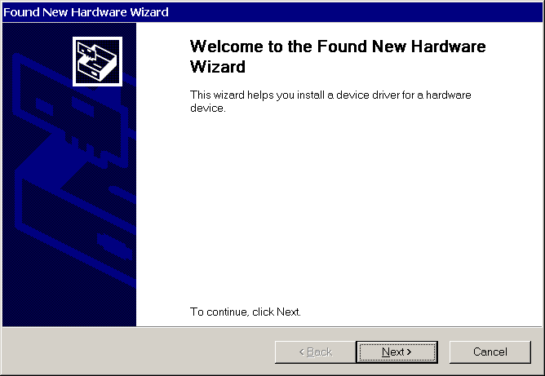

➢ Select “Search for a suitable driver for my device (recommended)” and click [Next].
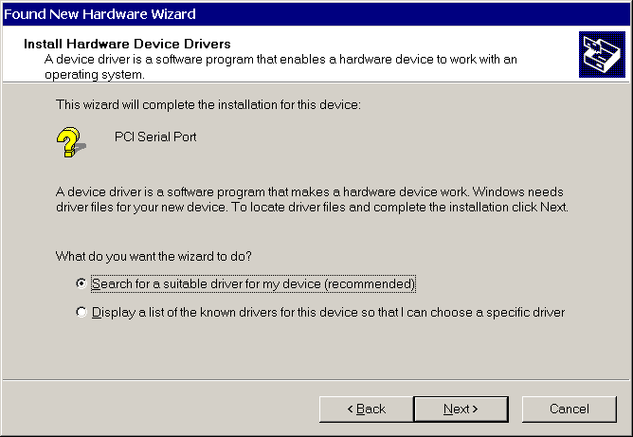

➢ Please insert the driver disk and select the driver location.
Click [Next].
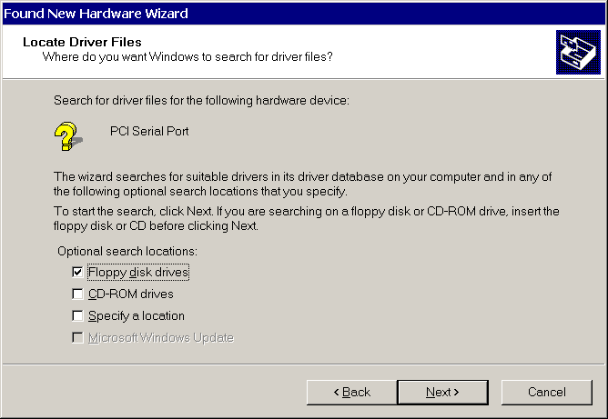

➢ Click [Next].
Windows 2000 will install PCI multi I/O card driver to your computer.
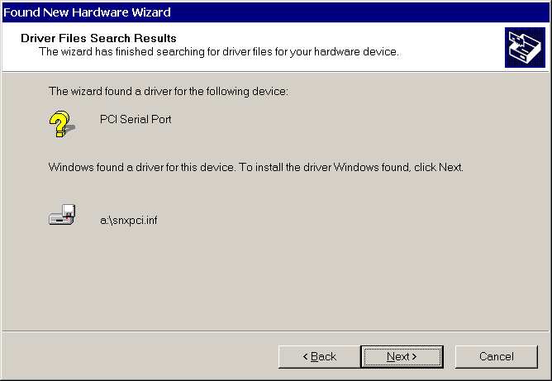

➢Click [Finish].
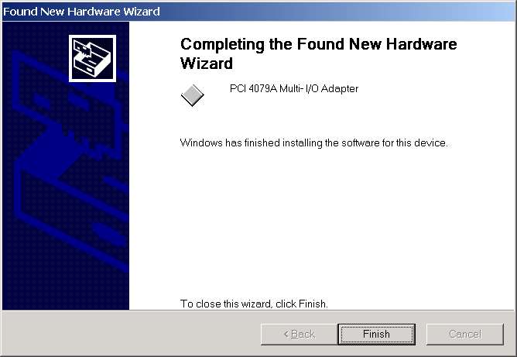

Windows 2000 uninstall guide
- Click the “Hardware Wizard” in “Hardware” of System Properties.

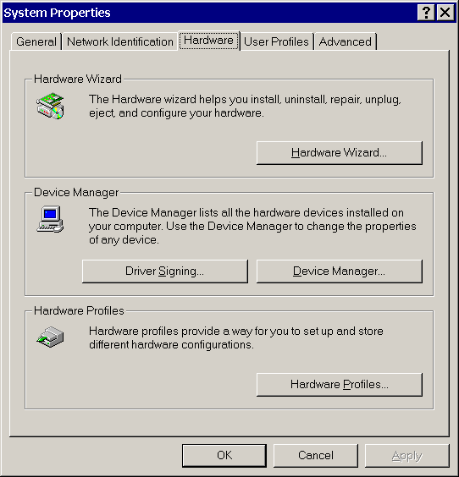

- Click [Next].
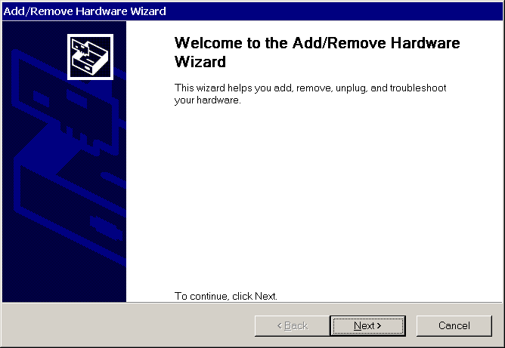

- Select “Uninstall/Unpluging a device and click [Next].
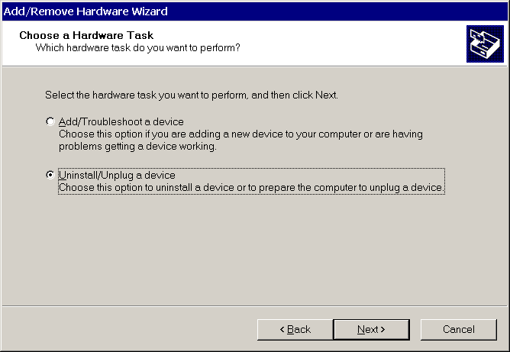
- Select “Uninstall a device and click [Next].
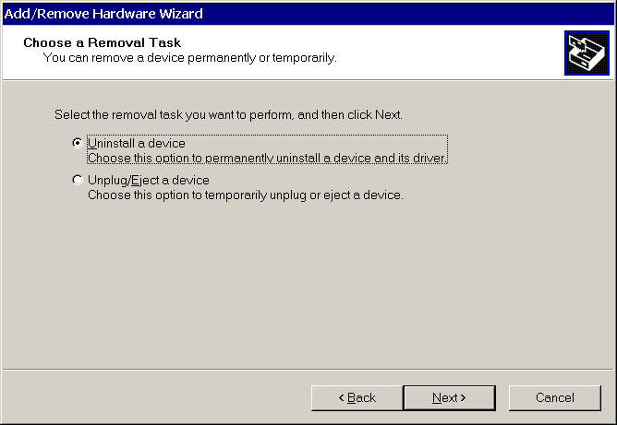

- Select the “PCI 4079A Multi I/O Adapter” and click [Next].
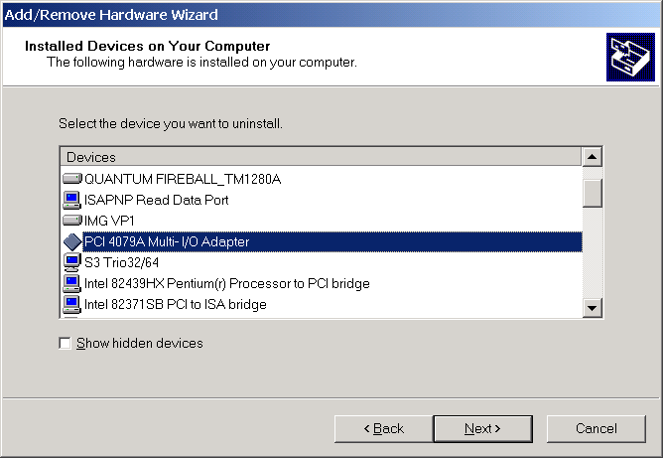

- Select the “Yes, I want to uninstall this device” and click [Next].
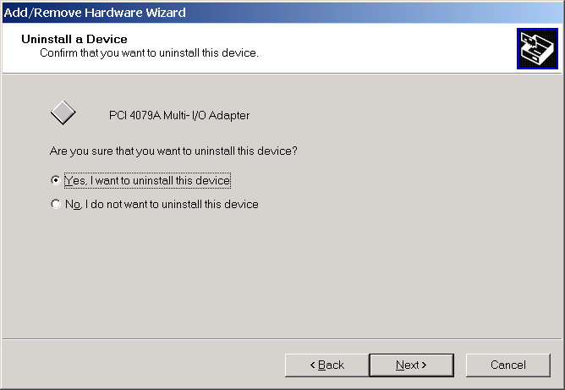
- Click [Finish].
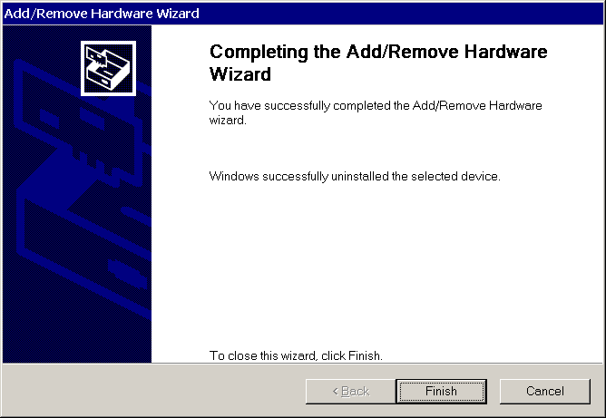

How to check your Win2000 installation
Step 1:
Double click the System icon in control panel.
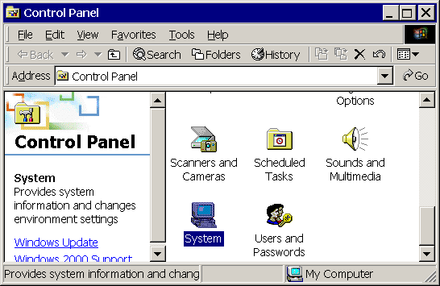
Step 2:
Select the “Hardware” in system properties and click the “Device Manager”.

Step 3:
After install PCI multi I/O card (for example 4079A), you will find three ports added (COM3, COM4, LPT2).
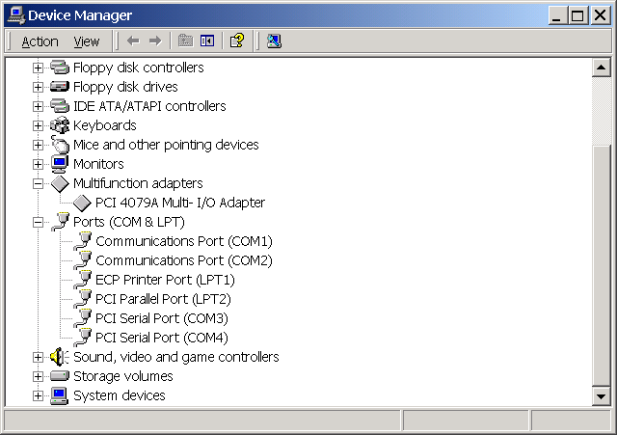
Note: Sometimes you may find the PCI serial port does not locate just behind the on board Communication Port. It may happen as following. The COM3 and COM4 are not used.
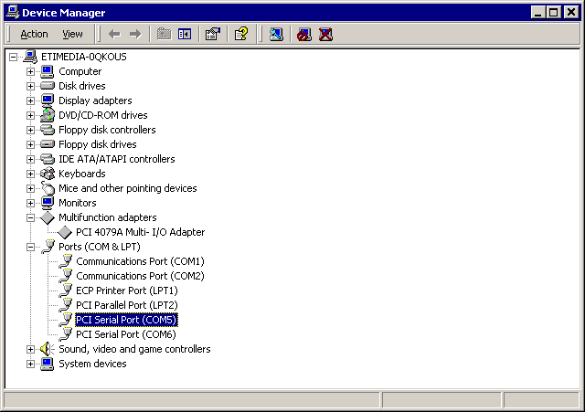

This problem is caused from the following reasons.
- When you plug the installed PCI card to another PCI slot without un-istalling and re-installing the driver.
- When you remove the installed PCI card and installed a different PCI card without un-istalling and re-installing the driver.

There are three methods to solve this problem.
- When you want to remove or change the PCI card, please un-install the driver first.

- Change the individual COM port number in Advanced Setting for COM port. For example, change the COM5 to the actually unused COM3 port.
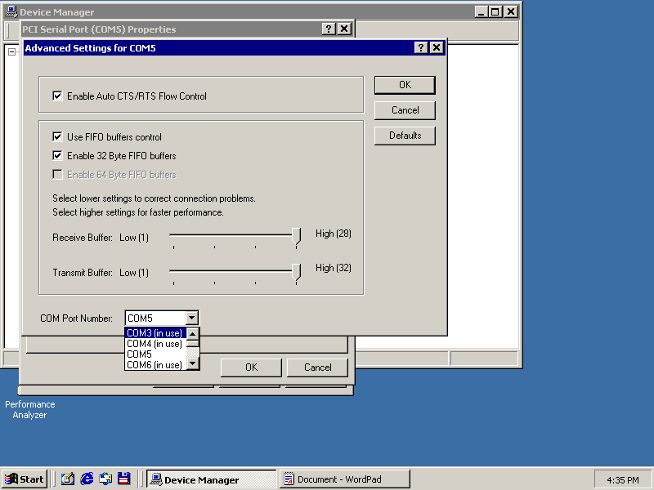
- Delete the hidden and unused COM port from un-installing a device.
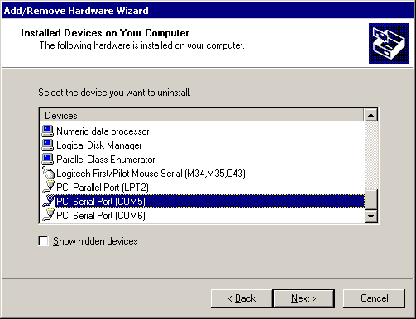
- Click the “Show hidden devices”, You will find all COM ports. Please remove the driver and all COM ports and re-install the driver. You will find the continuous COM port index for the COM ports.
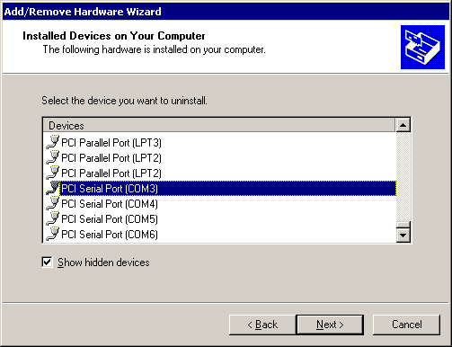

How to Configure COM port
Step 1:
Select the PCI Serial Port you want to configure for example COM3.
Press the right button and select [Properties].
Step 2:
Click the [Port Settings].
Configure the Bits per second, Data bits, Parity, Stop bits and Flow control if you want to change.
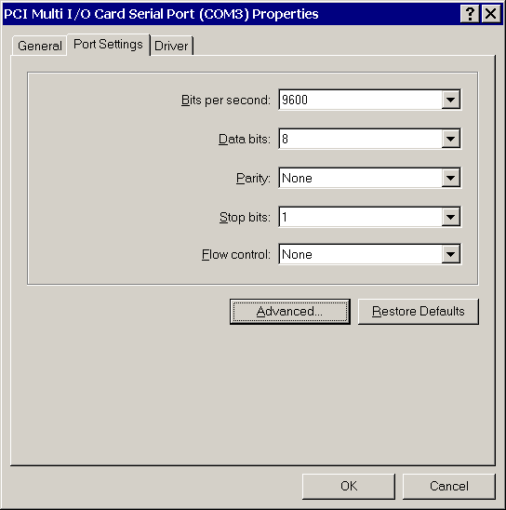

There are three kinds of flow control: Xon/Xoff, Hardware and None. The Xon/Xoff is using software protocol. The Hardware means the flow control is using RTS/CTS, but the RTS/CTS is controlled by software. The None means there is no flow control.

Click the [Advanced] if you want to set more advanced features.

Step 3:
Configure the Enable Auto CTS/RTS Flow Control, 16/32/64 bytes FIFO length, and Receive/Transmit Buffer trigger level if you want to change.

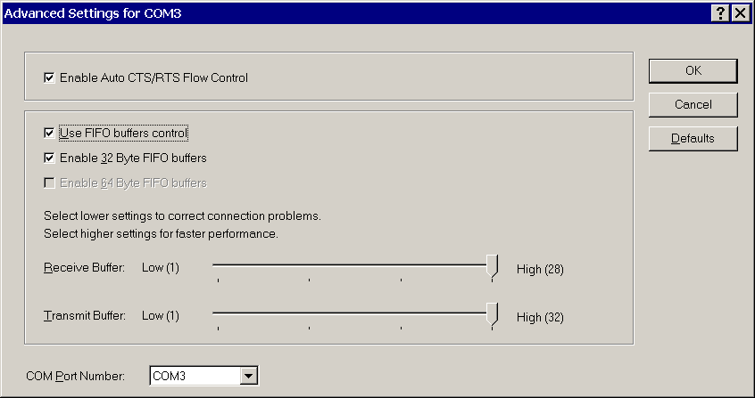

Enable Auto CTS/RTS Flow Control means the CTS/RTS flow control is controlled by hardware automatically. System will be more stable if the function is enabled.

If your card can support 32 bytes FIFO, you can use 16 or 32 bytes FIFO. The default value is Use 16 Byte FIFO buffers. If your card cannot support 32 bytes FIFO, the Enable 32 Byte FIFO buffers will be shadowed.

Set the Receive/Transmit Buffer to higher value will get faster performance because the interrupts will be reduced, but the time for interrupt service routine will become shorter. The receive buffer overflow will be easily happened if the CPU speed is not enough to handle. If the system is not stable, select the lower value to correct problems.

If you want to change the COM port index, please select from “COM Port Number” and choose the new index that is not in use.

