The chart below shows the recent 3 days of Space Weather Events, R-S-G Reports provided by NOAA SWPC services:
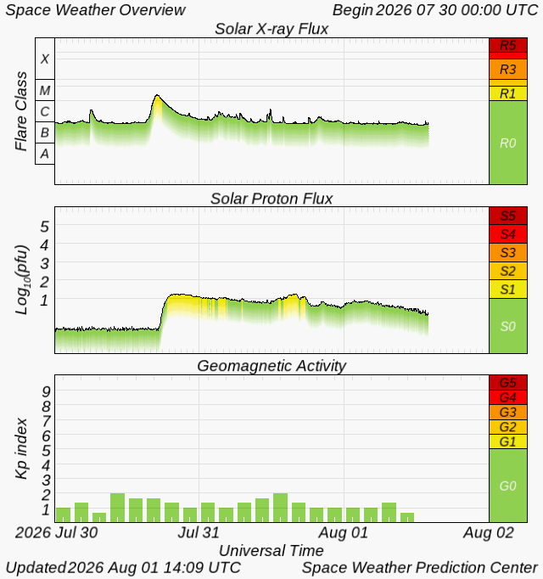
How do each of the above events influence propagation?
Solar activity directly alters the Earth's ionosphere, shifts radio skywave absorption, and changes refraction boundaries, which collectively dictate the Lowest Usable Frequency (LUF) and Maximum Usable Frequency (MUF).
Generally, higher ionization from space weather increases the LUF by causing more signal absorption in the lower ionosphere (D-layer). Conversely, the MUF is driven by the electron density in the upper ionosphere (F-layer); factors that increase F-layer density raise the MUF, while geomagnetic disruptions that deplete it will lower the MUF.

Detailed Influence of Space Weather Events
- Solar X-Ray Flux
- Solar flares emit intense X-rays that ionize the lower ionosphere (D-layer), on the sunlit side of Earth.
- This causes radio blackouts (known as a Shortwave Fadeout), where HF signals are absorbed rather than reflected, leading to sudden loss of communication.
- Impact on LUF: Increases dramatically. Solar X-rays (especially during solar flares) penetrate deeply into the ionosphere, heavily ionizing the D-layer.
This drastically increases ionospheric absorption of High Frequency (HF) radio waves. During extreme X-ray events, the LUF can rise so high that it surpasses the MUF, causing a complete high-frequency radio blackout.
- Impact on MUF: Minimal to slight increase. X-rays mostly affect the lower D and E layers rather than the upper F2 layer which determines the MUF.
A minor, short-term increase in MUF may occur due to temporary density boosts in the E or F1 layers, but it is rarely the dominant effect.
2. Solar Proton Flux
- Energetic solar protons funnel into polar regions, enhancing the D-layer and blocking HF signals at high latitudes. This is especially problematic for transpolar flights and Arctic communications.
- Impact on LUF: Increases severely at high latitudes. Energetic protons guided by the Earth's magnetic field collide with the D-layer specifically in the polar and auroral regions. This creates massive, localized ionization and causes intense radio absorption known as a Polar Cap Absorption (PCA) event. The LUF skyrockets in these regions, cutting off trans-polar radio paths.
- Impact on MUF: Slight decrease or negligible change. Similar to X-rays, protons deposit their energy too low in the atmosphere to significantly aid F-layer refraction. However, the secondary systemic turbulence can slightly degrade the stability of the F-layer, leading to a marginal depression of the MUF over polar routes.

3. Geomagnetic Activity and Storms
- Triggered by coronal mass ejections (CMEs), these storms disturb Earth's magnetic field.
- They can disrupt the ionosphere, causing erratic signal paths, fading, and reduced reliability on HF bands.
- Operators track the K-index and A-index to gauge conditions. Low values mean stable propagation; high values signal trouble.
- Impact on LUF: Increases moderately. Triggered by Coronal Mass Ejections (CMEs) or High-Speed Solar Wind Streams, geomagnetic storms disturb the global ionosphere. Auroral particle precipitation ionizes the D-layer at mid-to-high latitudes, lifting the LUF and increasing background signal noise.
- Impact on MUF: Decreases significantly (Negative Storm Phase). While a brief "positive phase" might initially spike electron densities, prolonged geomagnetic storms cause atmospheric heating and composition changes (increasing the molecular-to-atomic ratio). This rapidly accelerates electron recombination in the F2-layer, depleting the plasma density and causing the MUF to plunge.
Table 1: Summary Comparison
Space Weather  Event | Ionospheric Region Affected | Effect on LUF | Effect on MUF | Primary Geographic Region
X-Ray Flux | D-Region | Increases sharply  (Can cause total HF blackout) | Negligible / Slight increase | Entire sunlit hemisphere
Proton Flux | D- Region | Increases severely  (Polar Cap Absorption) | Negligible / Minor decrease | Polar and high-latitude regions
Geomagnetic Activity | D & F₂  Regions | Increases moderately (Higher noise & absorption) | Decreases significantly  (F₂ plasma depletion) | Global (Most intense at mid-to-high latitudes)

Lower HF bands (80m/40m) are highly vulnerable to solar flare absorption, while upper bands (15m/10m) suffer from F2-layer depletion during geomagnetic storms. Operators utilize high Solar Flux Indices (SFI >150) to predict better propagation and monitor low Kp/Ap indices (<2) for stability, switching to digital modes (FT8), NVIS antennas, or SATCOM to bypass disruptions. For a complete overview, visit Moonraker. [1, 2, 3, 4, 5]

