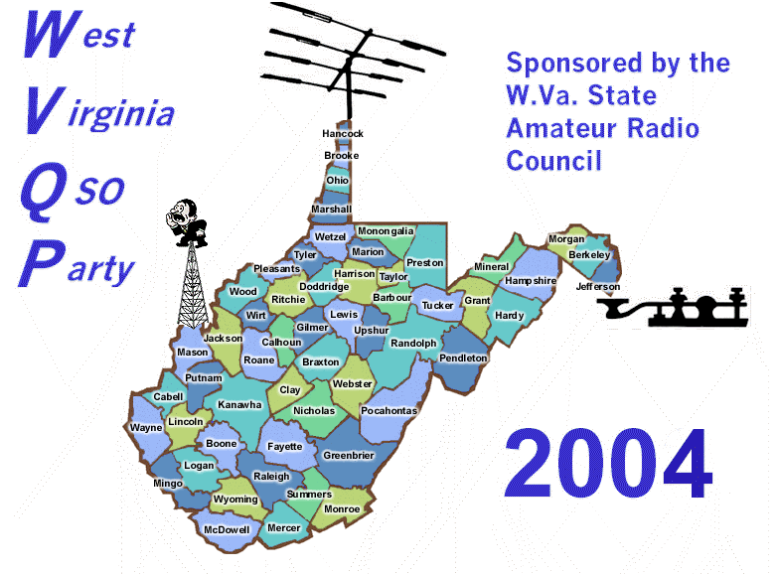

WEST VIRGINIA QSO PARTY
Sponsored by the West Virginia State ARC.
1600z Saturday, June 19, 2004 through 0200z Sunday, June 20, 2004

MAIN CATEGORIES

Single op (Fixed)
No more than one signal on the air, one person operating and logging.

Multi/Multi (Fixed)
Unlimited number of signals and operators

Mobile

MOBILE OPERATIONS
Mobile stations may work and may be worked by other stations upon changing counties. Mobile stations may operate from a county line if the definition* of a county line is met. A station working a station on a county line may receive credit for both counties as multipliers and mobiles may receive bonus points for each county. West Virginia stations on a county line may be claimed as both a QSO and a multiplier from each county. (2 QSO’s and 2 multipliers)
*County line definition: County lines are defined as where two counties meet as long as the line is not “wet”. “Wet” is defined as two counties that are separated by water, i.e., creek, river, lake, etc. You may not operate from a bridge connecting two counties.

Mobiles: Keep separate log for each county.

POWER CATEGORIES
QRP 5 watts or less at all times.
Low Power 100 watts or less
High Power 101 watts and above

MODES

CW, SSB, MIXED

BANDS
80m through 10m, no WARC bands or VHF.
Suggested frequencies, CW 35 kHz up from low end; phone 35 kHz up in the general sub band and Novice portions of 10M.

MULTIPLIERS
West Virginia stations use WV counties, states, Canadian provinces, and DXCC countries.
All others use only WV counties (max 55). Multipliers count one time regardless of band/mode.

POINTS
Contacts with WV mobiles:
CW = 3 points SSB = 2 points
All other contacts
CW = 2 points SSB = 1 point

Work stations once per band and per mode.

EXCHANGE
WV stations send RST and county.
All others send RST and State/Province/or DXCC country.

BONUS
Bonus Points: Work W8WVA once per band per mode and receive 100 points for each contact (to be added to final score).
West Virginia mobiles receive a bonus of 100 points for each West Virginia County activated from which they log 5 valid contacts.

FINAL SCORE
Multiply QSO points by the number of multipliers. Then add the W8WVA and/or mobile bonus points for the final score.

REPORTING
Logs and summary sheet must be e-mailed or postmarked no later than July 19, 2004 to WA8WV @ aol.com or Dave Ellis WA8WV, 610 Hillsdale Drive, Charleston, WV 25302.

Confirmations will be sent to all entrants who send electronic logs.

AWARDS
Plaques to high score in all main categories in state, high score over all in and out of state and high score QRP. Certificates to high score in each category in and out of state, WV county, state, Canadian Province and DXCC country.
Specially designed WV QSO Party T-shirts will be available to all participants who submit entries with at least 25 QSOs. To get your WVQP 2004 commemorative T-shirt, send a check for $10 payable to Dave Ellis, along with your shirt order size M/L/XL/XXL. Please allow 6-8 weeks for delivery.

