WA3GNW HAM RADIO ACTIVITIES
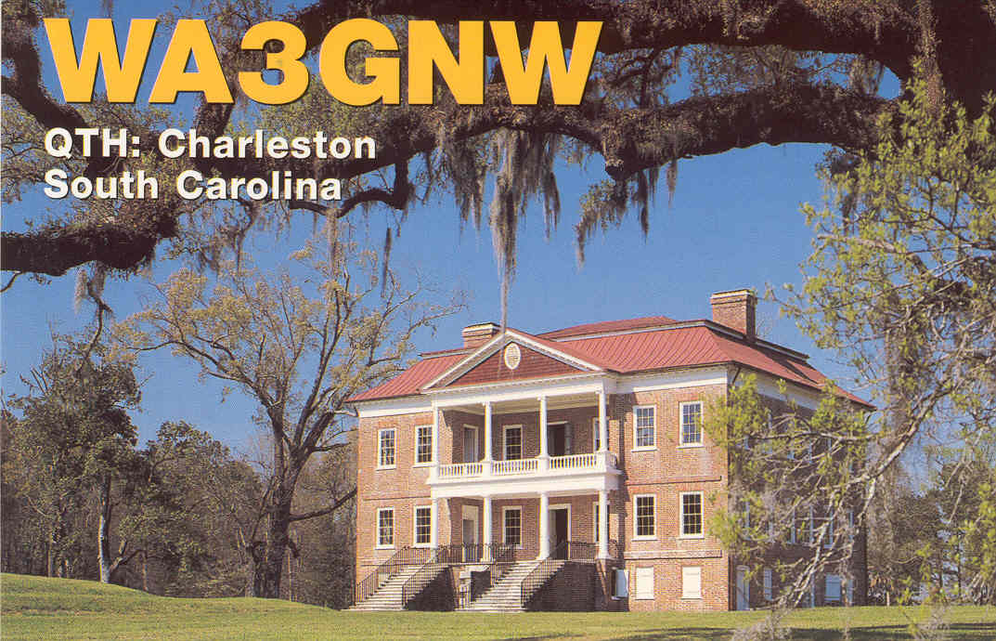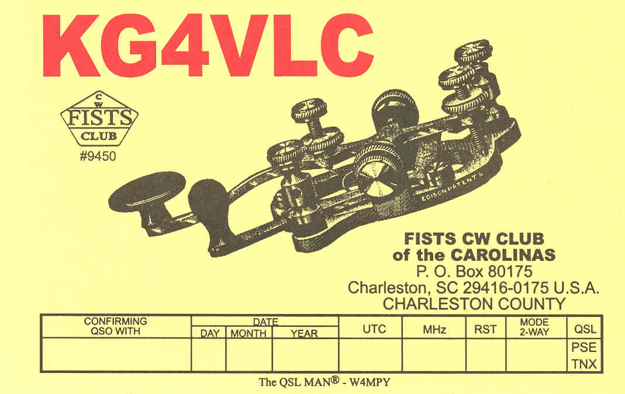

MEMBERSHIP

ARRL: LIFE MEMBER

10-10: LIFE MEMBER, #32118, VP #3239

MARAC

FISTS CW CLUB: #7878, CC #1117 AWARDS

IOTA -400

DX CLUBS WAZ: MIXED, ALL SSB, 15CW

INDEXA: LIFE MEMBER DXCC: 327 CONFIRMED

NCDXF USA-CA ALL COUNTIES #965

CHILTERN DX CLUB 5BWAS

EUDXF WPX AWARD OF EXCELLENCE

