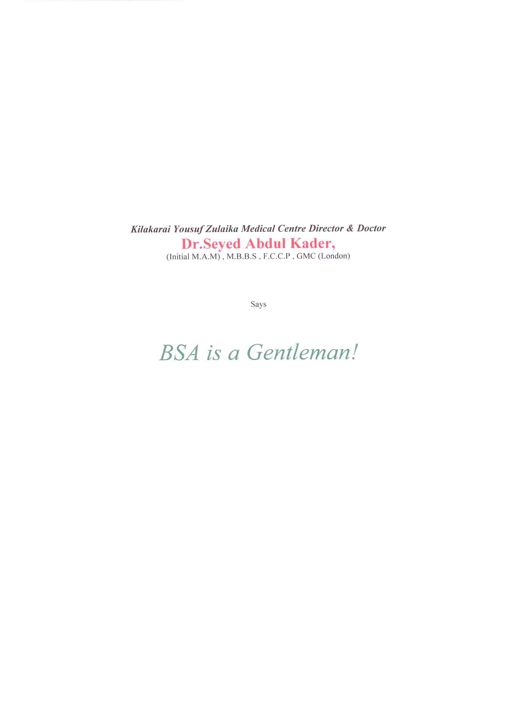

“Humanity must be able to achieve fame; otherwise there is no use of being born”.

These are the words of Thiruvalluvar which, Alhaj B.S.Abdhur Rahman Sahib aptly followed. He was born in a village near the seashore and at a tender age instead of attaining higher education, travelled for across the sea all alone and incessantly toiled very hard, to come up in life. Due to his dedication, he was able to establish many business organizations in many countries throughout the world. Approximately 70,000 people have been benefitted by him. They are employed in his organizations and their families have prospered very well all because of his great sacrifice and generosity. The whole world is awe-struck and the Indians are proud of such a great philanthropist and his humanitarian personality.
I am really delighted to have been granted this golden opportunity, to write a few lines about such a remarkable man, Alhaj B.S.Abdhur Rahman.
He started Yousuf Zulaikha Hospital in his mother’s name (Non-Profitable Organization) with the intention of providing both medical facilities, to the downtrodden and poor people in his native place at a very minimum nominal cost.
In the year 1989, the inaugural ceremony of the hospital was provided by our former President, Thiru R.Venkate Raman. In his speech, after declaring open the hospital, he spoke about Alhaj B.S.Abdhur Rahman mentioning that, he is able to achieve a very high status due to his non-stop efforts, tireless hard work & dedication combined with truthfulness and a desire to perform well.
The words of President appreciating his generosity and dedication to the betterment of weaker sections of society are still ringing in my ears.
Several ministers namely , Thiru Nedunchizhian , Thiru kandasamy and speaker Thiru P.T.R. Palanivel Rajan have visited this hospital on different occasions and all of them spoke very highly of Alhaj B.S.Abdhur Rahman
Once during conversations with VIP’s, including late president Thiru R.Venkatraman, Alhaj B.S.Abdhur Rahman mentioned with nobility that this hospital was started because it is the desire and advice of Dr.Seyed Abdul Kader. This will always be an unforgettable event in my life.
Alhaj B.S.Abdhur Rahman, a great personality with abundant luxurious comforts prefers to lead a very simple life. It would like to cite a few examples:
Once I had accompanied him to the hospital in Dubai for a medical checkup. After a little while his wife Marhuma Thirumathi Muthu Zulaikha and his mother Marhuma Yousuf Zulaikha came there in another car. He chided them for wasting fuel unnecessarily since I was there already to help him. He always insisted on economy.
Another day he decided to have a haircut and could make use of his cars to commute, but he preferred to go by his office tempo-van sitting on an uncomfortable seat next to the driver.
This proves his economical way of leading a very simple life.
His mother Marhuma Yousuf Zulaikha Umma always affectionately used to introduce me to others present with her that “I am her sister’s son”. She and Dr. Suhaibu Alim kakas mother, therefore her own sister, and my mother , Marhuma Kamarunnisa got along very well together like own sisters.
When I was staying in Dubai with Alhaj B.S.Abdhur Rahman, I was able to recognize, understand and appreciate his good virtues and intentions. He has become a living legend and an icon of philanthropy and enlightenment.
His aim was to eradicate poverty completely. A remarkable personality, he has chosen to transform the lives of the people who stand in need of his warmth and reassurance. His good and worthy intention was, to share his hard earned abundant wealth to uplift the poor sections. His determination, dedication large heartedness and his magnanimous generosity has made it possible. He glorifies God by serving humanity.
Result of his Farsightedness:
- To increase Knowledge: He has established many free educational institutions
- For Orphans : He has Provided many children homes and Orphanages
- To Promote Religious values : He has built many Madrassas and Masjids
- To Provide Medical Facilities : He has built and provided free hospitals

His Innovations and performances are outstanding and never ending!

He realized that women should be benefitted with quality education and he established and started many primary schools, High Schools, Colleges for Women, Teachers Training Colleges and Nursing Schools for Women. The innumerable girls who were benefitted in all these institutions by gaining knowledge are now serving in good positions, in various organizations all over India today. Alhaj B.S.Abdhur Rahman Plays a very vital role in removing the unemployment problem all over Tamil Nadu.
In order to facilitate employment for the young men of Tamil Nadu, he created infinite jobs in all his various organizations, in foreign jobs in all his various organizations, in foreign countries and saw to it that the youth, were employed according to their qualifications. He even started an institution offering Jobs and course for uneducated Young men in the field of Building Maintenance (MBM- Modern Building Management) .
“Those who have abundant wealth do not have the attitude of being charitable towards others; those who have this inborn attitude do not have sufficient wealth to do so; Wealth and charitable nature rarely go together.
Alhaj BSA is one of the unique personalities who have proved his uniqueness as mentioned above.
He married Madam Muthu Sulaiha in the year 1954.They lived a life of mutual love for more than 50 years, begetting six children. She always accompanied him in his business tours. She supported him always in everything. Four of his sons along with others were brought up as good administrators.
At a very young age he was one of the first south Indian to go to Belgium to start a new business. He was full of implicit self-confidence, faith and courage. He flourished in his business in Belgium and started newly in many countries like Saudi Arabia, Kuwait, Iran, Iraq, Oman, Qatar etc.
His business flourished everywhere and he earned great profits. Wherever he started business, the Government, Kings, Sheiks and other wealthy people showed great interest to join in his business. Thus, his business everywhere was a joint venture. It shows the amount of confidence they had in Thiru B.S.A. Whichever business, he started, he acted with great involvement with the sole aim of victory and he achieved his goal!
He is his own equal in exhibiting friendship. His friends circle is a very huge one. To cite an example, the ex-Chief Minister of Tamil Nadu, Honorable Thiru. M.G.R used to be a very good friend of Thiru. B.S.Abdhur Rahman and always had high regards for him.
“It is no wonder that two souls of Philanthropists were united in Friendship! “
Thiru.B.S.A. married his relative Dr.Rahmath Nisa , a famous medical specialist. She is his second wife and constantly takes care of his health affairs, thus assisting him to be always healthy, active and enthusiastic in his business affairs.
Ask not what the country did for you; instead think what you have done for your country!”
Thiru B.S.Abdhur Rahman has proved this remarkably well by improving the economy and state of his countrymen.
“A mother is happy when she gives birth to a son. But she will be happier when she hears that he is noble”
These words have been said by Thiruvalluvar. Alhaj B.S.Abdhur Rahman is an example of these words. He has earned a great name for himself and has become an eminent historical achiever, always on the top of the ladder. By Allah’s grace your achievements must always flourish thus vanishing the sorrows of humanity!
“We are proud to exist and live in the period that you are living. We consider this as a boon.”
Your life history ie, your biography should be included in the syllabus enabling youngsters to understand the greatness of hard work, thus inculcating good virtues leading to the prosperity of the nation.
You are a great unique man who has touched the peak of glory. Let your good work prosper. We will have no poverty in our country!

