500 Hz 5 Pole (Elecraft)

The asymmetry in the response suggests that this is a LSB Ladder filter.

Because the delta Group Delay of this filter as measured is considerably less than that of the 400 Hz 8 Pole INRAD filter, the effect of this filter on pulsed signals within its passband should be less than that of the INRAD filter.

The usual cause of a “Kink” in a crystal filter’s response is a mismatched crystal which is not tuned to the correct frequency.

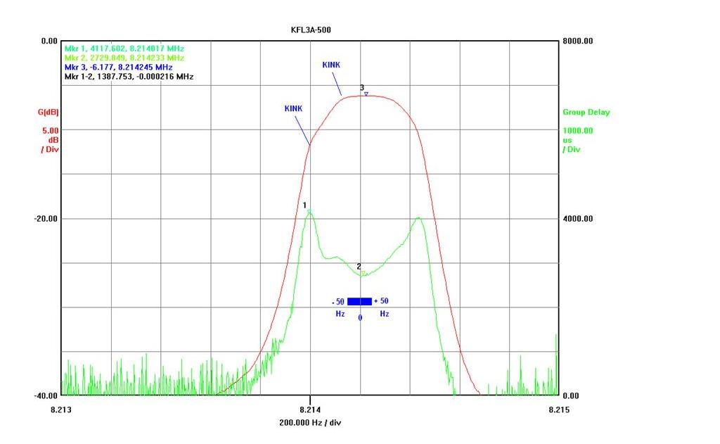

400 Hz 8 Pole (INRAD)

The asymmetry in the response suggests that this is a LSB Ladder filter. This filter appears to have been designed to provide good selectivity at the cost of Group Delay Variations within the passband.

My Impression is that there is something wrong with this particular filter. The large increase in Group Delay seen in the region of the HF skirt is difficult to explain without performing some diagnostic tests within the filter.

The Group Delay Variations inside this filter’s passband are surprisingly large.

If however these test results do illustrate the typical Group Delay Variations of this type of 400 Hz filter, then to determine the effect that this filter has on pulsed signals passing through the filter at various offsets from centre would require a different type of test. Nevertheless I would anticipate that some undesired effect would be found.
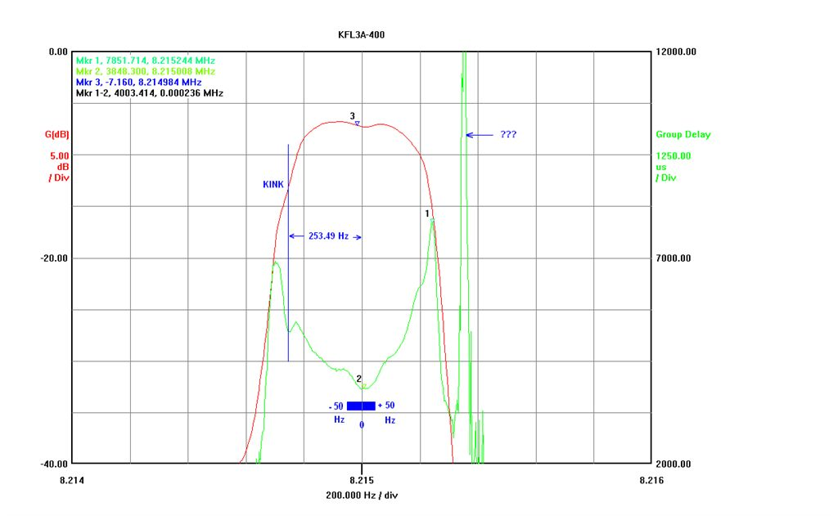

250 Hz 8 Pole (INRAD)

The asymmetry in the response suggests that this is a LSB Ladder filter. This filter appears to have been designed to provide good selectivity at the cost of Group Delay Variations within the passband.

While the Group Delay Variation in the region plus-minus 50 Hz relative to the centre frequency (8.215 MHz) is quite small, it does increase quite rapidly at larger offsets.

It is very possible that either noise or CW signals at the larger offsets could cause this filter to “ring”.

