FT-847 Mods
ALC modification

You know this situation from the VHF Contest for sure - on the opposite hill is the station with commercial equipment and solid state PA. His signal has splatters over whole band and the result is, that our competitors already have within few hours of contest tes QSO more. When we visit that station, the only response to our complaints is uncomprehending look of operator, because he is using "professional equipment" and so all should be perfect.
But, reality is different. Beside many of other problems (look here), like phase noise of oscillators and more - some transceivers has even serious problems with transmitter splatters.
And because FT847 transceiver is quite popular we are pleased to bring you recommendation how to modify ALC circuits for transmitter splatters suppression.
ALC modification is focused on the circuit changes on AF-CNTL board. Original ALC circuit is in the modification changed to peak detector. On the board is removed original C1070 1µF/50V. Into ALC loop is added new tantalum capacitor C1070 as well on value 1µF/35V, which together with Q1023, R1082 and R1086 creates quasipeak detector with regulation time abt. 0,5 msec and deregulation abt. 1sec. This modification is very simple, in the transceiver is not needed any readjustment and all functions (such a SWR protection) stay the same as before. Transceiver modification can be reversed to original status easy.
Modifications schematic drawing:
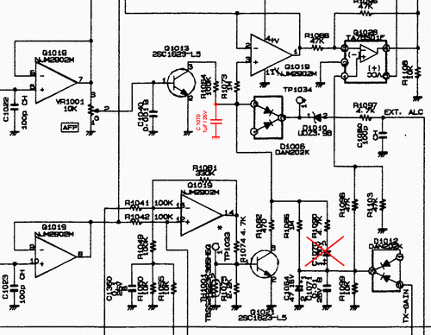
And what is the result? Check audio records (bad quality, but still clear) before and after modification here and here. Both transceivers (transmitter need receiver) were interconnected on test stand to have on receiver signal S9+ 20dB and detuned by 20kHz. In the second audio sample you can recognize, that splatters are gone and only audio cross talk and a bit higher noise due to phase noise of both local oscillators can be observed.

How to do it:
Remove the bottom cover, remove original C1070 and add new tantalum C1070. Solder them carefully by grounded micro soldering iron! Assembly your transceiver again and check all functions. No changes should be observed except suppression of splatters.
Look at original AF CNTL board Detail and modification drawings of original C1070 removal and addition of the new one Look at modified board
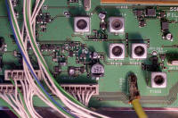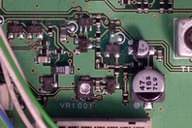
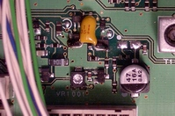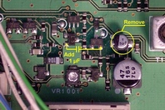

BTW - when you have your FT847 already open - add to frequency synthesis principal crystal oscillator the cap from foam polyurethane (the white "cube" on picture below). It improves frequency stability of transceiver a lot - it is important particularly for EME on WSJT. Recommended!
All the best and perfect contest results on VHF!  73 by OK1VPZ  PS: although ALC circuits of small transceivers FT857 and FT897 is very similar to FT847 ALC, we have tested, that these small rigs have no major splatters problems. It probably has relation with different gain in the transmitter chain and different PAs. But, based on SM5BSZ measurement, FT817 can be vas well as splatters source - if you hav this, you may try to modify ALC as on the schematic drawing. Unfortunately we can not to test it on more numbers of transceivers as we did it with FT847.  PPS: such splatters problem is not related to YAESU transceivers only. For example check ICOM IC275 modification here. | 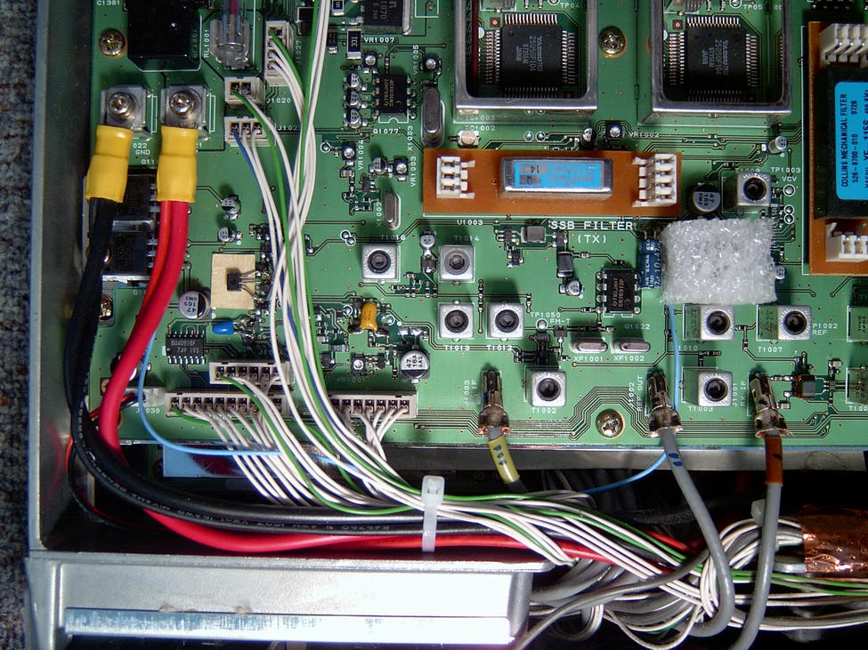  Final view to modified board of FT847 (AF CNTL unit)

General Coverage
Procedure.
- Disconnect all cables and connectors from your radio.
- Remove the carry handle by taking out the two screws at each end of the handle.
- Remove the other two screws on the opposite side of the radio.
- Remove the two screws from the rear of the radio, that hold the top and bottom covers.
- Remove the remaining two screws from the bottom cover near the front panel.
- Now you can remove the bottom cover from the radio.
- Place the radio on a clean surface with the top of the radio facing down.
- Place the front panel towards you.
- Now you should be able to see the Lithium battery to the top left hand side of the PCB.
- Look closely and you will see 6 small surface mount resistors just below the battery and to the left.
- They are labeled on the PCB as 1,2,3,4,5 & 6 (See photo below).
- You need to configure the resistors as in the photo below.
- After re-configuring the resistors double check your work and then replace all covers.
- Finally you need to make a note of any memory channels you have programmed including offsets etc.
- As the CPU needs resetting to acknowledge the new configuration.
- To reset the radio's CPU make sure the radio is OFF, then press and hold the and button's and turn the radio ON.
- Remember all the contents of the memory channels will be reset and lost. Also the Automatic Repeater Shift (ARS) will be lost.
- But all you need to do is, to reprogram the offset from the Menu option No:16 (10mtrs)
Menu No:17 (6mtrs) Menu No:18 (2mtrs) and Menu No:19 (70cms)

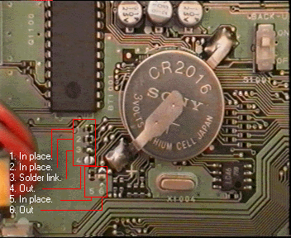

Notes from photo above
- The photo shows the radio AFTER the modifications.
- "In place" means that the resistor must be fitted in this location.
- "Solder link" means that you must solder a bridge across pad No3 if no resistor fitted.
- "Out" means remove any resistor from this location.

The coverage of the radio
after the modification.
Receiver (the same as before the modification)
Band Min RX freq. Max RX freq.
H.F. 100KHz 37MHz
VHF (A) 37MHz 76MHz
VHF (B) 108MHz 174MHz
UHF 410MHz 512MHz
Transmitter
Band Min TX freq. Max TX freq.
H.F. 1.8MHz 37MHz
VHF (A) 37MHz 76MHz
VHF (B) 137MHz 174MHz
UHF 410MHz 470MHz

If you decide to carryout the same modification on your FT847, then you do so at your own risk.
This modification verified to work on the following serial numbers:
8C020XXX 8G051XXX 8G060XXX 8H080XXX 8I100XXX 8J120XXX 8K130XXX 8K150XXX 8K151XXX 8L160XXX
Configuration of Chip Resistors.
As far as I know the information is correct, however proceed at your own risk.

TX Frequency Range |  |  | RX Frequency Range |  |  |  | Jumpers |  |  |  |  |  | Remarks
HF | VHF | UHF | HF | VHF(M) | VHF | UHF | 1 | 2 | 3 | 4 | 5 | 6 | FM CH Step | RPT Shift
1 | 144-146 | 430-450 | 0.1-30 50-54 |  | 144-146 | 430-450 | X |  |  | X | X | X | 5/20kHz | 0.6/5 MHz
1 | 144-148 | 430-450 | 0.1-37 37-76 |  | 108-174 | 420-512 | X |  |  |  | X | X | 5/20kHz | 0.6/5 MHz
2 | 140-154 | 420-450 | 0.1-37 37-76 |  | 108-174 | 420-512 | X |  |  |  |  | X | 5/20kHz | 0.6/5 MHz
3 | 144-146 | 430-440 | 0.1-30 50-54 |  | 144-146 | 430-440 |  | X |  | X | X | X | 12.5/25kHz | 0.6/7.5 MHz
3 | 144-146 | 430-440 | 0.1-37 37-76 |  | 108-174 | 420-512 |  | X |  |  | X | X | 12.5/25kHz | 0.6/7.5 MHz
2 | 140-154 | 420-450 | 0.1-37 37-76 |  | 108-174 | 420-512 |  | X |  |  |  | X | 12.5/25kHz | 0.6/7.5 MHz
4 | 144-146 | 430-440 | 0.1-30 50-54 | 70.00-70.50 | 144-146 | 430-440 | X | X |  | X | X | X | 12.5/25kHz | 0.6/1.6 MHz
4 | 144-146 | 430-440 | 0.1-37 37-76 |  | 108-174 | 420-512 | X | X |  |  | X | X | 12.5/25kHz | 0.6/1.6 MHz
5 | 140-154 | 420-450 | 0.1-37 37-76 |  | 108-174 | 420-512 | X | X |  |  |  | X | 12.5/25kHz | 0.6/1.6 MHz
6 | 144-146 | 432-438 | 0.1-30 50-54 |  | 144-148 | 432-438 |  |  | X | X | X | X | 12.5/25kHz | 0.6/1.6 MHz
6 | 144-146 | 432-438 | 0.1-37 37-76 |  | 108-174 | 420-512 |  |  | X |  | X | X | 12.5/25kHz | 0.6/1.6 MHz
7 | 144-148 | 430-450 | 0.1-30 50-54 |  | 144-148 | 430-450 | X |  | X | X | X | X | 5/25kHz | 0.6/5 MHz
7 | 144-148 | 430-450 | 0.1-37 37-76 |  | 108-174 | 420-512 | X |  | X |  | X | X | 5/25kHz | 0.6/5 MHz
8 | 144-146 | 430-440 | 0.1-30 50-54 |  | 144-146 | 430-440 |  | X | X | X | X | X | 12.5/25kHz | 0.6/1.6 MHz
8 | 144-146 | 430-440 | 0.1-37 37-76 |  | 108-174 | 420-512 |  | X | X |  | X | X | 12.5/25kHz | 0.6/1.6 MHz
2 | 140-154 | 420-450 | 0.1-37 37-76 |  | 108-174 | 420-512 |  | X | X |  |  | X | 12.5/25kHz | 0.6/1.6 MHz

For HF, 6mtrs and 4mtrs range see table below.
 | 160m | 80m | 40m | 30m | 20m | 17m | 15m | 12m | 10m | 6m | 4m
1 | 1.800-2.000 | 3.500-4.000 | 7.000-7.300 | 10.100-10.150 | 14.000-14.350 | 18.068-18.168 | 21.000-21.450 | 24.890-24.990 | 28.000-29.700 | 50.000-54.000
2 | 1.800-2.000 | 3.500-4.000 | 7.000-7.500 | 10.000-10.500 | 14.000-14.500 | 18.000-18.500 | 21.000-21.500 | 24.500-25.000 | 28.000-30.000 | 50.000-54.000
3 | 1.815-1.890 | 3.500-3.800 | 7.000-7.100 | 10.100-10.150 | 14.000-14.350 | 18.068-18.168 | 21.000-21.450 | 24.890-24.990 | 28.000-29.700 | 50.080-50.400
4 | 1.810-2.000 | 3.500-3.800 | 7.000-7.100 | 10.100-10.150 | 14.000-14.350 | 18.068-18.168 | 21.000-21.450 | 24.890-24.990 | 28.000-29.700 | 50.000-52.000 | 70.000-70.500
5 | 1.800-2.000 | 3.500-4.000 | 7.000-7.500 | 10.000-10.500 | 14.000-14.500 | 18.000-18.500 | 21.000-21.500 | 24.500-25.000 | 28.000-30.000 | 50.000-52.000 | 70.000-70.500
6 | 1.820-1.890 | 3.500-3.800 | 7.000-7.100 | 10.100-10.150 | 14.000-14.350 | 18.068-18.168 | 21.000-21.450 | 24.890-24.990 | 28.000-29.700 | 50.000-52.000
7 | 1.800-2.000 | 3.500-4.000 | 7.000-7.500 | 10.000-10.500 | 14.000-14.500 | 18.000-18.500 | 21.000-21.500 | 24.500-25.000 | 28.000-30.000 | 50.000-52.000
8 | 1.810-1.850 | 3.500-3.800 | 7.000-7.100 | 10.100-10.150 | 14.000-14.350 | 18.068-18.168 | 21.000-21.450 | 24.890-24.990 | 28.000-29.700 | 50.200-51.200

Separate receive connectors for 432 and 144MHz
In many instances using a separate receive antenna connection is an advantage, e.g. high power and pre-amp usage, squeezing every last dB of NF out of the system,
or just plain saving on external relays.
I have installed separate SMA antenna receive connectors as described below:
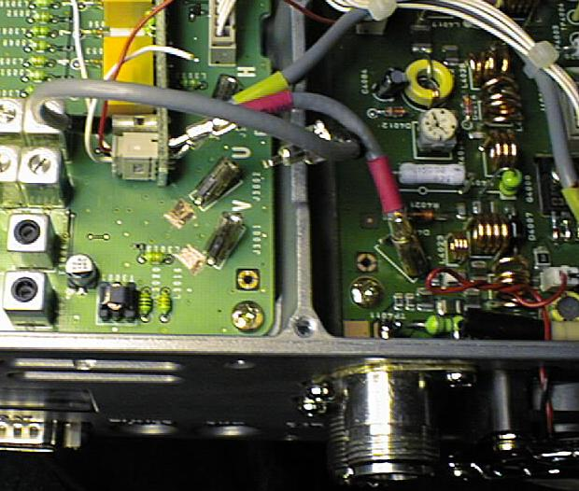
Here you see coaxial connections to the receive circuit (marked V and U), with the cables unplugged, and a small area in front scraped clean for soldering.
Also visible is a slight enlarging of the rear air grille to receive one of the SMA connectors. Note also that the 144 antenna connector has been replaced
with an N-connector - something Yaesu should have done from the factory!

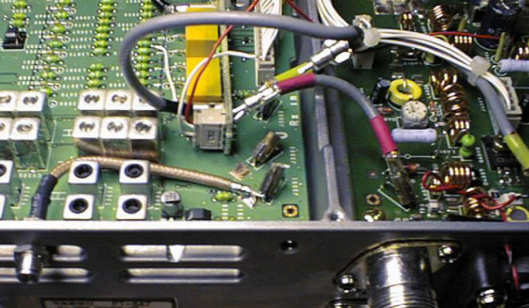
Now the 144 receive connector has been mounted and soldered in place.

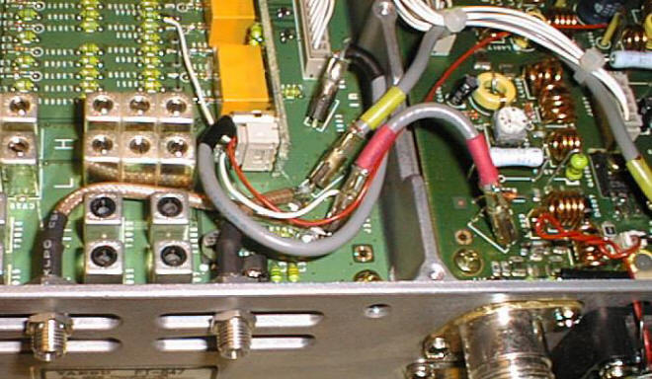
and the 432 as well. The original connection from the Tx/Rx switching circuit has been restored, and everything works as before,
with the exception that you now have the option of using a separate receive connection, with a gain of almost 1dB noise figure!
Finish off by securing the SMA connectors with judicial usage of Lock-Tite or Epoxy.

Other Mods performed on my FT-847:
I have replaced the headphone resistors with 10K ohm to gain equal AF level between the speaker and my head-set.
A 220 ohm/1W resistor has been inserted in the supply to the rear fan to reduce speed and noise. I am looking for a circuit
to control both fans thermostatically! I have now disconnected the rear fan completely, to no ill effect, although I would think
twice if living in a tropical climate - Caveat emptor, let the buyer beware! This is now superseded by my "Temperature
controlled Fan-Speed" mod - see link below!
68K ohm has been inserted before the audio chip to improve the AF level control.
As mentioned above, I have also replaced the PL sockets for 144 and 50MHz with an N-socket.
While replacing a broken On/Off switch (For the third time in 6 years! (Shame on Yaesu)), I created yet another useful
(for me at least) mo: Often, while contesting or DX'ing with headphones on, I have guests in the schack who want to listen in,
instead of fooling around with external splitters etc. I just soldered a 47Ohm resistor over the headphone switch so that instead
of muting the speaker completely, it now just reduces output.
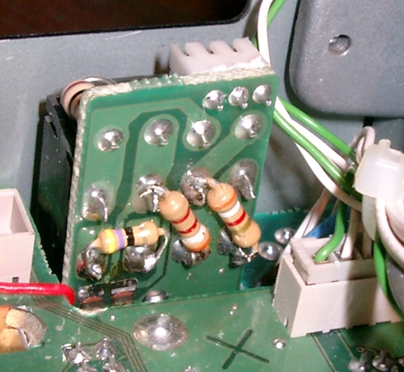

I have recently changed the IF-filters in the radio to the following set-up: SSB-Rx: Inrad #702, 2.1KHz Crystal filter
( http://www.qth.com/inrad/ ); SSB-Tx Collins 2.6KHz Mechanical filter, and CW: Collins 500Hz Mechanical filter.
On SSB Rx the improvement is incredible, the Inrad filter completely changes the radio's QRM-tolerance in a crowded HF
band or during a 2m contest, of cause it cannot do anything about pass band disturbances, but any clean station,
even if only 5-10KHz away, is completely gone from the Rx, which was definitely not the case when
I used the Collins filter in the Rx, and I have some very strong contest stations close by (Like SK7MW, OZ1IEP and others).
This Collins filter is now doing good service in the Tx side, with reception reports indicating much nicer modulation
than with the original Yaesu Ceramic filter.

Just recently I had quite a scare with my FT847: After 7 years of hard use, more than 1000 FSK441 and JTxx QSOs and 8000+ SSB QSOs all on 144MHz, it developed an intermittent Tx problem: No output, but everything else normal (I operate split Tx/Rx as per my homepage). Long hours of fault finding and experimental replacement of components (The PA transistor checked out OK), failed to clear the problem. I then discovered a faint cracking of the surface of D4007, one of the PIN-diodes of the antenna TX/RX change circuit, and a mechanical prod of the diode provoked the fault at will.

This is what I found after pulling the PA PCB:
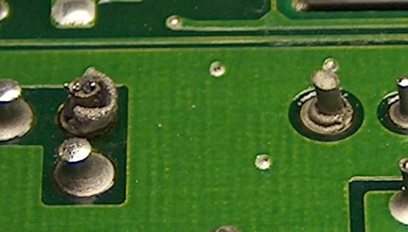
As you can see all the other solderings are OK, while the two leads of D4007 are completely detached. It turned out that the solder layer on the Iron component leads had evaporated completely, defeating all attempts to resolder it. A new diode was soldered in - this time using 5% Silver solder, and all is now well.

For additional mods and tips, please have a look at the FT-847 FAQ, created by W1EMT, Jay - excellent! and, of cause, more of my own mods:
Temperature controlled fan-speed
"Oven" stabilized Reference Frequency Crystal!
AGC-On/Off switch Mod for the FT-847 New

Thermostatic Fan Speed Controller
For several years i have mostly used my Yaesu FT-847 with the annoying rear fan disconnected, but lately I have noticed
that the radio gets quite warm to the touch, and noted some frequency drift when running high-dutycycle modes like WSJT
for extended (hours!) periods of time. I cannot accept the obvious solution - letting the fan run, when not really needed most
of the time! The solution: Thermostatic control.

The solution developed can be applied to any low-voltage DC-driven fan, but here it's been implemented specifically for the FT-847.
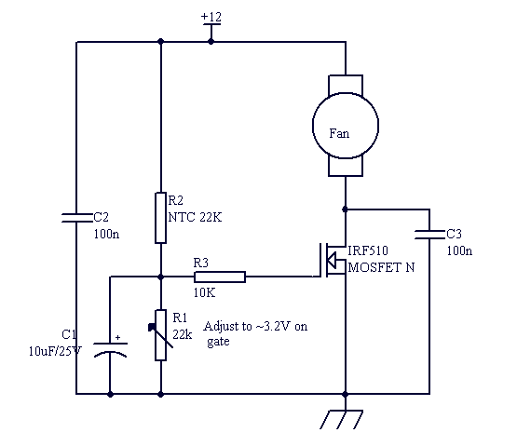
None of the component values are critical, and any N-channel MOSFET with a reasonably low on-resistance can be used. I selected the IRF510 because I had a supply already in my component drawer, and because it's cheap (~ 0.3$)
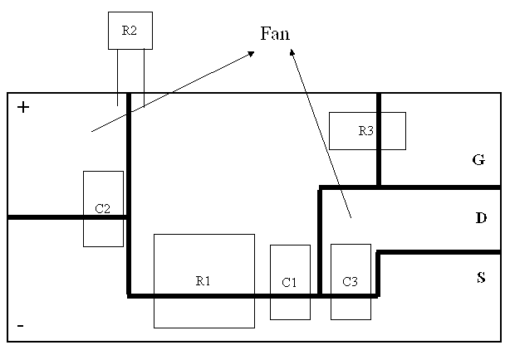
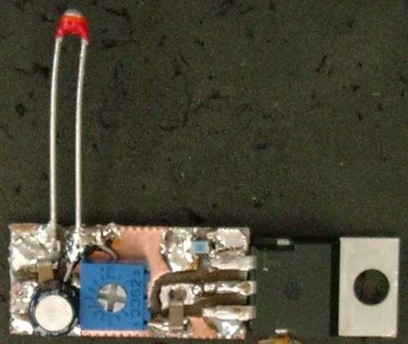
The circuit has been mounted on a hand milled PCB (size 10x20mm). In the picture the NTC resistor has just been soldered on with long leads for testing purposes. Where available SMD components have been used.
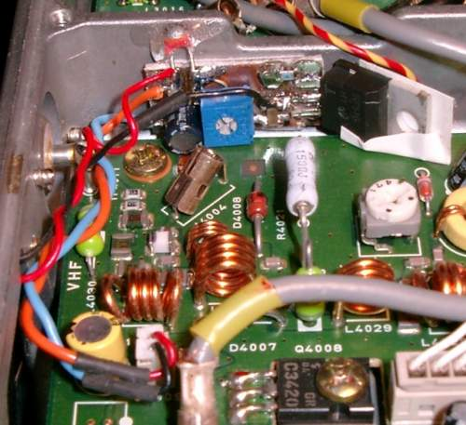
Here the Fan controller has been mounted in the VHF/UHF PA compartment of the FT-847, note that the 144MHz cable to the Rx side has been removed for clarity. The MOSFET has been wrapped with a small piece of electrians tape to make sure that there is no contact between the Drain flange and the PA board. The controller PCB itself has been fastened to the chassis with a small piece of adhesive foam. The lead from the fan to the connector has been cut, the red lead to the fan soldered to the + 12V pad and the black the the Drain pad on the controller. The rest of the leads, leaving the connector has been taken to the + and - 12V pads on the controller using two approx. 5 cm long leads. The NTC resistor has been glued to the chassis for positive thermal contact.
Final adjustment for approx. 3.2V on the Gate finishes the job.
Now a temperature increase of 5-6 degrees centigrade will cause the fan to start, and it'll continue to run at required speed until everything has cooled down sufficiently. Note that the supply voltage for the fan drops about 1.5V when transmitting, causing the fan to increase speed in Rx mode (until subsiding with temperature decrease).

Volume control mod

I often use the FT847 at low volume,squelch open, to be able to pick any propagation opening,and it is impossible to set it it at a comfortable audio level.

The modifications that i have found on this subject searching the net ,(basically inserting a resistor in serie with pin 1 of the AF amplifier),improved it a bit,but not enough.They lowered the main volume,and did really not fix the "jumps" problems.
So , i decided to look at the schematic, and found a very simple solution, that is working really fine.
The volume control is now truly analog,and goes smoothly from 0 to full,almost as loud as before.
In the ´847,the volume control potenciometer is directly connected to the front panel microprocessor,wich aparently makes the A/D convertion.
My idea was to disconect the potenciometer, wire the circuit in full volume position, then use the (now unusued) potenciometer to conventionally control the volume, directly at the input of the AF amplifier.
First, the usual precautions and disclaimer about modifying your radio.don´t forget to disconnect everything, and use antistatic precautions.
Now,remove both covers, and flip down the front panel so you can have access to the back of the volume potenciometer:
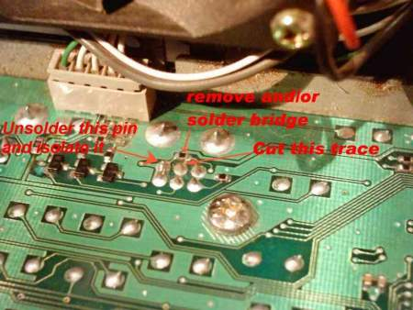
As you can see on the picture, you will have to:
- Remove the solder from the first pin (from right) of the volume control potenciometer.It is the closest to the radio,oposite of yourself (if you are facing the radio, as you surely do :-) )-
- Scrap with a sharp knife (or something else) around the pin to be sure there is no more contact.(It is easy).This pin will be left alone unconnected.
- Bridge the small black resistor.I have removed it and made an (ugly) solder bridge, but you can solder a small wire.It will look better, and can be removed if you decide to.
- Cut the trace between the center pin of the potenciometer and the circuit so it becomes isolated.
The last pin remains to ground.
Here is how it should look:
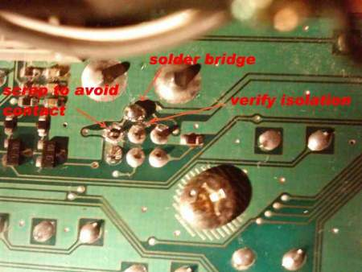
Now all you have to do is to solder a thin wire from the center pin of the potenciometer to the back of your radio, at the input of the AF amplifier IC:
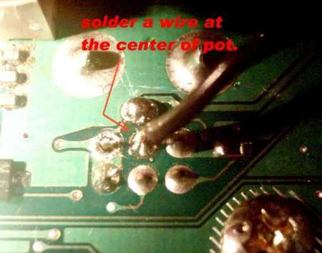
You can close the front panel now,turn over your radio and find the audio amplifier.It is located at the rear right of the 847(when you face the front panel,as always).
The wire can be joined to the other ones and fits nicely.
You have to solder this wire between the SMD capacitor and the resistor that are in serie with the pin 1 of the IC.There is no much room for the iron, but it can be done quite safely.there is nothing to diconnect here.Just solder the wire and enjoy your new radio!
You can connect the power supply now and check if everything is OK.
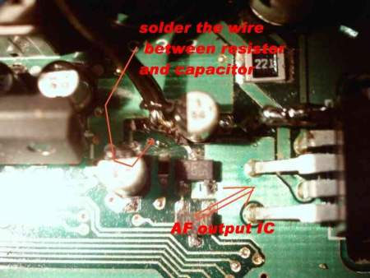
This picture is not too good , but you can´t miss the place once you are looking into the radio.

Fixing the drift

The Yaesu FT-847 is a fantasic rig but it suffers from frequency drift that is especially bad when the radio is operated on UHF SSB mode.

The problem is made worse when the radio is operated outdoors or in a mobile situation.
The culprit is the master timebase crystal X1001 that is located on the bottom circuit board between the plugin crystal filter modules. The fan in the front of the radio blows air that is recirculated in the radio directly onto the crystal. The heating and cooling effect from starting and stopping transmitting makes the frequency shift and rise and falls in ambient temperatures can make it worse..
The best way to stop it is to cut out a small block of styrofoam and push it over the X1001 crystal.

Chattering Relay Fix
Click here to Download or view

Power Switch

Now on to better things-My FT-847 is a very early one SN 8C0200317. I sent it back to the factory for them to upgrade the CPU to work with CT contesting software. They did that free under warranty and any other updates that were pertinent at that time frame. So basically I've been very happy with the unit.
I have installed the TX & RX Collins SSB filters and the CW Narrow Collins. I've also converted the Icom EX-1514 External Vox to compliment the unit. Now to the best !!
I've read about and have always worried about the power switch! Though my power switch has showed no problem as of yet(maybe because of the lack of use) I ran across a idea that I couldn't resist and it has turned out terrific. My power switch now only conducts 30ma of amperage-Interested!!-I was!!!
While at Radio Shack I noticed a small 12VDC relay @ 10 AMPS Contacts that looked small enough to mount behind the front panel!! Still interested? I was!
So for $3.99 I took a chance that my memory was still active. The following photos shows how perfect this relay fits. It's as though it was made in heaven! The wiring is pretty much straight forward so you shouldn't have any problem with it, especially with the photos. Basically, the original green and white wires to the circuit board plug(on the front panel) were cut and re-routed to the relay switched contacts. Then I tapped 12VDC at the rear power connector BEFORE the relay switched + 12vdc(activated by the front panel power switch) and spliced that to one the front panel plug leads that was cut(Orange wire).Then the other lead of this front panel plug was connected to one of the NEW relays coil contacts(Red wire/White tracer).The other lead to the NEW relay's coil was connected to ground(Black wire). As shown in the photos, the relay was mounted with double sided tape next to to cooling(unbelievable perfect fit!) fan and high enough to clear the phone plug circuit board when the front panel is tilted back into place. Now the power switch only conducts the voltage and current to activated the NEW relays coil! Oh, life is GOOD!
Use this information any way you please so other users can quit dreading the Power Switch gremlin from visiting their shack's.
Cheers and Beers-
The Radio Shack Number for the relay is RS-275-0248A
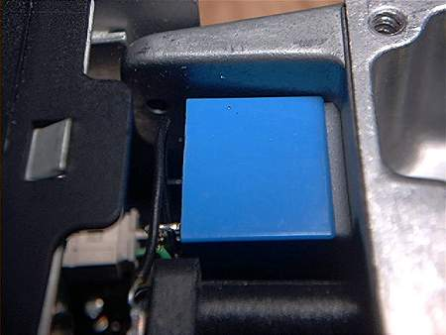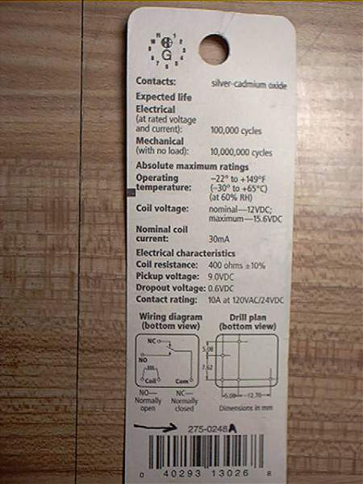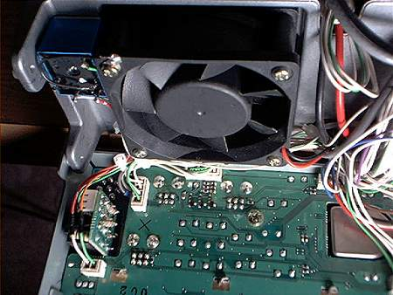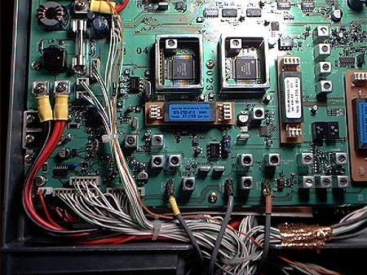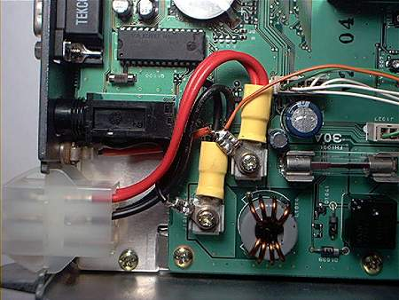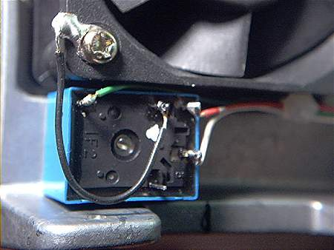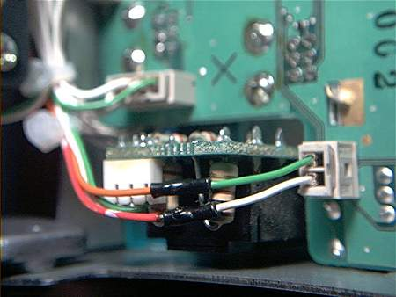

Simple Roger beep

Simple Roger beep circuit designed for FT 847 (installed into microphone)
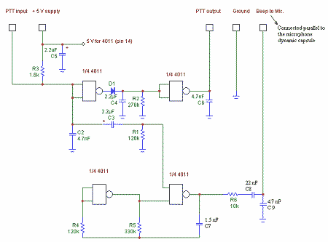

Easier audio level fix

Installed 33 ohm 4 watt resistor in series with the external speaker. It was the first one that found in my junk box.
I am now pleased with the volume control of the FT-847.
You can also do the same for the internal speaker.
Any value 22-47 ohm will do - and it does not have to be 4W, 1W resistors are ok too.

Throttling Back Audio Output Level, Rev. 1

Although Yaesu did a fantastic job of gain distribution in the FT-847 receiver, they bombed when it came to the last stage, the audio output. Even at lower settings of the AF Gain, the resultant audio is room filling and control is very critical. The TDA2003H audio amplifier integrated circuit (IC) is not being over-driven, it is just getting too much audio signal from the previous stage at the lowest input level. Operational and distortion improvements can be gotten with this modification. Read the entire procedure before starting the actual modification. Later model FT-847s may not have these audio problems. Also remember that if your rig is under warranty, and you modify it, the warranty is void.
Take off the FT-847 covers and turn the rig over on its top, exposing the bottom. Near the rear of the rig, on the opposite side from the input power connector, locate audio amplifier IC Q1086; it has five (5) pins and is close to the purple 470 F audio output capacitor, C1242. The input to the audio amplifier is on Pin 1, the pin with the long leg at the end nearest the rear of the rig. There is a small 1 F audio input capacitor, C1225, close to the pin. The modification consists of opening input Pin 1 of the IC and inserting a 47 Kê resistor in the opened input lead. The easiest way is to snip (cut) the middle of the IC pin, separate it, and add the resistor in series with the input lead.
To insert the series resistor:
- Cut input Pin 1 of audio IC Q1086, observing ESD precautions.
- Separate the two halves of the cut lead.
- Prepare the 1/4 W, 47 Kê resistor with just enough lead length to contact the separated IC input lead.
- Tin the resistor leads and the IC leg contact points.
- Tac solder the resistor to the separated leg of the IC.
The 47 Kê resistor gives just enough level reduction, allowing setting of the AF Gain control at 10 or 11 o'clock instead of 8 or 9 o'clock, the initial lowest level settings of the control . There is still enough audio to "blast out" the internal or external speaker.
With this modification, the audio seems even smoother and cleaner, and the problem of erratic audio for the first quarter turn of the AF Gain control, as reported in older units, is also gone. With the above mod and the replacement of the original ceramic SSB IF filter with International Radio #702 SSB crystal filter, for better receiver selectivity, there is a feeling of having acquired a new receiver.

Sensitivity settings

To change the sensitivity setting on the FT847 power off.
On the MH-31 mic. press & hold the DWN FST UP buttons & power on. This will give access to a menu to change the settings for each individual band & mode, but the operation has to be gone through for each band.
Make a note of settings before changing, otherwise you will have to resort to the restore factory settings Menu to return towhee you started.

External RX Input Modification

(C) DL4MEA 09/1998
D: Beim Einsatz des FT847 mit einem externen Vorverstärker und Endstufen ist es zum Schutz des Vorverstärkers empfehlenswert, eine doppelte Kabelfuhrung aufzubauen. Damit wird in der gesamten Anlage nur ein einziges Koaxrelais benötigt, und der Vorverstärker ist definitiv vor Sende-HF geschutzt.
Die hier vorgestellte Modifikation erlaubt es jederzeit den FT847 wieder im Normalbetrieb einzusetzen.

E: If the FT847 is used together with an external mast-mounted preamp, it is suggested to run two coax cables from the mast to the shack. Not only that you save costs for a several coax relays, but also you protect the preamp from any TX power.
The solution described here allows anytime to use the FT847 in the normal way.

(you may klick on the pictures to get them in the full scanned size)
FT847 RX signal flow before and after the modification:
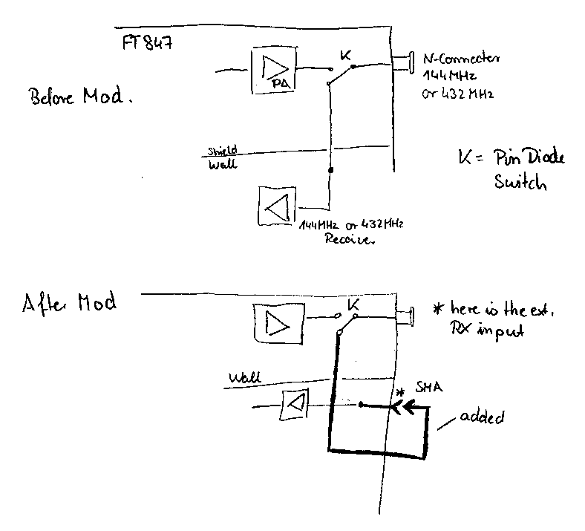
FT847 rear view after modification:
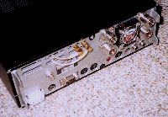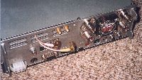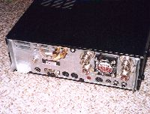
FT847 inside view of the modification:
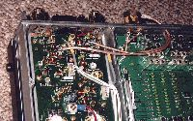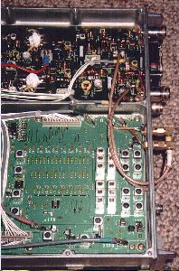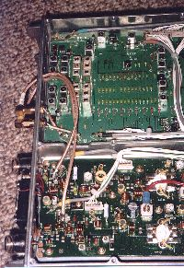
Details scanned with higher resolution:
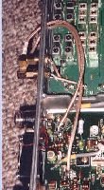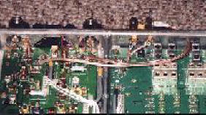

SSTV interface width PTT keying

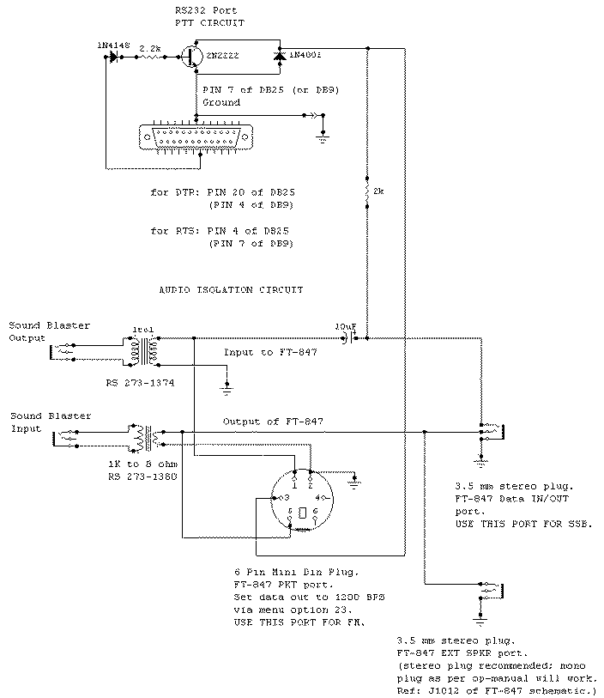
Note. Due to the low voltage output levels of the PKT and Data IN/OUT ports, it is recommended to use the EXT SPKR port as output to the sound blaster. This will ensure proper SSTV signal triggering and synchronization.

How to modify FT-847 with full TX-RANGE on HF

It's correct: to close the jumpers 1,2,3 and opening the others ?
The second method sayed:
- pad 1 is already shorted with a chip resistor - NEGATIV ON MY TRX !
- short pad 2 and 3 with solder ... check pad 6 and if it has a chip resistor remove it ...
Here are my factory-settings in FT-847:
pad 1 = open
pad 2 = shorted with a chip resistor
pad 3 = open
pad 4 = open
pad 5 = shorted with a chip resistor
pad 6 = i'm not shure if open or closed, only a big solder-point
I'll send also a foto of my factory-jumper-settings
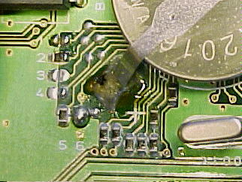
I'm happy about any detailed information !

Antenna tuner mod, for wider range

The fix is on in one of the menus in the Yaesu 847. After this mod the 847 will tune up to a 7:1 instead of 3:1
The first thing you need to do is get into the service menu. You do this by holding down the three buttons on the mic and turning on the radio.
The first menu will be Fm-51 do not change that one. Rotate the sub-tune knob until you see the menu that says SWR 3.0 to the left this you will see two small numbers or numbers letter combination. Rotate the MEM/VFO CH knob until you see 9A then push the menu button and you are done.

Enter the Alignment Menu
This radio has an Alignment Menu in addition to a User Menu. To enter this Alignment Menu, you turn off the transceiver, press the UP, DWN, and FAST keys on the microphone together, while turning the transceiver on again.
In the alignment procedure, each alignment parameter is selected by rotating the SUB-TUNE dial. The alignment is performed by pressing the MCK/W key while injecting a signal of the required frequency and level. Pressing the MENU key after a setting is made stores the entry. To exit the alignment routine, press POWER.
This radio seems to be very high tech in all. I have not entered the Alignment Menu, and do not suggest that anyone do so, without the proper test gear and electronic knowledge.
TX coverage continues on 137MHz to 174MHz and 410MHz to 470MHz
One problem that happens after the mod is the AUTOMATIC REPEATER MODE no longer functions but repeater shift still works.
What really appears to happen is the Auto repeater mode gets set to USA spec.
To recap then here is the pad info
Pad 1 is short
Pad 2 is short
Pad 3 is short
Pad 4 is open
Pad 5 is short
Pad 6 is open
I Hope this helps, Remember that transmitting out of band and on a frequency you are not licensed for is an offence!
One other annoying problem is the fan that is running continuously, This can be changed by connecting the fan to the PA fan, which, under rx mode has the fan running at a much slower and quieter speed, but at tx the fan runs as normal.
So you are not actually stopping the rx fan, just slowing it down, which basically lowers the air flow, but still circulates the air during rx.

ATTENTION
The KB2LJJ takes no responsibility for any damage during the modification or for any wrong information made on this modification.

