4el 3mtr 50Mhz Quad

DETAILS
Created: 21 February 2009

G0KSC SC0604Q 4el 50Mhz OWA Quad Antenna with a 2.998 Metre Length Boom
Some have said there are no benefits to be seen from Quads over Yagi's with more than 3 elements. This model is set to prove this statement wrong. Over 10.4dBi has been achieved with respectable front to back ratio on a boom length of less than Three metres in length. This is around one metre less than would be required to see similar gain from a Yagi. In addition, I have been able to model the antenna without the narrow bandwidth characteristics normally associated with an antenna of this kind.
If Quads are your type of antenna, this one maybe for you.
As with all my antennas, this is a non-critical design and therefore, any small errors in you calculations when building the antenna WILL NOT have a great impact on the antennas final performance.
Dimensions in Metres
Element spacing:
- Ref = 0
- Driven = .942
- D1 = 1.668
- D2 = 2.998
Elements lengths - full quad length:
- Ref = 6.344
- Driven = 6.144
- D1 = 6.032
- D2 = 5.936
Performance figures @ 50.250Mhz:
- Froward Gain: 10.44dBi free space
- Front to Back: 20.09dB
- Radiation angle at 10 Metres above ground: 10 degrees

Element diameter:
This antenna has been models with 12# copper wire. You will need to mail me if you wish to use a different gauge as the model will change. Isolated spacers will be needed. fiberglass would be a good option.
NOTE:
Build orientation is as per the layout image below with the feed point on the bottom section of the quad indicated by a red circle.
Feeding the Antenna
Whilst OWA is not normally a term used in quad antennas, I felt it appropriate due to the low SWR and wide bandwidth of this antenna. Like all of my antennas, this has a 50Ohm impedance so can be fed directly with 50Ohm coax, no matching is required. However, a balun or RF chokes should be used in the coax as close to the feedpoint as possible.

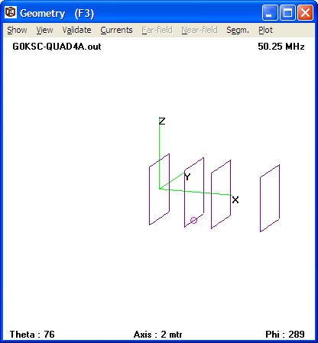
Orientation of the G0KSC OWA Quad

