A copy of the April, 1938, issue of:
‘The Amplifier’’

About the Amplifier
by James S. Farrior (Radio Amateur W4FOK since 1938)

In February, 1938, I was selected to be the Chief Net Control Operator at WUGA, the Net Control Radio Telegraph Station for District H, Civilian Conservation Corps, Ft. Benning, Georgia. Although I was probably the youngest operator in the Net, I had been chosen after winning a competition in typing, sending and receiving Morse Code, operating procedures, and radio theory. The CCC radio network traffic handling procedures and operator requirements were identical to those used in the U.S. Army Signal Corps. Around a dozen candidate operators were called to Ft. Benning from their camps and the tests were administered by Capt. Dexter W. Phillips, the District Signal Officer, and his assistant Ensign Dausman. We had not been told why we were being called to Headquarters
I don’t remember how frequently the “The Amplifier” was issued. Among other things, Capt. Phillips used “The Amplifier” as a means to inform the Net personnel with respect to his rules, his expectations, and his plans for net expansion. He also provided information and guidance with respect to how the operators could increase their technical and operating efficiency. He also made it very clear that those operators who did not meet his expectations would be replaced by more promising men who were at that time completing their training at the District Radio School at WUGA. The men had already had some experience doing hard labor at such tasks as digging ditches, planting trees, and building paths and roads, so their motivation to maintain and improve their performance was very strong.
Some of the camps in the District had not yet been equipped with a radio station, and the objective was to have a radio telegraph station at each camp as soon as possible. Before a camp station could be added to the Net, a trained operator and the necessary equipment were required. When the desired Harvey 50T transmitter and the RME-3 receiver were not available, surplus army equipment was used. Capt. Phillips mentions me by name at the end of the first paragraph of page 3 of this issue of “The Amplifier”.
The time that an enrollee could stay in the C.C.C. was limited by law to two years. Any man had usually been in the C.C.C. for at least several months before he was nominated to attend the Radio School. By the time he had received his training and was serving as an operator at a camp station, he typically had not much longer than a year left to serve. This was during the “Great Depression”, and Capt. Phillips strongly believed that anyone who had made the most of their C.C.C. Radio Operator training and experience would have little difficulty in obtaining a good job after their discharge. Capt. Phillips comments about that in this issue of “The Amplifier”. “The Amplifier” also contains a section for comments by the Net personnel. My input appears on page 10. I used the sine “SF” because another operator was already using “JF” when I came out of the code school at Ft. Barrancas, Fla.
I can testify that my C.C.C. experiences certainly gave me a jump start in my career as it made it possible for me to obtain a good position as a Civil Service Radio Telegraph Operator at WVR, the Army’s 4th Corps Area Net Control Station at Ft. McPherson, Atlanta, Ga. Somewhat similar things happened for those operators with whom I kept in touch for a number of years.
Until recently, when I wrote my C.C.C. book, I had not seen a copy of “The Amplifier” since 1938. I could hardly believe it when Donald LeFevre, Radio Amateur KD5RCG , told me that he had found the April issue of “The Amplifier” on a Swedish Website and I was able to download it. It had been sent to Sweden after WW-II along with a surplus Harvey 80-T supplied by a surplus dealer in Philadelphia. Obviously, that Harvey 80T was from a District H C.C.C. Radio Net station. Very little information has been found about the C.C.C. radio network. It is amazing that about the only significant find was on a Swedish Internet Page, and that it was from the WUGA Radio Net at a time when I was Chief Operator.
The address of the Swedish download site is: http://www.swedeart.com/harvey/html/the_amplifier.html

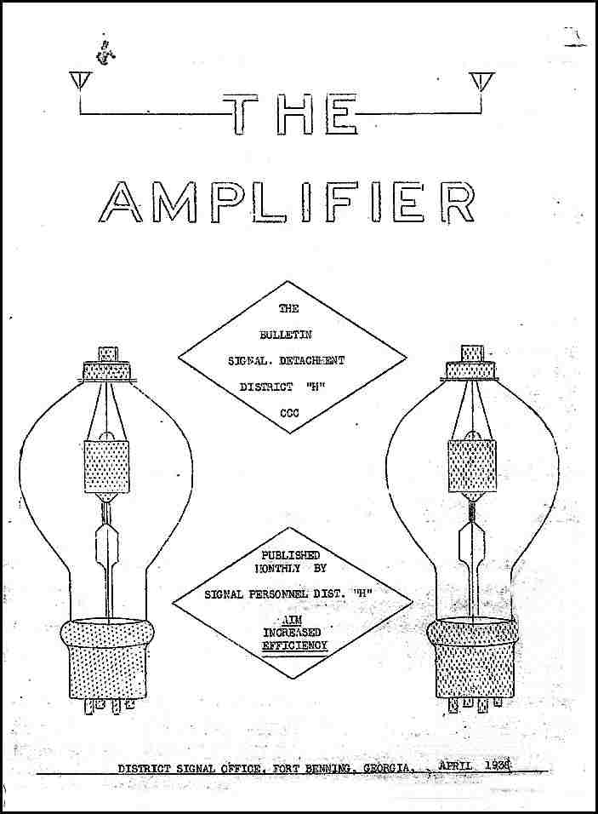

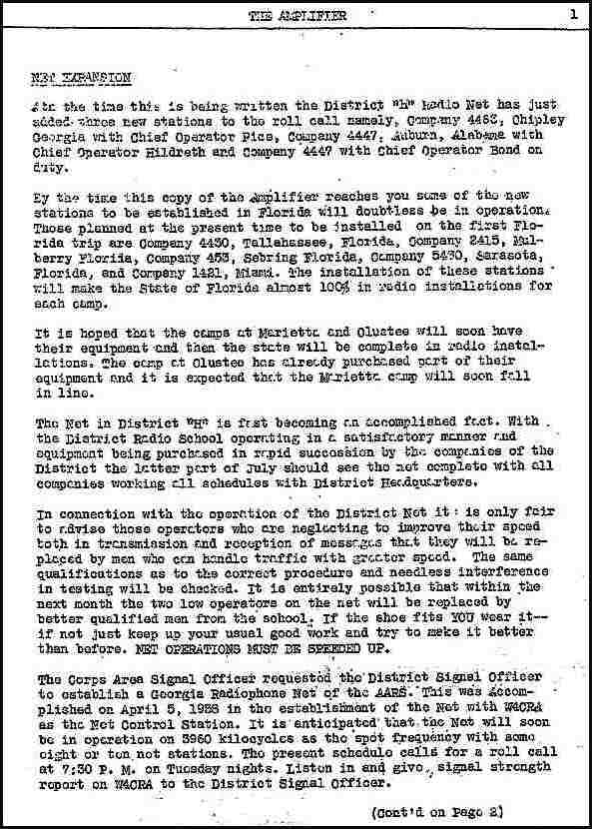
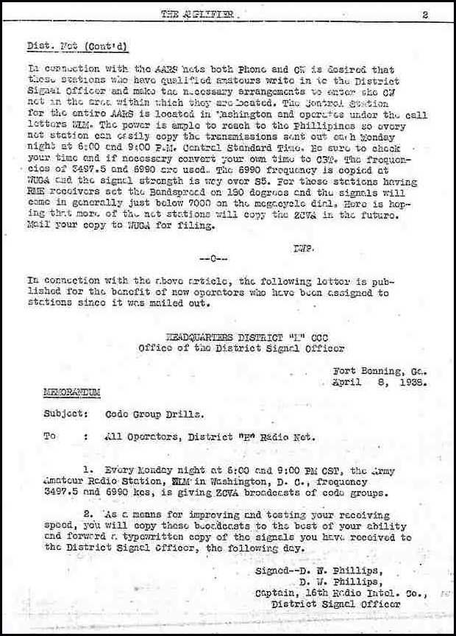
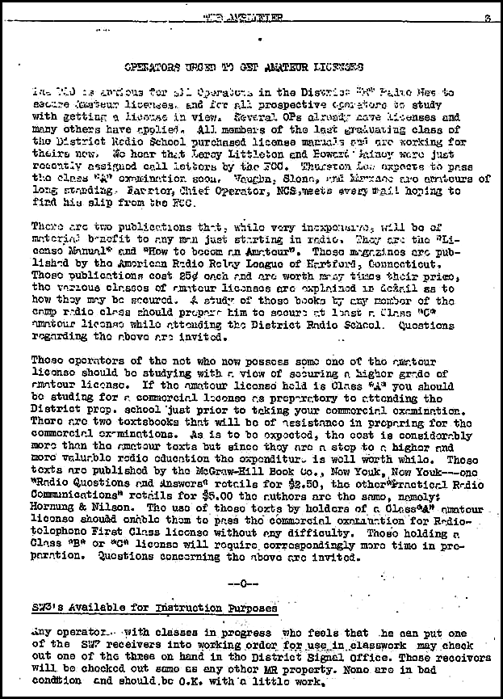
My name appears at the end of the first paragraph of this page. Jim Farrior, W4FOK (since 1938)
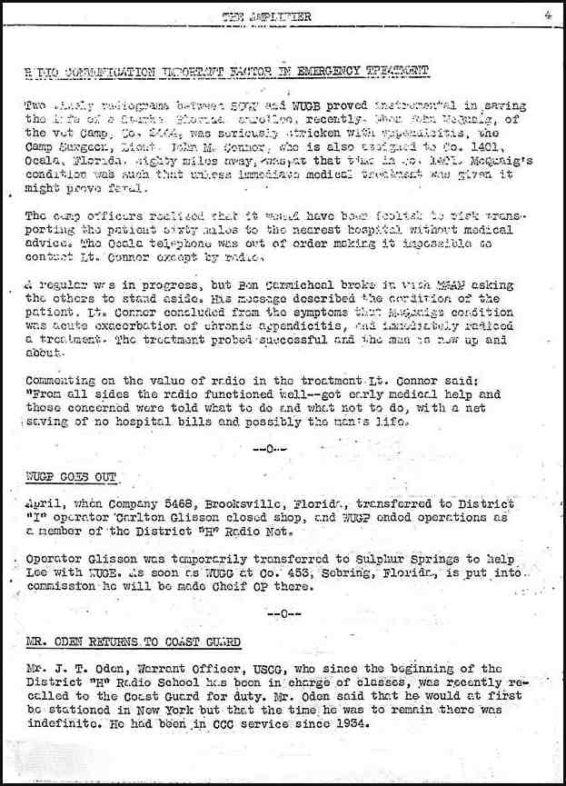
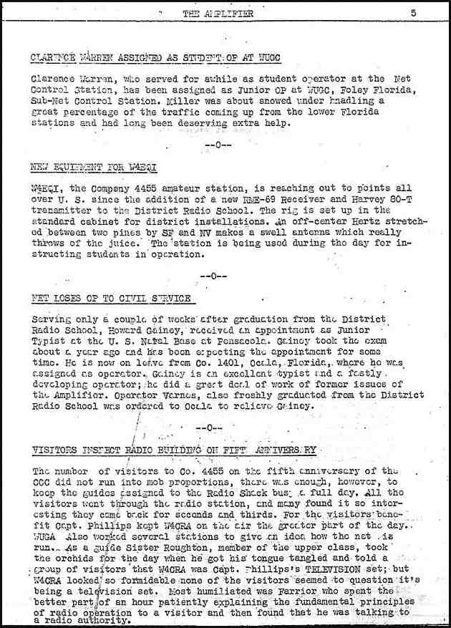

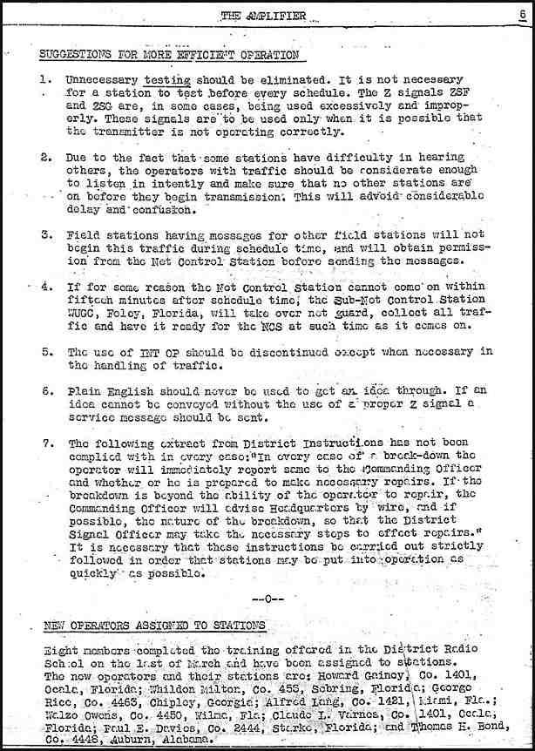

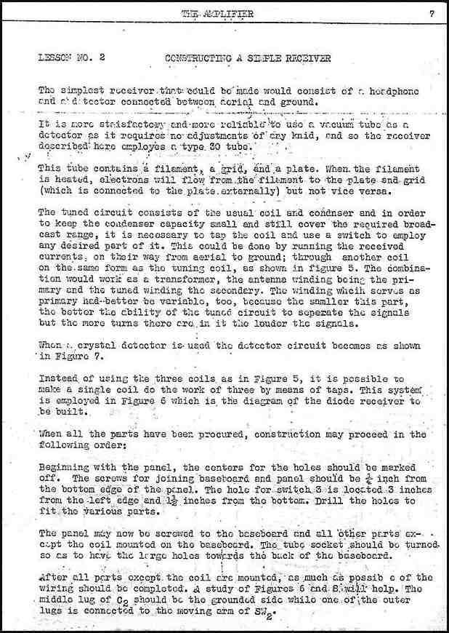

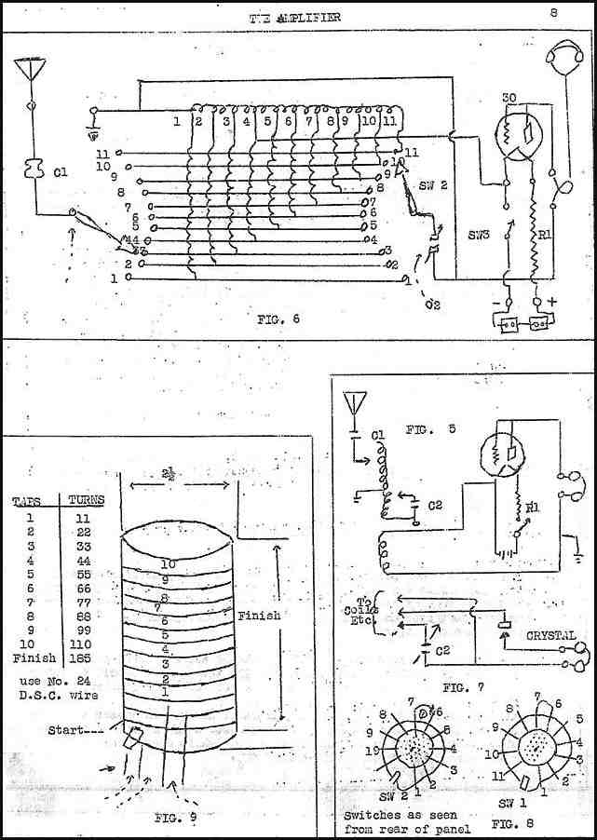

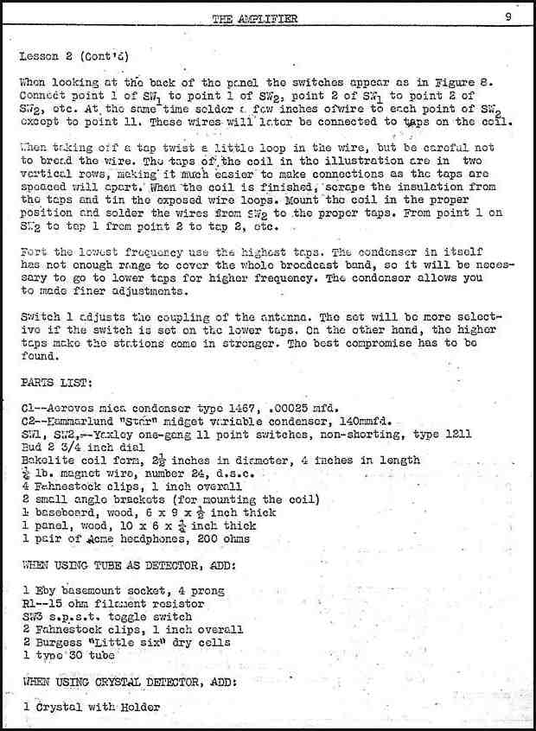

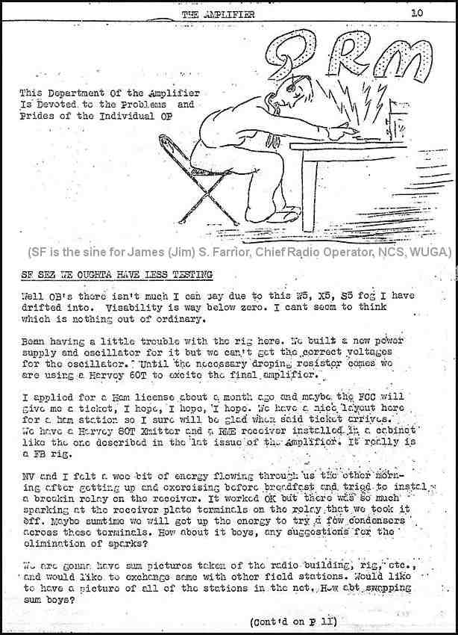

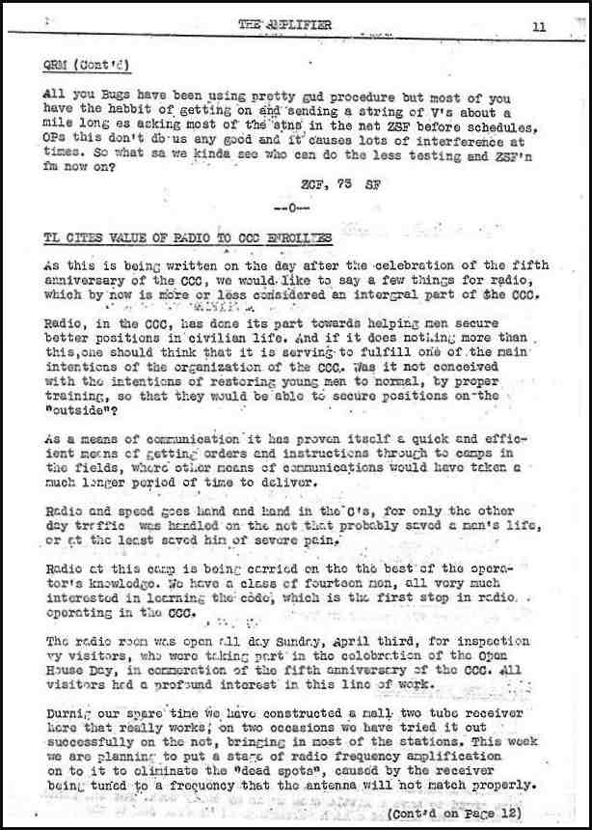

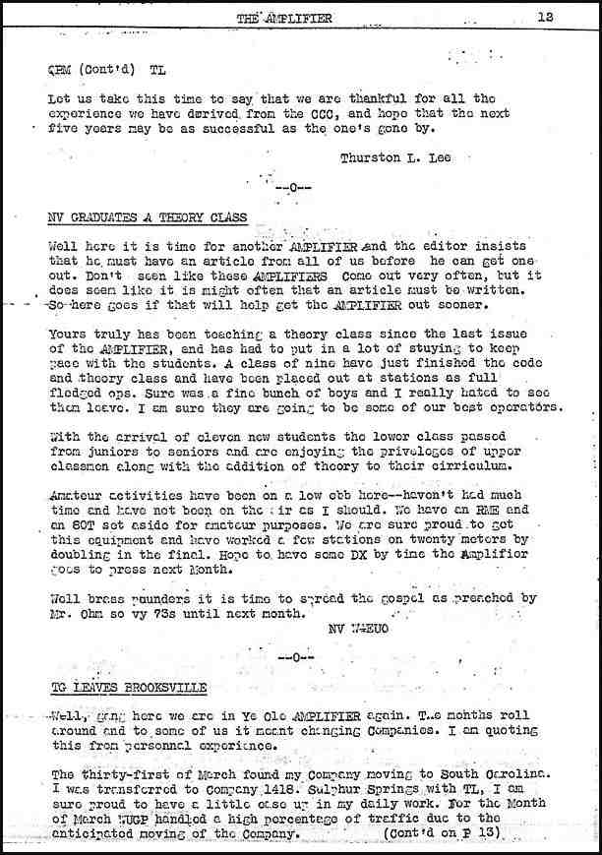
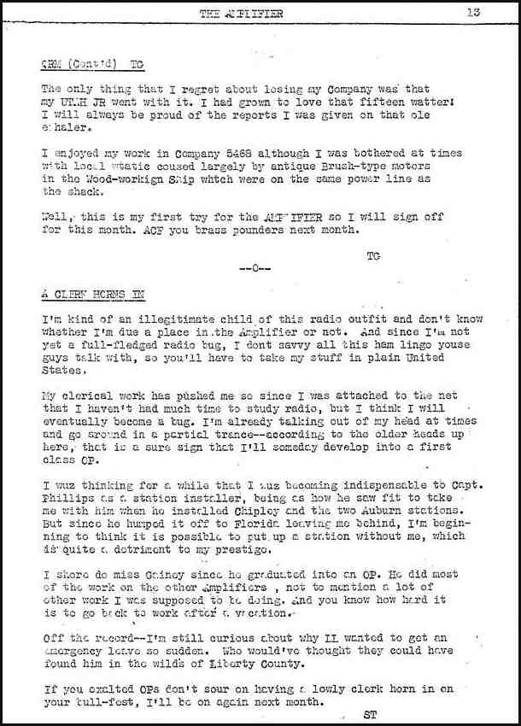
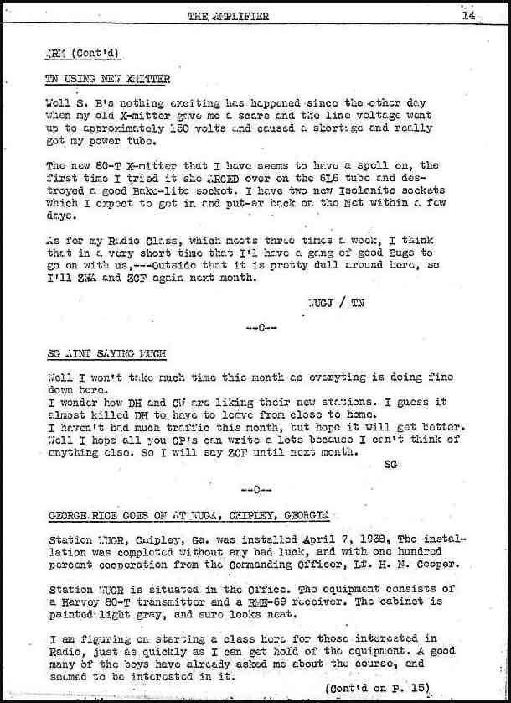

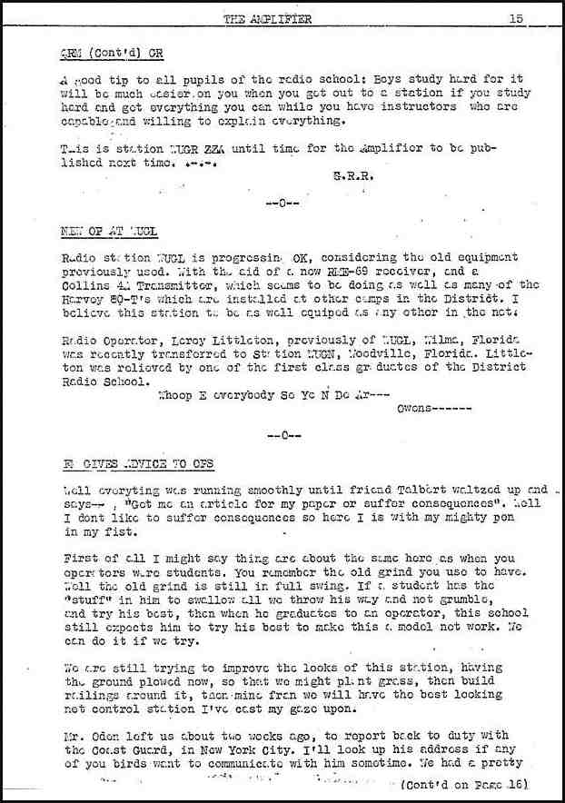

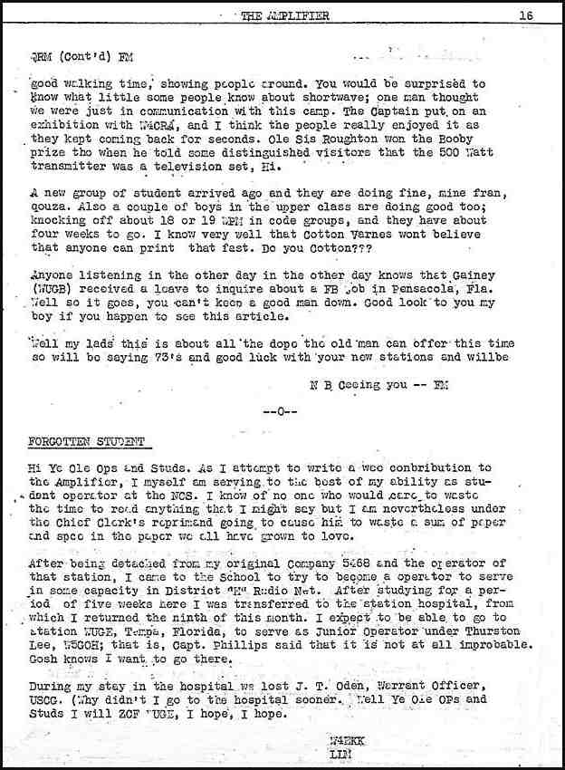

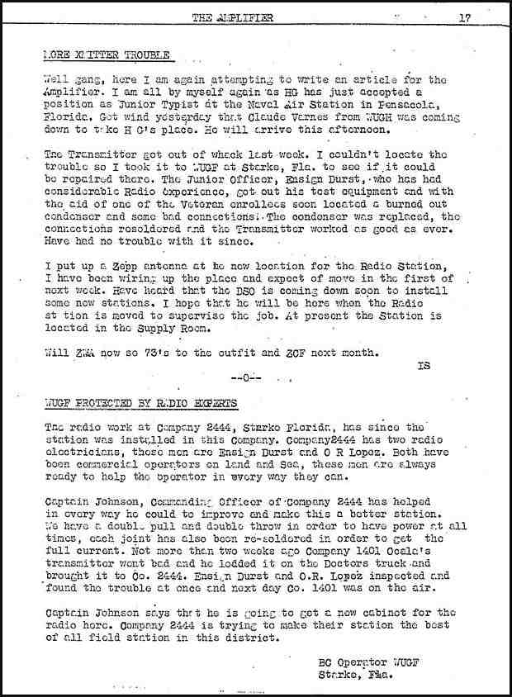
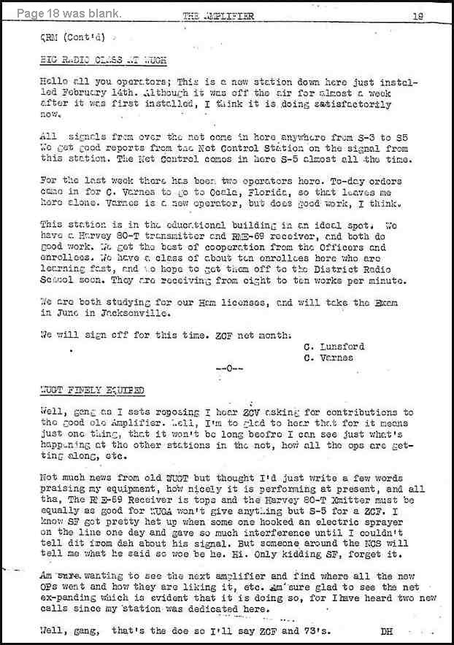
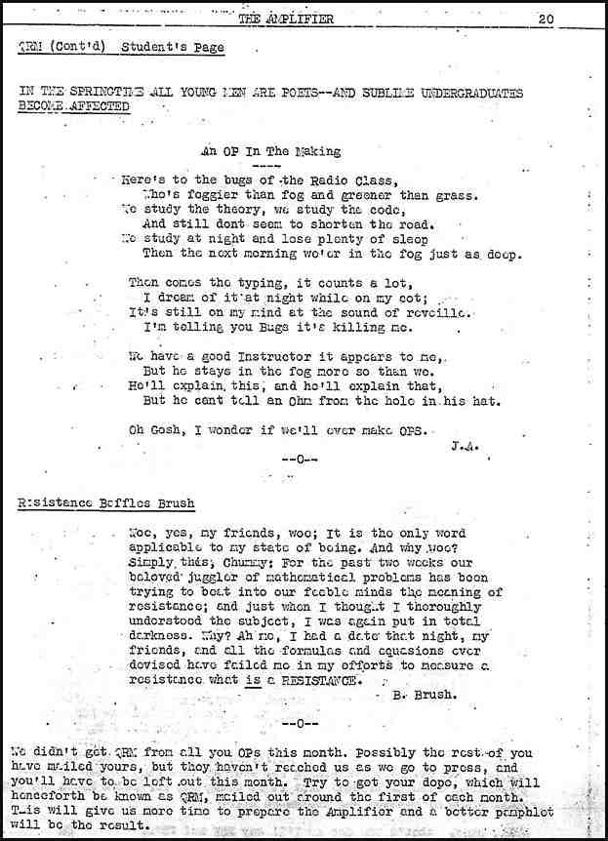

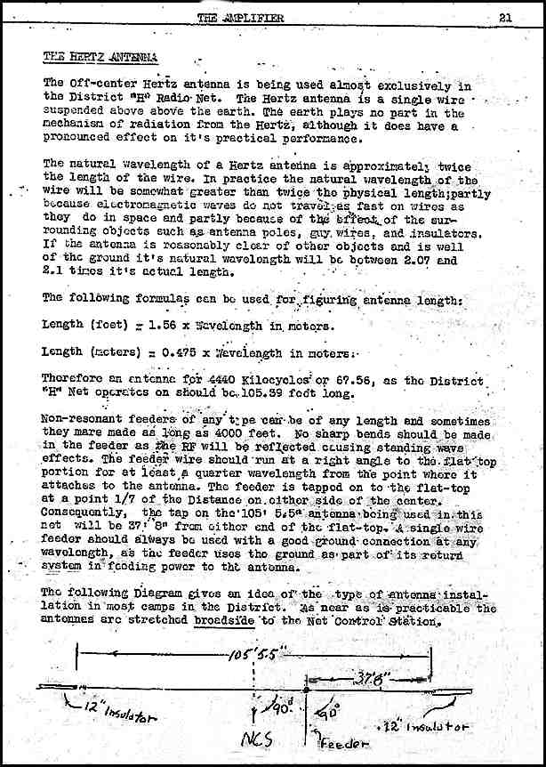
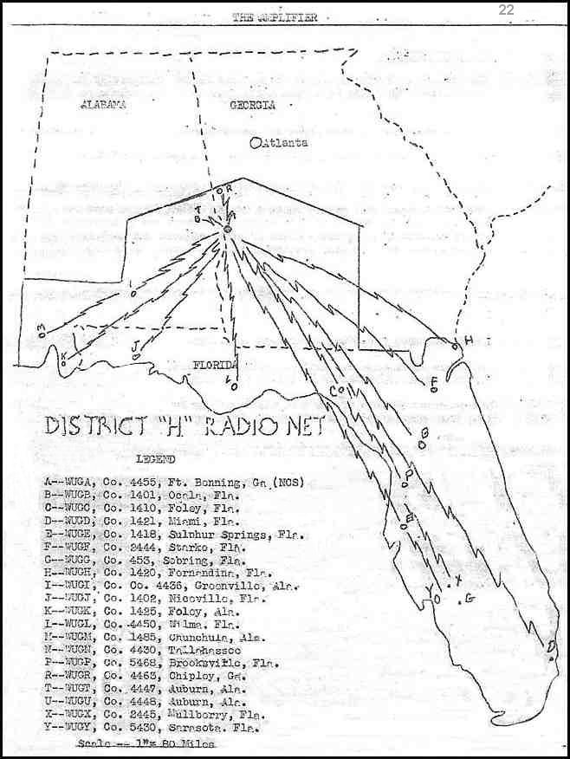
Last Page

