My C.C.C. and Radio Telegraph Experiences

A short title for:

“My Experiences in the Civilian Conservation Corps, and How I Learned Telegraphy and Became a Radio Amateur and a
Professional Radio Telegraph Operator.”

by

James (Jim) S. Farrior

Radio Amateur W4FOK (since 1938)

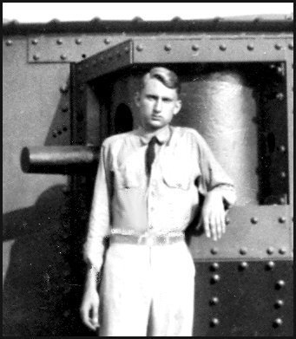
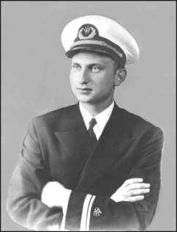

The author at Ft. Benning, Ga. (1938) The author in New York City (1943)
while serving as a radio telegrapher while serving as a Radio Officer
in the Civilian Conservation Corps in the U.S. Merchant Marine

Printed by: Hamilton Press, Fernandina Beach, FL
Bound by: The National Library of Georgia, Roswell, Ga.
©James S. Farrior 2004, 2005
This version is suitable for printing or for viewing on the screen.
File: ccc.radio.23aug05.doc
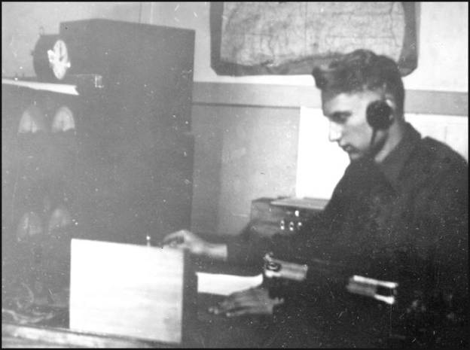

FRONTISPIECE - This 1939 photo shows me sending messages using a “bug” semi-automatic telegraph key at WUMA/WUNA, the Net Control Station at District “D” Civilian Conservation Corps Headquarters, Ft. McClellan, Alabama, where I was Chief Operator. There were actually two “nets”, both operated from the same desk. One net was for the Alabama stations (camps), and the other for the Mississippi stations. Each net had its own frequency. While one net was being “worked”, the other net was being monitored for emergency traffic. When all traffic had been cleared, both frequencies were monitored during the work hours. Two RME-69 communications receivers, one for each net, can be seen on the operating table. The two transmitters can’t be seen as they are on the other side of the room, to my left. I liked my job very much.
Before my time at WUMA/WUNA, the District Signal Officer, Lt. Robert Lowery, had set up a school to train operators while the camp radio stations were being set up. Initially, most camps had two operators so that trained replacements would be available when operators left the C.C.C. or new camps were formed. I had an assistant operator, D. R. Parkman, who was a veteran of WW-I. The C.C.C. accepted needy veterans who were in good health. There were special camps for such veterans.

My C.C.C. and Radio Telegraph Experiences

By Jim Farrior, W4FOK (since 1938)

About this Book
This book is a greatly expanded version of a paper that was written in response to requests from fellow radio amateurs. Those requests were mostly feedback from users of a computer program named “The Mill” that I had written in the early 1980s for teaching both American Morse Code and International Morse code. Later versions have been placed on my Web Page as a download. The users wanted to know how I happened to become a telegrapher and a radio amateur. Readers of my original paper also asked questions about the Civilian Conservation Corps (C.C.C.) , in which I was serving when I became a radio telegraph operator. This expanded version gives a more complete account of my experiences as a member of that organization.
When Franklin D. Roosevelt was elected President, the Great Depression had devastated the economy. There was wide spread poverty and unemployment. Initiated during the early days of Roosevelt’s administration, the C.C.C. provided work and training for young men and some W.W.-I veterans, and a small income for their needy families. Many young men learned work ethics and skills that would serve them well for the remainder of their lives. It also prepared young men to be better soldiers when many of them later served in WW-II. Unlike most government programs, the C.C.C. more than paid for itself in improvements made to parks, woodlands, etc. Most C.C.C. veterans are now deceased, and the C.C.C. is a little known part of American history.
In preparing this expanded version, I decided to include some additional personal and family information, etc., primarily for the benefit of my relatives and long time friends. Perhaps it will add some interesting background for other readers.

Introduction
I was born in Birmingham, Alabama, on January 11, 1920, the son of James S. Farrior Jr. and Ruth Thompson Farrior. My mother’s father, Joseph O. Thompson, was a successful Birmingham business man, land owner, and a political leader.
My father’s father, James S. Farrior Sr., was a Civil War veteran, and he and my grandmother, together with their younger children, were living in Letohatchie, Alabama, at the time of his death in 1903. Letohatchie is a small town in Lowndes County that was located on the L&N Railroad about 20 miles south of Montgomery. Following his death, my grandmother and her young children moved to Birmingham where her older children already lived. She died in Birmingham in 1906.
My father’s older siblings became prominent people in Birmingham, and his family and my mother’s family were friends. He was a WW-I veteran, and he and my mother were married shortly after his return to Birmingham after the war.
Unknown to my mother, my father had become an alcoholic before their marriage. Within a few years following their marriage his affliction rendered him unable to hold a job. His brother, Will Farrior, was a prominent business man in Birmingham, and the husbands of his sisters May and Katharine were prominent professional people. All were members of Birmingham society. Their repeated efforts to rehabilitate my father failed, and by the summer of 1930, my father’s behavior had become too much of an embarrassment and expense to them. Their solution was to move our family to Letohatchie, now usually spelled Letohatchee, where my grandparents had lived and where Farrior relatives still lived. To get my mother to leave Birmingham, where her mother, father, and several of her siblings and many close friends resided, she was told that we were going to Letohatchie to visit Buck Farrior, my father’s first cousin, and his family. Consequently, very little was taken with us on the train.
Our Family Moves from Birmingham to Letohatchie, Lowndes County, Alabama
Buck Farrior was the son of my grandfather’s brother, Ed Farrior, who had died in 1917. He was Chairman of the Lowndes County Board of Commissioners, and he, his wife Jewell, and three children lived on a farm between Letohatchie and Hayneville, the county seat. Included in Buck’s large land holdings was the 2,000 acre farm known as the “Jim Farrior Place”, that had belonged to my grandfather, James S. Farrior Sr. I understand that Buck sold off the Jim Farrior Place during the depression.
There were five of us, my mother and father, me (age 10 years), my sister Anne (age nearly 8 years), and my brother Joe (age less than 1 year). When we stepped down from the train, Buck was a very fine man. After meeting us at the train he took us to his home, which he and his family shared with us for several weeks until a house was found in Letohatchie. Their two young sons, Dick and John, were good playmates for me, and there was always something fun and interesting for us to do. Buck also had a daughter, Anne, who was about my sister Anne’s age. I quickly learned how much better it was not to live in a large city. My mother was very distressed when she realized that we had moved to Letohatchie, and for some years afterward she believed that we would somehow be able to return to Birmingham to live. However, that would never happen.
Before the Civil War, my great grandfather, John Farrior, had moved with his family from Montgomery to Greenville, in Butler County, the county to the south of Lowndes. Some years following the Civil war my grandfather, James (Jim) S. Farrior Sr. (1847-1903), who was a Confederate Veteran, and my grandmother, Minnie Williams Farrior (1853-1906), bought a plantation located about 4 miles northeast of Letohatchie and moved with their children from Butler County to a home on their plantation. My father was born at their plantation in 1893, and in 1895, my grandfather built a home in Letohatchie. Thereafter, he commuted daily to his farm on horseback. After my grandfather’s death in 1903, my grandmother and her three younger children moved to Birmingham, where her older children already lived. She died there in 1906.
When our family arrived in Letohatchie in the summer of 1930, the population was about 200 people. The older people in Letohatchie remembered my grandparents well and spoke very highly of them. Sadly, I didn’t record any of their stories. A number of cousins, children of my grandfather’s brother Edward Farrior. and their descendants, were living there when we arrived in 1930, and some still do. Today (2005), things are very different. The population of Letohatchie has decreased. Montgomery now is less than 30 minutes away by interstate highway, I-65. There are no longer any stores, and when the depot burned, it was not rebuilt. Once there were three churches, the Baptist, the Methodist, and the Episcopalian. Today, there remain only a few houses, a new Baptist Church on the original site, and a small post office building built some years ago.
The house into which we moved in 1930 was of poor quality with cracked and broken windows, bad screens, cracks in the flooring, and two small wood burning fireplaces. It was without electricity, running water, or an inside bath. It had an outside toilet, a small garden area, a small hen house, and a small barn structure with a stall for a cow. The shallow well on the back porch provided extremely bad tasting water. My aunts shipped to us the most important things that we had left in Birmingham. Since we could not use the gas stove, it was left in Birmingham, and my aunts had shipped a very small wood-burning cook stove, hardly large enough for cooking.. There were no telephones in Letohatchie homes.
Neighbors immediately came to our aid. Mr. John Mims, who owned the field in back of the house, plowed an area of his field and planted some food crops for us like potatoes, corn, beans onions, greens, etc. My father stayed sober for a few months after moving to Letohatchie, and during that time he and Mr. John Mims, using hand tools and a mule team, cut and hauled firewood for the stove and fireplace. They also cut by hand and hauled hay for the milk cow that was loaned to us by Buck Farrior.
Mrs. J. W. Dixon, a widow that everyone called “Auntie”, was very kind and helpful. She lived across the road from our house in the home that had been built by my grandfather in 1895, and where his family had lived until shortly after his death in 1903. Mrs. Dixon was the sister of the wife of Ed Farrior, my father’s brother, and she had raised some of Ed Farrior’s children. Buck Farrior had been one of those raised by Mrs. Dixon. Some of Buck’s grown siblings still lived with Mrs. Dixon. Shortly after we moved in, Auntie provided us with some garden tools, chickens, chicken feed, a churn, and other things necessary to begin our life in the country. She also made a nearby pasture available for the cow. Other fine neighbors provided us with a variety of things. There was no possibility of employment for my father, and he began drinking again, borrowing money wherever he could to pay the bootleggers.
As a 10 year old boy, my only regrets about leaving Birmingham were that when our belongings were shipped to us, my most precious possessions, my bicycle and the Erector Set that my Aunt Katharine had given me, were not among them. My clamp-on skates did arrive, but there were no paved surfaces in Letohatchie. I kept the skates as a souvenir of my Birmingham days, but I never put them on again. The only boys in my age group were Jimmy and Hartwell Payne, Kenneth King, Jack Whitley, and Bill Colvard. Early on, Bill lived in Letohatchie only when school was out.
We became members of the Letohatchie Baptist Church. When the wooden church building had been built, my grandfather had served as Chairman of the Building Committee. A few years after our arrival, I was baptized in a local pond.
In Birmingham, children could not enter school before their sixth birthday. Since my birthday was on January 11th, I would have been older than most of the other students. To prevent that, my mother had taught me a course of study which allowed me to skip the first grade and enter the second grade when I was six. Having finished the fifth grade before leaving Birmingham, I was able to begin school in Letohatchie in the sixth grade when I was ten. As will be related in this story, events would cause me to lose the head start I originally had plus an additional 2 ½ years.
Letohatchie had an old wooden three-room schoolhouse that covered the first through the ninth grade. There were three teachers, each of whom taught three grades. My grade had three students, myself, Kenneth King, and Loraine Singleton, and we stayed together through the ninth grade. Upon completing the ninth grade, the students first went by train, and later by school bus, to the Lowndes County High School at Fort Deposit, some 20 miles away. For financial reasons, I had to drop out of high school after the first semester of the 11th grade. Some time after I dropped out, the school districts were changed, allowing the Letohatchie high school students to attend the Hayneville High School, which was only 7 miles away. The old Letohatchie school was closed, and my brother Joe and sister Anne went by bus to a school in Hayneville. Buck Farrior bought the old three room school and used it to store hay for his cattle.

I discover telegraphy and electricity

The L&N depot at Letohatchie served a rather large surrounding area. Beginning when I was 12 or 13 yeas of age, I enjoyed hanging around the depot, and became fascinated by the click-clack of the telegraph that was used for train traffic control, railroad business, and for telegrams. I still remember how excited I was when the agent/operators offered to teach me telegraphy.

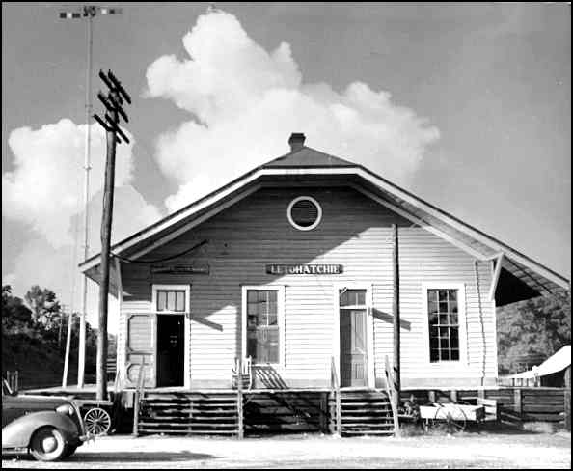
The L&N Depot in Letohatchie, Ala., looking northeast - I took this photo in the summer of 1940. The train tracks were on the left side of the depot. Across the tracks was located a large wooden water tank for filling the steam locomotive’s water tender. The semaphore used to signal the train engineer is visible above the depot. The Office is inside the left door, and it contained the telegraph desk and agent’s desk. It was was manned by three men, working in three “tricks, and they served as both Telegrapher and Agent. The office includes the window to the right of the left door. On the right is the White Waiting Room, which had a small ticket window inside between the office and the waiting room. Blacks purchased tickets at the office desk and waited on the outside platform. The office had characteristic smells caused by stale tobacco, the smoke from the locomotives, and the oiled sawdust that was sprinkled on the floor before sweeping. There was also the characteristic sound caused by hissing steam, and the clicking of the telegraph sounder and relays.
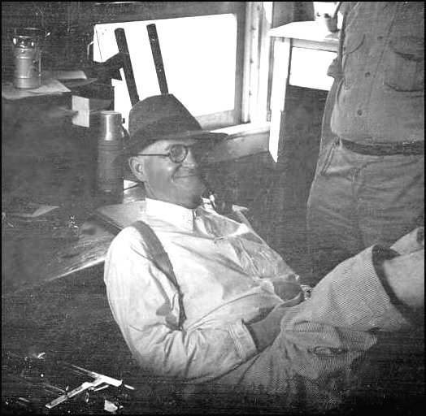
The depot’s office in 1940 - Mr. Archie Rogers, one of the three Operator/Agents, is seated with his back to the telegraph desk and his feet on the office counter. He said that he kept his feet on the counter because a mouse once ran up his leg. A semi-automatic telegraph key, called a “bug” is on the desk by his shoulder, and the telegrapher’s typewriter, which has all capital characters and is called a “mill”, is beside his right arm. He could lean out of the window and view up and down the tracks. The two black objects above his hat, are the handles that operate the semaphore that sent signals to the trains. Beside his head can be seen his coffee thermos, and on the shelf above is his “electric lantern”. My step father, Mr. Melvin Sanderson, is standing beside him, ready to relieve him. Train orders for a through train were clipped to a light weight hoop that was held by the operator for the engineer to catch on his arm as the train passed through. The engineer would remove the train order from the hoop and drop it to the ground to be retrieved by the agent. The outgoing mail bag was hung on a special holder beside the track and it was grabbed by an arm projecting from the mail car as the train passed. The mail was sorted en route. These methods had been in use by the railroads for many years.
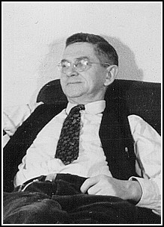
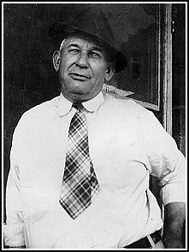

Mr. Melvin Sanderson Mr. Frisco Davis

Station Agents/Telegraph Operators at the Letohatchie L&N Depot
The depot was manned around the clock, and the three men worked three eight-hour shifts (tricks). While on duty, they handled all of the record keeping, ticket selling, train orders, telegrams, etc. They were all good American Morse telegraph operators. Melvin Sanderson was my stepfather. Melvin Sanderson was at home, and Frisco Davis was on the porch of Hardy Williamson’s store. They, together with Archie Rogers, taught me telegraphy.

Mr. Archie Rogers, who is shown in a previous photo, gave me a telegraph key and sounder that he had used many years before when he had learned telegraphy. The operators kept me supplied with some used lantern batteries so that I could practice. The code that I learned was the American Morse code, which was used in those days by the railroads, telegraph companies, news services, financial offices, and other “land line” telegraphy services in the United States and Canada.
I still have the treasured sounder and the telegraph key. The sounder is now connected to my computer, and a computer program that I wrote can generate telegraph signals to energize the sounder. It is very nostalgic to hear, and read, the sounder clicking out American Morse train orders, telegrams, and other messages similar to those that were heard in the old Letohatchie depot so many years ago.
Shortly after I began learning telegraphy, someone loaned me an issue of “Popular Mechanics” and I saw where I could buy, for about five dollars, postpaid, a box of used electrical materials for experimentation. I had just sold for three cents each some baby turtles that I had caught at local ponds, so I immediately ordered it. This magic box included, among numerous other things, two telephone receivers, two carbon microphone buttons, two hand-cranked telephone ringer generators, a crystal with holder and cat-whisker for building a crystal set radio, a bi-metal strip for making a temperature operated switch, and a box of assorted hardware. It came with a small booklet about electricity and describing how to use the supplied components for making electrical experiments. I found all of this to be extremely exciting.
By that time, we had moved into the old Sam Powell house, which was of even less quality than the original house, and it also had no electricity, running water, or inside bathroom. It was located in a pecan orchard across the street and to the north of the original house. The shallow well was about 200 feet from the house. However, it was on a 4 acre plot that provided more garden space, a pecan orchard, and pasture for the cow. A stone’s throw away was a small pond, known as Sam Powell’s Pond, that had many very small catfish about 5 inches long. We were very short of food, and I would catch a dozen or more, cut their heads off, gut them, and my mother would cook them in the pressure cooker until the bones were soft enough to be eaten like sardines.
The best thing was that had a back porch that was closed in with scrap lumber to make a room for me. The room had space for me to build a small workbench for performing my experiments. The used dry cells and lantern batteries supplied by the telegraph operators provided electricity for my experiments. My excitement level grew with each experiment.
Of all the items in my magic box of materials, the crystal set radio components were the most fascinating, and building a crystal set radio was my first project. I had only one component to make, and that was a variable inductance that consisted of two disk-like coils, one fixed on a shaft, and the other sliding on the shaft. The inductance of the coil assembly could be changed by sliding the movable coil closer for further away from the fixed coil. That rather crude device permitted the crystal set to be tuned.
After the parts had been assembled on a “bread-board”, and the aerial and ground wire had been connected, I put the telephone receiver to my ear and heard nothing. That was immediate disappoint, but I can hardly describe the excitement when moments later I moved the cat-whisker on the crystal and suddenly heard WSFA, the nearby broadcast station, which had a transmitter that was located between Letohatchie and Montgomery. Adjusting the inductance increased the volume significantly. This crude radio was more than a novelty, because we neither a radio nor a newspaper. Although only WSFA could be heard during the day, at night several distant stations came in. After going to bed, I would place the telephone receiver on the pillow beside my ear, and would hear interesting things to tell family members the next morning.
Some weeks later, my crystal set was improved considerably when Mr. Archie Rogers, the railroad telegrapher who had given me the telegraph instruments, gave me an old radio, from which I obtained a tuning coil and condenser assembly that had a knob and dial. That replaced the crude inductance previously described, and at night, I was able to separate the stations better. They were also somewhat louder.
No homes in Letohatchie had telephones, but soon a friend, Bill Colvard, and I strung up a telephone line and our homes were the first to have telephones. We used discarded railroad telegraph line-wire and insulators left by railroad repair crews. Only one wire had to be strung from tree to tree because a ground connection was used for the return. Two “bells” were built using metal from a tin can and electromagnets that were wound on an iron bolt with wire from the primary winding of an old Model T Ford ignition coil. The makeshift bells didn’t look like much, but when the crank of the ringer generator was turned, they made a sound that couldn’t be ignored. Since Bill used one of my telephone receivers at his house, it was necessary for me to plug my other telephone receiver into the crystal set or the telephone, as needed.
The only other person that I knew, beside myself who was interested in such things was a high school friend, John “J.D.” Lamar of Fort Deposit, Ala. When I was 14, and in the 10th grade, I traveled to Ft. Deposit by school bus. I spent a weekend with him at his home where we performed some destructive experiments on an old Gilfillan radio set. While connecting some wires, I received my first severe electrical shock when I came into contact with the 110-volt power line. It was quite a jolt, and for a few moments, I wondered if I wanted to have anything more to do with electricity. I was glad that I didn’t have to worry about getting shocked at home.
Later both of us would have careers in radio, and would both become radio amateurs. Both of us were licensed in 1938. Although I didn’t know it at the time, J.D. received his license about three months earlier than I did. His call was W4FLF, and mine was W4FOK. We were the first in Madison County, Alabama, to obtain an amateur radio license. We still have the same calls. We differ in age by only a few months, with J.D. being the oldest. We both now have heart pacers. During WW-II, we both had similar experiences in North Africa. It was at a military hospital in the same area in Algeria where I had been that John met Alice, his future, and present wife. Although we didn’t correspond often through the years, we now communicate by telephone and e-mail. Recently (in2003), when discussing our destruction of the old Gilfillan radio, we decided that although it was a pity to have destroyed what would now be a valuable collector’s item, it had been worth it as it was instrumental in launching two careers in radio.
My mother divorced my father in December of 1935. She had been running a small store and filling station for several years, but the income was insufficient to support the family. After the divorce, I saw my father only two times. The first time I met him was on a Letohatchie road. He was intoxicated and volunteered that he was going to buy me some clothing. He didn’t. The next and last time I saw my father, was when I caught a ride on the milk truck to Montgomery, and he boarded at the next stop. Although early in the morning, he was already intoxicated and had to be helped into the truck. During the ride he stared at me, but didn’t speak.
Due primarily to financial reasons, I had to drop out of school at the end of the first half of the 11th grade. Because of that and continued financial difficulties, I could not enter the 12th grade when the school opened in September of 1936. I spent much time running the combination filling station and store, and also had domestic duties such as milking the cow, maintaining the garden, cutting firewood, etc.
For a number of months during 1936, I had a job with the J. T. Farmer Baseball Bat Company pulling a cross-cut saw in Big Swamp. I was the only white worker on the crew. We cut down large sugarberry trees, and sawed them into lengths slightly longer than a baseball bat. Using wedges and sledge hammers, these lengths of logs were split into several wedge shaped sections. These were hauled to Letohatchie where a large lathe had been set up near the depot for turning them down to a diameter slightly larger than a baseball bat. Francis Williams, a friend of mine about three years older than I, had the job of operating the lathe. A wedge shaped sections would be chucked up in the lathe, where it slowly rotated. By depressing a large foot pedal, the rotating section would be brought into contact with rapidly rotating blades that would quickly reduce the log section to a cylindrical billet of the correct diameter.
Power for running the lathe was obtained by using an ancient truck, with one rear wheel jacked up above the ground. A pulley was attached to the wheel, and a belt delivered the power to the lathe. To keep the engine from overheating, the cooling was increased by circulating the cooling water through both the radiator and an external 55 gallon drum filled with water. The turned billets were loaded into box cars to ship to the bat company’s plant in Opp, Alabama. After the billets had been cured in kilns, they were used to make baseball bats that carried a label that indicated that they were made of second growth ash, when in reality it was first growth sugarberry. For my work, my mother received 90 cents for my 8 hour day in the swamp. Francis was paid $1.10 per day, and I really envied his job. Several years ago, shortly before Francis died, I saw him for the only time since I had left Letohatchie. We were both visiting Letohatchie, and we enjoyed reminiscing about our career with the bat company.
I join the Civilian Conservation Corps and go to Valley Creek State Park Camp, near Selma, Ala.
To provide work for myself and income for the family, I joined the Civilian Conservation Corps (C.C.C.), the members of which wore old surplus U.S. army uniforms without insignia and lived in camps often located in State or Federal parks. The primary objective of the C.C.C. was to provide work for young unmarried men and income for their needy families. The enrollees received $5.00 per month, and $25.00 per month went to their family. However, the work done by the C.C.C. also turned out to be of much immediate and lasting benefit to the public. The C.C.C. improved public parks, or lands, by planting trees, and building paths, roads, lakes, cabins, other buildings, etc. Needy veterans of WW-I in good health were also eligible to join, and were usually assigned to special veteran’s camps. There were also some Local Experienced Men, called LEMs, who could be married, and who, because of their skills, served as heads of work groups. They were paid somewhat more than the junior enrollee. Enrollees could stay a maximum of two years in the C.C.C.
I really had no idea of what I was getting into, but realized that, at least for a while my electrical experimentation had come to an end. Sadly, I took down the telephone line to Bill’s house, and carefully packed all of my precious experimental things in a wooden box and nailed it shut. My mother assured me that she would keep my box of “stuff” safe until my return. Sadly, I sensed that whatever the future brought, my boyhood period had come to and end.
C.C.C. enrollees were required to be 17 years old, but when I enrolled in Montgomery, Ala., early on a Thursday morning, January 7, 1937, they overlooked the fact that I lacked 4 days of being 17 years old. About 40 men came for induction, and after recording our individual data, we were told to undress, and to line up nude for a medical inspection. Initially, each man stepped on a scale, and his weight and height were noted. A doctor, accompanied by a man who recorded information, walked down the line, spending a very short time with each man. Each man was checked for vision, hearing, the condition of his teeth, etc. He was made to jump up and down, squat, touch his toes, and then stand still while his heart and lungs were checked with a stethoscope. All of the men were accepted, including one man who fainted when the doctor touched the man’s chest with his stethoscope. Literacy was not a requirement.
The testing having been completed, we were divided into several groups, each of which would be taken to a different C.C.C. camp. Typical Army type trucks with canvas covers were waiting outside, and my group of about 14 men was directed to board a certain truck. I was obviously considerably younger than the others.
Shortly before lunch, we arrived at C.C.C. camp 444 at Valley Creek State Park about 16 miles north of Selma, Alabama. We were directed to one of the four barracks, where we were assigned beds. We were then given a WW-I aluminum cup, which had a peculiar shape and a folding handle, and a WW-I mess kit that was oval in shape and had a lid that served as a plate. The folding mess kit handle closed over the lid and latched. The knife, fork, and spoon were stored inside the mess kit. Most, if not all of us, were seeing these military things for the first time.
We were shown the location of the latrine, which was in a building with a long seat in the center of the room. There were two rows of holes of the appropriate size to serve as toilets. It was mounted over a deep trench that had been dug into the ground, and even though some lime was sprinkled in the trench daily, the stench often drifted over the camp. I had no problem with that, as the outhouse we had at home was no better. We were also shown the bath house, that contained a row of showers against one wall, and on the opposite wall was a row of large pegs on which to hang clothing. This was far better than at home, as at home we had to walk to the well, draw water and haul it back, heat it on the wood burning stove, and bathe as best we could in a small galvanized tub. For shaving, pans of water could be filled from faucets and placed on a waist high shelf at each end of the room. Mirrors were mounted above the shelf. That, too, was far better than at home. We were told that to accommodate the large number of men wanting to use the facilities, everything had to be done rapidly.
After we had been made familiar with the camp, we were told to take our mess kits to the mess hall and line up with those already there. Since the main work sites were not far from camp, most of the men came back to camp for the noon meal. There were also a few men who worked in the camp. We learned that food was taken to one group of men who worked at a gravel pit a considerable distance away.
Someone warned us that anyone trying to break into the mess line was a candidate for being hit over the head with a mess kit. Although the food wasn’t very good, I found it edible and sufficient. There was no choice, and each man was served some of everything available. The food situation had not been very good at home, so I didn’t find it bad. After we had finished eating we went to a place behind the mess hall where there were two 55 gallon drums containing hot water heated by a wood fire. One of the drums contained soapy water, and the other contained clear water. Everyone scraped their mess kits into a garbage container and then swished them around in the drum containing the soapy water. Finally, they were rinsed in the drum containing clear water. We could sling them dry on the way back to the barracks.
Shortly afterward we were told to return to the mess-hall for a talk by the Commanding Officer, who was an Army Lieutenant, and by Mr. Sim Pace, a civilian who was the “Using Service” Supervisor in charge of the work being done by the men. The C. O. gave us a pleasant welcome followed by a recitation of the camp rules and a warning that camp rules would be strictly enforced. Breaking the rules could lead to an immediate discharge from the C.C.C. He said that there would be unannounced barracks inspections from time to time, and we were expected to keep our barracks neat and clean and the beds made properly. Although there would be no military training, we could expect that on some weekends we would be turned out for a roll call and for group exercise. Mr. Pace told us that the work being done was to improve the State Park by building a lake, roads, some buildings, and by planting trees.
Following the talks, we visited the supply room and were issued our meager supply of clothing, etc. The man in charge of the supplies was called the “supply sergeant”, and the man in charge of the mess was called the “mess sergeant, but they were C.C.C. men. We were told to be with the rest of the men at a certain place in camp a few minutes after breakfast, when we would be told which work group we would join. When the men returned tired and dirty from work, and after they had taken a shower, they gave us friendly welcomes, and showed us how to make our beds.
After dark, a group of rather tough looking C.C.C. men with flashlights entered our barracks, and the leader announced that it was time for the newcomers to be initiated. He directed us to form a line and to follow him into the woods. His men joined the line at intervals, and one brought up the rear. I have to admit that I didn’t feel very brave as we entered the woods and started down a seldom used path. The woods were very dark, and there was nobody close to me with a light. Not knowing what to expect, I took advantage of an opportunity to slip out of line unnoticed as the group pushed its way through some dense bushes that nearly covered the path. Their destination was within hearing distance of where I stood beside the path, and I heard a lot of shouting, cursing, and fiendish laughter before the men could be heard returning. I was really concerned that I might be discovered, but as they were threading their way past me through the dense dark bushes, I quickly stepped into the line. No one knew that I hadn’t participated in the initiation, and I wasn’t about to tell anybody. From their discussions afterward, I learned that nobody had been harmed, but some complained of rough and vulgar treatment. So ended my first day in the C.C.C.
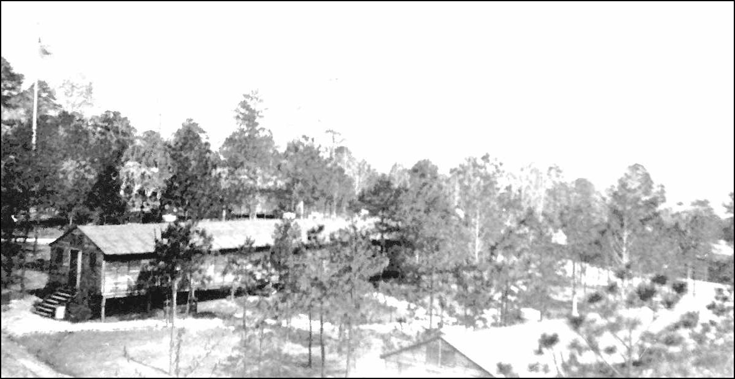
A 1937 view of C.C.C. Camp 444, Valley Creek State Park, near Selma. - My barracks was the one in the center. The photo was taken from the camp’s water tower using my mother’s old Kodak box camera that she had sent me shortly after I arrived in camp.
The next morning I had the misfortune of being assigned to work with the group at the distant gravel pit. Six of us got into the back of a dump truck and traveled over very dusty, bumpy roads for nearly half an hour. The old truck put out a lot of smoke and fumes, that burned our eyes and made it hard to breathe. At the gravel pit, there was an ancient tractor with a blade on the front that pushed the gravel into piles, and our job was to throw the gravel into the truck with shovels. To reduce the height we had to throw the gravel, the road through the pit was kept somewhat lower than the surrounding gravel piles. However, it was still difficult to throw the gravel into the truck. We were allowed to take a breather from time to time. About the time we would finish loading a truck, another truck would appear. I felt sorry for those who had to do this work during the summer. The same food that they had in camp was brought to us, along with mess kits. After a week of that exhausting work, I joined a group that was spreading the gravel on a park road. Moving gravel around at ground level was much easier. Later, I was assigned to plant trees, which was fun compared to the other jobs.
The camp at Valley Creek State Park was probably typical of many C.C.C. camps. It was built among the trees. All of the buildings were of a temporary nature, because most of the camps would typically complete their work in several years and would be reestablished at another location. I understood that the building design was the same as the army used for temporary camp buildings. As I recall, the camp had a combined officer’s quarters and office building, four barracks that housed a total of about 200 men, a mess hall, a building with a recreation room and a few books, a small building housing the canteen, an office building for the camp’s work supervisor, a latrine, a bath house, and a building used by the motor pool. There was also a small sick bay, and a doctor would come to the camp from time to time . Once a military dentist, an army lieutenant, came to camp and brought an orderly with him. The orderly operated the foot powered device, like was used with an old sewing machine, that drove the dentist’s drills, etc. The dentist inspected every man’s teeth and put in fillings as required. I received my first filling. Months later, the filling fell out, and it was not replaced for several years. On another occasion, a doctor came to camp, formed the men in a line, and gave them “short arm” inspections.
In the recreation room, I spotted a closed door and peeked inside. There, to my surprise and delight, was a small darkroom with a sink, running water, darkroom light, trays, bottles, printing frames, etc., but no enlarger or photographic materials. I found out that it was there for our use, but nobody had ever used it. The user would have to supply only the chemicals and papers. I had never before seen a real darkroom. At home, I had used my mother’s old box camera to take photos which I developed and printed. Since we didn’t have electric lights, I had to use sunlight to expose the papers, which required that I work in the daytime. I had used a closet, and a flashlight with red tissue paper tied over the light, and used sparingly, served as a darkroom light. Chemicals and papers had been bought with money received from selling baby turtles. My trays had been bread pans borrowed from the kitchen. Developed film and papers were carried to the well where there was plenty of water available to wash them sufficiently to remove the hypo. Sometimes, I made and sold copies of photos to local people, mostly to the colored people.
After I discovered the darkroom, Mother sent me her old box camera. There was a Sears catalog in the recreation room, and I immediately ordered from Sears some photographic papers, several tubes of “MQ” developer at 5 cents per tube, and some fixer. The developer and fixer could be used with both film and paper. About two weeks later, I was set up to take photos of the men with the box camera, and I made prints for which I could charge 3 cents each. Since most of the photos were group photos, and I could sell prints to all of the men in the photo, I was able to sell almost as many as I had time to make. My profit was about 1 cent each. The money I made was used to order from Sears a Kodak box camera that was much better than Mother’s old camera, as it had a “portrait” lens, that permitted close-up photos.
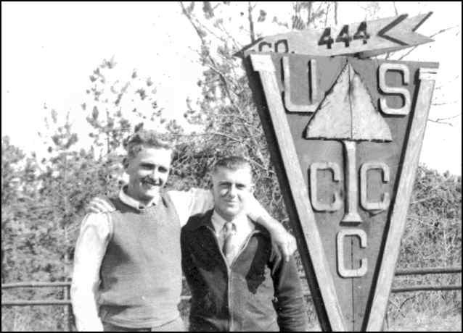
CTC Men of Co. 444. -
These men are in their civilian clothing, and are standing at the nearby road on a weekend hoping to catch a ride into Selma for recreation. Most men seldom left camp due to lack of money. I made and sold a number of prints like this.
My lot in life suddenly changed for the better. In Letohatchie, I had a good friend, Frank
McEachern, who was somewhat younger than I was. He lived with his grandparents, Mr. and Mrs. Bragg Payne. His mother, Mrs. Sellers, lived in Montgomery, and she worked in a government office that had something to do with the C.C.C., and through a stroke of good luck, Mr. Pace, the Camp’s work supervisor, met her when he went there on business. Mrs. Sellers told him about my being at his camp, and said that I could type. That was stretching it a bit, as I had only taken typing for half a semester in the tenth grade. Upon his return, Mr. Pace assigned me to work in his office, and my days of hard manual labor suddenly came to an end. My office work greatly improved my typing skills, and I also did other office work that was a good learning experience for me.
Another benefit from working in Mr. Pace’s office was that he decided that it was appropriate to his position for him to have a driver. He taught me how to drive his car, and after that I drove him on his inspection tours of the various work sites. Since I lived in the barracks with the men who did hard, dirty, exhausting manual work all day, I fully expected some sarcastic comments from them as they would see me driving Mr. Pace, and trailing along with him to take down notes during his inspections. The notes were typed later. However, that didn’t happen, and I decided that most of the men, if not all, would have had no desire to swap jobs with me.
Driving Mr. Pace to the place where a dam for a lake was being built gave me a chance to see that work was done. There was no motor driven machinery, and the heavy work was done by a number of mules, each pulling a rather large scoop. Dirt would be scooped from the area where a large pond would be, and the scoop would be drug by the mules over the ground to the top of the dam being built. At the proper place, the operator would lift the handles of the scoop, and the front lip of the scoop would dig into the earth, causing the dirt to be dumped. The men would spread the dirt with shovels. I don’t remember ever learning where the mules and scoops were kept, but they were not kept near our camp. Perhaps they were supplied by a contractor.
The old Southern saying, “Them who have, git”, is very true. My assignment had an even greater benefit. Each camp in our C.C.C. District had a small radio telegraph station, which was equipped with old surplus army gear and was manned by a C.C.C. member. At our camp, the radio station was in a small room in the headquarters building. The radio was powered by a small generator in a small shed some distance away from the building.
Staying in camp provided an opportunity for me to become friends with the radio operator. I can’t recall his name, but I owe him a large debt of gratitude. He went out of his way to explain the radio operation to me and to help me learn the International Morse code, which is different from the American Morse code that I already knew. He held a Federal Radio Telegraph License, and when he was offered a job as radio operator aboard a ship, he sold me for $2.50 his collection of tools, radio parts, etc. He said that he hated to part with those valuable things, which he had been collecting for some time, but simply had no place he could leave them while he was at sea. His loss was my gain. Included were a pair of old earphones, and a buzzer for building a code practice set, which immediately came in handy. It also included long nose pliers, wire cutting pliers, some screw drivers, drill bits, soldering iron, and other tools, and a collection of nuts, screws, bolts, washers, and other useful hardware. I simply had to have that wonderful stuff to add to what I already had in the wooden box at home. My mother loaned me the money until payday, when I would receive $5.00. I was delighted! Having no place to keep such things at camp, I sent most of it home. Those things would come in very handy later.
By far, the most important thing that the radio operator had done for me was to submit my name to the C. O. as a candidate for attending the District Radio School at Ft. Barrancas, Fla. Mr. Pace had a good bit of time and effort invested in me, but kindly told me that he would release me if I received that opportunity.
To my great surprise, I received a letter from Mother telling me that on May 7, 1937, she had married Melvin Sanderson, one of the telegraph operators at the L&N depot. Melvin was a fine man, and had been one of the operators who had helped me learn the American Morse code. The Sandersons were among the first people to settle in the Letohatchie area in the early 1800s. Melvin wanted mother to close the small filling station and store, which was hardly breaking even, so she could devote herself to making a home for the family. They moved out of the shack in which we had lived for several years, and moved into rooms in a fine old two-story home belonging to Mrs. Carey Powell, an elderly lady, who wanted to share the kitchen and the cooking duties. Mother said that the rent was $15.00 per month. For the first time since moving to Letohatchie, the family would have electricity, and there was a refrigerator in the kitchen. My small amount of clothing, .22 rifle, telephone equipment, crystal set radio, my original box of electrical materials, and my newly acquired tools and radio stuff were being stored in a safe place. Melvin had told Mother that he wanted me to return home at the appropriate time and finish high school. After years of a miserable existence, Mother’s marriage to Melvin was a turning point in the life of our family.

The Radio Telegraph School at Ft. Barrancas, Florida
Our Commanding Officer received a request for a candidate for the radio school, and he submitted my name. A few days later, about the first of June, 1937, I was sent by a slow train on an L&N line that ran due south from Selma to Pensacola, the closest town to Ft. Barrancas, where the C.C.C. District Headquarters and the net control radio station and radio school were located. A C.C.C. camp had once been located there, but it had been closed. The buildings still remained, and the dozen or so radio students slept in one end of one of the vacant army type temporary barracks like those at Selma. The best thing was that we ate in a nearby Army mess hall. What a great improvement over C.C.C. camp food! I could hardly wait for each meal.
I had already learned the code, and was nearly at the code speed we were supposed to have when we finished the training. Capt. Dexter Phillips, the District Signal Officer, had noticed my interest in the radio equipment and he let me assist him in making some modifications to his 1,000 watt ham station, which was in a special room in the same building as the classrooms and the Net Control Radio Station. I was really excited when he let me sit in his “ham shack” as he “worked” amateur radio stations around the world. His radio call was W4CRA, and he jokingly said the “CRA” stood for “Crazy Radio Amateur. I became very interested in Amateur Radio.
The old brick Fort Barrancas (built in 1839), and the very old Spanish Fort San Carlos (1696) were located on the bay overlooking a wide sandy beach. They were only a short walk from our class building and our barracks, and there was plenty of time after school and on weekends to explore the forts, and to enjoy swimming and sunning on the beach. The school was fun, and life was enjoyable. I felt sorry for my barracks buddies back at Selma who were doing things like throwing gravel into a dump truck and eating in the C.C.C. mess hall.
There were many things to see. We were within walking distance of the Naval Air Training Station, and we could go there and watch the small sea planes used for training as they would take off and land in the bay. We saw one take off and then crash land in the bay. In the late afternoon, we could go to the pier where the recreational fishing boats would return with their strings of snapper and grouper.
My Uncle Hundley Thompson, my mother’s brother, was a Lieutenant in charge of one of the huge Coastal Artillery guns at Fort Pickens (built 1829-1834) on Santa Rosa Island. It was directly across the bay from Ft. Barrancas. Actually, Fort Pickens had been built for the kind of guns that existed at the time it was built and could not have supported the new much larger guns. The new hydraulically controlled guns were in reinforced concrete bunkers adjacent to the old fort. Even though the guns were on the other side of the bay, we could feel the concussions when they were fired. When Uncle Hundley learned from my mother that I was at Ft. Barrancas, he contacted me and took me to a movie in Pensacola. Uncle Hundley had always taken an interest in me and continued to do so during his life time. He was indeed a fine fellow.
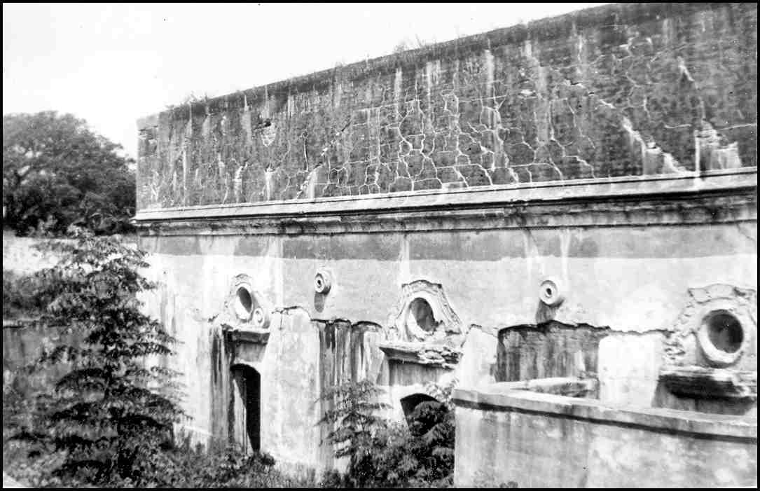
Front view of Old Fort Carlos - This old fort was originally built by the Spanish in 1696, captured by the French in 1719, retaken by the Spanish and again by the French. Last rebuilt by the Spanish before 1790, captured by the English in 1814 and by the U.S. in 1818.
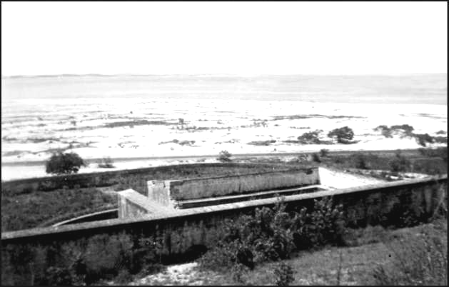
Old Ft. San Carlos as viewed from top of old Ft. Barrancas, built 1839 - 1844. Fort Pickens, built 1829 - 1834, is directly across the bay on Santa Rosa Island, where the large Coastal Artillery guns were located.

The previously mentioned improvement in food due to eating in the Army mess hall was due to several reasons. Instead of the “field-kitchen” type of food served in the C.C.C., the army kitchen was equipped with good stoves and ovens, and far better serving tables. Instead of eating from metal mess kits, the army mess had ceramic plates and dishes, and regular knives, forks, and spoons.
The food budget per man for army personnel was significantly larger than for C.C.C. men. The army cooks had been trained in a cooks and bakers school, and the Mess Sergeant was specially trained to plan meals and select foods at the market for menus that were healthier and better tasting. The army’s larger food budget provided milk, cereals, deserts, and fruits like apples, oranges, grapefruit, and bananas , which I don’t remember ever getting in the C.C.C. mess.
Our quarters were on the edge of some woods, and in a clearing not very far into the woods was located another large old fort, Fort Redoubt. (1839). Old Fort Barrancas and Fort Redoubt were part of the same coastal defense installation. Although Fort Redoubt was in a restricted area, no guards were posted there. We could easily climb over the cattle fence, walk through the woods, and explore as much as we wished.

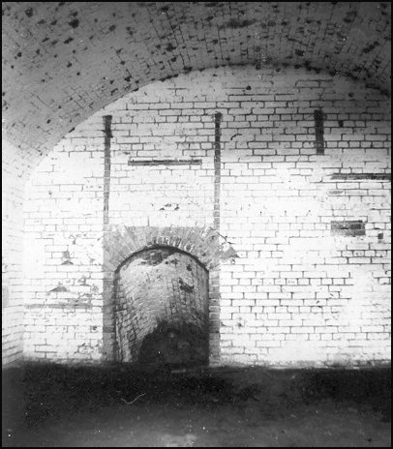
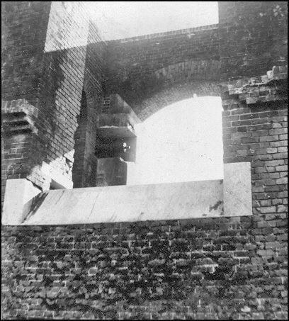
Left: - Ft. Redoubt’s dry moat had a bridge, probably a draw bridge, to this entrance. Right: - The moat was drained by a tunnel running a considerable distance to a point in the woods where the land was lower than the bottom of the moat. It terminated in a pipe-like section too small to crawl through. The depicted entrance in one of the rooms lead down to the tunnel, perhaps for maintenance purposes. The room was rather dark, and my camera was placed on a ledge and a long time exposure was made. Several of us crawled to the end of the tunnel and back.
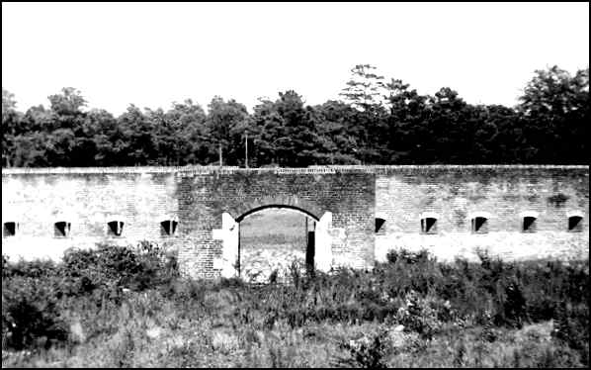

This view is from the top of Ft. Redoubt, and is from above the level of the bridge, then missing, that led into the fort. This wall has ports to provide protection for the entrance, which is below the opening shown above..

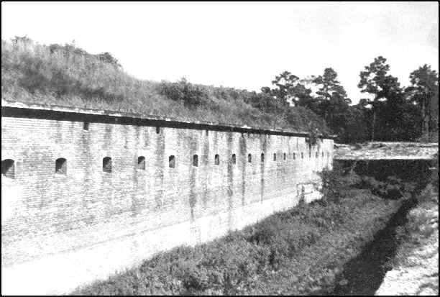
Ft. Redoubt - Looking down the side from the entrance end of the fort

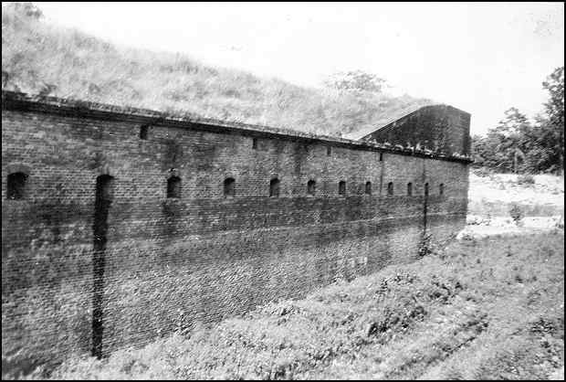
Ft. Redoubt - Looking up the moat toward the entrance end of the fort

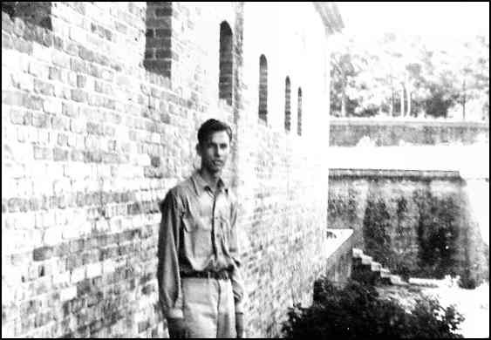
Kyle Ward at Ft. Redoubt. - The fort was in amazingly good condition. He and I were the most adventuresome of our group of students, and we spent hours exploring the many rooms and examining the interesting architectural features of the old fort. Kyle was very smart, and a good student, but he never showed up in our radio net. He must have been sent to a camp that was transferred to another C.C.C. District when some of the camps were redistricted shortly after we left school. In the summer of 1940, I was walking down a street in Montgomery, Ala., and was passing a fruit and vegetable shop when I heard someone shout “Jim Farrior!”. I was surprised to see Kyle behind the counter serving customers. He rushed out to greet me, but had to return to his customers. I waited a few minutes, but I was in a hurry and told Kyle that I would be back to see him. I regret that it didn’t happen, and I never heard of him again. Perhaps he never served as a radio operator.

The Radio Operator School was completed -- Assigned to Morton, Mississippi
I really enjoyed the radio school, and our lifestyle there, and wished it could have lasted longer. Because I already knew most of what was being taught, it was like a vacation. I pitied my friends back at Selma who were doing hard manual labor in the summer sun. After 2 1/2 months of studying basic radio theory, maintenance, and radio telegraphy at Ft. Barrancas, I was sent on Aug. 20, 1937, to a C.C.C. camp at the Roosevelt State Park 4 miles NW of Morton, Mississippi, where I served as the second operator for several weeks. A few days after I arrived in Morton, the net control operator at Ft. Barrancas passed along some very disturbing news. He and a number of other operators in the net would soon complete their two year maximum stay in the C.C.C., and it appeared that there would soon be insufficient operators available to assure viability of the radio net. Capt. Phillips was trying to find a solution, but the prospects didn’t look good. I had horrible visions of going back to ditch digging, tree planting, or even shoveling gravel.
Transferred to the C.C.C. Camp at Greenville, Alabama
On Sept. 18, 1937, I left Morton headed for the C.C.C. camp (Company 4436) at Greenville, Alabama, where I would replace an operator whose C.C.C. time had run out. Getting to Greenville by train was quite an experience. I first had to go by train from Morton to Meridian, Mississippi. After a wait, I boarded a poor quality train on which I rode as far as Akron, Ala., a very small town south of Greensboro, Ala.
When I arrived at Akron in the early afternoon, it was too late for me to make connections with the train to Selma, and the station agent told me that I would have to wait nearly 24 hours and take the same train the next day. I had considerably less than a dollar in my pocket, including the money I had been given for the two meals that I would have missed if I had made proper connections. I bought something to eat at the local general store, and realized that my remaining money would not allow me to eat much for the rest of the trip. I also had no place to sleep.
The railroad station was manned for only one shift, and had no waiting room. When the station agent went off duty, he left a straight chair on the platform on which I could sit. The platform was covered with cinders and soot from the steam locomotives, so I couldn’t lie down on it. Thank goodness, there were no mosquitoes and it didn’t get too cold, so I managed to get a little sleep during the long miserable night.
The next day, after what seemed like an eternity, the train finally arrived. The train was a combination freight and passenger train, with only one passenger car. It dropped off several freight cars on a siding, and picked up several more to take back to Selma. Several passengers boarded with me. Since there was only one car, the colored people sat in the back and the whites in the front. The passenger car was very old and dirty, and had hard wooden seats. Although not needed at the time, a centrally located coal-burning pot-bellied stove was used to heat the car. By lying on the seat with my legs in the aisle I managed to get some sleep before arriving in Selma.
The railroad station at Selma was much better, and I had time to get a bite to eat while waiting for the train to Montgomery. The train to Montgomery had a better car with comfortable seats, but it arrived in Montgomery too late to make a connection to Greenville. I spent the last of my money on a cinnamon roll at Montgomery. Fortunately, the station was not too crowded, and I stretched out on one of the hard benches in the waiting room and caught a few hours of sleep.
According to the schedule, L&N train #5 would leave Montgomery at 6:50 AM. It would stop at Letohatchie at 7:22 AM, if there were any passengers to get off or board, and would arrive at Greenville at 8:05 AM. I was really filthy, and before time to board, I washed my face and hands, and moments later boarded the train, and began the last leg of my journey. I was already more than 24 hours late on a trip that should have taken less than 24 hours.
I wondered what I should do if the train stopped at Letohatchie. I believed that Melvin Sanderson, who had become my step father since I last saw him, would still be on watch in the depot, so I decided that I would run in and say hello. However, the train didn’t stop, and as it passed I saw that my mother’s filling station and store, which was not far from the tracks, was boarded up. Up the street, I could also see Mrs. Powell’s home, where my family were then living and felt sad that I couldn’t have seen them.
This #5 train, is the same train that I used to catch each school day when I attended high school in Ft. Deposit, before we had a school bus. When it stopped at Ft. Deposit, I remembered those days and wished that I could have finished school. After I left home, students no longer went to Ft. Deposit, but rode a school bus to Hayneville, which was much closer. I hoped that some day I could finish school there.
I had only my barracks bag with me, as my foot locker that I had bought in Pensacola had been shipped from Morton. Upon arrival in Greenville, I was told how to get to the C.C.C. Camp, so I walked to camp and checked in at the Commanding Officer’s office.
When I told Lt. Derrick, the C.O., about my travel problems, and the fact that I didn’t have any money, he apparently felt sorry for me and gave me an advance of one dollar and told me to go to the mess hall where I would be given something to eat. Later, after being assigned to a barracks, I went to the supply room and was given bed clothing. After lunch, my foot locker arrived in camp. It had apparently traveled on the train with me. My assignment to Greenville was a very lucky one because it was the nearest camp to Letohatchie. It was only about 40 minutes from Letohatchie by rail, making it feasible for me to visit home when I could get some time off.
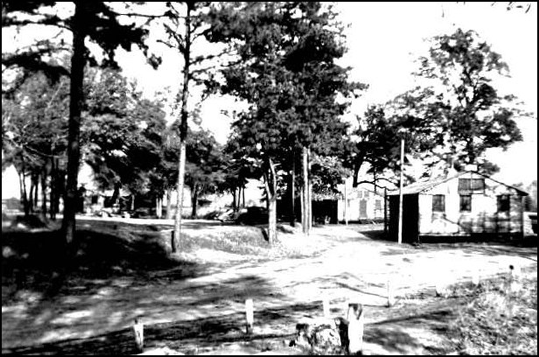
A camp scene at C.C.C. Company 4436, Greenville, Alabama - The building at the right side of the photo is the Headquarters Building, which housed primarily the Commanding Officer’s office and the radio telegraph station. The post at the front-left corner of the building supported the feeder end of the antenna, and the other end was supported by a similar post in a field to the right of the building. The barracks were also located in the field. The mess hall, supply building, recreational building, and shop were all located in a shady, park-like area.

The previous radio operator was known as “Screw-Loose Benson”, and although he had left, his reputation remained. I hoped that the reputation didn’t belong to the job. The camp had the same buildings as at Valley Creek State Park and at Morton, but it was located in a beautiful park-like area on the eastern edge of Greenville. One was free to walk to town whenever duties permitted. I thought that everything was working out fine, but when I went to the office to check into the radio net, Lt. Derrick told me that the receiver had failed just before Screw Loose Benson had left. They were waiting on a new receiver from district headquarters in Ft. Barrancas.
The receiver, which was an old National SW-3 (three tube) receiver, was indeed dead. The tube filaments lit up, but nothing could be heard. Perhaps Screw-Loose Benson had done something to it. That was very bad luck, because while waiting for a new receiver to arrive, I was assigned to a work group that dug ditches and planted trees all day. We also ate food that was delivered to the work site and was stone cold by the time we ate it. Back to square one!
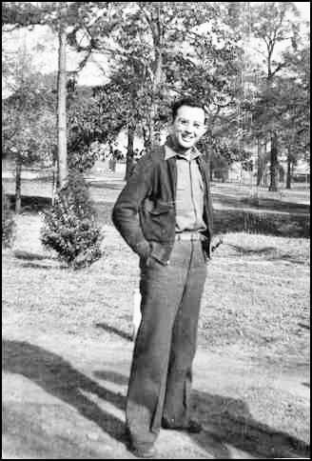
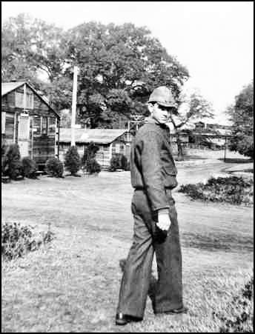

The Mess Sergeant The Supply Sergeant

Below: The Company Clerk and Canteen Steward
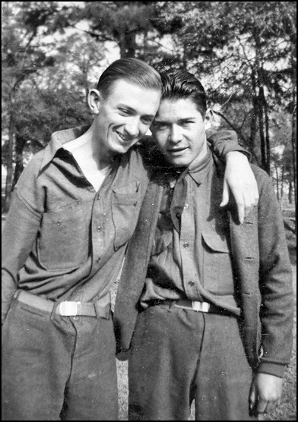
Few of the men in our work group showed evidence that they had received any schooling. However, one man reported that he had read in the newspaper where someone had recently gone higher up in a balloon than anyone had gone before. Another man very seriously wanted to know if he went high enough to hear the angels singing. Nobody in the group acted as though that was a silly question. However, another man seriously opined that he didn’t believe that the man could have gone high enough for that. That was the most stimulating conversation that took place in our work group.
Our work group rode in the back of a truck to and from our work site out in the country. When we would pass the Magnolia Cemetery on the western edge of Greenville, one of the men took a fiendish delight in screaming out at the top of his voice, “skull orchard!”, even when there were people visiting graves in the cemetery.
I would have disliked the man’s disrespectful behavior even more had I known at that time that the old Farrior Family cemetery plot was located there. It contains the graves of my great grandparents, John and Sarah Farrior, and my grandparents, James S. and Mary Elizabeth Farrior, and some great aunts, great uncles, and cousins. At that time, I knew nothing about the history of the Farrior family, except that my grandfather, James Spurlock Farrior Sr., (I’m the third) had lived in Letohatchie, and his old home (built in 1895) was still standing. It was then occupied by Farrior cousins, descendants of my grandfather’s brother, Edward Farrior.
I didn’t learn until many years later that in 1832 my great great grandparents, William and Nancy Farrior, with their large family had come to the Union Springs area in Central Alabama from North Carolina, and that my great grandfather, John Farrior, after having run a store in Montgomery during the 1840s, had moved with his family to Greenville before the Civil War. My grandfather had served in the Civil War, and had returned home to Greenville, where he married my grandmother in 1871. Some years later they moved with their children to a farm near Letohatchie. In the 1960s, my first cousin Alvahn Holmes, who lived in Baltimore, and I had the tombstones and slabs cleaned and re-set, and the wrought iron fence repaired. Since then, I have visited the cemetery a number of times, and recently found that the handsome wrought iron gate with the name “Farrior” on it has disappeared, apparently to make it easier to get a riding lawn mower into the enclosure.
After about two weeks with the work group, I decided to take the matter into my own hands. One Saturday, without asking Lt. Derrick, I took the ailing receiver to a radio repair shop in town. I was lucky because the repair shop was run by a radio amateur, Ed Montgomery, who listened with compassion to my sad story. When he learned that all that stood between my being a ditch digger and my being a radio operator was the inoperative receiver, he put it on his workbench and checked it out. An inductance in the plate circuit of the audio stage was open, and at no charge, he replaced it with a resistor. Although not an ideal fix, the receiver worked well enough for me to get WUGI back on the air. What luck! Lt. Derrick was happy to have the radio back in operation, and immediately gave me some messages to send. He assumed that I had fixed it, and made some kind comments, but I couldn’t see any reason for destroying his pride in having such a competent radio operator. Besides, Ed Montgomery didn’t need the credit as much as I did. Life at Greenville had suddenly become quite pleasant.
After the ditch digging experience with work-mates who seemed to feel that ditch-digging was a high calling, it was really good to be able to stay in camp and operate the radio. One evening, Ed Montgomery, whose ham radio call was W4FAZ, took me to his home and showed me his fine homebuilt 160-meter ham station in an attic room. He told me how much fun he had had building and operating the equipment, and I knew then and there that some day, somehow, I would have a amateur radio license and would build my own equipment. Only recently, in 2003, I learned that Ed Montgomery and J. D. Lamar, my previously mentioned friend from Ft. Deposit, were good friends, and that after I left Greenville, Ed would make arrangements to have the radio operator then at Greenville give J. D. the code test for his amateur radio examination. The nearest Federal Communications Commission office was in Atlanta, and the rules permitted that anyone living in a distant location could be given the entry level (Class “C”) amateur radio license exam by a person holding a higher grade license.
It was a most happy day when the fabulous RME 69 receiver arrived and was placed on the operating table. What a beauty! It even smelled good. In addition to copying the messages that I heard on our net, I practiced copying on the “mill” (typewriter) for several hours per day the fast code transmitted by Press Wireless. Gradually, I became quite good at it. Mother loaned me $8.00 to purchase a McElroy speed key (bug), and I repaid her over the next several months. Many hours were spent learning to use it proficiently.
There was no darkroom at Selma, so I couldn’t sell photos to the men. Instead, there was a small woodworking shop, and I learned to use the lathe, drill press, circular saw, and planer. Only one other man in camp showed any interest in the shop, so we had it to ourselves. Using the equipment was fun and good training, but I couldn’t find any way to earn some extra money, as I had done using the darkroom at Selma.
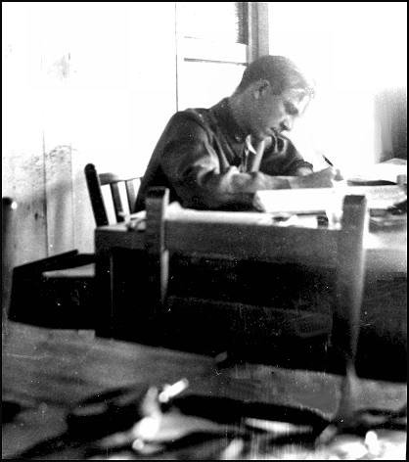
Lt. Derrick. the C.O., at his desk. - His office was rather small, and the radio table was very close to his desk. He also had a company clerk, a C.C.C. man, whose desk was across the room from him. The headphones for the radio can be seen in the foreground. Lt Derrick spent most of the day doing paper work at his desk. As can be seen, when my chair at the operating table was pulled back, it almost touched Lt. Derrick’s desk. I’m sure this cozy situation wasn’t very good for him, but he never complained to me about the almost constant code that could be heard in spite of my using the earphones and having the volume turned down.

Shortly after WUGI was back on the air, Pascal Morris, my assistant operator, arrived. Actually no assistant operator was needed, and it was a temporary assignment to await a vacancy. One good thing about having the assistant operator was that I was able to get permission from time to time to spend a Saturday and Sunday in Letohatchie. As I recall, the net had schedules all day on Saturday, but not on Sunday.
Previous to my first visit home after joining the C.C.C., I had not observed or felt much happiness in our home. However, Melvin welcomed me like I was his son, and I was delighted to find Mother, Melvin, Anne and Joe all very happy and enjoying Mrs. Powell’s home. Even Mrs. Powell, who had lived in the big house by herself, seemed to be glad to have them. For the first time in Letohatchie, our family had electricity, a refrigerator, running water, a bathroom and an inside toilet. Mother was delighted to be able to spend her day making a home for the family, rather than worrying continuously about how the family was going to have food to eat. I had not seen them for nearly a year, and both Joe and Anne had grown a lot. What a pity I could not have remained there to enjoy it with them! I was pleased to see that all of my stuff was stored in a safe, dry place.
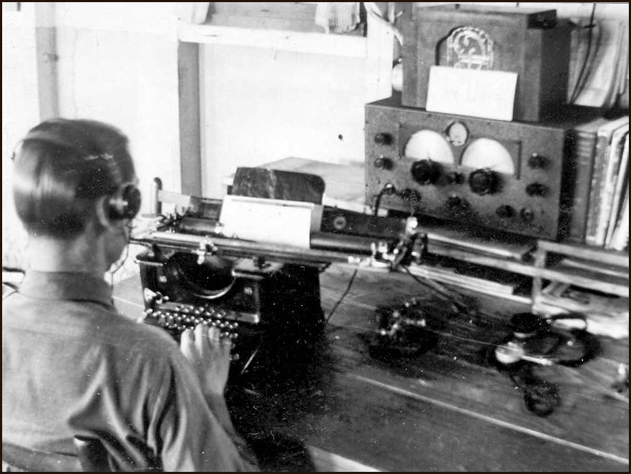
Radio Station WUGI at the C.C.C camp in Greenville. - Pascal Morris is copying a message on the “mill”, the telegrapher’s name for the typewriter. Ed Montgomery, W4FAZ, the owner and operator of a radio repair shop in Greenville, with whom I became friends, gave me the speaker that is on top of the RME-69 receiver. The 28 watt transmitter, not seen, is on a shelf just above the speaker. The speaker could be used only when Lt. Derrick was not present. When the net was not in session, short wave and long wave broadcast stations could be received. The book beside the receiver is my much studied radio theory course that I bought in Pensacola.
At our camp, there were two wires that ran down the center of the barracks to provide power for the several overhead light bulbs. The two insulated wires were separated and held in place by ceramic insulators, and where the light bulb sockets were connected, the wires were bare. One big powerful, but not very bright, man in our barracks had a silly habit of touching one of the bare spots on the wire, and challenging the men to line up holding hands. The last man in the line had to touch the bare spot on the other wire, thereby completing the circuit through the men. What a jolt! Anyone who wouldn’t participate was called a sissy, so everybody present usually got in line. It didn’t make any sense to me, but I didn’t want to be called a sissy.
My family moves into their own house in Letohatchie
Mother wrote telling me that she and Melvin had decided to buy Mrs. Alma Williams house, which was a rather nice house by Letohatchie standards. Miss Alma was a widow, whose husband had many years before died a horrible death from rabies, after having been bitten by a dog. She was moving away to live with her sister in another town. Miss Alma, who was a nice elderly lady, had some fruit trees in her yard, and in season, she would sometimes hand me a much appreciated piece of fruit when I would pass her house. The house had electricity, but had no bathroom, inside toilet, or running water. On a small screened porch in back of the kitchen there was a well with a rope, pulley, and bucket. The house had a large backyard, a hen house, a feed house, a cow shed and lot, and also a large garden. There was no down payment, and the payments would be $20.00 per month, only $5.00 more per month than the rent paid to Mrs. Powell. They were happy to have a nice place of their own, and they moved into the house on Oct. 1, 1937. Mother had maintained a goal of some day moving back to Birmingham, but I’m sure she no longer had to desire to do that. Things had changed considerably in Birmingham, and she was now quite happy in Letohatchie.
About two weeks after they had moved, I spent a weekend at the new home, and was delighted to see how happy they were. Melvin treated me like a son, and told me that he wanted me to leave the C.C.C. at the appropriate time to enter school the next year so that I could finish high school. Mother had already checked and had been told that I could enter the 12th grade in spite of my not having attended the second semester of the 11th grade. Melvin said that I could close in the back porch to make a bedroom. I made a design having two small windows to provide light and ventilation, and prepared a list of materials that would have to be ordered and shipped in by rail. When I told Melvin I could do the work in two weekend visits, he said that he would order the materials right away. Unfortunately, in January Pascal was transferred to another camp at Chunchula, Alabama, making it difficult for me to get any time off. I left Greenville before the materials arrived, and they were stored in the feed house.
The C.C.C. Camp at Torch Hill, near Ft. Benning, Georgia
The previously mentioned problems about the radio net possibly having to shut down were all solved as a side effect of a redistricting of C.C.C. camps. In early February 1938, I copied the last message that I would receive at WUGI. It stated that WUGI would be temporarily closed, and that I was directed to depart immediately for Company 4455 at Torch Hill, at the northern boundary of the Ft. Benning military reservation. Since I might not return to Greenville, I was directed to carry my personal things with me.
The Net Control Operator explained to the net that due to the redistricting, the Greenville Camp and some others were being assigned to District H, which had its headquarters at Fort Benning, Georgia. District H already had a functional radio net and code school. The Net Control Station at Ft. Barrancas was being closed, and Captain Phillips had already departed to become the Signal Officer for District H.
The next morning, I took the train to Montgomery, and waved a sad goodbye to Letohatchie when passing through. At Montgomery, I took a train to Opelika, where I changed trains and went to Columbus, Georgia, which was a short ride. A truck from the camp met me at the station in Columbus, and I was taken to the Torch Hill Camp. This travel experience lasted a little over 4 hours, and had been a breeze compared to the awful trip from Morton to Greenville.
The Net Control Station for District H, WUGA, was located in its own building at the Torch Hill Camp. It was already operating with those stations, new and old, that then had operators. Capt. Phillips had inherited a code class, with instructors, that had 16 students, 8 of which were new, and 8 were nearing graduation. One of the operators at WUMA, the Net Control Station, had already left because his time had run out, and the other operator had to be replaced because he would soon leave.
Capt. Phillips had called in a group of operators to be tested to see which one would be chosen to replace the outgoing Chief Operator. A few days later, after all of the candidates had arrived, we were given examinations in radio theory, code copying skills, and the Army Signal Corps traffic handling procedures.
Capt. Phillips interviewed all of the candidates, and his deputy, Ensign Dausman, administered the tests. My many hours of studying radio theory, copying code, and practicing with my bug really paid off because after the tests, I was selected to be the Chief Operator. Noel Vaughan and Franklyn Moorehead, would continue to be the classroom instructors. Noel Vaughan would also serve as my assistant operator. In addition, the administrative clerk, Samuel Talbert, would remain on the station staff.
I was the only one in the group of men that had been called in who personally knew Capt. Phillips (W4CRA), and that probably had something to do with my being selected. It was hard for me to believe that I had gone from a student at the school in Ft. Barrancas to Chief Operator of the Net Control Station at Ft. Benning in less than nine months. And part of that time had been spent doing manual labor at Greenville.
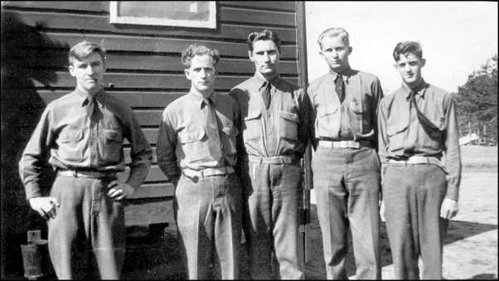
Left to right:
Samuel Talbert, Clerk;
Noel Vaughan, Instructor;
Franklyn Moorehead, Instructor;
Clarence Warren, Operator. WUGC;
Dolton Hildreth, Operator. WUGT

I took this photo, but wish that I had let Clarence or Dolton take a photo of Sam, Noel, Franklyn, and me together because we were the ones who ran the station. In early 1941, while working as an Army Signal Corps radio telegrapher at Ft. McPherson, in Atlanta, Ga., I ran into Franklyn where he was working as a radio telegrapher at the Atlanta Airport. I saw Noel in September of 1988 at Melbourne, Fla., at a ham fest. He had retired after a long career in aviation radio. He was 74 years old and looked great.

My becoming Chief Operator of the Net Control Station was indeed a lucky break, as I gained both management and operating experience. I had the responsibility of running the net, which had 12 stations in addition to the Net Control Station. The stations were located at C.C.C. camps in Georgia, Alabama, and Florida. After my selection, everyone at the station and in the net called me “Big Chief”. I had only a one day overlap with the previous Chief Operator.

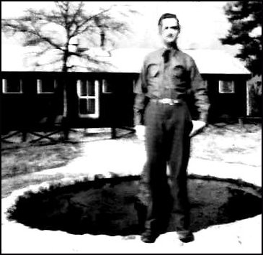

Left: - Pascal Morris, who had been my assistant operator at Greenville before he was transferred to WUGM at Chunchula Ala. After the selection process was over, Pascal returned to Chunchula, and Samuel J. Grice was assigned to replace me at Greenville.

In the photo, the building behind Pascal is the Camp Headquarters building which contained the officers’ quarters, recreational room, and office. I was in that building only once, when I was called on the carpet by the Commanding Officer, who read me the charges. I had disobeyed camp regulations and had gone into the mess hall without wearing my cravat. It really scared me because I had never been in trouble before, and didn’t know what to expect. Perhaps I might get kicked out of the Corps! I was greatly relieved when I only got a verbal reprimand after promising to sin no more.
In 1948, while I was attending Auburn University and living in Opelika, my wife Peggy and I went to Columbus, Ga. We took the opportunity to visit the Torch Hill site where the C.C.C. camp had been located. It was a beautiful site, overlooking the Chattahoochee River valley. We had arrived just in time as a bulldozer was preparing the site for a housing development. The view from the site was I remembered it, but the only relic of the C.C.C. camp was the small stone-lined goldfish pool seen in the above photo. But for that, I would not have been sure that I was at the correct site. If we had arrived an hour later, perhaps that, too, would have been leveled. Probably none of the people who would live in that development would ever hear about the more than 200 young C.C.C. men who had once lived on that site.
At WUGA, I gained a considerable amount of maintenance and repair experience on a variety of communications equipment, in addition to handling telegraphic traffic for about eight hours per day. Capt. Phillips, had a good library of technical books, which I enjoyed studying. He had installed his amateur station in a room in our building, and he often invited me to sit in on his amateur operating sessions.
Initially, all of the stations in the net had old army surplus equipment, but Capt. Phillips was very good at getting funds, and immediately began replacing the old equipment with new RME-69 communications receivers and new 80 watt Harvey 80T transmitters. That was an excellent combination that met all of our needs.
Early one Saturday morning, Capt. Phillips and I went in a military truck with a driver to install the radio station at Co. 4447 in Auburn, Ala. Dolton Hildreth, who had finished his training and was being assigned to the station, came with us. We also brought the receiver, transmitter, antenna, and wooden cabinet that would hold the equipment. Two telephone poles had been obtained ahead of our arrival, and using an A frame and with help from some of the C.C.C. men, we erected them in the correct places for the antenna. Pulleys, with ropes, had already been placed at the top of each pole so that the end fed half-wave antenna could be raised quickly. An open wire ladder feeder led from the near end of the antenna to the station, which was located in the Commanding Officer’s office. Once installed, we contacted Noel Vaughan back at WUGA to check it out. We arrived back at Torch Hill in the late evening.
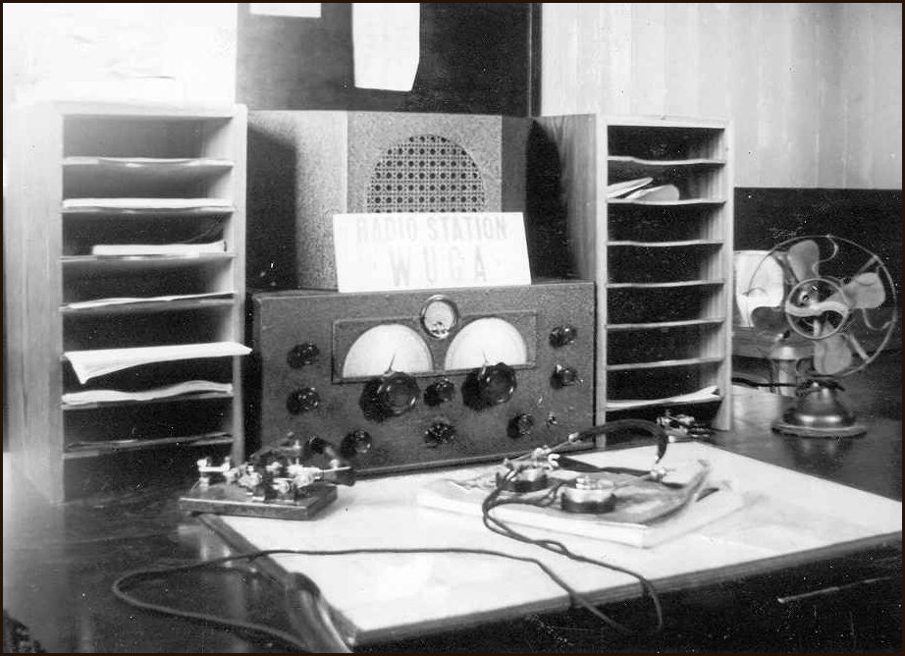
The operating desk at Radio Station WUGA, the Net Control Station for the District “H” Headquarters. - The RME-69 receiver was brand new and replaced an older Hallicrafters SX-18 receiver. Capt. Phillips’ personal receiver was a RME-69, and he liked it so much that he saw to it that eventually all stations in the net had RME-69 receivers. The net frequency was 4,440 kc/s. The station occupied a wooden temporary army barracks type building. There was no air conditioning or central heating. The telegraph key on the left is my cherished McElroy “bug” that I had bought while at Greenville. It was my most prized possession.

Capt. Phillips was an excellent administrator, and had a good technical background in communications. I understood that he was the owner of a telephone system in a town in Florida. He was not a very good telegrapher, and his principal experience with telegraphy had been to learn the code in order to get his amateur radio license. He preferred using voice instead of telegraphy when using his amateur radio station. On the other hand, Ensign Dausman had years of experience as a radio telegrapher in the Navy, and was a very skilled operator. He personally gave me the code test when they selected me to be the Chief Operator. He sent fast, perfect code on a bug, and I had no problem copying it on the mill (typewriter). He was the net control operator for a Navy amateur group that met once a week, and I stood in for him when he couldn’t make the schedule. The Navy operational procedures were very similar to those used by the Army and the C.C.C.
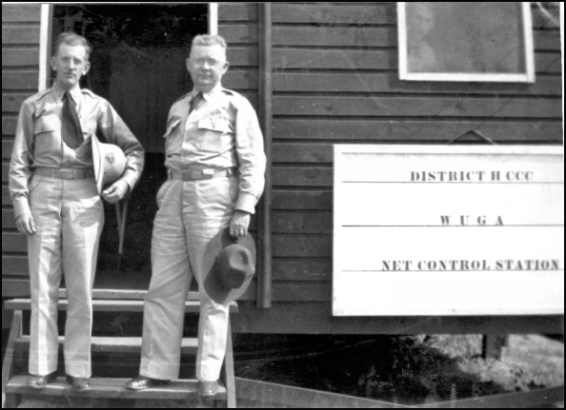
Ensign Dausman, Assistant Signal Officer, and Capt. Phillips, Signal Officer. - The operating room where I worked is just inside on the right. I didn’t take this photo because I was on duty I can be seen, very dimly, looking out of the window of the operating room.

The radio school at the Net Control Station consisted of two classes, an Upper Class and a Lower Class, each typically having 8 to 10 students. Noel Vaughan, who was also my assistant operator, was the Upper Class Instructor. When the Upper Class students graduated they were posted to camps as radio operators. The Lower Class students then moved into the Upper Class and a new group of men from the camps became the Lower Class.
Early on, a very few of the students would demonstrate an inability to learn the code, or were otherwise unqualified, and they were sent back to their camps. The possibility of being sent back to their camps to do manual labor was sufficient motivation for the students to do the best they could.
Keeping all of the radio stations manned, some with two operators, was difficult because of men leaving the Corps for various personal reasons, or for having completed the maximum allowable service of two years. Only men who were recently inducted were considered as candidates for the radio school.

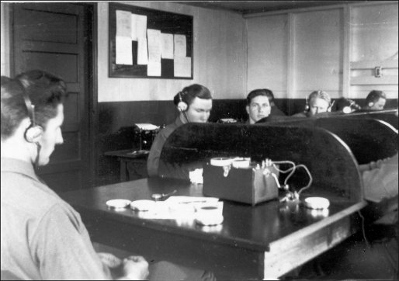
Franklyn Morehead, the Lower Class Instructor - He, is using an “Instructograph” automatic code sending machine for sending code characters and text that could be heard in the earphones. The machine used paper tapes with holes corresponding to the code characters to be sent, and the tape speed could be adjusted to send at the desired speed. A telegraph key on the instructor’s desk could be used to send messages of the type the student would be required to copy when assigned to a station. The student’s desks also had a telegraph key, and both sending and receiving were practiced.. One student could send a message to be copied by the other students. The Upper Class spent more time simulating traffic handling.

When I arrived at the Net Control Station and became Chief Operator, the Upper Class of nine students had been there for almost three months and were nearing graduation. The lower class had been there for nearly six weeks. The Upper Class graduated just in time to replace some operators that were leaving and to staff some new stations that were being put into service. The concept was to always have two operators at some of the stations so that there would be operators available when needed. However, when I arrived, none of the stations had two operators.
Since the Net Control Station operator would normally send traffic on a semi-automatic key (bug), the Upper Class instructor would often use a bug to send code practice. At the stations, the operators were required to deliver their messages typed on radio-telegram forms, so the students were given basic instruction in touch typing and the art of copying code on the telegrapher’s typewriter, which is called a “mill”. The mill has all capital characters. Mills were available for the students to practice typing after class, and most of them did.
By the end of the school, the students had achieved a code speed of at least 15 words per minute. The students were taught the same traffic handling procedures as were used by the U.S. Signal Corps. Enough basic radio theory was taught to enable the students to tune their equipment properly.
Each student was expected to continue practicing after arrival at his station by copying on the typewriter the messages that were sent to other stations in addition to those send to his station. At his station, he could also gain practice in the evening by copying the amateur and commercial transmissions that could be heard on the air.
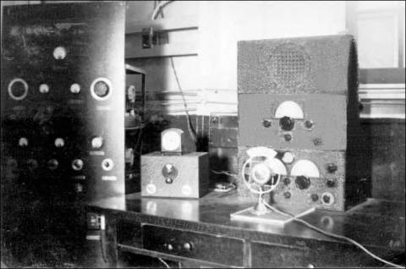
Amateur Radio Station W4CRA - Capt. Phillips’ fabulous 1 KW station was brought from Ft. Barrancas, where I had helped him do some work on it while a student there. The radio frequency rack is on the left, and the class B modulator rack is on the right, but is not shown in the photo. The unit on top of the RME-69 receiver is a RME DB-20 preselector, which made the receiver far more sensitive. The small box to the left of the receiver is an “electron coupled oscillator” (ECO), which allowed the transmitter frequency to be set to any frequency in the amateur bands. Capt. Phillips had an excellent technical radio background, but was not a good telegraph operator. Instead, he used a microphone. He operated primarily on 20 meters, and he enjoyed contacting foreign stations. In those days, the transmitting components were large and very heavy, especially the transformers. Today, a station having the same power will fit into two relatively small desk-mounted cases. One would be a transceiver, and the other an RF power amplifier. . The class B modulator equipment would not be required today as a modern amateur radio station using voice would use single sideband modulation (SSB) instead of class B, amplitude modulation (AM).
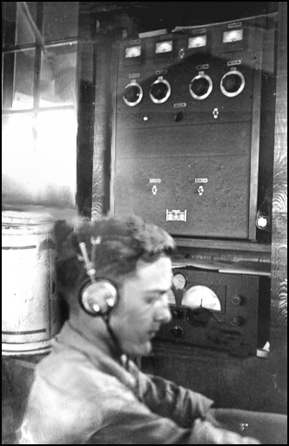
Radio Station WUGO, Auburn, Ala., with Dalton Hildreth at the operating desk. - The installation, which uses an 80 watt Harvey 80T transmitter and a RME-69 receiver is identical to the standby station at WUMA, which was also used as a radio amateur radio station with the call W4EQI.
When I was at Auburn installing the equipment, I would not have dreamed that I would some day attend college there and would receive a degree in Electrical Engineering (Communications Option). While attending Auburn, I served as Chief Engineer of the local broadcast station, WJHO. Following graduation, I taught radio engineering subjects at Auburn for a year before joining Dr. Wernher von Braun’s guided missile group in Huntsville, Alabama.

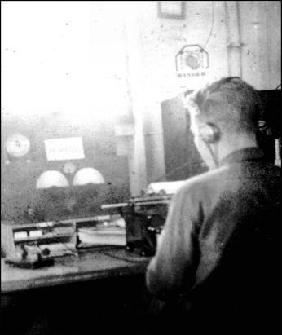
Left -- Thurston L. Lee (W5GOH) - He sent me this photo of him when he was the operator at WUGE, Sulphur Springs, Florida. He was one of the best operators in the net. He already had his amateur radio license when I went to WUGA.

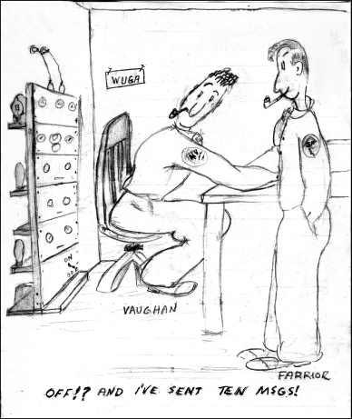
One day Noel Vaughan was operating, and he thought he had sent a message. However, unknown to him, the transmitter’s plate voltage was off. He could hear the side tone, but there was no power output. He was patiently waiting for an acknowledgement when I spotted the problem.

Sam Talbert, our clerk, was a good cartoonist. He also had a good sense of humor, and he sketched this cartoon to record the event. Sam was a pipe smoker who nearly always kept his pipe in his mouth. Since the three of us were buddies, Noel and I had also acquired pipes, but I didn’t take to it and soon quit. Noel was still smoking his pipe when I left the C.C.C.
While at Torch Hill, I was very happy and proud when I received my amateur radio license (on Aug 2, 1938), with the call W4FOK, which I still have. Capt. Phillips gave me the test. At Torch Hill, we had a standby radio station equipped with a RME-69 receiver and a Harvey 80T transmitter, the same setup as shown in the previous photo of Dalton Hildreth at WUGO. Most of the outlying stations had the same equipment. I could also use the standby station for amateur radio when not on duty. It had a “club call” of W4EQI, and I used it before I was licensed. Such operation was legal when done under the supervision of a licensed amateur, and Noel Vaughan held the call sign W4EUO.
When the C.C.C. camp at Torch Hill C.C.C. camp, where we lived and where WUGA was located, closed down, WUGA was moved to a centrally located site on the Ft. Benning Army base. We moved into a small building that contained a new 400-watt Harvey transmitter, an office, a classroom, a shop, a storeroom, and a dormitory room.
Although the new radio station was immediately put into operation, the sleeping quarters were not ready, so for several weeks we slept at a vacant C.C.C. camp at Harmony Church, about three miles east of the main post. Like the Army companies in those days, the C.C.C. camps were either black or white, and the Harmony Church camp had had black enrollees, but white officers. We lived in what had been the officer’s quarters. There was a recreational room with a pool table, so we played a lot of pool in the evening while we were there. We had a military truck for commuting between camp and work.
We ate at an Army mess in walking distance from our new location, so once again I enjoyed excellent food. The Post Theater and the army PX were close at hand, so we could take advantage of things that were not available at Torch Hill. Compared to our previous living conditions, the Army was ‘first class”.
The only thing that was not good about our new facility on the army base was that we were not equipped for amateur radio operation. We didn’t have the W4EQI club station that we had had at Torch Hill. There was also no place for Capt. Phillips to install his amateur station, so he moved it to his home in Columbus.
A photo of me standing beside a giant WW-I tank that was on display near our Net Control Station building.
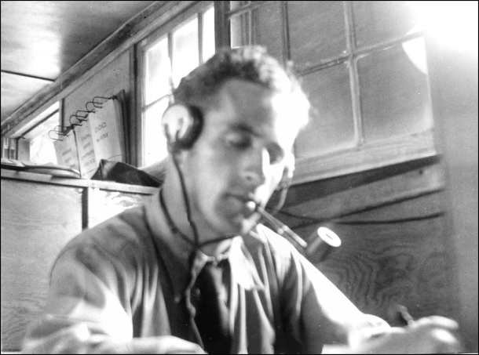
Our store room contained not only our spares, etc., but also some old surplus radio equipment that had been brought in from the stations when they were upgraded. I wasn’t allowed to take one of the old transmitters, as they had not officially been declared junk, but from the junk I collected some parts, including an old inoperable pair of headphones, which I fixed. The prize, however, was an old National SW-3 regenerative receiver, which was inoperable, but I knew that I could repair it. Without it, I would probably not have been able to put a station together, as I had no parts with which to build a receiver. The National SW-3 was an old three-tube battery set that was identical to the receiver that had been at Greenville when I had first arrived there. One man's junk was certainly another man's treasure. I also found enough parts to build a power supply for the transmitter. My foot locker was filled with radio stuff, and I had to keep my clothing and other personal things in my barracks bag.

Noel Vaughan, my assistant operator, copying a message at our new station location.

In the photo, Noel is using his right hand to send with a “bug”. In his left hand he is holding a pencil with which the writes on the message, while still sending, the time sent, the sign of the operator to whom sent, and the date sent. That was a trick that took some practice.
Noel’s call sign was W4EUO, and I talked with him over ham radio after WW-II. I also saw him at a ham fest in Melbourne, Florida, in 1988. I received a letter from his wife in 1998 saying that Vaughan had died of cancer on August 5, 1997, at age 83. His career was in aviation radio repair and maintenance.
In accordance with Melvin’s and Mother’s invitation, and my plan, I left the C.C.C. on Sept. 1, 1938, and went back home to Letohatchie. Noel Vaughan became the Chief Operator at WUGA. As expected, I was allowed to enter the 12th grade even though I had only attended the first semester of the 11th grade. The first thing that I did after I arrived at home was to enclose the back porch for which the materials had been previously bought and stored in the feed house. I hired a colored boy for 50 cents per day to help me for several days so that I could quickly have a room of my own.
Back home in Letohatchie -- My first Amateur Radio Station
The next thing I did was to begin construction of my first amateur radio station. I was very lucky, because my family had electricity in the home, without which my amateur radio station would have been impossible. The tools and other things that I had bought from the departing radio operator in Selma stood me in good stead.
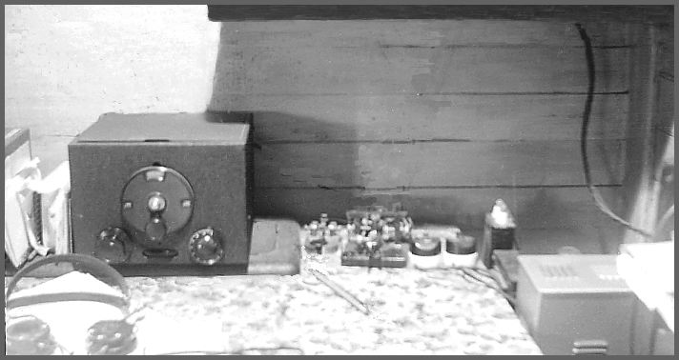
My first Amateur Radio Station. - The National SW-3 receiver and operating table.

The above photo, taken about late November 1938, shows my SW-3 receiver on the operating table. The transmitter is on a shelf above the receiver. As can be seen, there is no microphone on the table as only telegraphy was used. I couldn’t use the speaker that Ed Montgomery had given me at Greenville because the SW-3 didn’t have sufficient audio power to drive a speaker. Later, I would build an audio amplifier.
To the right of the receiver is my solid brass hand key, and next to it is my treasured Mac bug, both of which I still have. Two switches can be seen on the table beside the bug. The left one switched the heater power to the transmitter tubes, and the other switched the high voltage power supply for the transmitter plate circuits.
The top of the transmitter power supply is visible on the right hand side of the table. It was built entirely from junk parts, and was capable of supplying much more power than needed for the one-tube transmitter. There was not much safety, as the power supply high voltage was across the exposed terminals of the capacitor shown just to the right of the right-hand switch. I would be able to use the power supply later when I upgraded my transmitter. About the only things that I had to buy were batteries to supply the filament and plate requirements of the old National SW-3 receiver. I sat at this operating table for many hours, often far into the night, enjoying ham radio operating at its best. Among the first contacts I made were some of the C.C.C. operators with whom I had worked and who were hams. I also made a number of new friends who enjoyed CW (code). I don't think I've ever heard CW signals that sounded better than those received on that old SW-3 regenerative receiver.
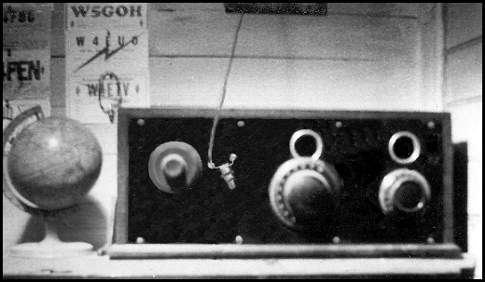
My First Amateur Radio Station -- The one-tube transmitter.

The above photo, taken about November 1938, shows my first transmitter, which rested on a shelf above the operating table shown in the previous photo. It is contained in a case from an early radio that someone gave me. The round holes above the dials were originally for looking in to see if the filaments of the tubes were glowing. For my usage, I removed the top of the case to provide adequate ventilation.
The transmitter was built bread-board style on the bottom of the cabinet. It used a single type 6L6G tube in a tri-tet crystal controlled oscillator that had an output between 10 and 15 watts. That was ample power for plenty of contacts, both foreign and domestic. I had only one crystal, an 80-meter crystal to which frequency the grid circuit was tuned (right hand dial). The plate circuit could be tuned (left hand knob) to either the 80-meter frequency, or the second harmonic on 40 meters. Plug-in coils provided band switching for the plate circuit. Contrary to convention, I have always designed my equipment with the output on the left so that when the chassis was flipped over, end for end, for construction or repair, the dials would be in front and the stages would be in the same order, left to right, as they are in conventional circuit diagrams.
The antenna was an “off-center Hertz”, now known as a “Windom”, that was a single wire cut to be a half wave length long on the 80 meter band. The single wire feeder connection was made at a point 1/3 of the way from one end of the antenna, which is a compromise that made the antenna system work equally well on both the 80 and 40-meter bands. That connection point gave a low standing wave on the feeder.
I had no insulators for the antenna, so I used two Coke bottles of the old type that curved in near the bottom. The antenna wire was tied to the cap end, and the supporting rope was tied near the bottom. The cotton rope was waterproofed by rubbing it with bee’s wax.
The meters had already been salvaged from the junk at Ft. Benning, so I didn't have any meters. Without the funds to purchase a meter, I had to build, test and operate the equipment without the benefit of any kind of meter. The only measuring devices that I had are the two simple ones shown in the photo. On the wall, near the left top corner of the transmitter, can be seen an oval object hanging on a nail. It is actually several turns of hook-up wire connected to a small dial-light bulb. It could be held near the plate coil when tuning and would glow more brightly at resonance.
On the front panel of the transmitter just to the right of the left hand dial can be seen another small dial-light bulb. The antenna feeder wire comes through the front panel and connects to the bulb at the right terminal of the bulb socket, and the feeder wire can be seen connected to the left terminal, so that the feeder current would flow through the bulb filament. The dial at the left is for a capacitor that controls the coupling of the feeder to the transmitter output. At maximum power output, the bulb would glow at an almost normal brilliance. Another crude measuring device was that I could tune the plate circuit to resonance by observing the bluish glow of the type 83 mercury vapor rectifier. That also gave an indication of the amount of current being drawn. Not shown above the transmitter was a blade switch that allowed switching the antenna between the receiver and transmitter. It was a little inconvenient, but no real hardship. On the wall can be seen some of the QSL cards of my C.C.C. buddies: W5GOH - Thurston Lee, W4EUO - Noel Vaughan, W4FEN - Leroy Littleton.
School work was very easy, but I felt strange being with students so much younger than I was. When I finished the 12th grade with good grades, I had fully expected to graduate. However, just before graduation time, after I had participated in the graduation rehearsals, the principal, Mr. W. T. Porter, called me into his office and told me that since I had never attended the second half of the 11th grade, I could not be given a diploma. That unexpected news made my mother so angry that she went to the County Courthouse in Hayneville, and talked with the County Superintendent of Education. She argued that she had been told that I could skip the last half of the 11th grade and I had been allowed to attend the 12th grade. Now, she argued, they were going back on their word, even though I had made excellent grades in the 12th grade. However, her arguments didn't prevail, and she later told me that she had gone outside and had sat on the courthouse steps and cried. She feared that even after so much effort, I might never get my high school diploma.
I was unemployed for several months, but then decided to reenter the C.C.C., as I was legally allowed to serve for a total of two years. My plan was to complete my C.C.C. service and then go back home to finish the last half of the 11th grade so that I could receive my high school diploma.
Back in the C.C.C. at Ft McClellan, Alabama
On a Thursday, Oct. 5, 1939, after being accepted in Montgomery, I boarded a truck with several other men headed for C.C.C. Company 4488 in Ashville, Alabama, northeast of Montgomery. While traveling to Ashland, I had worried that the Ashland camp might be in a district that had no radio net, and I might have to plant trees and dig ditches instead of being a radio operator. However, when the truck arrived at the camp I immediately spotted the radio antenna! The operator let me use his telegraph key to talk with the Signal Officer, Lt. Robert Lowery, W4DQW, at the District “D” Net Control Station in Ft. McClelland, Ala. He told me that he needed a Chief Operator and I copied a message from him to the camp C.O. informing him that an Army truck would come to get me the next morning. Since there was no C.C.C. camp at Ft. McClelland, I would remain a member of the Ashville camp, and would be assigned to the District Headquarters. What luck! After breakfast, I was issued my C.C.C. clothing. I had not dreamed that I would ever wear the C.C.C. uniform again, but I felt quite at home in it. I placed my civilian clothes in my foot locker, which I had brought with me, and waited for the truck to come and pick me up.
When I had left Montgomery, headed for Ashville, I hadn’t realized that I was traveling in a bee line toward a good job. Ft. McClellan was only 30 miles from Ashville, so in less than an hour after leaving Ashville I was at Fort McClellan. On the way, the truck driver, himself a C.C.C. man attached to District headquarters, told me that there had once been a C.C.C. Camp at Ft. McClellan. The buildings were still there, and one of them was being used to house a few C.C.C. men who were assigned to District Headquarters to serve in various capacities, mostly as truck drivers. This was the same housing situation that had existed when I was at Ft. Barrancas.
After finding a vacant bed, and having placed my foot locker at the end of it, I walked over to the nearby radio station and checked in. The station had a small staff, and there was no radio school at that time.
In addition to Lt. Robert Lowery, the District Signal Officer, there was a civilian clerk, Mr. Springmann, and a civilian radio technician, “Red” Clearman. Lt. Lowrey had built the radio net from scratch, and had set up a code school to teach enough operators to staff the stations. Some stations had two operators. While that was taking place, Red Clearman was building small transmitters for the camps. These small transmitters had been designed by Lt. Lowrey. The camps used Hallicrafters S20R Sky Champion receivers, exactly like the inexpensive receiver that I would buy later when working in Atlanta. For the Net Control Station, Red had also installed two larger commercial transmitters, in 6 foot racks, and two RME-69 receivers.
“DR” Parkman, a WW-I veteran, had been acting as Chief Operator. Everyone welcomed me warmly, and within minutes I was happily sending and receiving messages. It was hard for me to believe that just the day before I had eaten breakfast at home in Letohatchie, with no idea that things could possibly turn out so well, and so quickly. I was prepared for the worse, but this was the best the C.C.C. had to offer. The living situation here was very similar to what I had at Ft. Benning, as we ate in a nearby Army mess. We also had access to the Post Theater and the PX. Certainly, there was nothing to complain about.
There were actually two radio nets, and the Net Control Station had two receivers and two transmitters, but only one operating desk. Having two receivers made it possible to monitor one frequency while the other frequency was being used, so that emergency traffic would not have to wait. Each net had more than 6 stations. The Mississippi stations used 4305 kc/s, and the Net Control Station used the call WUNA when working them. I don’t recall the frequency used by the Alabama stations, but the call the Net Control Station used to work them was WUMA. The Net Control Station had very good equipment and I received some good technical and operating experience while there. To improve my copying ability, I copied “Press Wireless” nearly every night. Amateur radio was not possible as the transmitters and antennas were not compatible with radio amateur frequencies. What a pity!
While at Ft. McClellan, I again had access to some junk radio parts. I collected everything I would need to modify my SW-3 receiver to use cathode type (heater) tubes, and to build a voltage regulated power supply to replace the batteries previously used. Also collected were parts to build a much better transmitter. It was all used stuff, but I was able to get all of the needed tubes, plus some spare tubes that had plenty of life left in them. I also found two meters that could be used to measure plate currents in the driver and amplifier stages of the transmitter.
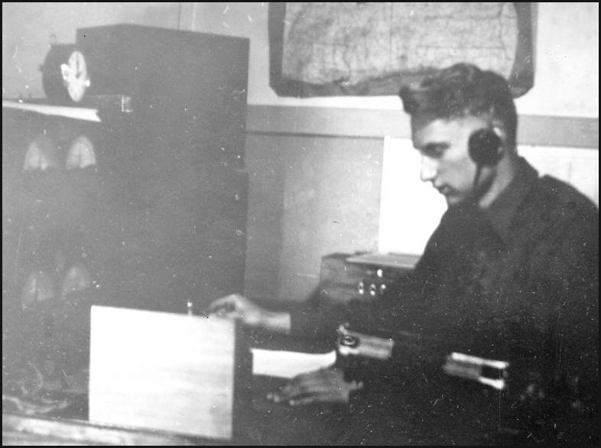
The Operating Desk - I am sending messages using a “bug” semi-automatic key at WUMA/WUNA, the Net Control Station at the District Headquarters at Ft. McClellan. There are two RME-69 receivers, one for the Alabama stations and the other for the Mississippi stations. The two transmitters can’t be seen as they are on the other side of the room, to my left.

After WW-II, while I was going to school in Auburn, I talked to Bob Lowrey, W4DQW, on amateur radio and we swapped war stories. He became a Colonel in the Signal Corps and had had a career in Radar. It turned out that we had a number of common friends, among them being Capt. Phillips, the Signal Officer at Ft. Barrancas and Ft. Benning, and Pappy Jones, the supervisor at WVR, Ft. McPherson, Ga., where I worked as a telegrapher in 1940/41. Pappy Jones was a well known radio amateur who wrote a monthly article named “Squinch Owl” for QST, the radio amateur magazine. Pappy had a good sense of humor, and called his always busy wife “Hurricanie”. Pappy wrote to me frequently during WW-II while I was in the U.K. After the war, he moved to California and died there. In a letter from Bob Lowrey dated 2/16/1983, he told me that Capt. Phillips had died several years before. The last letter received from Bob Lowery was in 1997, when he was 87 years old and not well. I wrote to him several times after that , but received no reply.

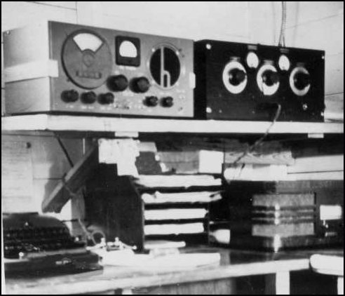
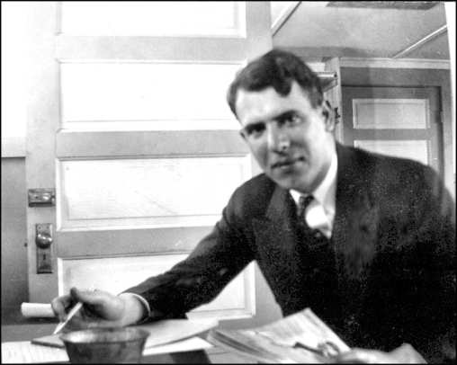
The field station at Quitman, Miss. Lt. Bob Lowrey at his desk at WUMA

All field stations in District D had the same equipment as at Quitman. The receiver was a Hallicrafters SX 20R receiver, and the small low power transmitter was built by our technician, Red Clearman. In 1940, after I began working at WVR in Atlanta, I bought a SX 20R receiver. I still have it in 2005, and it still works. It rests on a shelf to remind me of the good old days in amateur radio.

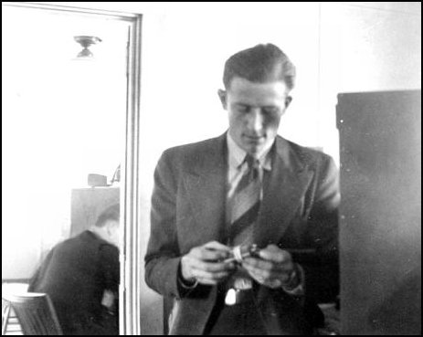
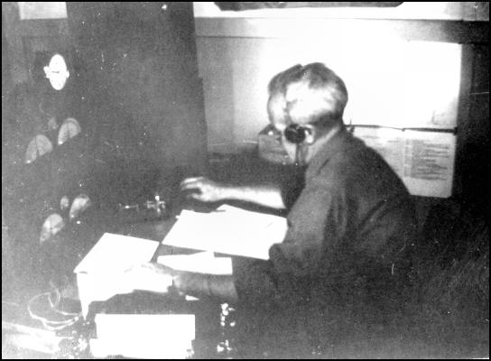
“DR” Parkman, 2nd Operator WUMA & “Red” Clearman, Technician
WUNA. DR was a WW-I veteran. Red always wore a coat and tie.

Home Again -- My 2nd Amateur Radio Station -- Graduation from High School!
Melvin and Mother had told me that they wanted me to return home and complete high school, so on March 31, 1940, I left the C.C.C. for the last time and went back home to attend the required second half of the 11th grade. I was then 20 years old, and felt like an old man among my much younger classmates. I still felt bitter about the treatment I had previously received from the Lowndes County school officials when I was not permitted to graduate after I had completed the 12th grade.
Within several weeks after I arrived at home I had finished building the new transmitter and the modified receiver, and was on the air again. This time I had the advantage of higher power, and was not “rock-bound” (crystal controlled), but could roam the bands with the variable frequency oscillator that I had built.
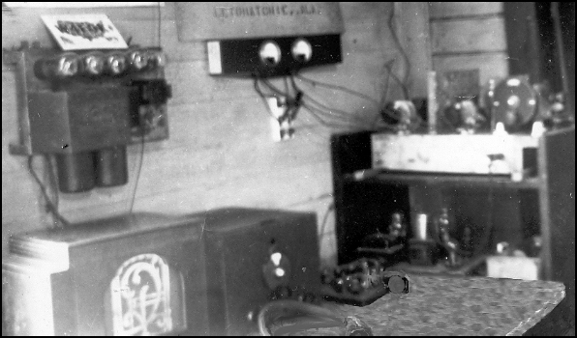

My second Amateur Radio Station - Built in early 1940

The above photo, taken in April 1940, shows the setup of my second amateur station. On the table can be seen the modified receiver, with my McElroy bug at the right, and at the left the speaker given me by Ed Montgomery when I was the radio operator in Greenville. Above the speaker is an audio amplifier built from an old junk radio that was given to me by someone in Letohatchie. The amplifier was used to drive the speaker when the phones were not being used. I had coils for the SW-3 receiver that covered the short wave bands, as well as the amateur bands, and I had some interesting short wave listening. That little radio really worked like a charm.
The transmitter is located on the top shelf to the right, with the power supplies below. At the right end of the transmitter can be seen the variable frequency oscillator (VFO) of the electron coupled type that used a type 6SK7 tube. The VFO had a high quality dial, and the operating frequency could be set quite accurately to any frequency in the amateur band using a calibration chart that I had constructed by asking amateurs who used crystal control to tell me their frequency.
I had designed, built, and tested the VFO section and had done additional work on the new transmitter while at Ft. McClellan where I had access to Red Clearman’s shop and tools. The VFO drove a type 6V6G buffer, which drove a pair of type 6L6G tubes in the final. The buffer and amplifier were biased to cutoff, and the VFO was keyed. Keying was excellent, and the monitor signal I heard while sending was good.
The transmitter power supply was the same as used with my first station, as it had been built with a larger transmitter in mind. Unlike my first station, my second one has two meters, shown mounted on the wall, that were also salvaged from the junk at Ft. McClellan. They indicated the buffer and final amplifier plate currents in the transmitter. The meters made tuning the transmitter much easier. A third meter had been used to build a much-needed current, voltage, and resistance tester. The output power was approximately 45 watts. Plug-in coils were used, and the station could be operated on the 80, 40 and 20-meter amateur bands, and the old Windom worked fine.
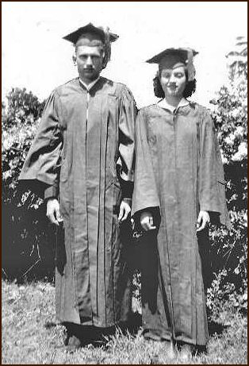
Left - My sister Anne, who is 2 ½ years younger than I am, graduated with me on May 20, 1940. I finally received my much delayed high school diploma. Mother used my box camera to take this photo at the corner of our home in Letohatchie.
Needing to find work as soon as possible, I tried to join the U.S. Army Air Force. I had been encouraged by some of the military radio operators that I knew at Maxwell Field, at Montgomery, and felt that with my experience I could get ahead quickly. However, the Army doctor rejected me for being underweight. I tried the Navy, and the Navy doctor rejected me because I had an irregular pulse. Hoping that there might be a need for civilian radio operators at WVR, the Army Signal Corps station at Ft. McPherson, in Atlanta, I wrote a letter describing my qualifications. I felt that to be a very long shot.

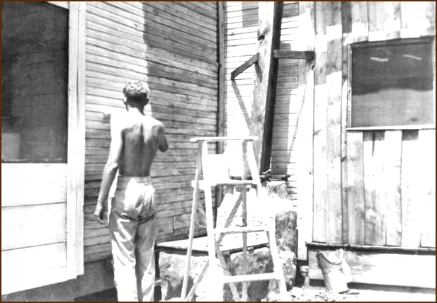
Left - Painting the back of the house. The screen window to my left was the back porch with the well. The board and batten wall on the right with the window is the where I closed in a porch to make a bedroom for myself. My first amateur radio station had been in that room. The bucket-like object on the ground under the board and batten wall is my old diving helmet, then discarded, that I had built in 1936 and had used to explore the bottom of the large Letohatchie Ponds.
The house needed painting, a job on which I spent two weeks applying three coats of oil paint. It had not been painted for many years, and the first two coats immediately soaked in. The flooring on the front porch had to be replaced and painted.

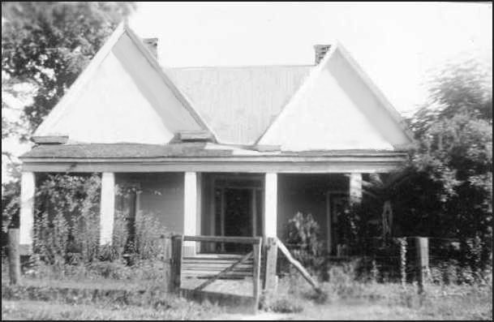
Melvin’s and Mother’s Letohatchie home, after the paint job.

My sister Anne married Don Slesnick in July, 1942, and their wedding was held at the Letohatchie Methodist Church. I was at that time on the Isle of Man, U.K., as a member of the Civilian Technical Corps. The family lived in this home from Oct, 1937, until June, 1944, when they moved to Montgomery because of Melvin’s railroad job having been transferred to the L&N Dispatchers office there.
Mother had lived in this home about half of the total time she had lived in Letohatchie. Melvin was the kind, loving, responsible father figure we had never had. By far, our family’s happiest days in Letohatchie were while living in this old house. Unfortunately, I was not at home most of that time. At Montgomery, Melvin served as a land line telegrapher at a high traffic desk, which was a very busy, high pressure job compared to his previous job as operator/agent at Letohatchie. However, he had the telegrapher’s love of telegraphy, and enjoyed his new job.
Eventually, many years after WW-II, the old Letohatchie home was bought by someone who lived in a trailer in the garden area and let the house and outbuildings deteriorate. Later, it was slowly demolished over a period of several years in the mid 1990’s, and except for the trailer, the lot is now vacant. (2005)
Joe was nearly 15 years old when the family moved to Montgomery. Melvin died of cancer in 1948. My Mother lived until 1994, when she died at my sister Anne’s home in Coral Gables, Fla.
An Exciting Trip down the Alabama River
Not being able to find a job, and needing something to break the monotony of my life, I decided to make a trip down the Alabama River from Benton to Mobile in a small paddle boat. I can’t explain how that particular idea came to my mind. I convinced my friend Guy Coleman, also unemployed, that it was a good idea and he agreed to accompany me. The local folks thought we were crazy. We located a junk boat, and by pooling our resources, we obtained enough provisions to last us for the trip. We would abandon the boat at Mobile and hitchhike back. A local man, Eddie Mims, kindly agreed to haul our boat to the river, and my sister Anne, my young brother Joe, Guy's brother Jimmy, and some other local kids went with us to launch the boat on August 28, 1940. After many exciting and sometimes dangerous experiences, we arrived exhausted and half starved in Mobile 14 days later.
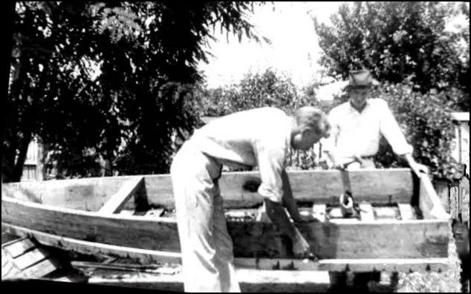
The old boat being repaired - Guy Coleman and I (left) are repairing the old boat that we used for the river trip. This was done in my backyard with the bow of the boat on a chicken coop and the stern on a bale of hay. After a coat of white house paint left over from the house painting, Guy’s brother Jimmy painted on the bow the boat’s name, “Teeny”, after the pretty girl who lived next door.
During the trip we had only a road map that showed no details of the river, so we never knew what we would find around the next bend. We really felt like explorers. At that time the river was in pristine condition, as there were no dams and locks on the river. There were no recreational boats on the river, and no docks or marinas. The only town of any size was Selma, which we passed the first night. Elsewhere, only a few structures of any kind and only a few lights could be seen from the river during the entire trip.
Upon our arrival at Mobile, I found a letter from Mother in General Delivery at the Mobile Post Office saying that I had been selected for a Civil Service job as a Radio Operator at Ft. McPherson, Ga. That was fantastic news! It surprised me, as I had not received an application form for taking the competitive test. They had obviously confirmed my qualifications by checking the references that I had given in a letter that I had written.
Radio Station WVR
A few days after our return from the river trip, I went to Atlanta and began work at the Army’s 4th Corps Area Net Control Station, WVR, located at Ft. McPherson, Georgia, adjacent to Atlanta. I was pleased to discover that I was among the most experienced operators there, and the only one with a knowledge of radio equipment. I enjoyed the work very much. The job paid $1,620 per year, which was more than I had imagined I would be able to earn at first, and I received a considerable amount of valuable technical and operating experience.
The kind lady at the boarding house where I lived allowed me to install my amateur radio equipment and put up a Windom antenna between some trees. I soon made the largest purchase I had ever made when I bought a Hallicrafters Sky Champion S20R. Although relatively inexpensive ($49.50), it was a quite satisfactory communications receiver. I used the transmitter shown in the photo taken in April 1940. The S20R is the same receiver as was used at the field stations in District D, and is shown in a previous photo. I again enjoyed many hours on the air. Although living in a city was strange to me, life was great! Today (2005), the old S20R receiver still works. Although no longer in use, it is very nostalgic to see it on the shelf, and to remember the fun it gave me over a number of my early years as a radio amateur.
After we returned from the river trip, Guy Coleman joined the C.C.C. and became a radio operator at the C.C.C. camp at Quitman, Mississippi. Quitman was a station in the net where I served as Chief Operator at Ft. McClellan, Ala. Guy also became a radio amateur with the call W5KFL. Guy later joined the Navy and became a Signalman. Sadly, he lost his life when his ship was torpedoed during WW-II. He was the only close friend that I lost during WW-II. In recent years, Guy’s brother Jim Coleman, who painted the name “Teeny” on the boat, gave me the previous photo of the Quitman station with the S20R receiver. He also gave me one of Guy’s W5KFL QSL cards.
I Join the Civilian Technical Corps and go to the United Kingdom
About the middle of 1941, I learned about the Civilian Technical Corps, a British organization being formed to recruit American technicians, among them radio technicians to work in the new RDF system (now called radar) that gave advanced warning of enemy aircraft approaching the shores of the United Kingdom. Believing that it was a worthy cause, and eager to gain more technical experience, as well as excitement, I submitted my application and was soon afterward accepted. Before leaving, I had a few days vacation at home, and enjoyed it very much.
I was very sad to know that it would be a long time before I would see my family again. It was also sad to realize that it would probably be years before I would again be able to use my amateur radio equipment. I packed my equipment it in a strong box, nailed it shut, and shipped it home. I knew that my mother would guard it carefully. Although leaving was sad, I felt that I had to do it. She was told to use my Hallicrafters receiver as the family radio, as they didn’t have a good radio. It was still serving as the family radio when I returned home after the war in December, 1945.

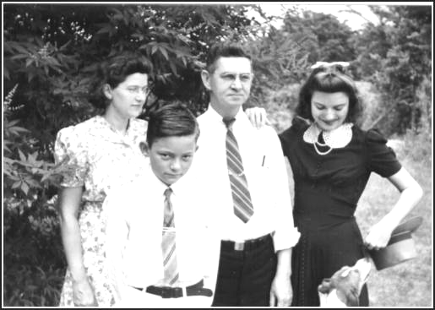
My family - Mother, Joe, my step father Melvin Sanderson, and Anne standing in front of the family home previously shown. They were dressed to attend church. -- This photo was taken in 1941 during my visit home shortly before leaving to join the C.T.C. This is my most nostalgic photo from that period.
On Sept. 19, 1941, I departed Atlanta by train and traveled to Montreal, Canada, where I officially became a member of the Civilian Technical Corps. I was issued a Royal Air Force uniform with black buttons instead of brass. To keep the enrollees busy, we were often marched up and down Mount Royal, which overlooks Montreal.
When the time came for me to depart for Halifax, Nova Scotia, to board a troop ship bound for England, I could not leave because my passport had not yet arrived from New York. Luckily that prevented me from being with that group of 19 C.T.C. men who lost their lives when their ship, the S.S. Vancouver Island was sunk in the North Atlantic with no survivors on Oct. 15, 1941. I left in the next group and sailed to Liverpool on the HMTS Andes, arriving there on October 17, 1941. After a brief stay at CTC headquarters in Bournemouth, England, I attended a RAF school for several months to learn to maintain and repair the early warning radar system known as the “Chain Home” (CH) system. Upon graduation, I was assigned to a CH station on the Isle of Man, an island in the middle of the Irish Sea. I had done well at school, and the head instructor told me that I had received by far the best posting. I greatly benefited from the training and technical experiences, and my time on the Isle of Man was enjoyable. I even had an opportunity to use radio telegraphy when I would often relieve the telegraph operator at the tracking station who was sending airplane plots to the plotting room. After a year and a half, it became apparent that the CTC might be terminated due primarily to the U.S. having entered the war, and I decided to make a change rather than to wait for events to happen over which I would have no control.
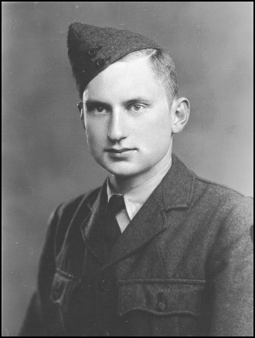
Left: - Jim Farrior, in CTC uniform. - Photo taken at Douglas, Isle of Man, April, 1943
I Join the U.S. Merchant Marine

I had thought that my professional telegraph operating career was over, but on May 21, 1943, in London, I joined the U. S. Maritime Service as a Radio Officer. I had never been in the radio room of a ship, but having had years of telegraph operating experience, and a considerable amount of electronic maintenance and repair experience, I felt no concern about being able to perform the job. After a short wait in Glasgow, Scotland, I traveled to Hull, England, and joined the S.S. John Chandler, a Liberty Ship, as Chief Radio Officer. The ship returned to its home port in New York. Because I had no seaman’s papers, seaman’s passport, or the required FCC Radio Telegraph license, I had to get those while in New York in order to continue sailing. The FCC license required an examination, which I found was not difficult.
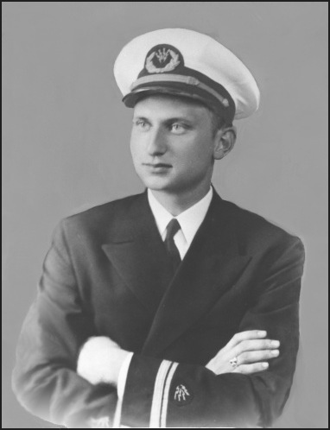
While our ship was being loaded with cargo, Capt. Wilder, our skipper, gave me several days off so that I could return home to Letohatchie for a visit. All of my family were there, including Anne, who had married but her husband had been posted to an distant army post in Texas. It was wonderful to see them and to hear their “southern” voices. It seemed like old times. I also had an enjoyable movie and dinner date in Montgomery with Teeny Jenkins, who had written to me while I was away.
Left - Jim Farrior, Chief Radio Officer (“Sparks”), S.S. John Chandler - This studio photo was taken in New York City on 22 July 1943
As Chief Radio Officer, I made a number of voyages in the Atlantic, and Mediterranean War Theaters on the Chandler, and in December, 1943, sailed out of New Orleans on the S. S. Anthony Revalli, another Liberty Ship, and made two voyages in the North and South Pacific War Theaters. On the last voyage that I made in the Merchant Marine, we arrived in Okinawa shortly after the Japanese surrender. We endured two terrible typhoons in Buckner Bay, during which many ships were sunk in the harbor, and many lives were lost. While there, I was able to visit with my uncle, Colonel Hundley Thompson who was Provost Marshal of Okinawa. He had received recent news from home. In December 1945, the war having finally come to an end, I left my ship in Long Beach, California, and returned home.

At home in Montgomery
In 1944, Melvin’s job had been moved from Letohatchie to nearby Montgomery, and Mother and Melvin had bought a small home in Montgomery. Now accustomed to country life, my mother had brought her chickens with her as there was room for a chicken yard. She and Melvin were very happy there. While waiting for the Spring quarter to begin at Auburn, I found some things to do. I bought a car and began dating some pretty girls. The home had a vacant space in a hallway, and Mother had a small table I could use, so I put up a simple antenna, unpacked my amateur radio equipment, and was soon on the air contacting some of my old amateur radio friends. We indeed had a lot to talk about. Amazingly, the equipment had waited patiently for me in its wooden box, and everything worked when power was applied.
The Alabama Polytechnic Institute
When I entered the Alabama Polytechnic Institute, now named Auburn University, for the spring quarter of 1946, the lady at my boarding house permitted me to put my Windom 20/40/80 meter antenna between two trees and also provided a small table for my radio equipment. I continued to use my old transmitter that I had built in 1940. For nostalgic reasons, I couldn’t part with my Hallicrafters Sky Champion receiver that I had bought in Atlanta, but I bought a surplus BC-348Q receiver. This surplus Army Air Corps receiver cost very little and came in the original unopened box. It was a fine receiver, and if it had not been surplus military equipment, it would have been far too expensive for me. Since it was made for aircraft power, I had to build a small power supply to replace the small motor generator that was inside the case.
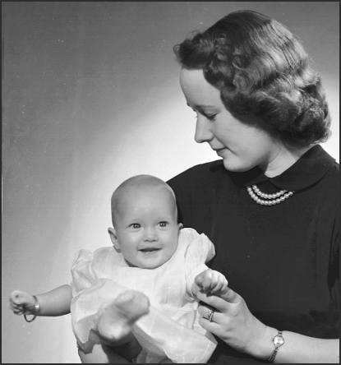
During the time I was going to school, I served as Chief Engineer of AM station WJHO that served the towns of Auburn and Opelika, Ala. At the station, I met, and later (12/24/47) married Peggy Adams. She had been the copy writer for the station. We had a short, but very happy honeymoon in Key West, Florida. Upon our return, we moved into an apartment at 500 ½ South 8th St. in Opelika. It was upstairs above where Peggy had lived with her mother. The building belonged to T.K Davis, Peggy’s brother-in-law, who would later become Mayor of Opelika.
Peggy and Baby Sue - 1948
Peggy and I were very happy when our first child Sue, was born on October 12, 1948, while I was still attending school. Having had no experience with babies, we had a lot to learn. Peggy’s mother helped a lot.
Having more than one job, and taking a full load at school, I was kept pretty busy and had no opportunity to use my amateur radio equipment. However, I did buy an enlarger and some other photographic equipment so that I could take and print photos of baby Sue.
After receiving a BS degree in Electrical Engineering (Communications Option) in the fall of 1949, I taught radio subjects at Auburn for a year as a replacement for a professor who had returned to MIT to complete the requirements for a PhD.

I Joined Wernher von Braun’s Guided Missile Team in Huntsville, Alabama
Shortly before completing my teaching contract at Auburn in 1950, I was offered a position with Dr. von Braun’s Guided Missile organization in Huntsville, Ala. That began an aerospace career in which I would remain until my retirement in 1980. After about two years, I became the first American in Dr. von Braun’s organization to be placed in a technical management position. Two of the German scientists reported to me. I was responsible for guidance schemes and for guidance and control hardware design and development for the guided missiles Redstone, Jupiter, and Pershing, and also had hardware responsibilities for America’s first satellite, the Explorer. Also included in my responsibilities, were the guidance and control system for the development phase of the Saturn Space Booster. During that period, I also received a commendation from the Navy for some guidance, control, and fire control studies that I personally made for what would become the Navy’s submarine launched Polaris missile.
Shortly after our initial arrival in Huntsville, we bought an almost new home on Thornton Circle with a separate garage that had a large attached room suitable for my amateur station and workshop. I had been inactive for several years as our home in Opelika provided no possibility for getting on the air. After moving in, no time was wasted in unpacking the gear, putting up the antenna, and getting on the air. I used my old transmitter that I had built in 1940. When a rather wealthy neighbor who had dabbled in ham radio, but had lost interest, offered to sell me his National HRO receiver for a price that I couldn’t refuse, I sold my BC-348Q receiver and bought the HRO. I had not imagined that I would ever own such a fine piece of equipment.
Later, we bought a considerably nicer brick home in Thornton Acres and had room for an office and the amateur radio. Using some of the parts from the old original 1940 transmitter, and some new parts, I designed and built a 20, 40, 80 meter, 400 watt CW transmitter that used an 813 final amplifier tube. This was far more power than I had ever had before. I was rather well equipped, but when a friend offered to sell me his old RME 69 receiver like I had used in the C.C.C., I couldn’t help but buy it. This receiver and my old Hallicrafters S20R were kept strictly for nostalgic reasons. By then, I had run out of space for additional radio equipment. The house had a utility room that I equipped with light-proof shades, which made it ideal for a darkroom. Unfortunately, few of my evenings were free as the nature of my work required that I bring home a considerable amount of work.
Rather early on in Huntsville, I became involved in amateur archaeology, and served as President of a newly formed archaeological club. We bought a small second hand 12 foot Arkansas Traveler boat with a Johnson 12 horse power motor. That gave us access to many ancient Indian sites along the Tennessee River where we could collect artifacts. We also used our car to travel to ancient Indian sites in our county and surrounding counties. Boating was so much fun that we soon sold the Arkansas Traveler and bought a new16.5 foot fiberglass boat that we named “River Flivver”. It had a 50 h.p.motor and was good for water skiing and moving at a rather high speed from one Indian site to another, as well as for picnics on the scenic lake. The trailer permitted us to take the boat with us on our yearly vacations to Panama City, Florida.
Peggy and I were again blessed when our second child, Janis, was born on 7/6/1955. Even while she was still quite small, we would take her for outings in River Flivver.
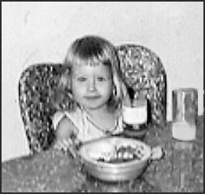
Left - Janis having breakfast - 1958

I Join Lockheed in California
In late 1959, Lockheed in Sunnyvale and Palo Alto, California, offered me a Director level position to be in charge of Guidance and Control, Aerodynamics, and Performance for the Polaris Fleet Ballistic Missile, and the Agena Space Vehicle. The position provided a substantial increase in pay and offered more opportunity for advancement.
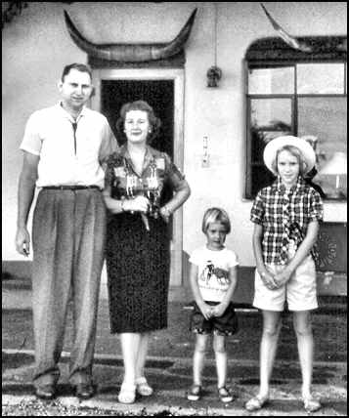
Our family had an exciting trip by car to California. My brother Joe, who changed his last name to Sanderson shortly after our mother married Melvin Sanderson, already lived in the Bay area with his wife, Dorothy, and children Joseph, Linda, David, and Mary. He gave us great assistance when, in advance of our arrival, he made arrangements for us to rent a home in San Jose until we found a nice home on Wakefield Terrace in Los Altos, which was much closer to my work.
Left - We pose at a motel in Santa Fe, N.M. during our trip to California in October, 1959.
As soon as we were settled into our home in Los Altos, I decided to get back on the air. Before leaving Huntsville, I had sold my transmitter and receivers except for my old Hallicrafters set, so I bought and built a Heathkit transmitter kit and an antenna tuner kit. At an amateur radio equipment store in San Jose, I bought a Hallicrafters SX 111, which was a very good receiver, although not as good as the HRO that I had sold.
At the same time, I bought a transistorized Hallicrafters TTO electronic keyer, which made both automatic dots and dashes, unlike my McElroy speed Key (bug) that made only automatic dots. Shortly before I had left Atlanta to join the C.T.C., I had designed and built a similar device that used vacuum tubes and relays. Although it worked well, and I had learned to use it, the other telegraphers at WVR objected to the clicking noise made by the relays. Having acquired all of the things I needed, I was soon back on the air enjoying amateur radio whenever I could find the time. Once one has learned telegraphy, it takes but a very short time for get back up to speed.
Our family found that California provided many recreational activities. We had brought our boat “River Flivver”, but boating there was not as nice there as on the Tennessee River. We mostly boated in San Francisco Bay and in the Sacramento River. We soon bought a vacation trailer so we could spend weekends in the Redwood forests, and also make longer trips towing the trailer. We towed it to the World Fair in Seattle, and to Death Valley, as well as other places. We would often drive up to San Francisco, where we could eat wonderful food in Chinatown. We had a very good life.
My work was interesting, challenging, and required much travel to Washington and to subcontractor facilities in all parts of the country. My organization contained over 500 technical and scientific people, many of whom had M.S. or Ph.D. degrees in Engineering and Physics. My travels often took me to Huntsville, so I remained familiar with the town and the people with whom I had worked there.
In 1962, as National Chairman of the Guidance and Control Committee of the American Rocket Society, and acting on my own initiative, I set up a two day Guidance and Control technical conference at Stanford University that was attended by about 550 scientists and engineers from around the country. It would have had a larger attendance if it had not required a secret clearance. In planning the conference, and getting approval to use University resources, I worked with and got to know the famous Dr. Frederick Terman, who compiled the “Radio Engineers’ Handbook”, which was published in 1943. I had bought a copy when my ship was in New York in Sept. of 1943. In 1962, Dr. Terman was Provost of Stanford University, and his Handbook was still considered a primary source book for radio engineering data and information.
In mid 1983, Mr. Dan Haughton, the Lockeed Corporate President, sent me and another Lockheed manager, Dr. Potter Kerfoot, to Huntsville to evaluate the possibility of Lockheed building an aerospace research and development center in the Huntsville Research Park that was under construction. We met with Dr. von Braun, and the heads of the MSFC Laboratories, all of whom were good friends of mine.

We return to Huntsville!
Based on our positive report, Lockheed made the decision to open the Lockheed Huntsville Research and Engineering Center, and I was chosen to be the Director. Our family made a rather quick trip back to Huntsville towing our vacation trailer, but staying in motels. Our boat “River Flivver” was shipped back to Huntsville.
At first, we lived in an almost new home on Hickory Hill Road in southeast Huntsville, but shortly afterward I designed and built a nice home on a wooded lot on Criner Road in Jones Valley. I purchased the materials and contracted out the various types of work to specialized subcontractors. The home had a room over the garage where I could install my ham equipment and store my Indian artifact collection. Also above the garage was a small room designed to serve as a darkroom.
I continued my amateur radio activity. Because of the speed limitations in manipulating a telegraph key, bug, or electronic keyer paddle, code can not be sent as fast as a highly skilled operator can read it. In the 1970s, an electronic keyboard became available that would send faster code if the operator was skilled in touch typing. That permitted an increase in the speed of a conversation using code. As it had no memory, sending had to be done in “real time”, which required learning a new skill. A certain time was required for each character, and pressing the next key had to timed exactly right, or the code would not be sent correctly. When such keyboards became available, I bought one that was designed and built by a radio amateur, K4KN. I enjoyed using it, and soon made several high-speed keyboard friends. Later, keyboards having memory became available so the operator could type ahead of the sending and the keyboard would automatically supply accurate spacing between the characters and the words. Operators with less typing skill could therefore send perfect code.
Building the Huntsville facility and staffing it with the right people was a difficult but rewarding challenge. Running the facility was very interesting, because the work done covered all of the aerospace sciences. It was difficult because the contracts were won by competitive bidding. Also, I was working closely with Dr. von Braun and my old friends at NASA and the Army in performing advanced research and development contracts. I became a member and officer in a number of professional organizations, and also served on the Advisory Board of the University of Alabama.
My interest in archaeology continued, and collecting artifacts from the fields in Madison County and surrounding counties was often a family affair. We also bought a 35 foot houseboat, which we kept on Guntersville Lake. Our boat slip was near Wernher von Braun’s slip, and he, his wife Maria and son Peter would often come there on the weekends and would fish from the dock. When von Braun was inducted into the Space Hall of Fame in Texas, I went to the ceremony with a group from Huntsville. Maria was at the head table, and when she got up to introduce the folks from Huntsville, she introduced me as her “fishing buddy”.
The houseboat was very enjoyable, because with River Flivver in tow, we would find a nice cove where we could anchor and spend the weekend. We could use River Flivver for water skiing, and exploring the lake shore for Indian sites.
Later, we sold the houseboat and I designed and built a cabin on beautiful Smith Lake in Walker County, where we would often spend weekends. Smith Lake was large with many coves, wooded shores, and deep crystal clear water. Our house was built on what had been the top of a high bluff, and the water level came up to nearly the top. The water depth was about 50 feet under the floating dock and boat house that we built for River Flivver. There were a lot of woods near the cabin where I could hunt squirrels, so we ate a lot of squirrel stew in season. We could also catch fish from the boat or from the floating dock.
As if I didn’t have enough to do, I bought a 402 acre farm in north of Huntsville at Petersburg, Tennessee, where cattle were raised and a 100 cow dairy was operated. I really enjoyed the farm, as there was were good woods for hunting, but after several years, I reluctantly sold it when it became obvious that absentee ownership was impractical due to the impossibility of keeping reliable help.
Sue had always displayed a considerable artistic talent, and after she finished high school, she enrolled as an art student at the University of Alabama Huntsville Campus.
It came as a surprise to Peggy and me when we discovered that our happy family oriented lifestyle couldn’t last forever. Shortly after Sue graduated, she married Jack Harden, a NASA aerospace scientist who worked at the Marshall Space Flight Center.
It seemed like only a short while after that before Janis married Larry Nall, a biology student at the University of South Alabama, and she joined him in Mobile. Peggy and I were left in a very lonely home.
If there was anything good about our children having flown the nest, it was that we were free to travel when I could get off from work. We began by taking a trip to Greece and Egypt. Later, we made trips to Mexico, where I became very interested in Mexican archaeology. We sold our vacation trailer and bought a motor home.
In 1973, Janis and Larry became parents and we became grandparents when Jennifer was born in Mobile where Larry was still a biology student at the University of South Alabama.
We retire, move first to Daphne, Alabama, and then to Merritt Island, Florida
I served as Director of the Lockeed Huntsville Research and Engineering Center for 17 years. It had become apparent to me that I would never have the time to do the many things I wanted to do plus work, so I decided to take early retirement. In anticipation of that, we bought a home at Daphne, Alabama, on Mobile Bay. The property consisted of a rental home, a small guest home and the main home on a 4 acre lot with 300 feet of white sand beach on the bay. It had a long pier that ran out to a dock and a boathouse with lifts for two boats. We renovated and enlarged the home, which was on pilings, and we intended to retire and move there in January, 1980. However, the major hurricane Frederick with exceedingly high winds passed directly over the bay destroying the guest house and doing considerable damage to the other property. It completely destroyed the boathouse and dock, washed out the access road, and felled a few ancient oak trees. We needed time to restore the property, so my retirement was delayed until July 1, 1980.
Shortly before my retirement date, someone saw me placing a “For Sale” sign in our yard, and bought the home at the asking price. We had to move out quickly, so the day after my retirement, Peggy and I left for our home at Daphne. I hired a colored man to drive a large U-Haul truck towing a large trailer, and I drove our motor home that was towing our station wagon. Our boat River Flivver had been towed to Daphne on an earlier trip.
Almost immediately after moving into our home at Daphne, I decided to replace all of my old radio equipment except, of course, my old Hallicrafters S-20 receiver that I had bought in Atlanta in 1940 and had kept for nostalgic reasons. I ordered a Ten-Tec OMNI C transceiver with crystal filters and power supply. Also bought was a second separate VFO (variable frequency oscillator), an antenna tuner, an electronic keyer, and a MFJ Super Keyboard II to replace my old K4KN keyboard that had no memory. While waiting for the equipment to arrive, I installed between some trees a 10/20/40/80 meter trapped dipole antenna that was cut for the CW section of the bands. This was the first time since I became a ham that I had no home-built equipment, except for the Heathkit test equipment that I had built and still used. A microphone came with the transceiver, but it was never used.
The new transceiver worked like a charm, and it still does after 23 years. After I got back on the air from my Daphne QTH (station location), I began to spend a lot of time “working” (communicating with) my keyboard friends.
Shortly afterward, I became a charter member of the “CFO” (Chicken Fat Operators). Membership was by invitation after one proved the ability to maintain a QSO (contact) at a code speed of at least 45 words per minute. I understand that the “Chicken Fat” in the name came from the fact that in the old days one spoke of a real fast operator as one who must have lubricated their telegraph key with chicken fat. I had the honor of having my CFO qualification test given by Jim Ricks, W9TO, the founder of CFO, in a long QSO at a speed over 45 words per minute. I didn’t realize that I was being tested as the speed seemed normal for Jim, but after our QSO he informed he that I had passed the code speed test and that I would soon receive my CFO membership certificate. I still remember how happy and proud I was to receive it, and to become CFO #431. The membership in the CFO was mostly American amateurs, but there were some from foreign countries.
Jim Ricks is now deceased, and the CFO is part of Amateur Radio history. However, a few of the old members are still on the air. Jim lived near Chicago, but I had known him by amateur ham radio since right after WW-II when I got back on the air from the boarding house in Auburn. At that time, Jim was known for the excellent electronic keyer he had invented. When controlled by a “paddle”, his electronic keyer made both dots and dashes automatically without the use of relays. It was known as the TO keyer. Years later, when transistors became available, he designed a keyer that used transistors instead of vacuum tubes and named it the TTO keyer. Hallicrafters bought the rights to manufacture and sell that keyer. I had bought one of them soon after I moved to California and used it until I got my first keyboard..
Our Daphne home on the bay was a very nice place to live. The area was very historic. Mobile was just across the bay, and the Civil War battlefields of Spanish Fort and Blakeley were only a few miles north of Daphne. My grandfather, James S. Farrior Sr., had fought in both bloody battles. After Spanish Fort fell, he and the other survivors escaped to nearby Fort Blakeley, where most were killed or captured the next day. Fortunately, he was captured. On a day trip, we went to Ship Island off the coast of Biloxi, Mississippi, where my grandfather had been held prisoner at Ft. Massachusetts. Our granddaughter Jennifer was a small girl at the time and was visiting use, so we enjoyed having her along on the trip. She got her historical facts mixed up when she referred to the Civil War as the “Silverware War”. She had heard me tell how my great grandmother’s silverware had been buried during the civil war.
Although we liked the Bay Area very much, our plans were to improve the Daphne property, sell it, and then move to Merritt Island, Florida, which we did in mid 1981. Sue and Jack already lived there, and Jack was a manager at the Kennedy Space Center. Larry had obtained a Master’s degree from Florida State University, and he, Janis, and Jennifer were living in Orlando, which was a short drive from Merritt Island. Our home on Riviera Drive was on a canal with a view of the Banana River. We had a dock and boathouse and enjoyed boating in River Flivver. Our swimming pool was cleaned more than it was used, but it served as a nice reflecting pool.
From time to time I ran into my old aerospace acquaintances and we would talk about old times. From the yard of our home we could view the Shuttle launches, and were watching when the Challenger Space Shuttle exploded, killing the astronauts.
Upon our arrival, I wasted no time installing my Ten-Tec rig and a 160 meter thru 10 meter vertical antenna. I joined the local amateur radio club and participated in the meetings. There were a number of members who had been radio amateurs for many years, and who remembered amateur radio as it was when most amateurs built their own equipment. In 1983, after getting my first computer, an Apple II, I acquired a 2 meter transceiver and antenna so that I could experiment with the digital mode named “Packet”. It did some amazing things, but I liked telegraphy much more.
Soon after I got the computer, I got the Magic Window word processor. I studied Basic programming, and soon programmed the first version of “The Mill”, a computer program that teaches both American Morse and International Morse. A much improved PC version is still popular and is available as a free download on my Web Site.
When Sue and Jack moved to Fernandina Beach, on Amelia Island, we went to visit them and found that it was a far better place to live than Merritt Island. We also had missed them after they had moved. We bought a home on a golf course in the “Plantation”, an up-scale housing development, and moved there in September of 1990. The house had two upstairs rooms, and I claimed a bedroom for my radio shack and computer room. There was no convenient way I could set up a darkroom. After a few weeks I was back on the air talking with some of my old friends using telegraphy. By that time, many of my oldest amateur friends had died, or were no longer active radio amateurs. After living in that home for a couple of years, we decided to get back on the water. We bought a beautiful marsh lot in “Plantation Point”, just north of “The Plantation”, and I designed and built the home in which we now live.
While Jennifer was still young, Jan and Larry had moved to Oyster Bay, on the Gulf Coast south of Tallahassee, where they enjoyed coastal living. Both Jan and Larry worked in Tallahassee. Larry was a biologist with the State of Florida, and Jan worked at a large hospital, where she was in charge of the medical labs.
On Nov. 11, 1995, Jennifer married Thomas Petrandis, the son of a very successful sea-food restaurant owner. Jennifer is now the business manager of the restaurant, and Thomas is the head chef. He also manages the Petrandis commercial fishing business. On March 18, 1997, Peggy and I were made great grandparents when their daughter Marina was born. On March 20, 2003, their second daughter, Savannah was born.
I begin my mini-career as an archaeologist
Archaeology had been a hobby with me for many years, and I had served as the Vice President of the Alabama Archaeological Society and President of the Madison County Chapter. After my retirement, I began digging in Central America. I dug at Colha (Belize) 1983; Copan (Honduras) 1984; Tikal (Guatemala) 1985; Rio Azul (Guatemala) 1985; 1986, 1987; Caracol (Belize) 1988; Kinal (Guatemala) 1990, 1991, Rio Bravo (Belize) 1993, 1994. I dug primarily with an archaeological team from the University of Texas (San Antonio}. Dr. Richard .E.W. Adams, a noted Maya archaeologist was the Project Director, and for several seasons I assisted Jack Eaton, a noted Maya Archaeologist and explorer. The digs were six weeks to three months in length, and most of them were deep in the jungle. In northern Guatemala at the Mayan sites of Rio Azul and Kinal, our camp was at an old chiclero camp site known as Ixcanrio.

The Jungle Telegraph Office
We lived in tents, and there was a radio/medical tent that I shared with the project physician, Dr. Edward Westphal. I would take with me a small amateur radio station in a small aluminum case that would fit under the seat in the airplane. Reliable daily communications were always maintained with several amateur radio stations in the United States. In Guatemala, we called our radio net the “Rio Azul Net” (RAN). The most active members of the net were Marty Morrison (NS5H), Orton Duggan (W4EQE), Frank Cicogna (N8GDO), and Ron Wiesan (WD8PNL). I was licensed to use the call W4FOK/TG, where the /TG indicates Guatemala. All of them were excellent telegraph operators who handled the radio traffic in a professional manner.
Every evening after returning to camp very hungry, tired, and dirty, I would quickly shower and then prepare messages for transmission. I was allowed to shower first so that I could go to the radio shack. My goal was to get the traffic cleared before supper was called. Not getting into the chow line promptly could cause me not to get my share of the beans and tortillas. That was very serious business!

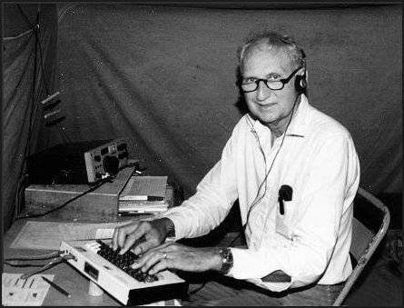
The Jungle Radio Station - This photo shows me in the radio/medical tent at our Ixcanrio camp deep in the Guatemalan jungle.
At my right, in the photo, is my small 20 watt Ten-Tec Century 22 CW transceiver. It performed remarkably well in both receiving and transmitting. The small antenna tuner is on top of the transceiver, but can’t be seen because it is black. Although I often used a keyer paddle in conjunction with the transceiver’s built-in electronic keyer, I preferred using the MFJ Super Keyboard II because I could store messages in it before the schedule began. The simple antenna, which was supported between a pole and a tree, was a single-wire fed off-center Hertz, known as a Windom, cut for 80 meters, but it also worked equally well on 40 and 20 meters. This made it possible to move to another band if conditions on one band deteriorated. At no time was communication impossible. Such reliability would have been impossible using telephony.
Since a primary subject of this small book is Amateur Radio and telegraphy (CW), it seems appropriate to include the following account of how Amateur Radio, using telegraphy, played an important role in an emergency situation.

Telegraphy in Action”. by Jim Farrior, W4FOK
(Published in the British publication "Morsum Magnificat", Number 54, Oct.1997. A Spanish translation was published in a Mexico City Radio Amateur journal.)
For a number of years I took a small amateur radio rig with me into the jungles of Central America, where I participated in archaeological digs. My amateur radio call, W4FOK, was issued in 1938, and I was licensed as W4FOK/TG in Guatemala, and as W4FOK/V3 in Belize. My little rig, a Ten-Tec Century 22, has an output of only 20 watts, and no voice capability. The transceiver, keyboard, keyer paddle, a.c. power supply, antenna tuner, 20/40/80 meter antenna system, tools, manuals, and spare parts, all fit in a small case which was carried aboard the aircraft. In each year of jungle operation, approximately 100 messages were handled by radio amateur volunteers in various parts of the U.S. Notably among those who nearly always met the regular evening schedule were W4EQE, NS5H, WD8PNL, N8GDO, and W9CN. Often there were others. Most of the messages handled were personal messages for the staff, but a number dealt with emergencies, mostly medical. All were handled promptly and accurately, and this could not have been done using voice due to the low power, the primitive antenna, and the congested state of the amateur radio bands.
Urgent Traffic by CW
In Guatemala, our camp was in the extremely remote, uninhabited north eastern corner of the Peten near a large Maya archaeological site known as Rio Azul. In 1986, when digging at Rio Azul, we found a Maya tomb just as we were closing the season. Had it not been for the radio, we would have had to back fill the extensive excavation without clearing the tomb, with a strong possibility that it would have been looted before the next season. However, in less than three hours after finding the tomb, by using our CW communications link, we had sent a message to the National Geographic Society's headquarters in Washington, D.C., and had received a reply authorizing funding for another week's work to clear the tomb. In 1987, we had a severe malaria epidemic at Rio Azul. Medical advice was obtained through an exchange of messages with the Center for Disease Control in Atlanta. A radio message was also sent to San Antonio, Texas, requesting that the U.S. Embassy in Guatemala be contacted and that arrangements be made for medical assistance. As a result, two days later, a doctor and a nurse arrived with medical supplies after a very difficult trip through the jungle.
Deadly Snakebite
In 1990, we dug at Kinal, another large Maya site 10 km from our Rio Azul camp. The dry season had not arrived, and we were spending up to six hours of the work day traveling through the muddy jungle between our camp and the work site. On March 12th, a little after 4 p.m., while he was cutting palm thatch for the camp buildings, a young Guatemalan native workman, Victor Medrani, was bitten on the lower right leg by a huge snake. A fellow workman killed the snake with his machete and ran at top speed to the camp bringing the snake with him. Dr. Dick Adams, the project director from the University of Texas at San Antonio, and I were the only staff in camp at the time, and we saw immediately that the snake was the dreaded Fer de Lance. Bites from this snake are often fatal, even with the best medical treatment. We grabbed the snake bite kit, climbed in the small four-wheel drive pickup and headed down the muddy jungle road. Victor, who had been left in the jungle beside the road was already very ill, in pain and bleeding from the mouth and eyes. Dick immediately injected the anti-venom we had brought, but back at camp, Victor's condition quickly worsened, and we had soon used all of the remaining anti-venom.
Call for Help
While others tended to Victor, Dick and I met in the radio tent to decide what might be the best course of action. It was clear that Victor would die if we could not get him to a hospital quickly, and our best chance was to use the radio to try to get a helicopter to pick him up. However, this would have to be done working through a U.S. radio contact, despite the difficulties often experienced in getting a telephone call through to Guatemala from the USA. It was time for the normal 5 pm radio schedule, and, as usual, Marty Morrison, NS5H, who lives in San Antonio, was on the job. She is a fine telegrapher, who sends fast beautiful code on a bug, and she normally handled all of our traffic for the San Antonio area. Through her, we sent a message to Dick Gill, a friend of the project who lives in Austin and San Antonio, requesting that he call the U.S. Embassy in Guatemala and try to make arrangements for a helicopter to pick up Victor from a cleared area near the camp. By 5:30 Gill had been located with the help of Jane Adams, Dick's wife, and he placed a call immediately. The telephone service between San Antonio and Guatemala City was working much better than usual, and the necessary contacts were quickly made. It then took an hour and a half for the U.S. Embassy in Guatemala City to determine that the Guatemalan military would not take their helicopter into the jungle at night, and no other alternatives were available, probably not even the next day.
Request for Medical Team
Upon receiving that information at 7:10 pm, we asked Marty, by CW, to ask Gill, who speaks fluent Spanish, to call the Fire Chief in Santa Elena, a small town on the edge of the jungle, to arrange for medics to depart Santa Elena as soon as possible with the necessary anti-venom, antibiotics, etc., to treat the patient. We would leave the camp shortly, and hopefully would meet the medics about half way, where they could begin treating Victor. Luck was again with us. It normally took a long time, hours and sometimes days, to get a call through from the U.S. to Santa Elena, but miraculously, the call went through immediately. At 7:25, Marty, back on the key, told us that the Fire Chief had agreed to help. However, he had no anti-venom, and no money to buy it. Through the CW link with Marty, and the telephone link to the Chief, we asked him to get the money from the Project's Guatemalan agent, Edmundo Solis, who lived in Santa Elena. We also suggested they take Edmundo and use his truck, as he was familiar with the jungle road and his vehicle was well suited to jungle travel.

Help On The Way
Marty was asked to pass along the information that our trucks would depart camp within the hour. Gill confirmed that he had made the necessary requests, but he could get no confirmation from Guatemala on the action taken until the following morning. The excellent telephone service we had experienced for a short while had returned to its normal bad condition. Fortunately, however, the medical team had been quickly assembled, the pharmacist located, and the needed supplies obtained. Because of the rain, however, their chances, and ours, of getting through the dark jungle and making a rendezvous that night were poor.
Medicine Man
At the camp, Victor was clearly very sick, and screaming with pain and fear. We had used all the drugs and other medications that could help, and the workmen were now insisting that one of their number, a medicine man, should be allowed to administer to him. He wanted to brush Victor's body with branches from certain shrubs, to lay leaves from certain plants on his leg, and have him drink a concoction made from jungle plants. What they wanted to do seemed to be rather harmless, especially in view of the situation that would have existed if their request had been denied and Victor had died. Remarkably, this treatment seemed to calm Victor down a bit, but he was still in agony, and everyone including him, I'm sure, felt he had little chance of surviving.
"Vaya con Dios"
A litter was made for Victor in a small four-wheel-drive van. Other trucks carried workmen with flashlights, machetes, a chain saw, shovels, cables, extra fuel, and other things they would need to force their way through the jungle. Everyone said "Vaya con Dios" to Victor, who groaned "gracias", and at 8 p.m. the convoy left camp. For half an hour, the sound of their engines could be heard as they struggled through the muddy jungle. Although Victor was wedged into his litter, we knew he was being bumped, jolted, and thrown about, and that this would continue for many hours. Marty was still on the radio, so I thanked her, Jane, and Gill for the tremendous job they had done. She said that they would continue trying to get through to Santa Elena to find out what had happened. In the meantime, there was nothing that we could do, so we arranged to contact them the next morning at 7 am on 20 meters. At 7 am Marty's signal was clear and strong, and she reported that Gill had finally received word that the team from Santa Elena had started out. At 8 am and again at 9 am, she reported that they had had no further luck in getting through to Santa Elena. The phone service had now returned to its normal state.
Dig Terminated
Two days later, at our normal CW schedule, Marty said that she had received a confusing report from Santa Elena. Apparently the patient had had his leg amputated, but attempts to verify that report had failed so far. The next day our team arrived back in camp with stories of their difficult trip but also some good news. Victor had survived the trip and had responded to the treatment. The report we had received related to another snake bite victim in the hospital. The scheme to meet halfway almost failed because the two teams were traveling on separate, parallel detours, and would have passed each other if one man had not by chance spotted a headlight through the jungle. Edmundo told me later that without the wireless telegraph to set up the jungle rendezvous with the medics, there was little chance that Victor would have arrived at the hospital alive. Because of the costs associated with Victor's hospital treatment, Dr. Adams decided to terminate the dig at Easter; and when we left the jungle at that time, we spent the night in Santa Elena.
Urgent Transfer
We fully expected that Victor would be well, or nearly so, and were shocked to find him very near death. He had had several operations to remove infections from his stomach, intestines, and elsewhere, and just prior to our arrival, his kidneys had failed. His leg was a mass of infection. The poorly equipped hospital had run out of antibiotics, and had not been able to handle the situation. Dr. Adams immediately decided that we must try to transfer Victor by air ambulance to a modern hospital in Guatemala City. Over objections by his family, and also by the local hospital who demanded that Victor's bill be paid immediately, Dr. Adams began making arrangements. It was already after dark, the bank was closed, and the small airport had shut down for the night. However, Dick had friends locally, and at the hospital in Guatemala, who helped him make arrangements for an air ambulance and for the airport to re-open. The Fire Chief who had come to our aid before, agreed to transport Victor from the hospital to the airport. Although the hospital was assured that they would be quickly paid, Victor's leaving was more like an abduction than a dismissal.
Leg Amputated
When Victor arrived at the hospital in Guatemala City his heart and lungs stopped, and he had to be revived and placed on life support systems, including kidney dialysis. In spite of his general condition, the doctors decided that his leg had to be amputated immediately if he were to have any chance of surviving. When I left Guatemala City a week later, he was out of danger, and would soon be transferred to a rehabilitation hospital. When he recovered, he returned to Santa Elena on crutches, and Dick arranged for him to be paid his normal wage for the remainder of the year. The next year, 1991, Victor was back at camp. He was in good spirits, looking healthy, and using crutches. His muscular appearance indicated that he had not been idle. When offered a job washing artifacts in camp, he asked for a "man's job". In 1992, still without a prosthesis, he showed an amazing ability to do hard work. I learned that arrangements had been made for Victor to be fitted with an artificial leg. Our project moved the next year to the Rio Bravo area in Belize. I suppose I will never hear of Victor again, but I will always wonder how he made out. Although Victor lost a leg, his life was saved, and Morse telegraphy played an important part in making that possible. Let's not ring down the curtain on telegraphy. It still lives! End of the article.
My computer program, “The Mill”, which is a free download from my Web Page, contains a simulation of all of the messages that were sent and received in connection with the above emergency event. To increase the realism of the simulation, each station is given a different CW “note”, and each operator is given a different “fist”. The Web Page URL is: <http://www.home.comcast.net/~w4fok>

Conclusion
Now (2005), I am 85 years old and still have my original amateur radio call, W4FOK. “The Mill” is still popular among radio amateurs around the world. The program is also used in a number of railroad museums in the U.S. and Canada to send American Morse code railroad messages, and in connection with railroad and telegraph office exhibits. Older people find the sound of the sounder to be very nostalgic, and younger people are amazed that the sound can be “read” by a telegraph operator. A maritime museum in England uses the program to send nautical messages in International Morse Code, including a complete simulation of the distress messages related to the Titanic disaster.
Some amateur radio operators reading my book may wonder why I haven’t mentioned more about the many different facets of Amateur Radio operating. I’ve briefly tried much of it, but found that for me designing and building equipment and CW QSOing were always the most rewarding. Part of the attraction of Amateur Radio is that there are so many different ways that one can participate. Some like designing and building their equipment, experimenting with antennas, using various modes of operation, mobile or marine operation, handheld operation, Field Days, etc. Personally, I think that it is sad that there are fewer code users and most do not build any of their equipment.
See the photo on the following page.

One nice thing about writing a book is that one can put in it whatever one chooses. Although not directly related to the subject matter, I could not end this book without presenting the following photo of Peggy and me with all of our descendants. Our daughter Sue lives near us on Amelia Island with her husband, Jack Harden. Our daughter Janis lives with her husband, Larry Nall, and they and their descendants live on the Gulf coast south of Tallahassee. The photo below was taken at our home on the marsh in Plantation Point. The panoramic view of the marsh and the Intracoastal Waterway from this room is both beautiful and interesting.
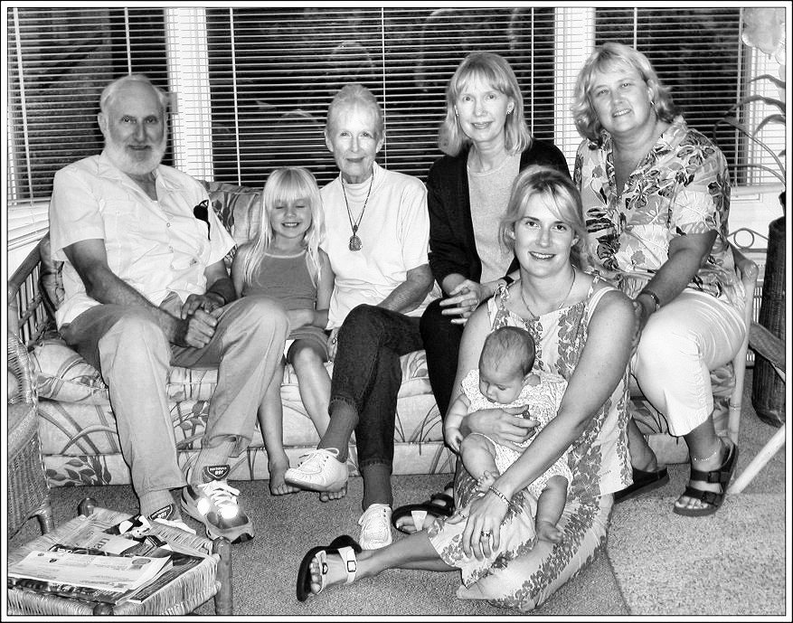
Our 2003 Family Photo - Peggy and me with all of our descendants. Left to right on the sofa: Jim Farrior, Marina Petrandis (age 6), Peggy Farrior, Sue Farrior Harden, Janis Farrior Nall. On Floor: Jennifer Nall Petrandis holds Savannah Petrandis (age 4 months). Janis is Jennifer’s mother. Marina and Savannah are Jennifer’s daughters. This photo was taken July 22, 2003, by my son-in-law Jack Harden using my new digital camera.

The END

